Learning Project WEEK 4 - Animals
Age Range: KS1
Staying active is really important when you are at home. There are lots of resources, here are just a few to use!
Joe Wicks PE sessions
Go Noodle
Super movers!
Cosmic Yoga

Weekly Maths Tasks (Aim to do 1 per day) | Weekly Reading Tasks (Aim to do 1 per day)
- White Rose has a daily Maths lesson which can be accessed online. They are available for individual year groups.  - In the home learning books, share what they have learned in their online Maths lesson from White Rose. They could stick the work in, but don’t panic! They could explain the work using pictures and diagrams. They can be as creative as they want to be.  - Working on Numbots - your child will have an individual login to access this.  - Play on The Mental Maths Train Game - practise adding and subtracting  - Look around your house and go on a number hunt. How many items can you find that have numbers on them? What is the largest number you can find? What is the smallest number you can find? Then play this game for ordering numbers.  - Practise learning about money by playing this game. You could also use real coins and play a similar game with family members.  - Complete the challenges set for you on Sumdog! | - Can you read fiction, non-fiction and poems about animals? There are lots of books that you can read for free here!  - Can you find adjectives in the books used to describe the animal?  - Listen to the stories:  Clark the Shark  Library Lion  - Create a bookmark with animal facts on. Can you illustrate the bookmark with pictures of animals on them as well?  - Read common exception words and time how long it takes for you to read them all. Can you beat your score by the end of the week?
Weekly Phonics/Spellings  Tasks (Aim to do 1 per day) | Weekly Writing Tasks (Aim to do 1 per day)
- Daily phonics - your child to practice their sounds and blend words. Interactive games found on link below.  - Phonics play  - Top Marks  - Spelling  - Spell the days of the week  - Spell common exception words  - Sumdog spelling games  Year 1 Spellings Y2 Spellings  corn dear  pork deer  horse know  before no  born road  more rode  score right  shore write  short passed  core past | - A-Z Animal list: Can you think of an animal for each letter of the alphabet. Can you add sound buttons to the words that you have written? *Look here if you’re not sure about sound buttons!  - Draw a picture of your animal and label it. Can you write sentences about the animal you have drawn using adjectives?  - Write a set of questions about animals you would like to find out about.  - Create a fact file about your favourite animal. Research an animal of your choice and explore the vocabulary required to describe them.  - Describe similarities and differences between animals. Could you choose one that lives in a hot place and one that lives some where cold? How have they adapted to where they live?
Learning Project - to be done throughout the week: Animals
The project this week aims to provide opportunities for your child to learn more about key animals they are interested in. Learning may focus on exploring the physical aspects of an animal, their habitat, categorising animals etc.
Find out about:
What are mammals?,
What are amphibians?
What are birds?
What are fish?
What are reptiles?
What are minibeasts?
https://www.bbc.co.uk/bitesize/topics/z6882hv

Create a mask : Using different materials around the house, create a mask of their favourite animal. Think about the colours and shape. Can they add different textures to their mask?
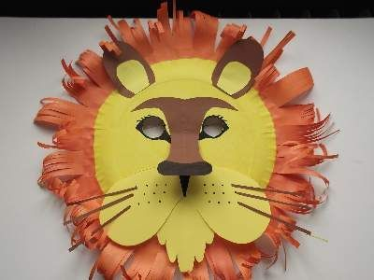

Where does your animal live? Play this sorting activity to develop their understanding of where different animals live.
Why is this warthog covering himself in mud? Explore the animal activities for KS1.

Animal grouping: Ask your child to group animals into two columns. Identifying animals that can fly and cannot fly, or animals that can swim and animals that can’t swim.
Then think about the diet of different animals. What do animals eat? Scientists group animals into three different groups according to what animals eat. These groups are carnivores, herbivores and omnivores. Carnivores eat other animals, herbivores eat plant material including fruit, leaves, vegetables, omnivores eat a mixture of meat and plant material. (Animals that eat other animals are called carnivores. Animals that eat plants are called herbivores. Animals that eat both plants and other animals are called omnivores)
Sorting Cards

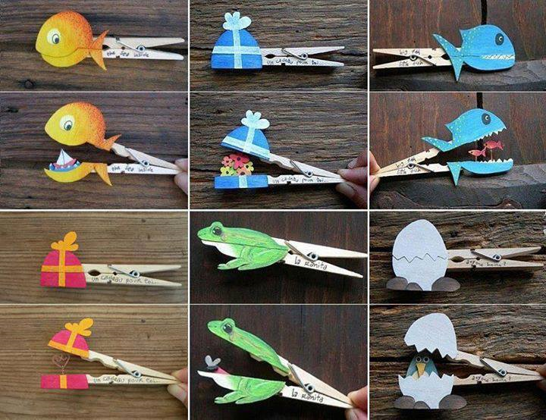
Needs of an animal. Can all animals be kept as a pet? Think about a particular animal and find out if that animal could be a pet. Draw pictures of different animals. Sort the animals into two groups; suitable for a pet and not suitable for a pet. Explain why you have sorted the animals into the groups you have. www.rspcaeducation.org.uk/teachers - Design a leaflet explaining to potential pet owners what each animal will need. - Interview a pet owner to discuss the responsibilities involved with looking after an animal. How often do they need to find their pet? Who helps clean? What does their pet eat?
Look at the picture to the side. Can you find some pegs at home and create your own mini animal or object, cut it in half and stick it to a peg.

Nocturnal animals - What do they think this word means? Watch and discuss the animals they saw. Have they seen these animals? How could they describe them? Play Nocturnal animals are more active at night than during the day. These animals sleep during the day, often in a burrow or den. They have special adaptations that help them survive in the dark. Over millions of years, these animals have developed traits that help them survive in the darkness. Nocturnal animals may have larger ears to hear better, bigger eyes to see better, and body parts that glow in the night. Create your own big-eyed nocturnal animal art. If it is safe to do so, could you go out after dark and see if you can spy any nocturnal animals?

Additional learning resources parents may wish to engage with
Classroom Secrets Learning Packs - These packs are split into different year groups and include activities linked to reading, writing, maths and practical ideas you can do around the home.
Twinkl - to access these resources click on the link and sign up using your own email address and creating your own password. Use the offer code UKTWINKLHELPS.

#TheLearningProjects

