Learning Project - Famous & Significant People
Online
Age Range: Y5/6
Staying active is really important when you are at home. There are lots of resources, here are just a few to use!
Joe Wicks PE sessions
Go Noodle
Super movers!
iMoves
Cosmic Kids Yoga
Weekly Reading Tasks | Weekly Spelling Tasks
Year 5 | Year 6
famous | pronunciation
dangerous | library
division | steal
safely | steel
percussion | frightening
discussion | worried
possession | difficulties
comprehension | exaggerate
anchor | nuisance
character | restaurant

Monday- Encourage your child to listen to a text being read. It could be that someone who is important to them reads them an extract of a book, or they listen to one on audible or BBC Sounds | Monday- Practise spellings on Spelling Frame. Use a dictionary to clarify any unfamiliar vocabulary.
Tuesday- Click here for a reading comprehension activity about a famous botanist. Challenge your child to read the text in under 3 minutes and complete the comprehension questions. | Tuesday- Choose 5 Common Exception words here. Ask your child to write the meaning, synonyms (word with the same/similar meaning) and antonyms (word that has the opposite meaning) for each word.
Wednesday- Visit Ducksters and encourage your child to choose a person that interests them to read about. Encourage them to write down as many facts about the person as they can in their own words. | Wednesday- Ask your child to mind map vocabulary that they associate with one or more of the following significant people: Guy Fawkes, Helena Lucas and Rosa Parks. Or they could choose a different person from here.
Thursday- Ask your child to create a profile about a famous book character e.g. Harry Potter, Matilda Wormwood or Percy Jackson. Look again at the website from the previous day and think about what sub-headings could be used to organise their fact file. Research the information needed. | Thursday- Can your child complete this segment puzzle (click Spelling Tiles) which focuses on words ending in: -able, -ible, -ably and -ibly?
Friday- Write the character profile that was planned the previous day. | Friday- Pick 5 Common Exception words from the Year 5/6 spelling list here. Direct your child to represent each word as a picture.
Weekly Writing Tasks | Weekly Maths Tasks- Addition and Subtraction  Choose a task or tasks from each day. These are to be used flexibly
Monday- Visit the Literacy Shed for this wonderful resource on The Clocktower or ask your child to write a letter/email to an important family member updating them on events from the last few weeks. | Monday- Play Top Marks Daily 10 Addition and Challenge Level 6.  Hint the timings of this game are flexible so you will have an opportunity to work out your answers.  White Rose Maths online daily maths lesson  Bitesize Maths online daily maths lesson  CODE Maths Hub Daily Fluency Activities - Day 1 Week 6
Tuesday- Using the words FAMOUS PEOPLE, get your child to write an acrostic poem about significant British people in history. | Tuesday- Play Top Marks Daily 10 Subtraction and Challenge Level 6.  Hint the timings of this game are flexible so you will have an opportunity to work out your answers.  White Rose Maths online daily maths lesson  Bitesize Maths online daily maths lesson  CODE Maths Hub Daily Fluency Activities - Day 2 Week 6
Wednesday- Listen to Martin Luther King’s speech I Have a Dream. Ask your child to write their own speech about their dreams.  Look at this lesson from BBC bitesize about writing a speech.  Encourage them to use the same techniques such as repetition, personification and powerful verbs. | Wednesday- Addition and Subtraction Practise  Using your digit cards 0 – 9  Write 8 pairs of addition and subtraction calculations using 5 numbers in each row.  34672 46190  + 15890 - 38753  Use inverse to check that your answers are correct.  White Rose Maths online daily maths lesson  Bitesize Maths online daily maths lesson  CODE Maths Hub Daily Fluency Activities - Day 3 Week 6
Thursday- Use your time to research the character profile that you began in reading – you need to make notes and write them in your own words. | Thursday- Here is an addition pyramid from Twinkl website. Using your digit cards explore making your own numbers to create your own 4, 5 or even 6 digit pyramid. As an extra challenge play this game adding decimals .  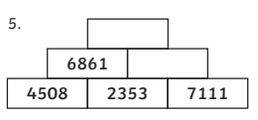  White Rose Maths online daily maths lesson  Bitesize Maths online daily maths lesson  CODE Maths Hub Daily Fluency Activities - Day 4 Week 6
Friday- Complete the character profile – think of 3 questions you would like to ask them – write them and down and then try and answer them ‘in character’ (as if you were them!) | Friday- Theme Famous Mathematicians  Create a famous mathematicians poster using this website. and showing key facts and pictures. Alternatively, if you are registered on Twinkl you may want to use some of these posters to help you.  White Rose Maths online daily maths lesson  Bitesize Maths online daily maths lesson  CODE Maths Hub Daily Fluency Activities - Day 5 Week 6

Learning Project - to be done throughout the week
The project this week aims to provide opportunities for your child to learn more about famous or significant people. Learning may focus on past or present inventors, explorers or scientists and how they influence society today.

- Famous Brits- Lots of significant people in history have been British. Emmeline Pankhurst, Guy Fawkes and Mary Anning are just a few. Ask your child to research one of these or another famous Brit of their choice. They could create a poster about them which tells the reader all why they are famous and any other interesting facts. Could you add a drawing or image of the person you’re writing about?

- The Queen’s Speech- The Queen spoke to the nation on Sunday 5th April from Windsor Castle. She had an important speech to deliver where she wanted to thank people for what they were doing and to give hope that things would eventually return to normal. Ask your child to think about what they would say if they had to speak to the nation? What messages of hope would they want to give to their friends and family? Your child could write their speech or record themselves delivering their speech. Remember to tweet a video of their speech using #TheLearningProjects.

- Inspiration for Inventors- These inventors talk about where they found the inspiration for their inventions. Ask your child what problems they incur in their daily life? What inventions would make their life easier? How could they turn their idea into a product? Direct your child to mind map ideas of how they could solve their problem before designing and annotating a product. Your child may even want to make a prototype or test parts of their design to see if it would work.

- Significant to Me- Discuss with your child a person who is significant to them. This could be a famous person who has inspired them or someone who has made a positive impact on them from their everyday life. Ask them to discuss the qualities that this person has - why are they inspiring? Why do they look up to them? You could share someone who is significant to you with your child as well and talk about how they have influenced you. They may wish to draw a portrait of this person.

- What it Takes- Ask your child to watch this interview with Paralympic gold medallist Helena Lucas. In this interview it talks about the dedication needed to be a successful sportsperson. If you want to look at different sports people, take a look here too! Direct your child to set themselves a goal to work on every day. They could create a poster outlining their goal and the steps they will take each day to work towards it. They may want to include steps they will take when they return to school.

- Mindfulness - Find a quiet space where you can sit comfortably without interruptions. This is your special mindfulness time which helps to keep your brain and body healthy. You are safe to close your eyes and relax. Think of a famous person you admire. What do you admire or like about that person? Are they compassionate? Are they heroic? Are they a record breaker? Now turn this into positive affirmation such as ‘I am strong’, ‘I am compassionate’, or ‘I am helpful’. Say these words inside your head every time you take a breath in, whilst picturing yourself feeling or acting in this way. Really try to imagine how good it feels to have this positive quality. Every time you breathe out, you can relax your body a little bit more. Keep breathing and saying the words silently for a few minutes, all the time imagining how good it feels to have those positive qualities in your life.
STEM Learning Opportunities #sciencefromhome
Sophia Barnacle
- Sophia was a British inventor who invented the Helter-skelter in 1907. Try using junk box material to make your own helter-skelter or marble run.
- Try and make a run that takes exactly 60 seconds for the marble to complete the run.
- To find out more about building your own marble run click here.
Additional learning resources parents may wish to engage with
- Times Table Rockstars. Your child can access both of these programmes with their school logins. On Times Table Rockstars, children should aim to play Soundcheck for 20 minutes daily.
- IXL online. Click here for Year 5 or here for Year 6. There are interactive games to play and guides for parents.
- CODE Maths Hub Daily Fluency Activities - Week 6
- https://www.topmarks.co.uk/maths-games/daily10 - arithmetic challenges
- BBC Bitesize - Lots of videos and learning opportunities for all subjects.
- Classroom Secrets Learning Packs - Reading, writing and maths activities for different ages.
- Twinkl - Click on the link and sign up using your email address and creating a password. Use the offer code UKTWINKLHELPS.
- Y5 Talk for Writing Home-school Booklets and Y6 are an excellent resource to support your child’s speaking and listening, reading and writing skills.
#TheLearningProjects
in collaboration with
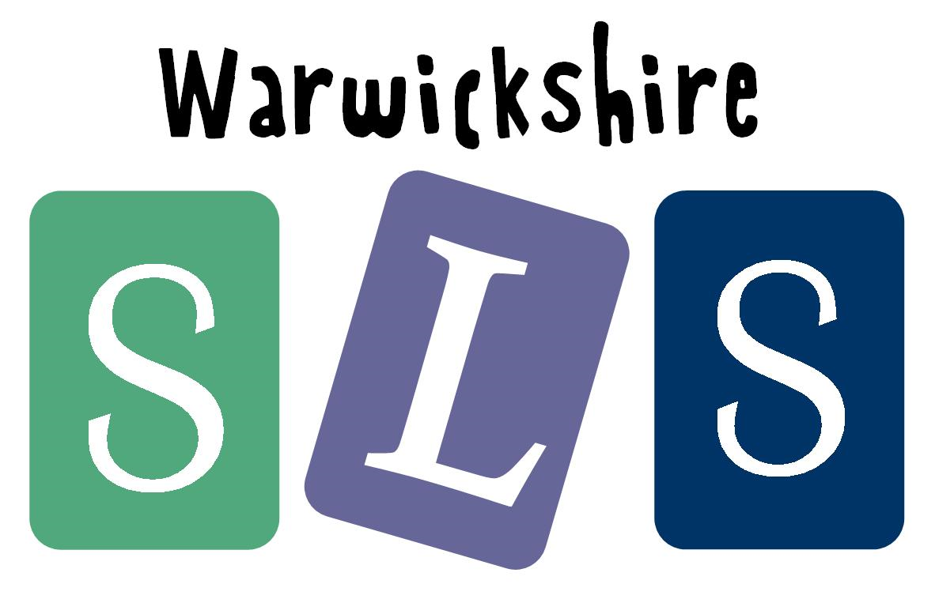
www.robinhoodMAT.co.uk

