Learning Project WEEK 5- Environments
Age Range: EYFS (Kynance)
Weekly Maths Tasks (Aim to do 1 per day) | Weekly Reading Tasks (Aim to do 1 per day)
MATHS FOCUS: Identifying 3D Shapes  - Talk with the children about the difference between 3D and 2D shapes (the children know that 3D are solid and 2D are flat).  - https://www.youtube.com/watch?v=guNdJ5MtX1A A super song to play everyday this week to help your child recognise 3D shapes.  - Cut 2D shapes out of paper and get 3D-shaped objects from the house. Can the children sort these items into 2D and 3D? What is the difference? ‘solid/flat’.  - Get 3D objects from the house. Talk about them having FACES. These are curved of flat surfaces on the 3D shape. Use paint to dip each face and push onto paper. What do you notice about their faces? Curved/flat? Do you recognise ant 2D shapes for faces?  - Have pictures of 3D shapes around the house. Can you find them? Talk about their properties. https://www.twinkl.co.uk/resource/T-N-008-3D-Shape-Posters these are helpful posters.  - Guess my shape game! Describe a shape whilst the children look at pictures of 3D shapes and ask the children to guess which one you’re talking about based on your clues.  - Go on a 3D shape hunt outside. During your daily exercise, can the children recognise any 3D shapes in the environment?  - Recap 2D shapes and teen numbers from last week. Hide them around your house and retalk over all of the learning that you did previously.  - Working on Numbots - your child will have an individual login to access this.  - Practise counting backwards from 20. This can be done through playing hide and seek, singing number songs, chanting, board games etc.  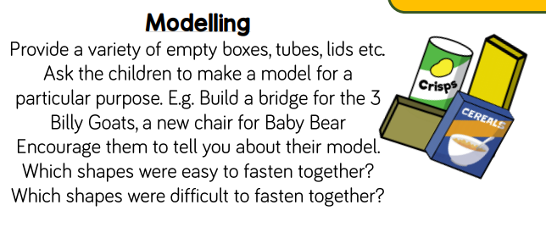 | GUIDED READING  This is used to help the children identify features of a picture or text through talk. The skill of comprehension is being used here and allows the children to develop reasoning, prediction and engagement with text.  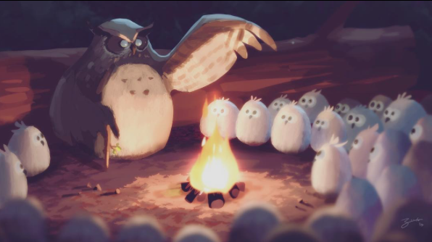  Show your child this pictures. Talk through these questions. There are no right or wrong answers and share your thoughts with the children too:  - What is happening here?  - Why are the owls sitting in a circle around the fire?  - Why are there lots of young owls but only one adult owl?  - How are the young adults feeling?  - How did the big owl become the leader?  - If you were an owl for a day, what would you do?  - Tell the ghost story that the adult owl might be telling. Make sure it isn’t too scary for the young owls!  Red words of the week:  they, you  Read a variety of books at home. Favourites can be repeated. Hearing the patterns of language in a story will support your child’s language development.  - Reception age children: Children to read to parents daily. Visit Oxford Owl for free eBooks that link to your child’s book band. You can create a free account.  Complete the linked Play activities for each book.  Sing the song, ‘Incy, Wincy Spider’ and add in the rain sounds using your rainmaker (from the learning project below).
Weekly Phonics Tasks (Aim to do 1 per day) | Weekly Writing Tasks (Aim to do 1 per day)
.  Tune in daily to Ruth Miskin’s phonics lessons on YouTube (times have been put on Tapestry so that you are challenging your child). This is crucial to support your child’s fantastic phonics progress already. After these sessions, practise writing words with the special friend that you have learnt, pinching the sounds on your fingers. Your child will explain to you, as they do this daily. https://www.youtube.com/channel/UCo7fbLgY2oA_cFCIg9GdxtQ  https://www.phonicsplay.co.uk/Phase3Menu.htm#  Play these games to support your child’s phonics knowledge.  Hide some flash cards/written sounds around the house. Can the children find them?  https://brizeprimary.org//documents/phonics_sounds_set_1__2_and_3-2.pdf this is the order in which the phonics sounds are taught. | - Can you make a poster that sense a lovely message to Key Workers and the NHS and put it in your window? Use your phonics to spell words (adults – please don’t correct the spelling of these words, application of phonics is more important).  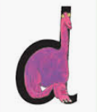  - Practise forming the letter ‘d’. Please ensure that your child is not drawing a circle and then adding a line. It is of upmost importance that your child is forming their letters correctly. Around the dinosaur’s bottom, up to his neck, down to his feet.  Practise writing your FULL NAME.  - Ask your child to write out the tricky words they are working on at the moment on pieces of paper and do a tricky word hunt in the house!  they, you
Learning Project - to be done throughout the week
The project this week aims to provide opportunities for your child to learn more about the environment. Learning may focus on changes to different environments, the impact of humans on environments, climate change etc .

Create a daily weather chart- Record using pictures and written labels (where appropriate). How has the weather changed over the week? If it is raining, leave a container outside to collect the rain e.g. a water bottle with the funnel cut off. Draw a line or make a mark to show where the rain came up to. Repeat overnight or the next day and compare your results.

Recycling/ Exploring Materials- Provide your child with a selection of packaging to sort into groups to recycle. Can they identify plastic, paper, card, metal.

Create your own rain cloud- Use a plastic container with a lid (e.g. a water bottle) and make small holes on one side. You could stick on cotton wool to decorate. Fill the container with water and watch as the water drips out.

Weather sounds (Rainmakers) Provide your child with either a plastic container, bottle or other junk modelling item. Pour in a spoon or two of rice or lentils and secure with a bottle lid or Sellotape. Decorate with stickers, glitter and sequins if you have them available. Have fun exploring making rain sounds.

Ice-Discuss with your child what they think happens when ice gets warm, support your child to write their ideas in a sentence e.g. I think the ice will melt in the sun. Encourage them to sound out using their phonic knowledge as they write, remember to include a capital letter to start, finger spaces and a full stop. Support your child to fill up ice cube trays or plastic containers, if ice cube trays are not available, and freeze. Once frozen, take them out and explore how quickly they melt: in your hands, in the fridge, on the windowsill and when blown with the hairdryer.

Search on Google Maps for the UK. Discuss with your child the colour of the land and sea. Scroll up to look at the Arctic. Discuss why the land looks different in the Arctic, because the land is covered in snow and ice. Discuss the differences in temperature in the UK and the Arctic. Look at the picture of the igloo.

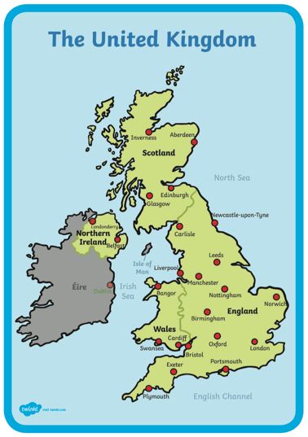
Fill an ice cube tray with water and when frozen take out and support your child to create their own igloo out of the ice cubes.

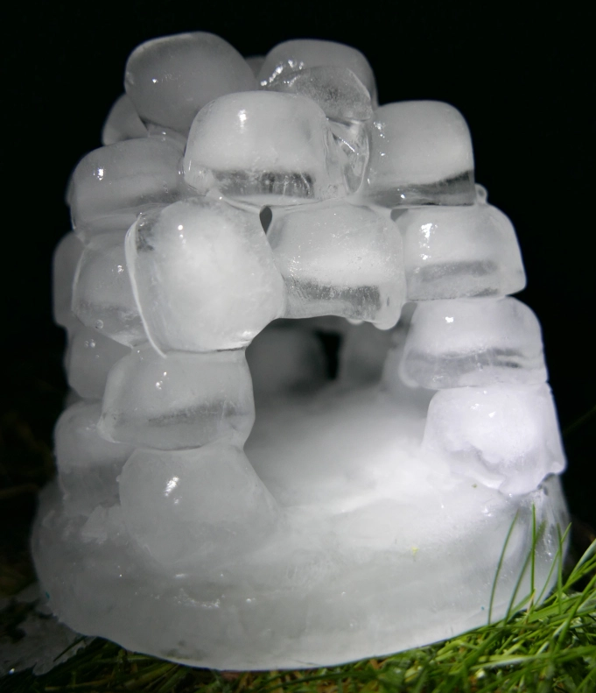
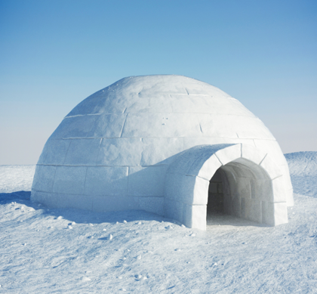

Additional learning resources parents may wish to engage with
Classroom Secrets Learning Packs - These packs are split into different year groups and include activities linked to reading, writing, maths and practical ideas you can do around the home.
Twinkl - to access these resources click on the link and sign up using your own email address and creating your own password. Use the offer code UKTWINKLHELPS.
Headteacherchat - This is a blog that has links to various learning platforms. Lots of these are free to access.
White Rose Maths -click for spring term guidance
#TheLearningProjects

Please check Tapestry for uploads or useful links and please, if possible, share some fabulous home learning!
Miss Guy

