Learning Project – Music Online
Age Range: EYFS

Staying active is really important when you are at home. There are lots of resources, here are just a few to use!
Joe Wicks PE sessions
Go Noodle
Super movers!
Cosmic Yoga
Weekly Reading Tasks | Weekly Phonics Tasks
Monday- Have a look at the musical instruments. Talk about the different instruments, can you match the names to the correct one? Discuss the different ways of playing the instruments. Which instrument would you like to be able to play?  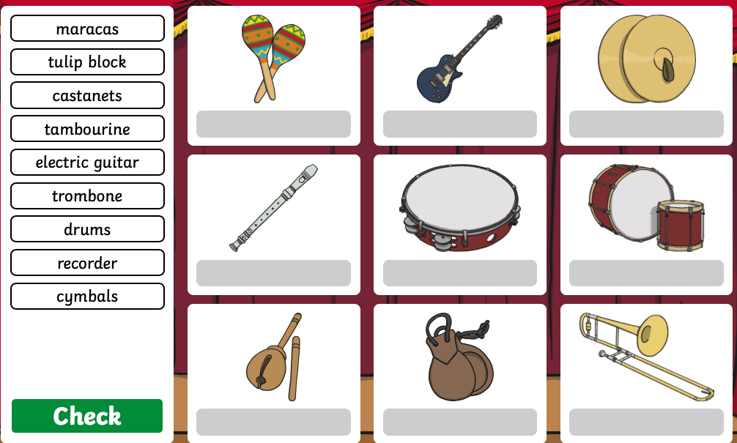  Practise reading the following words. Write them onto flash cards to use at home.  All, her, he, she | Monday- Play Odd Sound Out. You could play a practical version of this using objects from around the house. Can your child identify which object doesn’t begin with the same sound? Play f, ff, ll, ss Read and Race!  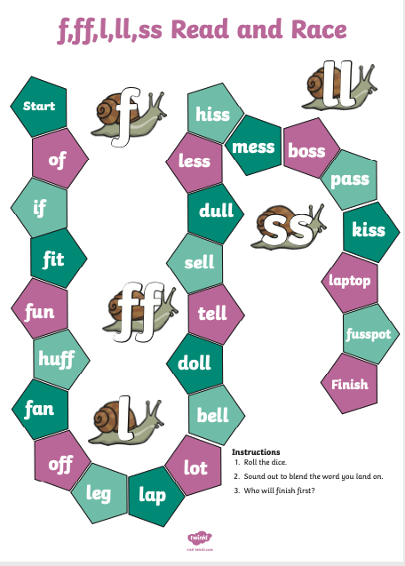  Teach speed sound ‘ow’ using flash card. Watch Geraldine the Giraffe search for ‘ow’ items around her house. Can you find anything in your house that has the ‘ow’ sound?
Tuesday- Read and sing the nursery rhymes below with your child. Which one is their favourite? Do any of the rhymes have the same rhythm? Can you think of rhymes that have the same rhythm?  Read keywords for this week (see Monday). | Tuesday- Choose a letter of the alphabet. How many instruments or sounds can your child name that begin with that sound?  Teach speed sound ‘oo – poo at the zoo’ using flash card, then complete the online wordsearch.
Wednesday- Read together the story of Mr Big. Discuss with your child how Mr Big felt when the other animals didn’t want to be around him.  Read keywords for this week (see Monday). | Wednesday- Play Online Buried Treasure - Click on the sounds your child is learning. Can your child explain what the real word means?  Teach speed sound ‘oo – look in a book’ using flash card then read the story’ A cook in a book’ (at the end of the pack) and colour all the words with the ‘oo’ sound.
Thursday- Write the questions onto cards for your child to read. Make yes / no cards for them to use to answer with after they have read the cards. Look at the question mark and discuss.  Read keywords for this week (see Monday).  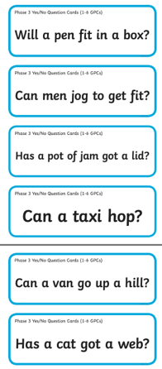  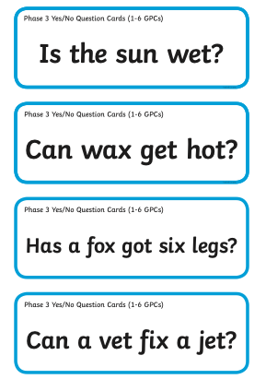 | Thursday- Ask your child to find a stick from the garden and explore making music around the house by tapping, hitting and scraping. You could ask them to make loud sounds, quiet sounds, sounds that are short and long.  Teach speed sound ‘ar-start the car’ using flash card, then watch the video to read the words with ‘ar’ in them. Can you make a list of any other ‘ar’ words?
Friday- We’re Going on a Bear Hunt Story sound effects- Read the story together and add in your own musical sound effects e.g. make swishy swashy sounds with fabric to go with ‘We’re Going on a Bear Hunt’. You can repeat this with as many stories as you like!  Practise reading these words regularly  Me, he, she, all, was, they, are, be, we, you, my | Friday support your child to use the phonic knowledge to match the captions to the pictures.  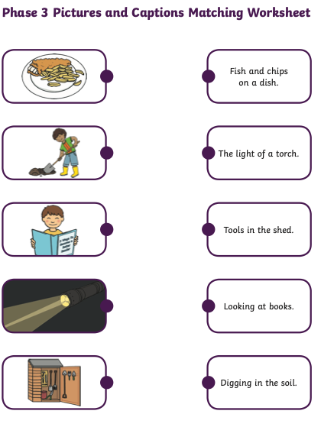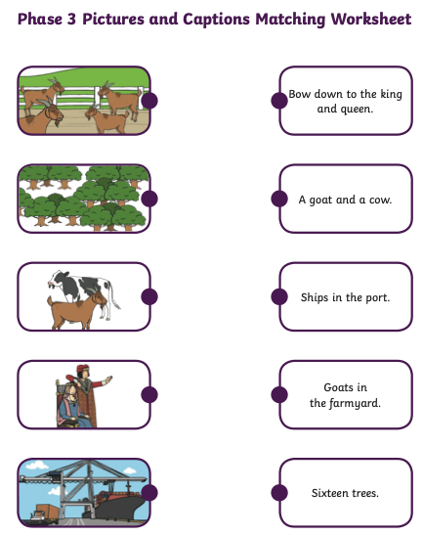  Teach speed sound ‘or – shut the door’ using flash card.
Weekly Writing Tasks | Weekly Maths Tasks- Shape
Monday- Ask your child to think about how some musical instruments are played, for example bang a drum, tap a tambourine, shake the maracas. Ask your child to write simple instructions to play their favourite instrument or instruments. Encourage your child should use their phonic knowledge to write words in ways which match their spoken sounds. | Monday- Provide opportunities for children to count beyond 10, learning the number names in order. Play I count, you count. Take in turns to count to 20, you say 1, child say 2, you say 3, child say 4 and so on until you get to 20. You can make it more interesting repeating the activity using whisper counting or shout counting.  You could use play spot the mistake after your child is secure with this (puppets or teddies are great if you have one) Make deliberate mistakes whilst counting up and down 1-20, 20-1. Ask your child to listen carefully and stop you if they hear something wrong. Mistakes can include missing out numbers, repeating numbers or saying numbers in the wrong place. You can extend this by asking your child to spot any mistakes as you write the numbers.
Tuesday- Your child can draw a picture of the events from their favourite Nursery rhyme. Ask your child to write out the words to the nursery rhyme. Remember capital letters, finger spaces & full stops. Your child should use their phonic knowledge to write words in ways which match their spoken sounds. The simple sentences which can be read by themselves and others. You should expect some words to be spelt correctly and others should be phonetically plausible. | Tuesday- Count from 1-20 with this song. Once familiar with the order of the numbers, play caterpillar count to collect the numbers in the correct order up to 15
Wednesday- Think about Mr Big. How did he feel after he had joined the band.  Re listen to the story. Write a list of emotion words to explain how Mr Big would have been feeling. | Wednesday- Use the 10 frames on this website to make different numbers up to 20. Start with making numbers to 10 then move into teen numbers by selecting the appropriate grid on the screen. Hold up a number card and ask your child to represent that number on the 10 frames, repeat with all numbers up to 20
Thursday- Following on from the reading activity today ask your child to write three of their own yes / no questions. Remember to encourage your child to use their phonic knowledge to sound out their question as they write it down. | Thursday Play Race to 20 game (number lines included in pack). Each person playing needs a 1-20 number line and 20 counters. Take in turns to roll a dice. If 1-5 is rolled they collect the corresponding counters and fill their track. If 6 is rolled, you go back to the start. Continue this until the first person reaches 20.  Extend: https://www.topmarks.co.uk/learning-to-count/helicopter-rescue
Friday- Listen to the story of We’re Going on a Bear Hunt. Draw a picture of the bear together and label it – One shiny wet nose, two big furry ears, two big goggly eyes! | Friday Play Bingo  Have number cards already matched with pictorial representation to support should your child need a reference point (included with pack)  Extend: Can you count backwards 20-1? Have a go at these games https://www.sheppardsoftware.com/mathgames/earlymath/BalloonCount20.htm

Learning Project - to be done throughout the week
The project this week aims to provide opportunities for your child to learn more about music. Learning may focus on famous musicians, listening to and performing music and exploring a range of music genres and instruments.

Drummers Drumming
- Using pots, pans and baking trays from the kitchen lay out your own ‘drum kit’. Allow your child to explore by banging and tapping the pans to see the different sounds they make. Extend this activity by tapping out a rhythm and asking your child to listen to it then repeat it. You could make this more difficult by adding in a blindfold so they have to rely on the sound to identify which pot or pan they need to hit to copy.

Make your own Music
- Your child could create a guitar using a plastic tub with elastic bands wrapped around it. Post a picture of your musical instrument onto your child’s Tapestry account. Can your child draw instructions on how to make a guitar for somebody else to follow?

Play ‘What’s that Sound?’
- Game 1- Hum a song to your child that they are likely to know. Can they guess which song it is from the tune alone? Take it in turns to hum out a tune.
- Game 2- Go into a room of the house while your child listens outside of the door. Make a sound or play a rhythm out on an item in the room e.g. tapping on the table. Open the door and ask your child to find what you used to make the sound.

A Family Music Show
- Ask each member of the family to prepare a song and then put on a singing performance. You could select someone to be the judge or ask a family member to watch on a video call and decide on the winner.

Discovering Different Eras
1920’s | 1930’s | 1940’s | 1950’s | 1960’s | 1970’s | 1980’s
- Click on the links above and listen to a sample. Which era did your child find most enjoyable to listen to? Can they dance in the same style?
STEM Learning Opportunities #sciencefromhome
Making Instruments – Make Sound Shakers
- Collect some different containers with lids, make sure you cannot see through them. The small plastic water bottles work really well. Put different materials in the containers. (Stones, rice, sugar, paper clips etc.)
- How many shakers can you make? Do they all sound the same? Can you make a shaker that is difficult to recognise? Can you make loud and quiet sounds with them?
- For more ideas take a look at the full resources here.
Wellness
Help your child find a quiet space where they can lay down comfortably. Today we will use music as a tool to help us relax.
Explain to your child that you will play some music for them to listen to as they lay still and focus on taking big, slow breaths. You could help them to relax further by guiding them first to relax their toes, then the rest of their legs, now relax the tummy and the chest, followed by arms and hands. Finally relax every part of the face. Now the entire body is completely relaxed. Your child can stay here, just listening and relaxing, for as long as they feel comfortable.
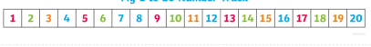
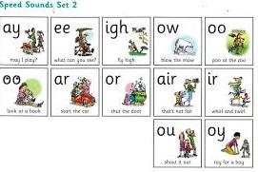

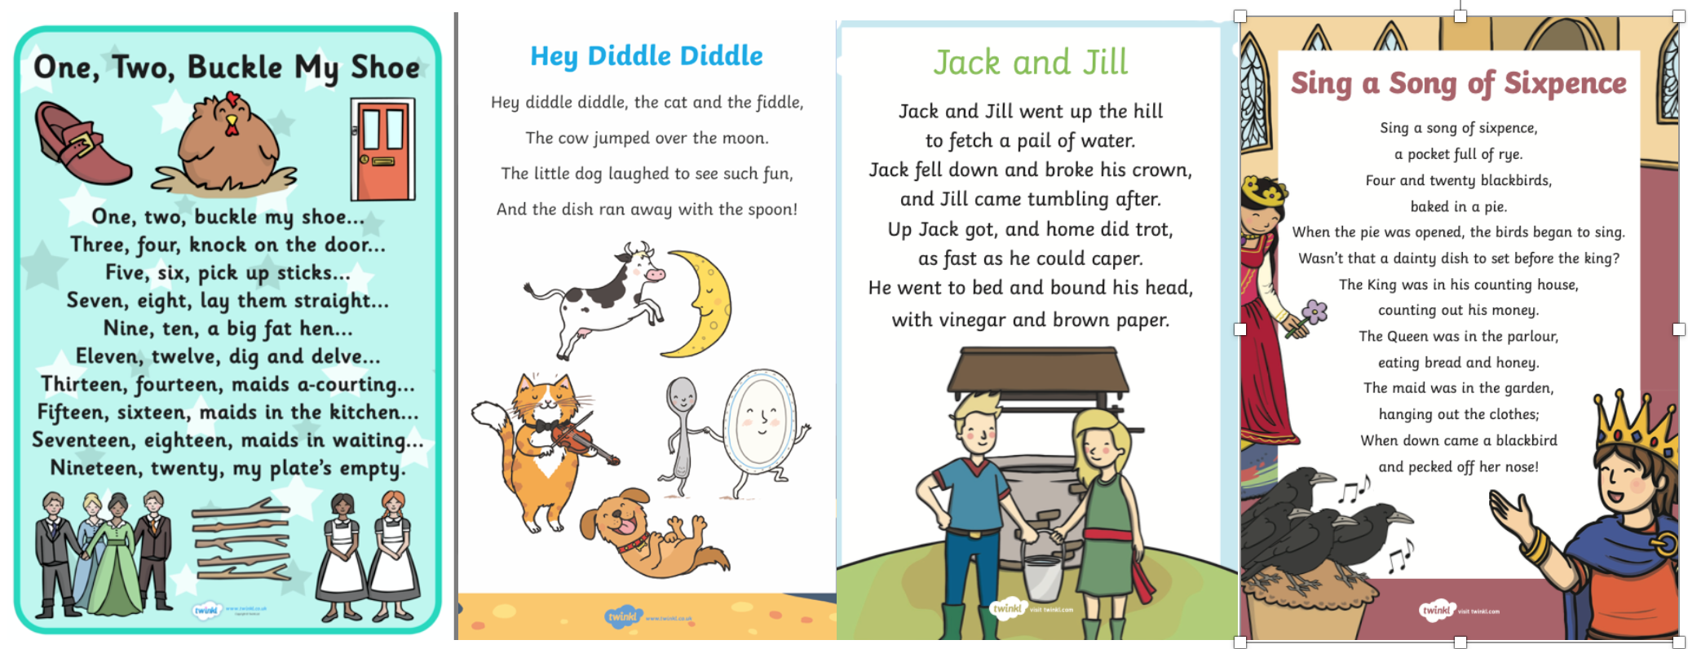
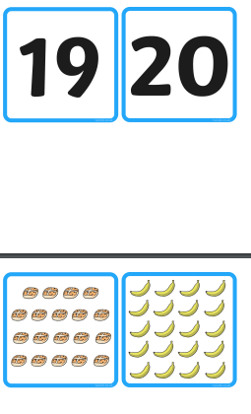
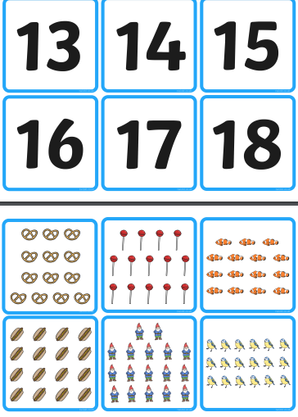
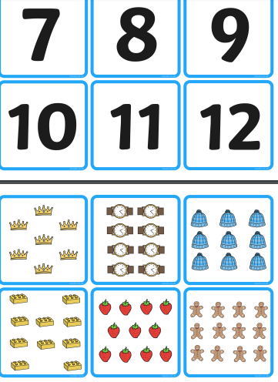
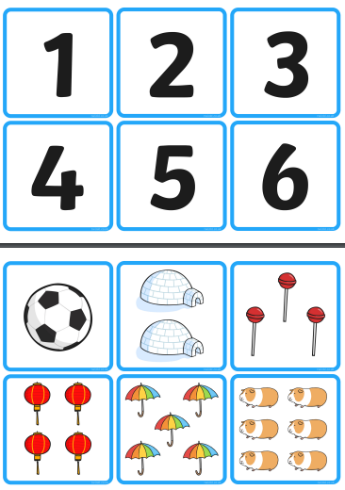
#TheLearningProjects
in collaboration with
