Learning Project WEEK 2- The area you live in
Age Range: Reception
Staying active is really important when you are at home. There are lots of resources, here are just a few to use!
Go Noodle
Super movers!
Cosmic Yoga
Weekly Maths Tasks (Aim to do 1 per day) | Weekly Reading Tasks (Aim to do 1 per day)
MATHS FOCUS: numbers 15-19 (understanding that these numbers are 1 ten and some ones).  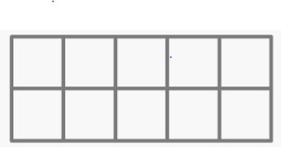  Draw two tens frames on the floor, or on paper, and ask the children to collect an amount (15-19) of items that will fit one in each square. Comment on the fact that we have a full ten and some extra ones and we have made our teen number.  - Working on Numbots - your child will have an individual login to access this.  - Play the Numberblocks adding game.  - Give the children 15 seconds to complete star jumps. Record how many they do. Give them 16 seconds. Does it change anything? What happens if you have 17, 18 or 19 seconds to complete them?  - What happens to our heart when we are doing our star jumps? How many heartbeats can you feel in 15 seconds?  - Watch a Numberblocks clips each day on BBC or CBeebies. Use the guide here to give you ideas on what to do with your child whilst watching an episode.  - Practise counting backwards from 20. This can be done through playing hide and seek, singing number songs, chanting, board games etc.  - Write out the digits 0 – 9 There are some sheets here that could help you.  - Use the ‘Tens Frames’ or ‘Five Frames’ on this game and practise recognising amounts. This can also be done by reading a dice when playing board games, playing with cards, identifying how many food items on the plate etc.  - Sing Number songs to practise counting, reciting numbers in order, one more, one less using number songs: Five Little Ducks, Five Little Men, Ten Green Bottles.  - White Rose have got lots of activities for children in the Early Years to complete. Have a go at some of them. If you need to record anything, write or draw it in your home learning book. | Tune in daily to Ruth Miskin’s phonics lessons on YouTube (times have been put on Tapestry so that you are challenging your child). This is crucial to support your child’s fantastic phonics progress already. After these sessions, practise writing words with the special friend that you have learnt, pinching the sounds on your fingers. Your child will explain to you, as they do this daily.  - Read a variety of books at home. Favourites can be repeated. Hearing the patterns of language in a story will support your child’s language development.  - Children to read to parents daily. Visit Oxford Owl for free eBooks that link to your child’s book band. You can create a free account.  Complete the linked Play activities for each book.  - Listen to a story being read: Story line and CBBC Bedtime stories.  - Listen to different David Walliams books here!  - Listen to a range of free books on audible.  - With your child, look in magazines, newspapers and books for the tricky words they are currently learning. They could use a highlighter to highlight in magazines and newspapers.  - Read the story Hansel and Gretel (or watch on YouTube)- What makes the house appealing to the children?  - Read the story of The Three Little Pigs (or watch on YouTube)- Discuss the choices the little pigs make about the materials they use to build their houses. Can children figure out the material their own house is made from?  - Read our tricky words for this week. Place them around the house and say them each time you walk past. Play splat with them. Talk about the ‘e’ pretending to be ‘ee’ at the end of each word.  - Your tricky words this week are;  he, she, we, be, me.
Weekly Phonics Tasks (Aim to do 1 per day) | Weekly Writing Tasks (Aim to do 1 per day)
- Sing Nursery Rhymes and songs together. Add in actions and change the words. Can children think of different rhyming words to add in? Repeat old favourites and learn new rhymes. You can find an A-Z of Nursery Rhymes here.  - Send your child on a sound hunt around the house. Can they find and record all of the items that make sounds? (e.g. hairdryer, TV, fridge, microwave, phone) | - Can the children write a letter to Miss Guy using the tricky word ‘to’? Upload this to Tapestry so that she can respond!  - Design your dream house. What rooms would you like to have in your house? Encourage children to be as imaginative as they can (e.g. a cinema room, a chocolate room). Can they label their house using their phonics knowledge?  - Practise name writing. Can they write their first name? Middle name? Surname? Ensure correct letter formation.  - Practise forming the letters of the alphabet. There are handwriting sheets on Twinkl to support you.  - Ask your child to write out the tricky words they are working on at the moment on pieces of paper and turn them into a pairs game: he, me, she, we, be.  - Can they use these words in a sentence? (Support children with sounding out but please allow them to try this independently – they will surprise you with what they can do!).
Learning Project - to be completed throughout the week
The project this week aims to provide opportunities for your child to learn more about the area in which they live. Learning may focus on your local area, famous people, key landmarks and links to your city.

- The rooms in my house-
  - Support your child to create a map or cross section of their home. Can they name all of the rooms? An adult could hide an object in a room and mark where it is on the child’s map. Can they use their map to find the hidden object? Label each room using phonics knowledge.
  - Gather an object from each room and challenge your child to return them to the appropriate room e.g. toothbrush from the bathroom, teddy from their bedroom.
  - Hide objects around the room and describe where it is e.g. “it’s under something red” Can your child hide an object and describe where it is for you to find?
- Go on a numeral hunt-
  - Search for numbers around the house (clocks, books, house numbers, car registrations, oven, washing machine). Can they record the numbers on paper? Where’s the most unusual place your found a number?
- Find your house on google maps-
  - Explore using google maps to look at your house from above and on street view. Use the arrows to move up and down the road and around your area. Can they find key places that they know e.g. the corner shop, their school, grandparents houses?
  - Search for a house in a different part of the world and discuss how it is similar or different to your own. You could use places children have visited on holiday or search places that are significantly different.
- Junk model your house-
  - Using old packaging (shoe box, cereal box etc.) support your child to make a model of your house. Can they count how many windows there are and stick on the right amount? Can they write their house number on the front?
  - Junk model your dream house. Use materials from around your house to decorate e.g. old wallpaper, fabric, wool.
- Go on a shape hunt-
  - Set your child a shape finding challenge around the house. Ask: Can you find a triangle/ square/ rectangle/ circle in this room? How many can you find? Can you draw all of the circles on one piece of paper, triangles on another etc.
- Use construction blocks to build your house-
  - Using Lego, Duplo, wooden blocks make a model of your house. Can they add in the rooms and doors in the right places? Write labels to match each room on pieces of paper.
  - Build your dream house out of construction blocks.
- Create a furniture collage-
  - Using old magazines and catalogues support your child to cut out and stick or sort objects into the room they would belong in. Support your child to use the correct scissor grip using this guide.
- Exploring with your senses-
  - Gather a collection of household objects e.g. fork, cup, toothbrush, teddy bear, book and show your child. Use a scarf/ material as a blindfold and pass your child one of the objects. Can they figure out what it is through touch alone? Give clues if they are struggling. Swap roles and ask your child to give you an object to figure out.
  - Explore the textures around your house. Can children find something rough, smooth, bumpy. They could take a wax rubbing of each texture (Lay a piece of paper over the top and rub over with the side of a crayon). You could continue this into the garden.
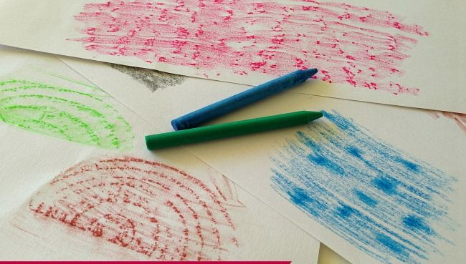
Additional learning resources parents may wish to engage with
Classroom Secrets Learning Packs - These packs are split into different year groups and include activities linked to reading, writing, maths and practical ideas you can do around the home.
Twinkl - to access these resources click on the link and sign up using your own email address and creating your own password. Use the offer code UKTWINKLHELPS.
Headteacherchat - This is a blog that has links to various learning platforms. Lots of these are free to access.

Thank you to all parents – Week 2 complete! We miss the children so much. Please send them our love. Please pass this information onto parents who may not be able to access this. Please also refer to the front on your green home learning book for fantastic links to educational resources and your child’s Numbot account. We would love to see your hard work uploaded to Tapestry, or record your work in your home learning book!
Thank you,
Miss Guy.

