Learning Project - Music
Age Range: KS1
Staying active is really important when you are at home. There are lots of resources, here are just a few to use!
Joe Wicks PE sessions
Go Noodle
Super movers!
Cosmic Yoga
Weekly Reading Tasks | Weekly Phonics Tasks
Monday- Listen to the programme Instruments Together. Your child can design a poster for a concert – who will be performing? What instruments will be played? | Monday- Can your child list different words that begin with the letters M, U, S, I & C? How many can they write? Can they identify rhyming words? Extra challenge: can you think of musical words that start with these letters?
Tuesday- Ask your child to read a favourite story or to read Rumpelstiltskin here. When reading, play some classical music. Talk to your child about how it made them feel. Mind map their feelings after this e.g. relaxed, calm. | Tuesday- Look at the following sounds: ai, ay, igh. Read the following words out and your child can match the correct sound to the word: nail, light, play, pray, night, paint, fight, spray, day, may, tray. Look for objects in the house with these sounds.
Wednesday- Read along to the story Every Bunny Dance. Following this, ask your child to list all of the instruments and dances that appeared in the book. What musical words did they find? | Wednesday- Ask your child to add the ‘ing’ suffix to these root words: beat, clap, dance, sing, hum e.g. beat+ing = beating. Does the rule change? When do you have to double the consonant? When do you drop the ‘e’?
Thursday- Practise a favourite rhyme or poem. Your child could learn the National Anthem for their country. Create actions and perform this to the family. There are some great examples of poetry being performed here. | Thursday- Play this plural game or this investigating ‘ai’ game.  Weekly Spellings  Year 1 Spellings Year 2 Spellings  true painless  amuse harmless  few careful  blue wonderful  new painful  cube cheerful  tube kindness  flute darkness  value sadly  Tuesday clearly
Friday- Listen to the story of a poor musician and a stray dog. Stop the film at certain points, e.g. 1:40, 5:11 or 5:43. Discuss together what the different characters might be thinking. Can your child draw thought bubbles showing this? | Friday- Write a list of musical words on paper/card such as – clap, play, sing, tune. Play snap using these words. Rule: to be able to read the word to win!
Weekly Writing Tasks | Weekly Maths Tasks- Shape  Choose a task or tasks from each day. These are to be used flexibly
Monday- Make an A-Z list of musical vocabulary. This could include instruments, artists or musical verbs. Apply some of these into sentences. | Monday- Create your own 2D shape picture by cutting out pictures from a magazine or create your own picture focussing on these shapes  square, circle, rectangle, pentagon (5 sides) hexagon (6 sides) and octagon (8 sides)  You may want to look on this website to give you some ideas.  Game – sit back to back with a partner – one of you describes the shape and you draw it. Try and include words such as sides and corners to help you.  As an extra challenge – draw your own shape picture and describe it for your partner to complete using positional language such as above below, beside next to etc.  You may want to share your shape pictures with your class teacher on Seesaw or Tapestry.  White Rose Maths online daily maths lesson  Bitesize Maths online daily maths lesson  CODE Maths Hub Daily Fluency Activities - Day 1 Week 8
Tuesday- Create fact files about musical instruments. This could include where they originate from, what they’re made from, etc. Your child can include an illustration of the instrument and label the parts. | Tuesday- Go on a shape hunt around the house or on your daily walk.  Then create your own shape poster showing shapes in the home using the shapes  below  square, circle, rectangle, pentagon (5 sides) hexagon (6 sides) and octagon (8 sides).  You may also want to play this Pattern sequencing games using 2D shapes to reinforce these skills.  White Rose Maths online daily maths lesson  Bitesize Maths online daily maths lesson  CODE Maths Hub Daily Fluency Activities - Day 2 Week 8
Wednesday- Can your child rewrite the events from Every Bunny Dance as a newspaper report? If this is too challenging, they could draw the events in a comic strip style using words such as ‘first’, then, and ‘after that’. | Wednesday- Go on a 3D shape hunt around the house or on your daily walk.  See if you can find examples of a cube, cuboid, cylinder, cone, sphere, square based pyramid and triangular prism.  You may want to share your shape pictures with your class teacher on Seesaw or Tapestry.  From this explore the different ways in which you can sort them by some of these categories - if it rolls / does not roll, if it can be stacked, the shape of its faces i.e. a square face, if it has more than 4 edges, if it has vertices.  Building with Sold Shapes by NRICH also has good discussion linked to this concept.  White Rose Maths online daily maths lesson  Bitesize Maths online daily maths lesson  CODE Maths Hub Daily Fluency Activities - Day 3 Week 8
Thursday- Task your child with writing their own family song. When ready, they can perform it- perhaps to a family member on Facetime (with adult supervision). Or they could share it with their teacher using SeeSaw or Tapestry. | Thursday- Using 3D shapes play Shadow Play from NRICH.  The attached sheet will give you details on how to play it.  You will need a torch for this activity.  White Rose Maths online daily maths lesson  Bitesize Maths online daily maths lesson  CODE Maths Hub Daily Fluency Activities - Day 4 Week 8
Friday- Visit the Literacy Shed for this wonderful resource on Once in a Lifetime - Collect verbs – flying, soaring, gliding and adverbs – silently, gently, serenely to do with floating and sailing gracefully. Or the children could write an ending to the story, where do these turtles take him? Or try some of the activities in the link. | Friday- Create your own Musical Shape Pattern like the one below where each shape indicates how many times the rhythm has to be played as seen below.  You could also include a hexagon – 6 sides and an octagon 8 sides too.  = 4 times as it has 4 sides  = 3 times  = 5 times  = 12 claps  = 10 claps  As an extra challenge create your repeating pattern – see if you can perform and continue it.  White Rose Maths online daily maths lesson  Bitesize Maths online daily maths lesson  CODE Maths Hub Daily Fluency Activities - Day 5 Week 8

Learning Project - to be done throughout the week
The project this week aims to provide opportunities for your child to learn more about music. Learning may focus on famous musicians, listening to and performing music and exploring a range of music genres and instruments.

- Famous Musicians- Find out about famous singers and bands from UK – perhaps even from the South West and Cornwall. Listen to some of their music. Ask your child to list what they like/dislike about the music. What genre of music is it? Does it remind them of any singers or bands that they know? Create a fact file about the musician/s.

- Local Music – visit this website and explore the Cornwall Music Education Hub. There is a selection of links to some useful resources and activities to help with your at home musical learning! You can even view the free virtual music festival on 23rd June!

- Making Music- Task your child with making a variety of shakers. Using empty bottles from the recycling, fill them with different dry foods/things from the garden. How can they make the shakers sound different? Ask your child to use the shakers during their family song performance (see above). They could also write a set of instructions for making your own musical shakers.

- Making More Music!- Can your child use different parts of their body to make music e.g. clicking fingers, stamping feet. After this, ask your child to design a new instrument. This could be an instrument that belongs to the woodwind or brass family. They can draw and label their design and then make it using materials from the recycling. Does it work? Ask your child to record 3 ways they could improve their design. Share at #TheLearningProjects. Or share them with your teachers using Seesaw or Tapestry.

- The Four Seasons- Vivaldi wrote The Four Seasons during the early Classical period. Divide a piece of paper into 4 and ask your child to draw each season in each box as they listen to the music here. Discuss how each movement sounds different e.g. Spring is energetic and has a fast tempo.

- What can I Hear? Ask your child to visit different places in the home and garden. Get them to list all of the different sounds that they can hear e.g. the humming of the fridge. Which room is the noisiest? Encourage them to use words such as volume, tempo, pitch and beat. After this, ask your child to record the sounds and play them to the family. Can the family guess where the sound is coming from? Alternatively, your child can replicate the sound and the family could guess this way instead.
Mindfulness
Help your child find a quiet space where they can lay down comfortably.
Today we will use music as a tool to help us relax.
Explain to your child that you will play some music for them to listen to as they lay still and focus on taking big, slow breaths.
You could help them to relax further by guiding them first to relax their toes, then the rest of their legs, now relax the tummy and the chest, followed by arms and hands. Finally relax every part of the face. Now the entire body is completely relaxed.
Your child can stay here, just listening and relaxing, for as long as they feel comfortable.
Click this link for a music suggestion.
STEM Learning Opportunities #sciencefromhome
Making Instruments – Animal Sounds
- How many different animal sounds can you make with your voice?
- Try making an instrument that sounds like a chicken. You will need: tin can/plastic cup, and some string.
- Make a small hole in the base of a tin can or plastic cup.
- Thread string through with and knot on the inside. Wet your fingers and run them down the string to produce a chicken noise.
- For more ideas take a look at the full resources here.
Additional learning resources parents may wish to engage with
- White Rose Maths online maths lessons.
- Numbots. Your child can access this programme with their school login.
- IXL- Click here for Year 1 or here for Year 2 . There are interactive games to play and guides for parents.
- Y1 Talk for Writing Home-school Booklets and Y2 are an excellent resource to support your child’s speaking and listening, reading and writing skills.
#TheLearningProjects
in collaboration with
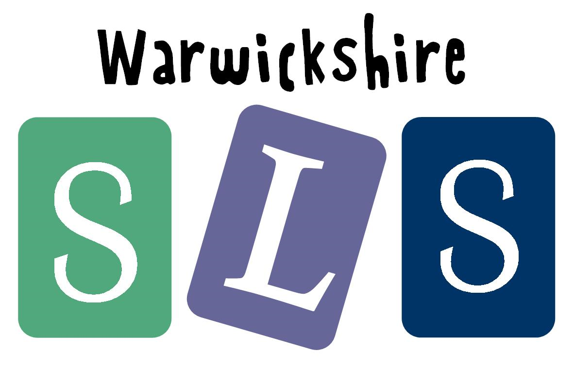
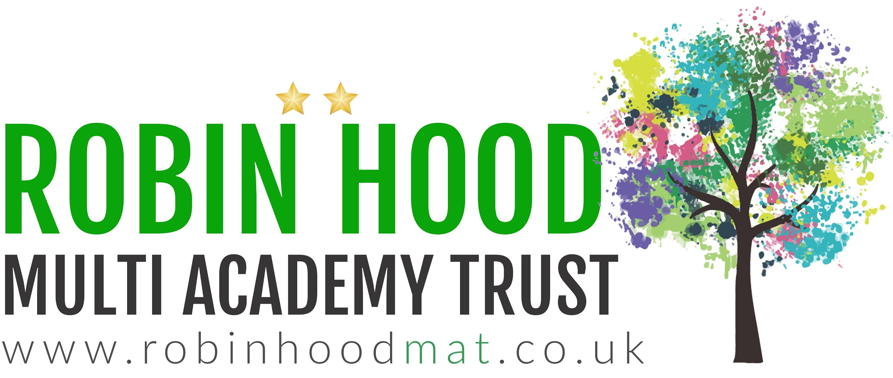
www.robinhoodMAT.co.uk

