Learning Project WEEK 9- Sports
Age Range: EYFS (Kynance)
Weekly Maths Tasks (Aim to do 1 per day) | Weekly Reading Tasks (Aim to do 1 per day)
MATHS FOCUS: Making more complex patterns.  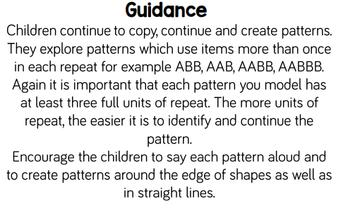  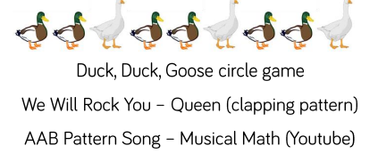  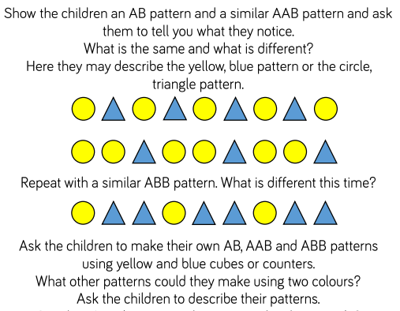  Use this opportunity to spend the week on music. Patterns within beats, pitch, volume are amazing for all aspects of learning (particularly phonics).Tap out beats, make up songs and ask the children to repeat. Can you film it and put it on Tapestry? | GUIDED READING  This is used to help the children identify features of a picture or text through talk. The skill of comprehension is being used here and allows the children to develop reasoning, prediction and engagement with text.  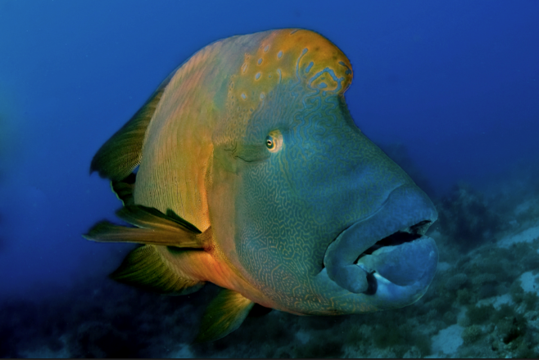  Show your child this pictures. Talk through these questions. There are no right or wrong answers and share your thoughts with the children too:  What does it mean to be envious?  In my story, why might some sea creatures be envious of this fish?  Which sea creatures may not be envious of this fish?  Have you ever been envious of someone else?  Do you think someone has ever been envious of you?  Is it wrong to be envious?  Do you think fish really have feelings?  Should we treat fish differently to the way we treat other people?  Would you treat a fish with no colourful pattern the same way as you would this fish?  Perfect picture!  Can you create your own underwater animal? Does it have any special powers?  Red words of the week:  Little, out  Read a variety of books at home. Favourites can be repeated. Hearing the patterns of language in a story will support your child’s language development.  - Reception age children: Children to read to parents daily. Visit Oxford Owl for free eBooks that link to your child’s book band. You can create a free account.  Complete the linked Play activities for each book.
Weekly Phonics Tasks (Aim to do 1 per day) | Weekly Writing Tasks (Aim to do 1 per day)
.  Tune in daily to Ruth Miskin’s phonics lessons on YouTube (times have been put on Tapestry so that you are challenging your child). This is crucial to support your child’s fantastic phonics progress already. After these sessions, practise writing words with the special friend that you have learnt, pinching the sounds on your fingers. Your child will explain to you, as they do this daily. https://www.youtube.com/channel/UCo7fbLgY2oA_cFCIg9GdxtQ  Play ‘splat’. Have some sounds that you have been working on for phonics and see who can find them and splat quick enough (or you could use water pistols!). | Can you draw a picture and write a sentence (or more) about your favourite memory from being at home during quarantine?  Practise writing your FULL NAME.  - Ask your child to write out the tricky words they are working on at the moment on pieces of paper and teach you how to spell them. Get them to pretend to be the teacher.
Learning Project - to be done throughout the week
The project this week aims to provide opportunities for your child to learn more about sports and games. Learning may focus on the history of sport, sporting-heroes, physical challenges and performance.
Ball Games
- Play a game of catch with a ball - when you drop the ball, you lose a point. You could record points using a tally chart and count up who has the most points at the end. CHALLENGE: See if you can catch the ball standing further apart, catch with one hand or use a smaller ball.
Play Skittles
- If you have a set of skittles, you’re ready to go, if not you can make your own skittles using plastic bottles. Take a plastic bottle and partly fill with soil/ stones or sand to weigh it down. If you don’t have plastic bottles available, you could use tin cans for an alternative version. Ask your child to count how many skittles there are to begin with. Roll the ball at the skittles and ask your child to count how many they have knocked over. Can they work out how many are left? CHALLENGE: You could write this out as a subtraction number sentence e.g. if you start with 5 skittles and knock over 2 your child would write 5 - 2. Ask them to count how many are left to find the answer 5 - 2 = 3

Competition Time
- Have a time challenge. Give your child an action to do e.g. hop, skip, jump, clap or star jump. How many can they do in one minute? Keep a record of the scores. Ask everyone in the house to have a go!

Parts of the Human Body
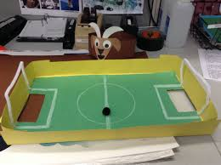
- Ask your child which parts of their body they use to run? To do a handstand? Draw the parts of the body and for a challenge ask them to label them using their phonics knowledge.

Create your own Junk Modelled Football Pitch
Using a lid of a shoe box or similar container, help your child to cut out two holes on each end as the goals. If you have green card or paper, stick this in the base, if not you can colour in plain paper using a crayon. Draw out the marking on the pitch using crayons or felt tips. When finished, stand your football pitch on a box on the table. Using something ball-like (e.g. a sweet), take turns aiming at your partner’s goal whilst the other tries to save the goal. If you score you get to eat the sweet! CHALLENGE: Write instructions to play your game e.g. 1. Put the ball in. 2. Flick at the goal. 3. Eat the sweet!
Additional learning resources parents may wish to engage with
Classroom Secrets Learning Packs - These packs are split into different year groups and include activities linked to reading, writing, maths and practical ideas you can do around the home.
Twinkl - to access these resources click on the link and sign up using your own email address and creating your own password. Use the offer code UKTWINKLHELPS.
Headteacherchat - This is a blog that has links to various learning platforms. Lots of these are free to access.
White Rose Maths -click for spring term guidance
#TheLearningProjects

Please check Tapestry for uploads or useful links and please, if possible, share some fabulous home learning!
Miss Guy

