Learning Project WEEK 7: Celebrations-online
Age Range: KS1
Weekly Maths Tasks (Aim to do 1 per day) | Weekly Reading Tasks (Aim to do 1 per day)
- Working on Numbots - your child will have an individual login to access this.  - Play on Daily 10 - play levels 1 or 2 to practise adding and subtracting.  - On a calendar (here is an online calendar if needed) go through and write down when different family members birthdays are or when special events are happening in your family.  - Ordering  - Then play this game to practise your ordering skills.  - Time  - Practise telling the time in words. This could be done through this game (scroll down to access the game). Read to the hour, half hour and quarter past.  - 3D Shapes  - Go for a 3d shape hunt around your home.  Then play this game to help you identify the different shapes  - Daily Fluency Activities can also be reached from this website ( Week 2)  - All  - Design a poster showing what you learned in your daily Maths lesson you can be as creative as you want to be!  Daily Maths Lesson  - This site has daily Maths lessons which can be accessed online.  - These are available for Y1 and for Y2. | - Find a book where you can see the characters celebrating. Is it a birthday? Can you read the book to someone over the phone?  - Read the story Kipper’s Birthday. Discuss how it may be similar or the same to your birthday celebration.  - Create a celebration book with your family. Can you add sound buttons onto the words?  - Create a Celebration Reading Den. What will you have in there? Who can read in there with you? Will you have cushions in there so you are comfortable?  - Read a poem about a celebration you have had or looking forward to celebrating with your family.  Free Ebooks you could use:  The Toys’ Party (Do you think you could make a tea party for your toys?)  The Birthday Cake  Special Days Poems  Happy Birthday, Winnie!
Weekly Phonics/Spellings  Tasks (Aim to do 1 per day) | Weekly Writing Tasks (Aim to do 1 per day)
- Daily phonics - your child to practice their sounds and blend words. Interactive games found on link below.  - Phonics play  - Top Marks  - Spelling  - Spell the days of the week  - Spell common exception words  - Spelling City  - Sumdog Spelling activities  Year 1 Spellings Y2 Spellings  bear most  pear old  wear only  tear gold  bare cold  care hold  share told  scared fold  spare sold  stare open | Ask your child to:  - Write an invitation for a celebration. This could be a birthday party, Easter celebration etc.  - Create a list of all of the celebration days they can recall and write a sentence about what they remember about each.  - Invent a story involving a celebration. They could write it out or make a story map. Encourage your child to use story language. (Here are some resources to help encourage good story language)  - Create a birthday card for the next family member’s birthday. Try and add a rhyming poem in the middle.  - Write a menu for a special celebration. It could be Christmas dinner or a Diwali feast. What other celebrations are there that have special food as part of the festival? What are the special foods?
Learning Project - to be done throughout the week: Celebration
This project this week aims to provide opportunities for your child to learn more about celebrations. Learning may focus on different types of celebrations that take place and who may celebrate them. It could look at how people celebrate different events differently in other parts of the world.

What does celebration mean to you?
Watch with your child. Make an A-Z list of celebrations around the world. How many can they find?
What have they celebrated this year with their friends and family? Can they remember celebrating their birthday? How did they celebrate their birthday? Could they draw a picture of their special celebration? Can they interview a family member about their favourite celebration? What did they do? Who can they remember?

Create a celebration card for a family member.
What will they put on the front? Will it be pictures, or will they write a birthday poem? Can they use different materials to design their celebration card?

Bake a cake:
Weigh out the ingredients and bake a cake for a celebration. Can they write the instructions and send them to a friend? Can they tweet their school with a photo of their cake and instructions? Here are some child friendly baking recipes!

Design a celebration party
Ask your child to choose a celebration. Who would they invite? Get them to make a list of things they will need? (banners, balloons etc...) Would they have to have a dress code? Can they design a celebration invite? On a piece of paper can they think about the colours and pictures they may have.

Months:
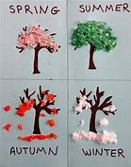
Can your child name the months in order? What do they notice about them? (Look at the letters at the beginning of the month.) Can they think of a celebration for each month they may have with their family? Find out when it’s people's birthdays or anniversaries. Which month has the most celebrations?

Seasons: Ask your child how many seasons we have? Can they name them?
Watch 1 Watch 2 Ask them to look outside their window and see if they can name the season we are in at the moment. What can they see? Can they see any flowers? Or new buds? Can they draw a picture of what they can see using different materials?

Calendar: Collect some materials to create a Seasons Calendar. Think about the design and what they will need. Here are some examples you could use.

Spring is in the air: Spring is around us. Traditionally people would ‘spring clean’. Can you help your grown up tidy up a cupboard so that it is clean and tidy for the rest of the year?

Celebrations across the four season:
Think about all of the celebrations we have around the world. Can they name them and place them into the correct seasons?

Autumn: Diwali, Bonfire Night, Harvest Festival , Hanukkah
Winter: Christmas, New Year
Spring: Holi, Easter, Mother’s day
Summer: Father’s day, EID, Vesak

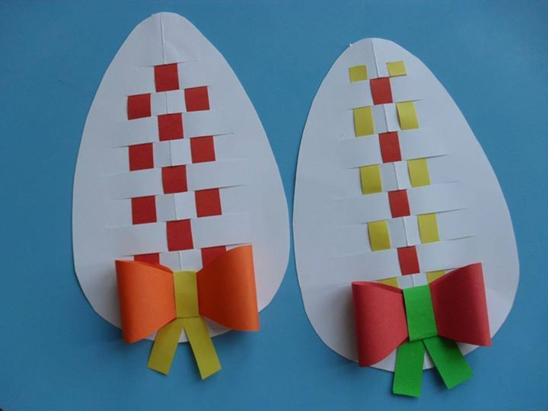
Choose one or more of the celebrations above and make a card for it. How will your design show which celebration it is for? Are there particular colours they can use? Could they make a pop-up card? Could they make a card using no pen and only fabric?

Think about Easter celebrations: What do we do at Easter time? Could they make an Easter card for a friend at school?

Have they ever taken part in an ‘Egg and Spoon Race?’
Find four friends or family members to take part. (The rule is to balance an egg or similarly shaped item upon a spoon and race with it to the finishing line) You can decide on the prize!

Traditional celebration: Talk to an adult and ask about any traditional celebrations you may have as a family. Why do you celebrate them? How do you celebrate them and when?
Do you have to wear different clothes and eat different food? Are there any celebrations your family take part in that your friends don’t? Write a note to a friend to explain what the celebration is and why it is important to you!

Gather the family and sing the song ‘Celebration’: Can you add actions to the dance? Could you have a concert and perform to your family and friends?

Mindfulness- Balance the toy

Helping your child to have some focused mindfulness time is a great way to help them cope with any difficult feelings or emotions, so over the next few weeks we are going to offer some simple techniques.
Try starting with short amounts of time and build up.

Help your child to find a soft toy (it will need to be something that will balance on their body, so make sure it’s not too big or heavy!). Explain to your child that they should lie down on their back with their legs stretched out straight and their arms straight down by their sides. Tell them you are going to balance the toy on their tummy, and they need to stay still so that it doesn’t fall off.
Explain this is a quiet time when you are both going to focus on your breathing because it’s a great way to keep your brain and body healthy. Ask your child to take big slow breaths. Can they feel their toy moving up and down? Encourage them to keep quiet and still, with just their belly moving up and down as they continue to focus on taking long, slow breaths.
You could try doing this a few times throughout the week. Aim to keep going for at least one minute initially and increase to around three minutes as your child becomes used to the activity.
Additional learning resources parents may wish to engage with
White Rose Resource Packs – Packs that will take you and your children through maths concepts in a step by step way!
Classroom Secrets Learning Packs - These packs are split into different year groups and include activities linked to reading, writing, maths and practical ideas you can do around the home.
Twinkl - to access these resources click on the link and sign up using your own email address and creating your own password. Use the offer code UKTWINKLHELPS.
Headteacherchat - This is a blog that has links to various learning platforms. Lots of these are free to access.
#TheLearningProjects

