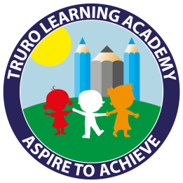
Truro Learning Academy
How to support your child with Yellow and Blue books
Children reading Yellow and Blue books are learning to: Phonic Skills
- Blend sounds to read CVC words.
- Blend and read simple words using adjacent consonants.
Mechanical reading skills
- Read High Frequency words.
- Use picture cues to help reading
Showing understanding (comprehension)
- Read simple sentences and understand their meaning.
- Recall the main points of a text.
- Use the structure of the story when re-telling it.
- Listen to familiar texts and express likes and dislikes.
How texts work
- Distinguish between a word, letter and a space.
- Understand, and use correctly, terms referring to the conventions of print; book, cover, beginning, end, page, word, letter, line.
Your child will be able to do some of these things more easily than others. If there is something that they find difficult, practising it during reading time at home will help them develop their reading skills.
Phonic Skills
If your child takes a long time to think of what each sound says, it will slow down their reading. Phonic sounds can be practised separately. Please ask us which sounds your child is working on.
Mechanical Reading
In order to fluently read blue books children will need to recognise on sight the 100 High Frequency Words. (These are the words that make up Year 1’s spelling list). You can practise recognising these words both in context (in a book) or out of context e.g. with flash cards. If there are particular words that they find tricky e.g. ‘was’ and ‘saw’ you could try putting them on post-its around the house. These words can only really be learnt by repeated practice as they aren’t ‘sound-out-able’.
Talking about the pictures in book band books before reading the page helps children get an idea about what words might come up on the page.
Showing Understanding
At this level we are looking to develop understanding on a simple level. Children should be able to answer simple questions that are directly answered in the writing.
They are also developing the skill to re-tell what happens and could practise this at home.
How texts work
If the book has a contents page, or an index, give them a chance to use it e.g. reading the names of poems in the contents of a poetry book and choosing one to read, finding it using the page numbers.

