Learning Project – Space Online
Age Range: EYFS
Staying active is really important when you are at home. There are lots of resources, here are just a few to use!
Joe Wicks PE sessions
Go Noodle
Super movers!
Cosmic Yoga
Weekly Reading Tasks | Weekly Phonics Tasks
Monday- Listen to Whatever Next?  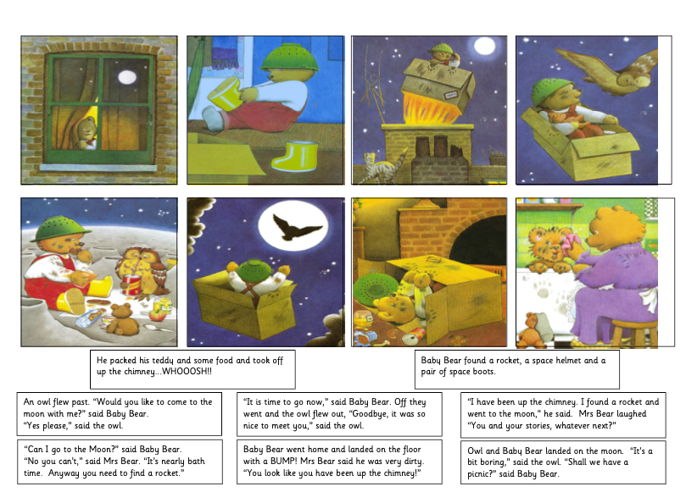  Practise reading the following words. Write them onto flash cards to use at home.  Little, were, when, went | Monday- Play the online game ‘Picnic on Pluto’. If your child is not at the stage of reading independently, you could sound the words out for them to blend together.  Teach Set 2 speed sound ‘air’ using the flashcards then complete this activity. Roll a dice and read the corresponding words.  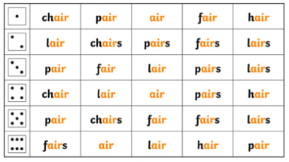
Tuesday- Visit Storytime from Space and let your child listen to the Story Time video of A Moon of My Own. Read the space sentences below.  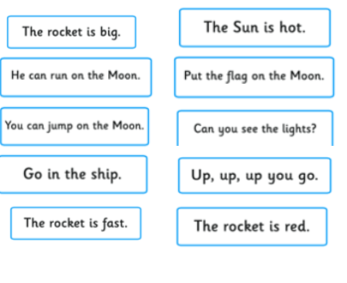  Read keywords for this week (see Monday). | Tuesday- Teach ‘ir – whirl and twirl’ sound using flash card and complete the following activities  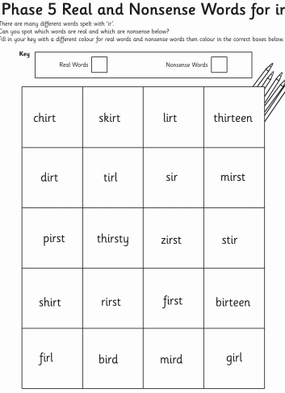
Wednesday- Listen to a space themed online story, Aliens Love Underpants, Roaring Rockets and using the space stories as a starting point, ask your child to make up their own story about space. It could use the same characters or settings as one of the stories you have shared together.  Read keywords for this week (see Monday). | Wednesday- Teach ‘ou – shout it out’ flash card. and read the below words.  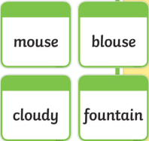  Write different sounds on paper (maybe re-use the sounds from a previous project). Put the sounds together to make different words only changing the initial sound e.g. t-i-n (tin), b-i-n (bin), ch-i-n (chin).
Thursday- Ask your child to draw a picture of one of the events from their made up space story. Can they explain what’s happening in the picture? Or, for more of a challenge, can they draw a book cover for their space story?  Read keywords for this week (see Monday). | Thursday- Teach ‘oy – toy for a boy’ flashcard and complete the activity  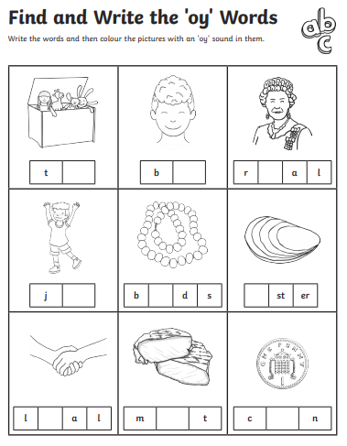
Friday- Visit Oxford Owl ebooks. Look at the picture book: ‘In the Sky’. Talk about the story together. What is happening on each page? Read keywords for this week (see Monday). | Friday- Play, ‘Pick a Picture’. You can orally sound out the word for your child for them to blend together if they are not yet at the stage of reading independently.  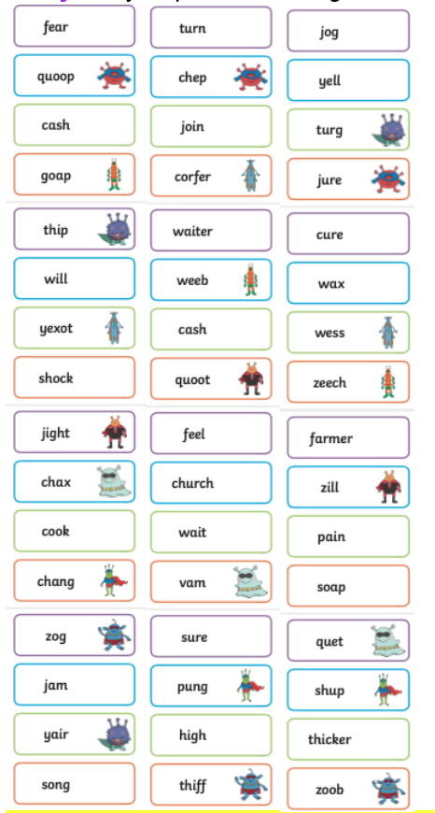
Weekly Writing Tasks | Weekly Maths Tasks- Halving
Monday- Ask your child to draw their own alien and label it. Can they create a fact file for their alien using sentences? E.g. My alien lives on Mars.  Practice your handwriting using the letterjoin sheets included in the pack. | Monday- Your child may already have some knowledge of halving and sharing things fairly. The difference between fair and unfair sharing can be used to emphasise the idea of half as being one of 2 equal parts.  Have two bowls of strawberries (or any other small fruit/food item) Explain that you are going to share them into 2 equal groups so there will be half for you and half for your child. Put a handful straight onto each plate without counting – make sure that one plate has much more strawberries than the other. Ask your child if that is fair. Prompt them to show you how to share the strawberries fairly.  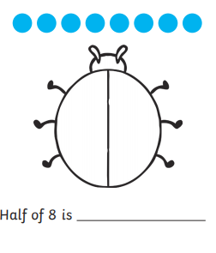  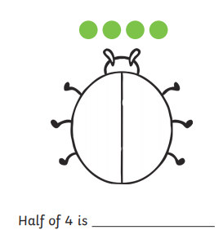  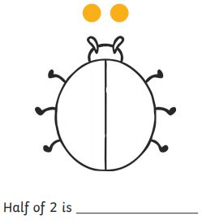
Tuesday- Write an invitation to the alien to invite them to your very own space party.  Practice your handwriting using the letterjoin sheets included in the pack. | Tuesday- Play a game of cards or dominoes. Ask your child to share the cards or dominoes out fairly at the beginning of the game between how many people are playing. They could say ‘one for you, one for me, two for you, two for me etc…’ to show that they know how many cards each player has. Start with two players and, if you can, add more after each game. Discuss that each player still needs an equal amount of cards to make it fair.
Wednesday- Your child can draw out or write their own menu for an alien. What does an alien eat? Moon-burgers, star biscuits or fruit rockets. Click here for more ideas.  Practice your handwriting using the letterjoin sheets included in the pack. | Wednesday-  Have a look at the pictures below. Share the fruit between the parrots and decide if they have shared them out fairly.  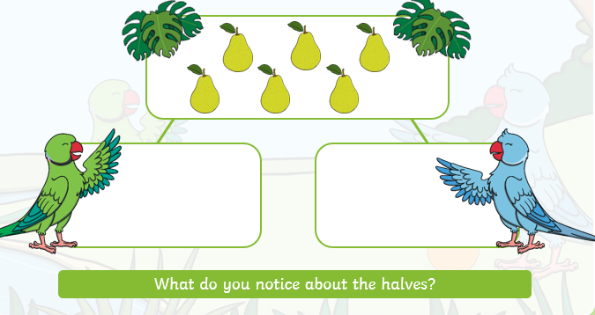  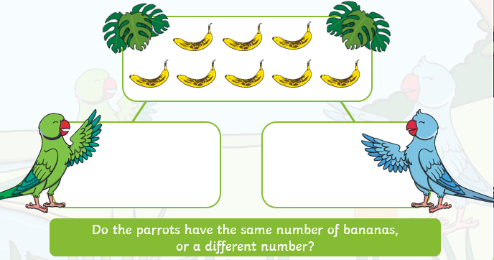  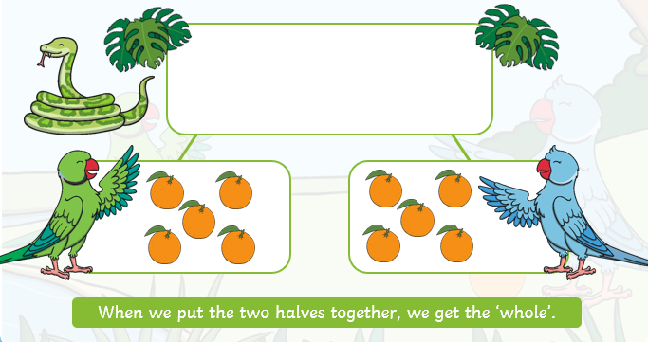
Thursday- Task your child with designing their own spaceship. Can they describe how the machine would move and label it using verbs?  Practice your handwriting using the letterjoin sheets included in the pack. | Thursday- Provide your child with thirteen items (grapes may represent beans well). Ask them to explore how they might share these fairly – reinforce that for them to be fairly shared they need to have an equal amount in each group.  Listen to the story Bean Thirteen here  Does this match their findings from attempting to share their 13 items? What about if they have 15 or 17 items? Or 12 or 14 items? You could use this to briefly introduce odd and even numbers.
Friday- Read the Aliens letter, write a list of objects that are magnetic and not magnetic. How many objects can you list?  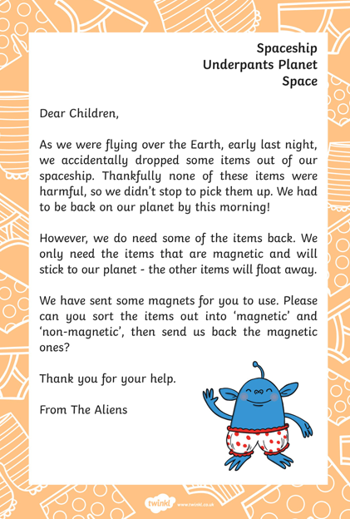  Practice your handwriting using the letterjoin sheets included in the pack. | Friday- Listen to the story The Doorbell Rang here  Use a packet of cookies or something else that can be shared if you don’t have cookies (cubes, toys, buttons) After listening to the story, listen again and share the items you have as they do in the story so that your child can see the items being shared between the different amounts of people. Discuss how each child always has the same amount to make it fair.  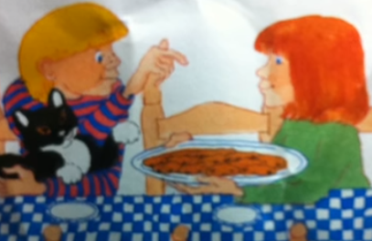

Learning Project - to be done throughout the week
The project this week aims to provide opportunities for your child to learn more about space. Learning may focus on our Solar System, the Sun and the Moon. It could look at life in outer space from the view of an astronaut and travelling through space.
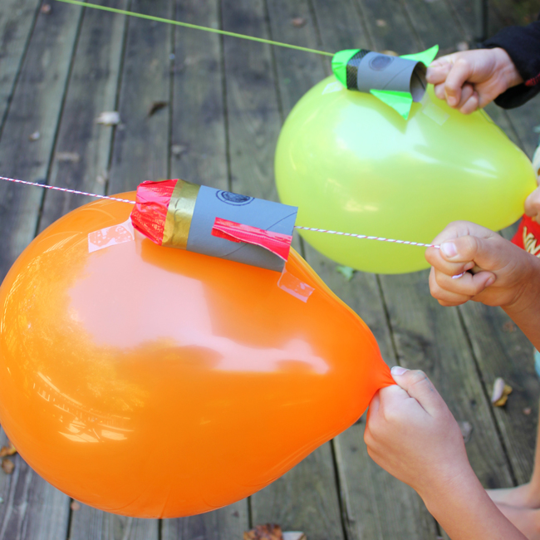
Remarkable Rockets
- Use junk modelling or craft items you have around your house to create your own rocket. Toilet roll tubes are a good starting point. You could have rocket races in the garden:
  - Tie a string up at an angle or use the washing line.
  - Blow up a balloon and sellotape it to your rocket. Hold the end of the balloon but do not tie it.
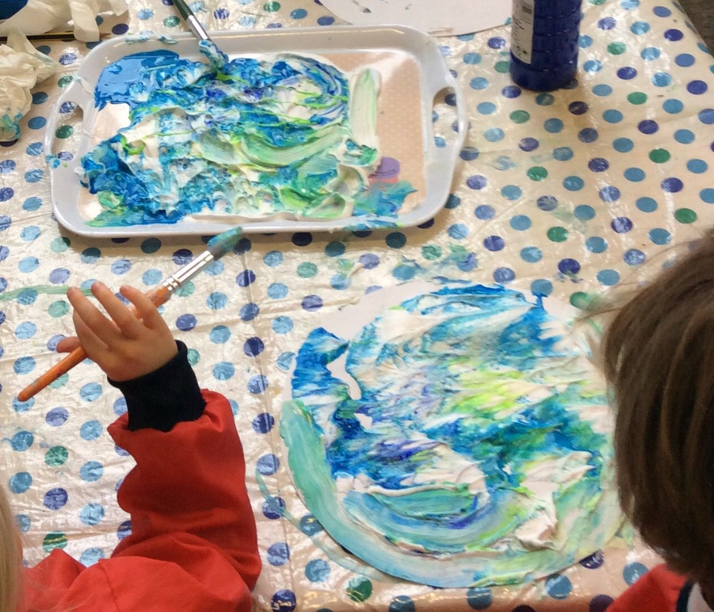
  - Let the balloon go and watch your rocket fly!

Make a Textured Planet
- Work with your child to create a replica of a planet. You could papier mache a balloon, or colour, paint or stick bits of materials on to the card to create textured effects. This shaving foam paint technique (see picture) creates a great textured finish when dry. Simply spray shaving foam onto a plate and drop in food colouring or poster paint.

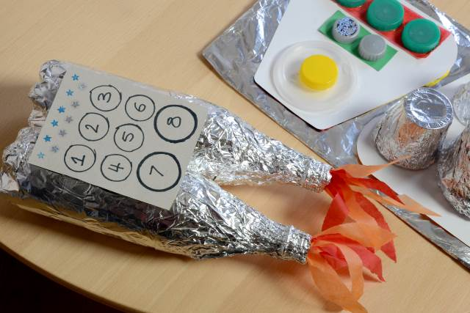
Explore Space Online
- Support your child in looking at the Earth from space using the Google Earth programme and identifying simple features such as water.
- Can you find your home? What does your child notice about the surrounding area?

Phone Home
- Create a space phone with your child using items from around the home. Get them to practise forming numerals correctly to create the buttons.
- Make a space phone book to support roleplay. Ask your child to draw a picture of a different alien on each page and write a phone number for them.

Have a Space Themed Party/Picnic
- Support your child to use tin foil to create shiny space suits for their teddies and dolls. They could have a space-themed teddy bear’s picnic afterwards where they share the biscuits in the next activity!
- Make yummy star biscuits to share at the picnic. Click here to find instructions on how to support your child in making simple star biscuits. They could share them at their space themed teddy bear’s picnic. Share photographs of your space themed picnic on to Tapestry.
Mindfulness
To link to the space theme, how about helping your child make a space mobile to use as a relaxation tool. You could do this by cutting out some cardboard stars and dangling them from a coat hanger (feel free to be more creative!). Find somewhere to hang the mobile so your child can lay down underneath and gaze up at the stars. It will work well outside with a gentle breeze to make the mobile move. Encourage your child to keep their body and their mind still. Then focus on watching the stars move and the feeling of their breath entering and leaving their body. Encourage your child to stay here for as long as they find comfortable.
STEM Learning Opportunities #sciencefromhome
Mission X – Astro Agility Course
- Complete an agility course to improve movement skills, co-ordination, and speed. Record your speed and see if you can get faster with practise. See here.
- Sign up and access all of the Mission X resources here.
Additional learning resources parents may wish to engage with
White Rose Maths online maths lessons. Watch a lesson video and complete the worksheet (can be downloaded and completed digitally).
Numbots. Your child can access this programme with their school login.
IXL Click on Maths, Reception. There are interactive games to play and guides for parents.
Talk for Writing Home-school Booklets are an excellent resource to support your child’s speaking and listening, reading and writing skills.

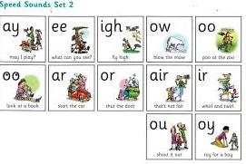
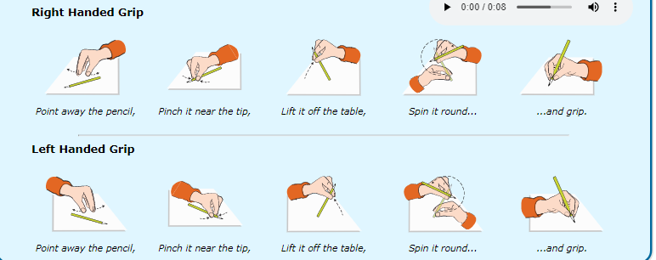

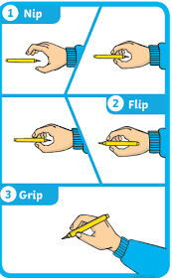
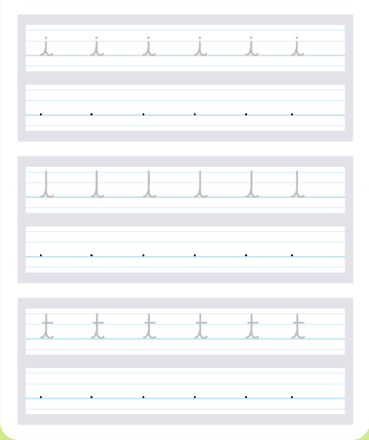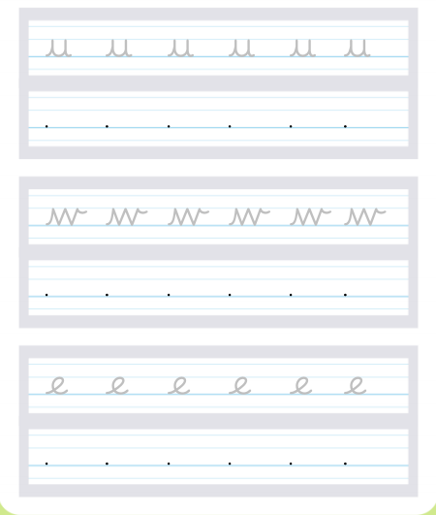

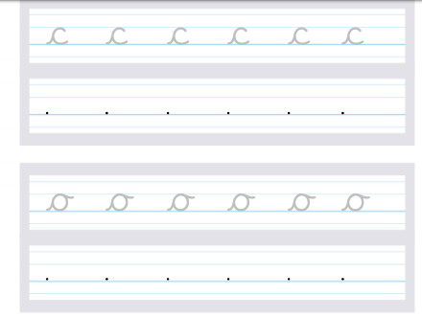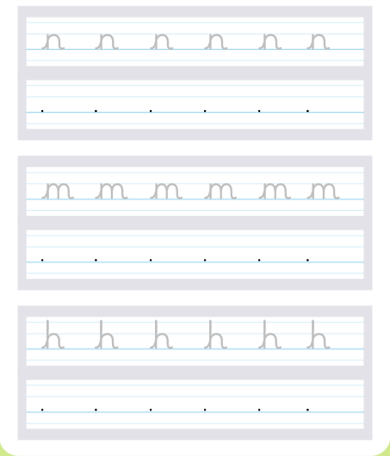

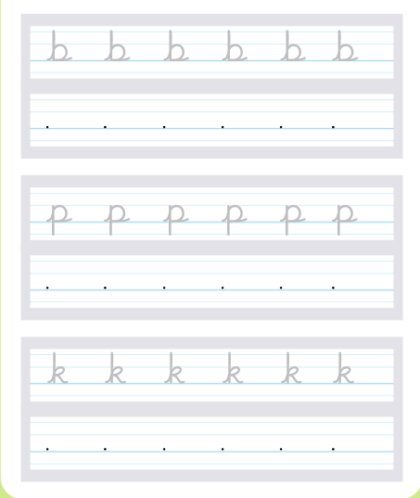
#TheLearningProjects
in collaboration with
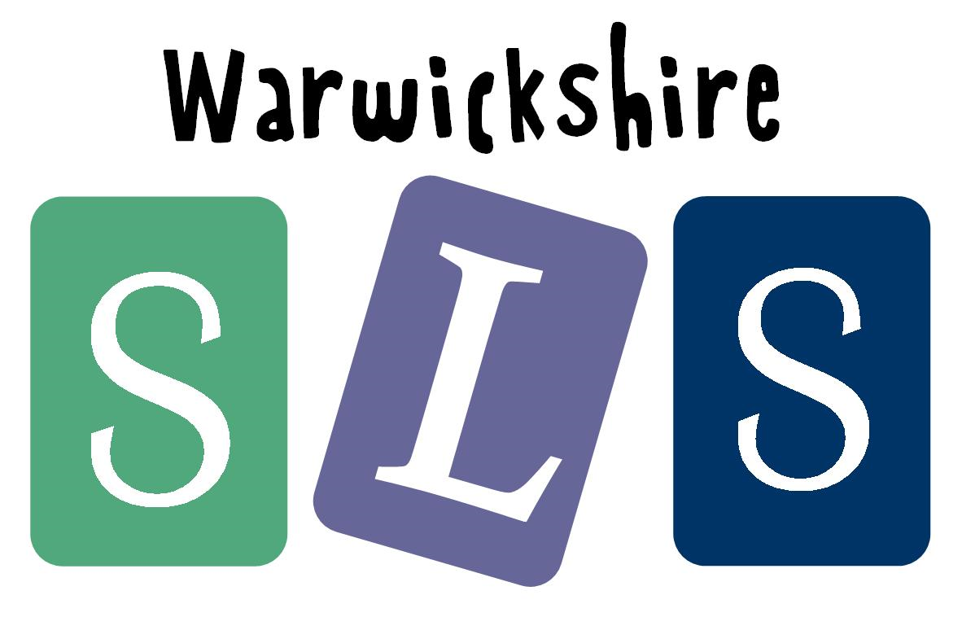
www.robinhoodMAT.co.uk

