Learning Project WEEK 8- Under the Sea
Age Range: EYFS (Kynance)
Weekly Maths Tasks (Aim to do 1 per day) | Weekly Reading Tasks (Aim to do 1 per day)
MATHS FOCUS: Making simple patterns.  This is about immersing the children into simple patterns in daily life.  Can your child make a repeating pattern using objects around the house/garden i.e. apple, banana, apple, banana.  CHALLENGE: Ask your child to build on the above to create more complex patterns e.g. apple, apple, banana, apple, apple, banana.  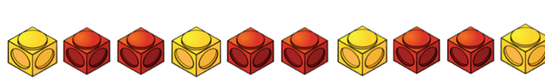 or  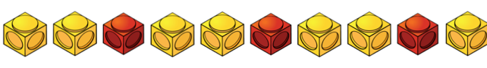  or  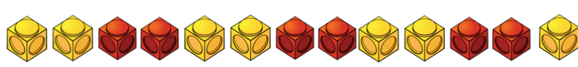  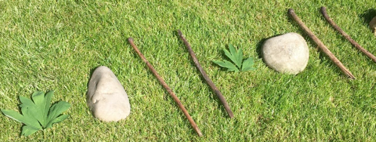  On a paper plate or on a circle of paper.  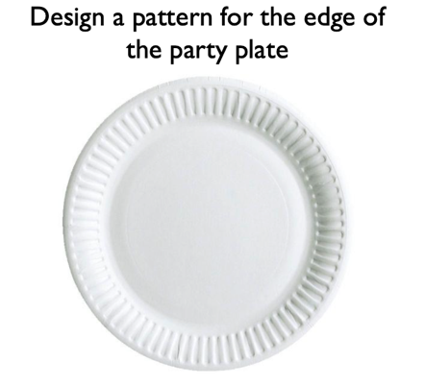  Take part in a repeated pattern dance. Include claps, jumps, punches etc. For example. You clap once, jump once, clap once, jump once and the children copy.  Can you create a repeated pattern dance using your favourite song? Please upload to Tapestry for us all to see! | GUIDED READING  This is used to help the children identify features of a picture or text through talk. The skill of inference is being used here but also helps the children to develop reasoning, prediction and engagement with text.  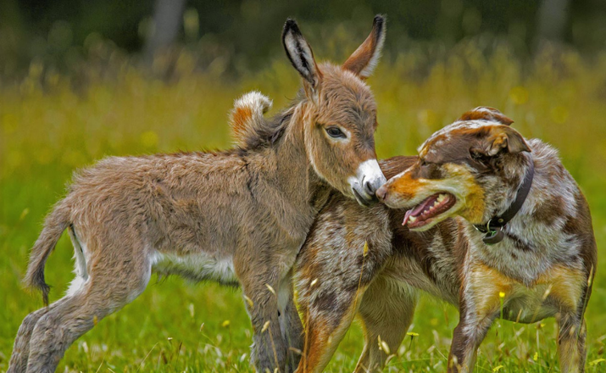  Show your child this picture. Talk through these questions. There are no right or wrong answers and share your thoughts with the children too:  What animals can you see in the picture?  In what ways are these two animals different?  In what ways might they be similar?  How do you think the two animals discovered each other?  How have they become friends?  What do you think makes a good friend?  How can you show other people that you are a friendly person?  What kind of people do you like being friends with?  What kind of people would you not want to be friends with?  Share the story ‘The Snail and the Whale’. If you don’t have a copy at home read this adapted version here or here online and then you can watch it at BBC iPlayer.  Perfect picture!  Can you draw a picture of two other creatures that would make unlikely friends?  Red words of the week:  what, when, some.  Read a variety of books at home. Favourites can be repeated. Hearing the patterns of language in a story will support your child’s language development.  - Reception age children: Children to read to parents daily. Visit Oxford Owl for free eBooks that link to your child’s book band. You can create a free account.  Complete the linked Play activities for each book.
Weekly Phonics Tasks (Aim to do 1 per day) | Weekly Writing Tasks (Aim to do 1 per day)
Tune in daily to Ruth Miskin’s phonics lessons on YouTube (times have been put on Tapestry so that you are challenging your child). This is crucial to support your child’s fantastic phonics progress already. After these sessions, practise writing words with the special friend that you have learnt, pinching the sounds on your fingers. Your child will explain to you, as they do this daily. https://www.youtube.com/channel/UCo7fbLgY2oA_cFCIg9GdxtQ  Play Buried Treasure online on PhonicsPlay  Buried Treasure: Write out some real words and made up words (e.g. tud, jup, fub). Place these in a pile and using 2 containers, label one as ‘Treasure’ and the other as ‘Bin’. Can your child read the word and decide if it is real? If it is real it goes in the treasure chest, if not it goes in the bin. Simplify this activity for Nursery by sounding the words out for them. | Can you get the children to make a poster about recycling plastic and the impact of plastic on sea life?  Watch ‘The Little Mermaid’ and stop it in the middle. Get the children to draw and write what they think happens next.  - Practise forming the letter ‘j’. Please ensure that you make it clear on the difference between j and i.  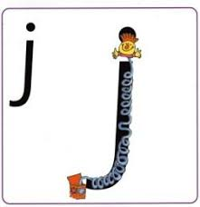  - https://www.twinkl.co.uk/resource/t-l-8548-upper-and-lowercase-letter-formation-powerpoint  Practise writing your FULL NAME.  - Ask your child to write out the tricky words they are working on at the moment on pieces of paper and do a tricky word hunt in the house!  what, when, some.
Learning Project - to be done throughout the week
The project this week aims to provide opportunities for your child to learn more about life in and around the sea. Learning may focus on the strange and wonderful creatures and plants that occupy our oceans, their habitats and how human beings affect this environment.

After listening to the story, ‘The Snail and the Whale’ (see reading task).
- Take your child on a snail hunt around the garden or local walk- observing social distancing. Can they think about the places a snail might want to live?
- Show your child the picture of the sea snail.
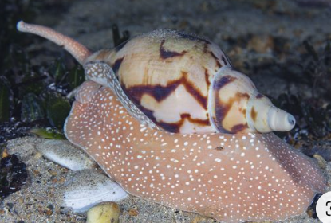

- Ask, how is it different from the snails they found in the garden?
- Have a snail race. Use chalk to draw out lines on the ground (or sticks to mark out the lines) to create a race-track. Place your snails at the starting line and watch them go! You could give your child a timer to measure how long it takes for the snails to make their way across. Share a picture of the winning snail on Tapestry.
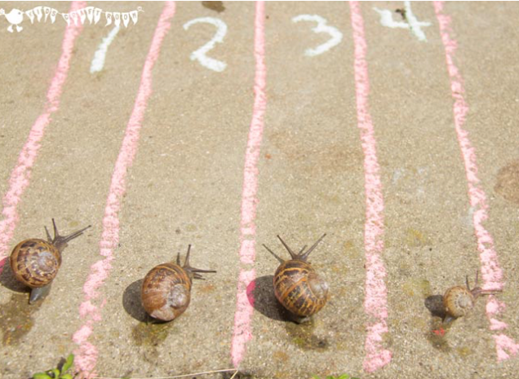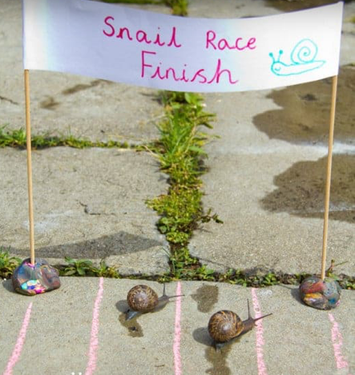

Make your own ‘Under the Sea’ Scene
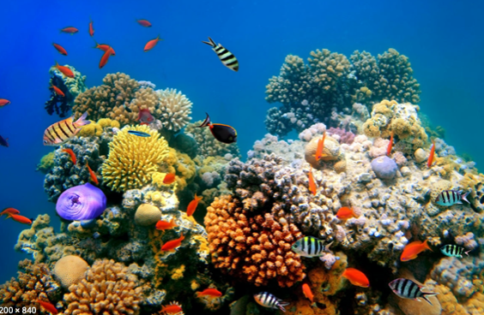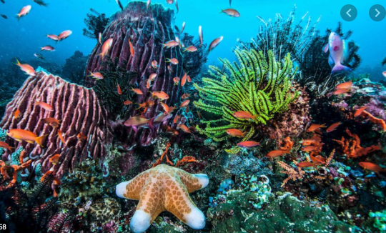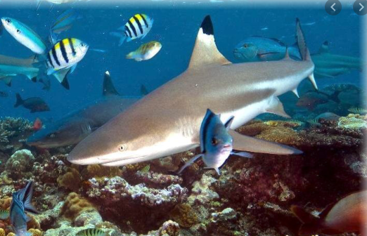

- Look at the pictures of a coral reef. Talk about the animals you can see. What are the animals called?
Use junk modelling or craft items you have around your house to create the scene. You could even add in natural objects e.g. grass as seaweed.

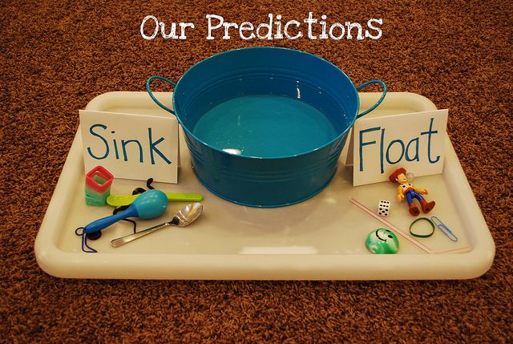
Make your own Fishing Game
- Make a fishing rod using a stick or similar (a wooden spoon would work well!). Tie some string on to one end and tie a magnet onto the end of the string (you could use a fridge magnet).
- Using the rod, your child could explore which items are attracted to the magnet around the house

Explore Floating and Sinking
- Fill up a bowl, sink or basin and provide your child with a range of objects to explore. Which ones float and which sink? Ask them why they think they float/ sink? CHALLENGE: Keep a record of the objects that float and sink? This could be using pictures or written.

Mindfulness
Help your child to choose a piece of instrumental music that they find relaxing. Have them lie down on their back with their eyes closed and both hands on top of their tummy. Ask them to close their eyes and concentrate on their breathing. Can they breathe deep and slow so that they feel their tummy moving up and down under their hands? Ask them to stay like this as the music plays. Just breathing and listening, nice and still. Aim for at least one minute to start with and increase to a slightly longer session each time you do the activity.

Beach Safety
Please discuss how to stay safe when close to the sea and who can help us on the beach if we are lost or hurt. We use the phrase “slip, slap, slop” to remember to slip on a top, slap on a sun hat and slop on the suntan lotion to protect us in the sun.
Try these excellent resources from the RNLI education team.
https://rnli.org/youth-education/education-resources/lower-primary/copy-of-fly-the-flag
Additional learning resources parents may wish to engage with
Classroom Secrets Learning Packs - These packs are split into different year groups and include activities linked to reading, writing, maths and practical ideas you can do around the home.
Twinkl - to access these resources click on the link and sign up using your own email address and creating your own password. Use the offer code UKTWINKLHELPS.
Headteacherchat - This is a blog that has links to various learning platforms. Lots of these are free to access.
White Rose Maths -click for spring term guidance
#TheLearningProjects

Please check Tapestry for uploads or useful links and please, if possible, share some fabulous home learning!
Miss Guy

