W/C: Learning Project – Transport Online
Age Range: EYFS
Staying active is really important when you are at home. There are lots of resources, here are just a few to use!
Joe Wicks PE sessions
Go Noodle
Super movers!
Cosmic Yoga
Weekly Reading Tasks | Weekly Phonics Tasks
Monday- Sing the nursery rhyme ‘Wheels on the Bus’ with your child. See attachment at the end of this document. Can they add verses about different modes of transport? What sounds and actions do other kinds of transport make?  Practise reading the following words. Write them onto flash cards to use at home.  have, said, come, out | Monday- Take a look at this website. Select Set 2 Speed Sounds. There are a variety of resources linking to the previous weeks learning of the set 2 sounds. Over the week, complete some of these activities to support any weaknesses in phonic learning so far.  Complete the rhyming strings.  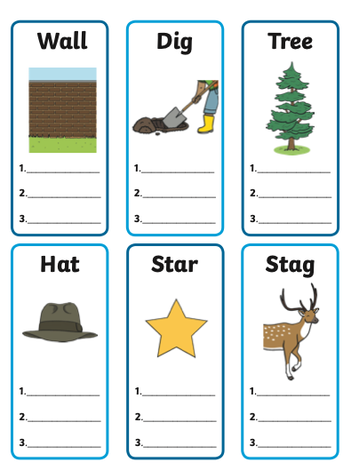
Tuesday- Follow the story The Bus is for Us with your child. Ask them to recall the different types of transport mentioned in the story. Encourage your child to read the yes/no questions. Make yes no cards for them to use to answer.  Read keywords for this week (see Monday).  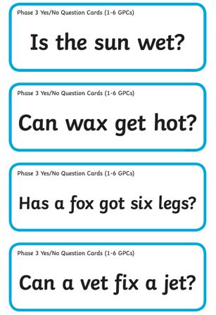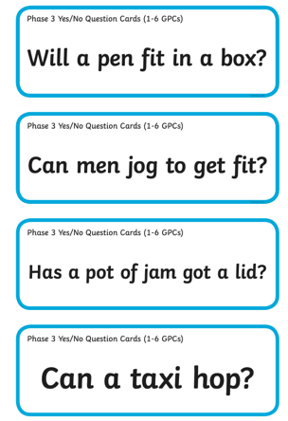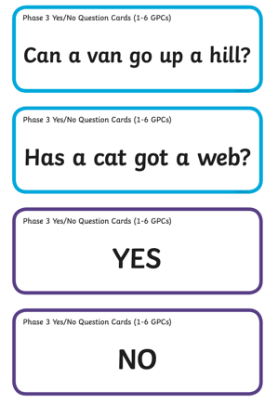 | Tuesday- Take a look at this website. Select Set 2 Speed Sounds. There are a variety of resources linking to the previous weeks learning of the set 2 sounds. Over the week, complete some of these activities to support any weaknesses in phonic learning so far.  Play Rhyme Racer (click games tab to access) - collect all the rhyming words. What rhyming words did you find? Play Read and Race to develop confidence.  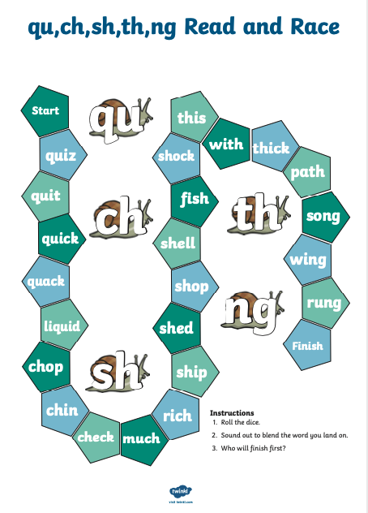
Wednesday- Tell your child that they’re going on an imaginary journey. What do they need to take? Play the memory game - ‘I packed my bag and in it I put a…’ Take it in turns and keep adding to the list. Each time repeat the whole list.  Read keywords for this week (see Monday). | Wednesday- Take a look at this website. Select Set 2 Speed Sounds. There are a variety of resources linking to the previous weeks learning of the set 2 sounds. Over the week, complete some of these activities to support any weaknesses in phonic learning so far.  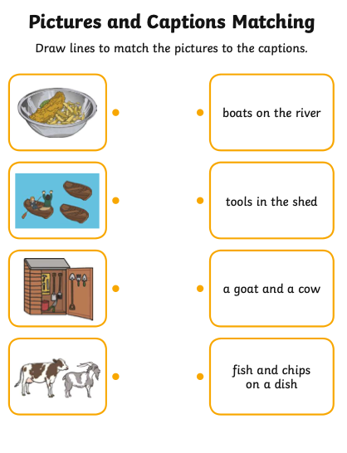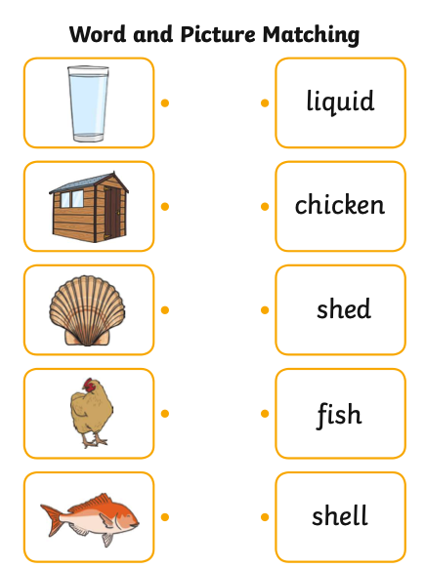
Thursday- During your daily walk discuss with your child the things they see. Ask them to note the different transports. When you get home, ask them to recount the events from your journey in order. Sing The Vehicles Song together.  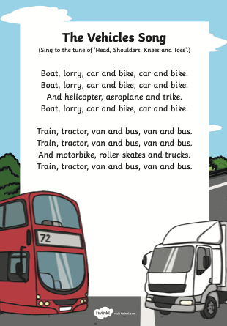  Read keywords for this week (see Monday). | Thursday-. Take a look at this website. Select Set 2 Speed Sounds. There are a variety of resources linking to the previous weeks learning of the set 2 sounds. Over the week, complete some of these activities to support any weaknesses in phonic learning so far.  Play keyword bingo!  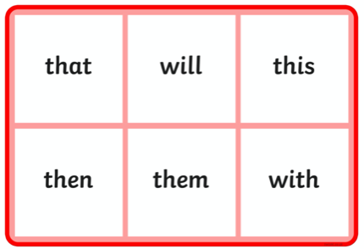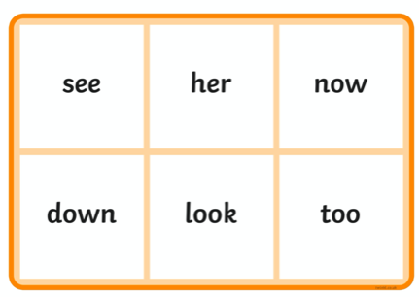
Friday- Listen to ‘The Naughty Bus’. Your child can make a wanted poster for the Naughty Bus.  Read keywords for this week (see Monday). | Friday- Take a look at this website. Select Set 2 Speed Sounds. There are a variety of resources linking to the previous weeks learning of the set 2 sounds. Over the week, complete some of these activities to support any weaknesses in phonic learning so far.  Play high frequency Snakes and Ladders  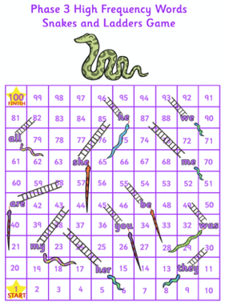
Monday- Practise reading the following words. Write them onto flash cards to use at home. Read/ listen to I Wish I Were a Pilot | Monday-Take a look at this website. Select Set 2 Speed Sounds. There are a variety of resources linking to the previous weeks learning of the set 2 sounds. Over the week, complete some of these activities to support any weaknesses in phonic learning so far.  Play Read and Race to develop confidence.  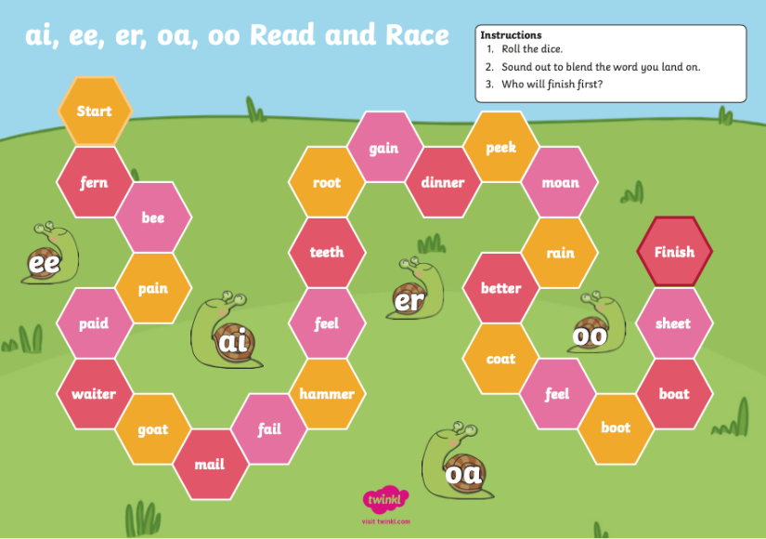
Tuesday- Read keywords for this week (see Monday). Encourage your child to read the yes/no questions. Make yes no cards for them to use to answer.  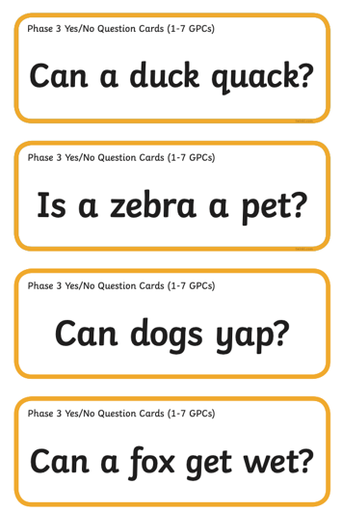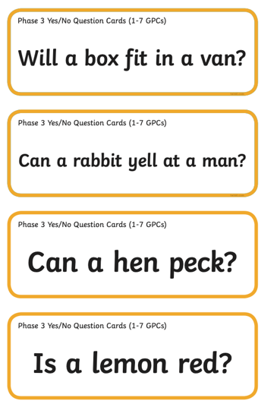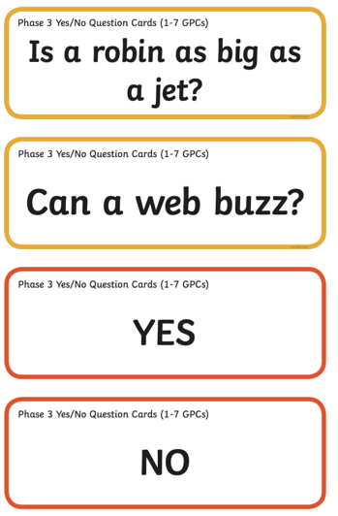 | Tuesday-Take a look at this website. Select Set 2 Speed Sounds. There are a variety of resources linking to the previous weeks learning of the set 2 sounds. Over the week, complete some of these activities to support any weaknesses in phonic learning so far.  Play keyword Bingo  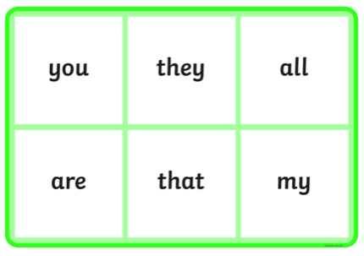  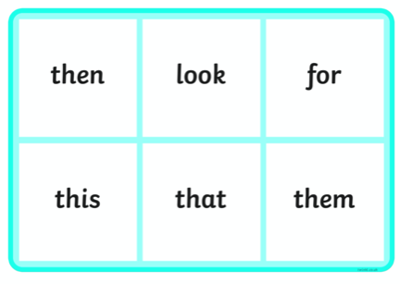
Wednesday- Read keywords for this week (see Monday). Read and sing Row, Row, Row, Row Your boat together.  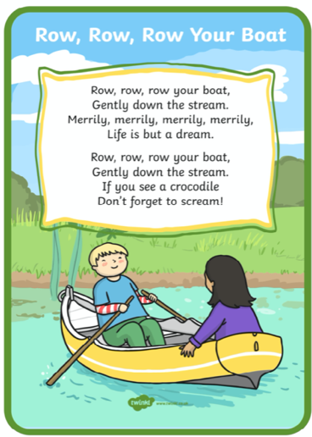 | Wednesday- Take a look at this website. Select Set 2 Speed Sounds. There are a variety of resources linking to the previous weeks learning of the set 2 sounds. Over the week, complete some of these activities to support any weaknesses in phonic learning so far.  Find and colour the sentence in the maze to match the picture.  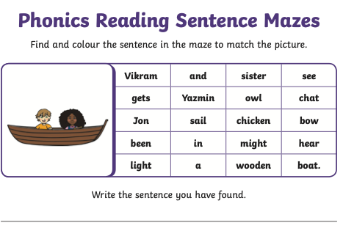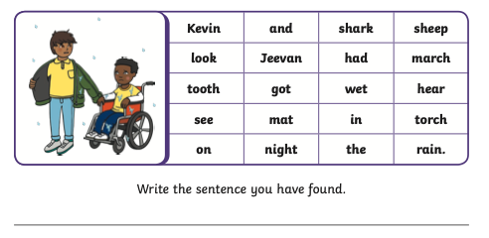
Weekly Writing Tasks | Weekly Maths Tasks- Capacity From - Nrich.maths.org
Monday- Ask your child to draw pictures of a bus and label the picture. Encourage your child to use their phonic knowledge to sound the word. Do not write the labels for your child to copy as this does not support their learning.  Practice your handwriting here | Monday / Tuesday-  White Rose Weekly Maths White Rose Maths -click for Summer Term guidance.  Set up a water tray with coloured water (plastic box / trug) and some boxes and flasks of various dimensions with some plastic cups. First of all, enjoy playing with water, pouring and filling containers.  Discuss – We want to take a drink to the park (possibly homemade lemonade), which bottles will hold the most?  What do you notice about the bottles? How are they different? What happens if you pour this one into the other one?  Reasoning – How can we find out which one holds the most?  How do you know which one holds more?  Developing How many cups will they each fill up?  Can we put them from smallest to biggest / from which holds the most to the least?  Recording can we put labels on the bottles to help us remember how much is in them.
Tuesday- When on your daily walk focus on road safety. Once home ask your child to make their own road safety poster - Stop, Look, Listen. Share your posters on Tapestry.

Practice your handwriting here
Wednesday- Imaginary journey-where would your child go? Why would they go there? What would they do there? They could draw out their imaginary land and write a list of all the items they will be taking with them. Demonstrate how to write a list for your child to see.  Practice your handwriting here | Wednesday- Using the water tray and plastic bottles etc discuss how some containers are different shapes or have great compacity than other, progress from just ‘bigger’ to ‘shorter’, ‘fatter’, ‘taller’, ‘thinner’ and ‘holds more than’.  Ask your child to explain how they know that the containers hold more “This is smaller because when you pour from the bigger one it overflows”, “This one is smaller because when you pour it into the bigger one the water only comes up to there” or “This one is bigger because you get six cups and that one only fills four cups.”  White Rose Weekly Maths White Rose Maths -click for Summer Term guidance.
Thursday- Write simple sentences about your daily walk journey. What did they see and hear? Remember to encourage capital letter to start, finger spaces between words, using phonic knowledge to hear sounds in words and ending with a full stop. We would love to see you writing and drawings on Tapestry.  Practice your handwriting here | Thursday Develop by asking how much lemonade do we have to make to make sure everyone gets one cup? Two Cups? What happens when we add more or less people?  White Rose Weekly Maths White Rose Maths -click for Summer Term guidance.
Friday- Make your very own Naughty Bus (see reading task today) and use this to retell the story. Your child could make a different mode of transport as a challenge.  Practice writing some joined words here. | Friday- Using just 1 cup of coloured water fill 6 different transparent containers. Discuss what happens to the water level in each and why.  White Rose Weekly Maths White Rose Maths -click for Summer Term guidance.
Monday- Having made your paper planes – see project below. Ask your child to design a certificate for the winner or winners. Remember to ask them to include a sentence for the reason for the certificate e.g. Award for making the plane that flew the furthest. Discuss how names start with a capital letter.  Complete an online wordsearch | Monday / Tuesday- White Rose Weekly Maths White Rose Maths -click for Summer Term guidance.  Presents! Provide and assortment of wrapped items for your child to explore, make sure some are small but heavy and other are light but large.  Place the presents in an area where they can be explored. Encourage the children to make predictions on the wrapped items.  Discuss – Tell me about this item. What is the same about these two? What is different? What does this item remind you of?  Reasoning - Do you think this one will be heavier . lighter than that one? Why do you think that? How will you test out your idea? Why or why not? Which do you think is the heaviest / lightest? Could we arrange them in some way? Why have you put that one there Can we arrange them in a different way?  Develop – What kind of thing do you think might be inside? Why do you think that? Can you find something that is the same weight as this present?  Record-Have you group the presents? What can we do to remember the order / arrangement?
Tuesday- Have some fun practicing writing the weekly words

Write a sentence or sentences about the transport picture.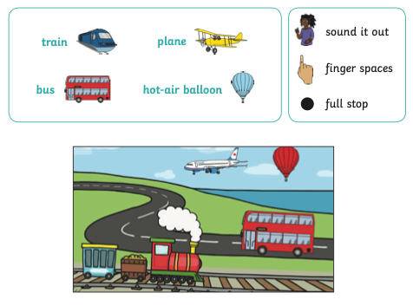
Wednesday How many facts do you know about boats? Can you write a Did You Know information sheet about boats.  Play this online word match game | WednesdayWhite Rose Weekly Maths White Rose Maths -click for Summer Term guidance.  Can your child say how many there are without counting? This is a hiding game that can be made more exciting by having gems, jewels or golden coins.  The Activity - Put three bowls over one, two and three jewels. Quickly lift and replace one bowl and challenge your child to say how many there are. Swap the bowls around rapidly for a minute. When you stop, can they point to the bowl with three? Lift the bowl and see if your child cab instantly say whether they are right or not.  Describe – Can your child see how many there are? How did they see them?  Reasoning- How did your child know there were three, ask them to explain.  Opening out – Can you make some different patterns with four jewels?  How can you arrange five jewels so you can quickly see there are five?  Recording – Draw, stamp, sticker or take a photo for your favourite patterns for 5.  Use spatial language to develop ‘above’ and ‘underneath’ including shape names or properties, such as ‘in a line’ or ‘triangle’.

Learning Project - to be done throughout the week
The project this week aims to provide opportunities for your child to learn more about transport. Learning may focus on modes of transport, transport in the past, the science behind transport, road safety and how to be safe around water.

Make Paper Planes
- Make paper airplanes using this guide. Ask your child/ children to come up with a name for their airplane and write this on the side. Have a competition to see whose airplane will fly the furthest/ highest. You could ask them to create a certificate for the winner. Take a photograph of the winning plane to share your success and upload to your Tapestry account.

Traffic Lights
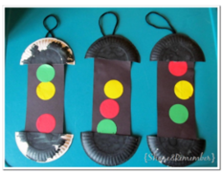
- Play the traffic light game- Ask your child to help create a set of traffic lights. This could be as detailed or simple as you like. Ask your child to run around the garden/ outdoor space. When you point to a colour on the traffic light they have to do the following:
  - Red- Stop or freeze where they are
  - Orange- Walk slowly
  - Green- Run
You can extend this by adding in different colours or actions e.g. when you bounce a ball on the ground, they have to jump up and down.

Origami Boat
- Follow the instructions here to make your very own origami boat. You could float these in a paddling pool, in the sink or in the bath. Experiment with filling your boats up with objects, does it still float?

Follow the instructions -
- Give instructions to guide each other around the house/garden i.e. forward two steps, turn left, forward two more steps.
- Can you support your child in drawing a map to show the way around the house? CHALLENGE: Work with your child guiding Bee Bot to the flower. Use the arrows and press ‘Go!’

Learn to Ride a Bike
- Support your child in learning to ride a bike. They could even do an obstacle course to help develop their control or have races to improve their speed.
Wellness
Explain to your child that sometimes when we think about new situations, or when we know things are going to change, it can make us feel worried. Feeling anxious or worried is normal; it’s a step our body takes to make sure we are safe.
There are techniques we can use to help us feel calm, even when things are changing or when times are difficult. Today we will learn one of these techniques. It’s all about using your superpowers! Stand in a quiet space with your legs slightly apart, your back straight and your head tall, with your arms bent and your hands on your hips. Make your position big and strong. Just like Superman or Wonder Woman might stand!
Keep still in this position and start to take long, slow breaths. You can even think about which power you would like to have to help you through the difficult time by saying things like ‘I am brave’ or ‘I am strong’. Notice how you feel after spending a few moments in this big, strong position.
Try it anytime you are feeling worried or nervous… it will really help you to feel brave!
STEM Learning Opportunities #sciencefromhome
Brilliant Boats
- Collect different materials from around your house. Paper, yoghurt pots, cereal boxes, tinfoil cake tins. Which objects make the best boats? Which boat will carry the most coins or marbles?
Additional learning resources parents may wish to engage with
White Rose Maths online maths lessons. Watch a lesson video and complete the worksheet (can be downloaded and completed digitally).
Numbots. Your child can access this programme with their school login.
IXL Click on Maths, Reception. There are interactive games to play and guides for parents.
Talk for Writing Home-school Booklets are an excellent resource to support your child’s speaking and listening, reading and writing skills.
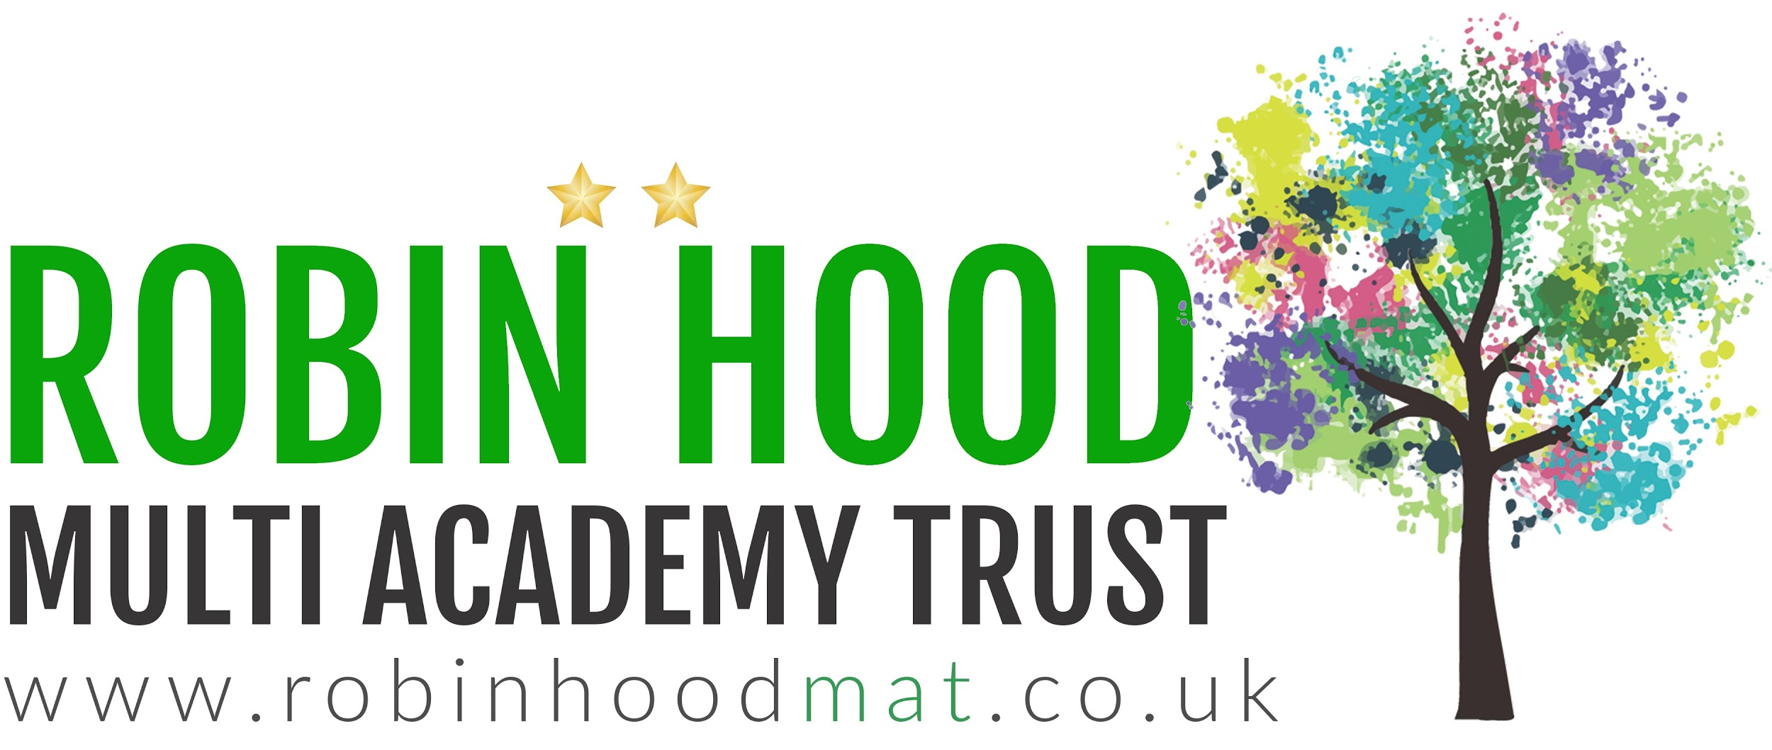
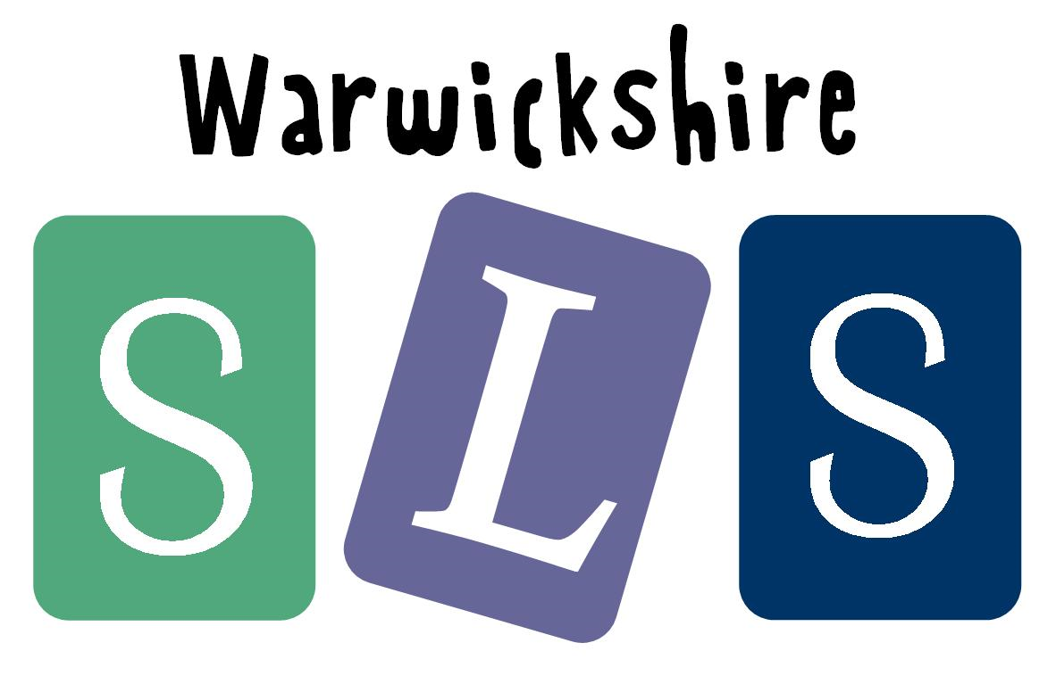
In collaboration with:



