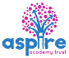
Learning Project - Around the World Online
Age Range: EYFS
Staying active is really important when you are at home. There are lots of resources, here are just a few to use!
Joe Wicks PE sessions
Go Noodle
Super movers!
Cosmic Yoga
Weekly Reading Tasks | Weekly Phonics Tasks
Monday- Listen to stories from around the world - including: Handa’s Surprise, The Tiger’s Child, and If The World Were a Village.  Practise reading the following words. Write them onto flash cards to use at home.  Once, little, was, so | Monday- Ask your child if they can think of a fruit or vegetable for each letter of the alphabet i.e. a=apple, b=banana.  Match the picture to the word  https://www.phonicsbloom.com/uk/game/word-pairs?phase=4
Tuesday- Ask your child to retell the story of Handa’s Surprise in their own words once they are familiar with it.  Read keywords for this week (see Monday). | Tuesday- Play Odd and Bob. Children sort real words and nonsense words by sounding out.
Wednesday- Follow the story All Are Welcome Here with your child. Discuss how your child feels TLA makes everybody feel welcome.  Read keywords for this week (see Monday). | Wednesday- ck,e,u,r,h,b Read and Race game - practise letter sounds, use phonic knowledge to blend the sounds together.
Thursday- Read the story of Handa’s Surprise again, look at the features of capital letters to start sentences, capital letters for names and also full stops and exclamation marks. – Cut the story up into cards – ask your child to sequence the cards in the correct order and retell the story.  Read keywords for this week (see Monday). | Thursday- Encourage your child to read the caption using their phonic knowledge and match to the pictures.  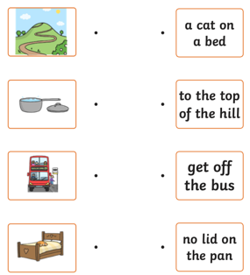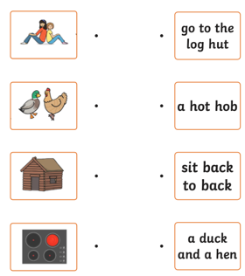
Friday- Play memory games, ‘I went to the market, I bought… The next person repeats the above sentence remembering the items bought already and adding a new one to the list each time. Use fruits like in Handa’s Surprise. –  Read keywords for this week (see Monday). | Friday- List countries from around the world e.g. Spain, Peru. Ask your child to identify the initial sound each country begins with. Can they identify other sounds e.g. S-p-ai-n?  Sentence substitution  https://www.phonicsbloom.com/uk/game/sentence-substitution?phase=4
Weekly Writing Tasks | Weekly Maths Tasks- Doubling and counting to 20
Monday- Encourage your child to look at the food in your kitchen and find out what countries some of it comes from. Search on a map for those countries. Help your child to trace the letter with which the name of those countries start. | Monday-.  Doubling: Double means ‘twice as many’ give your child the opportunity to build doubles using real objects. Mirrors are a fun way for children to ‘double’ the quantities they build. Encourage your child to say the doubles as they build them 3.g. double 2 is 4. Provide examples of doubles and non-doubles for the children to sort and explain. 2 dice or dominoes provide a great way to look at doubles.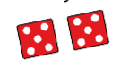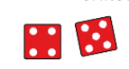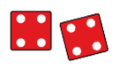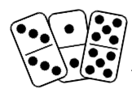  Counting to 20: On YouTube Kids search for a song ‘counting to 20’
Tuesday- After listening to the story Handa’s Surprise, ask your child to name and draw different fruits that they know. Label them using describing words. | Tuesday-  Doubling:Tell a story of someone having trouble looking after two dogs who will not do what they are told. Then they get given two more dogs to look after – now they have four and they have ‘double trouble’! What about if they have three dogs – how many would be double trouble? Ask you chld to model doubling numbers upto 5 on their fingers and to select images to match the story numbers e.g. dominoes and dot patterns.  What do you notice about the numbers and their patterns?  What do you have to do when you double? How do know a number is a double? 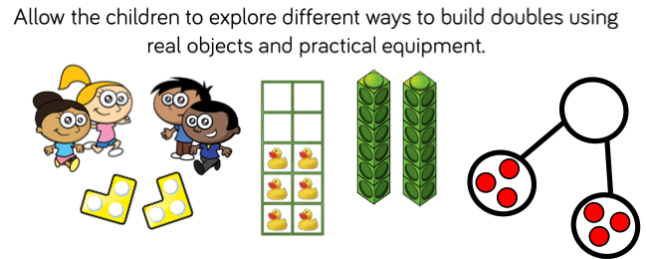  Counting to 20: Make number cards 1-20 on paper. Use lego or something similar and ask your child to build towers to match the amounts.
Wednesday- Ask your child to play in role as Handa from Handa’s Surprise. Ask them questions and they must answer as Handa e.g. ‘Handa, what is your favourite fruit?’ They might answer by saying ‘My favourite fruit is tangerines. I was very excited to find lots of them’. | Wednesday-  Doubling: Sit opposite to your child, set out a small quantity of small items like pebbles. As you child to make the same quantity and therefore doubling it. You could use fingers to match.  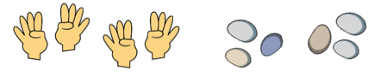  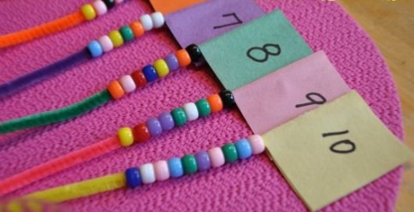  Counting to 20: Use pipe cleaners and beads or string with tube pasta to create a 1-20 number line.
Thursday- Your child can draw a picture of a suitcase and all the things they might take on holiday.  CHALLENGE: Ask your child to label the items. | Thursday  Halving: Show your child a plate of strawberries (or other small fruit). Explain that you are going to share them into 2 equal groups so there will be half for you and half for your child. Put a handful straight onto each plate without counting – make sure one plate has more strawberries than the other. Ask if that is fair? Prompt your child to show you how to make it fair.  Repeat with 3 and 4 plates  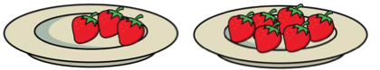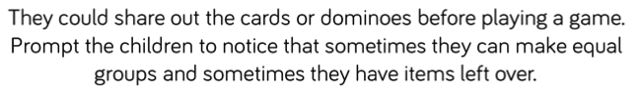  Counting to 20:  Play Teddy Numbers game up to 15. https://www.topmarks.co.uk/learning-to-count/teddy-numbers  CHALLENGE: can your child read the numbers in words?
Friday- Ask your child to pretend they are on holiday. Get them to make a postcard to send to someone at home. Ask your child to draw a picture of what they are doing on holiday. Can they make a list of what they are doing? | Friday-  Doubling: Teddy Bear Picnic -Provide 2 teddy bears, 2 plates and small even quantities of loose parts to represent different food items. Ask your child to share out the loose parts fairly so that each teddy gets the same. What will happen if another teddy joins the picnic?  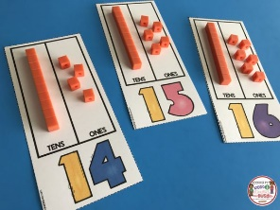  Partitioning number to 20:  Looking at the numbers 11-19. Think about how the number can be partitioned into tens and ones. i.e 12 is made up of 1 ten and 2 ones. Use numbers 11-19 partition them into tens and ones. You could use spaghetti as a ‘ten stick’ and pasta as ‘ones’ to represent the numbers.

Learning Project - to be done throughout the week
The project this week aims to provide opportunities for your child to learn more about countries and cities around the world. Learning may focus on different cultures and traditions, famous landmarks, food and clothing.

Flags
- Look at flags from around the world. Discuss which are your child’s favourites and why? Ask your child to design and make their own flag using 2d shapes.

Food Tasting
- Find some different foods/fruits from around the world and taste each one. These might include: pizza (Italy), curry (India) and taco (Mexican) or the fruits from the story Handa's Surprise. Your child can create a chart putting a tick next to each food they like and a cross next to the foods they dislike over the course of the week.

Pleasing Puppets
- Make your own Handa’s Surprise character puppet.

Where in the World?
- Discuss with your child where your family comes from in the world. If you have them available, show your child photographs of where you, or their grandparents, grew up. This might be similar to where they live now or completely different. Encourage your child to think about the differences between the places. Share your family photographs on Twitter at #TheLearningProjects so children can compare their own family origins with others.
- Compare pictures of a variety of people, including some from different cultures. Discuss how people can look different (hair, skin, eyes) but how everyone is the same inside and everyone is important. Can they think of anyone in their class who may look different to them for any reason? Discuss how this doesn’t make them any more or any less special than anyone else. The story of Elmer is great for representing this.

Mindfulness
- Help your child find a safe space where they can lie down quietly with their eyes closed for a few minutes (this is a lovely activity to do outside if the weather is good).
- Ask them to take a few deep breaths to relax their body. Tell them to imagine they are on a magic carpet that can fly anywhere in the world. Where would they like to go? Will it be somewhere warm, or somewhere cold, or maybe they would like to travel into space. Encourage your child to imagine how it feels as the magic carpet lifts them off the ground and up into the sky. Can they feel the wind on their skin, hear the birds flying past or sense damp clouds moving close by? Tell them the magic carpet is now flying closer to the ground near their chosen destination. Ask them to imagine looking down over the edge of the carpet. What can they see? What can they hear? How does it make them feel?
- Encourage your child to take slow, deep breaths as they carry on their magical journey for as long as they like.
- If your child finds it difficult to close their eyes and imagine somewhere else in the world, you could show them some photographs, or pictures in a book, and then try the activity again.

STEM Learning Opportunities #sciencefromhome
Engineering Around the World – Bridges
- A bridge helps people move over obstacles like a river, a valley or a busy road. The world’s longest bridge is in China and is 164.8km long. It would take more than two days to walk the length of this bridge. Do you have any bridges near your home? What do they look like?
- Try building a bridge out of paper, Lego or any other building materials you might have at home. Your bridge needs to be big enough for a toy car or small toy to travel over.
Additional learning resources parents may wish to engage with
White Rose Maths online maths lessons. Watch a lesson video and complete the worksheet (can be downloaded and completed digitally).
Numbots. Your child can access this programme with their school login.
IXL Click on Maths, Reception. There are interactive games to play and guides for parents.
Talk for Writing Home-school Booklets are an excellent resource to support your child’s speaking and listening, reading and writing skills.
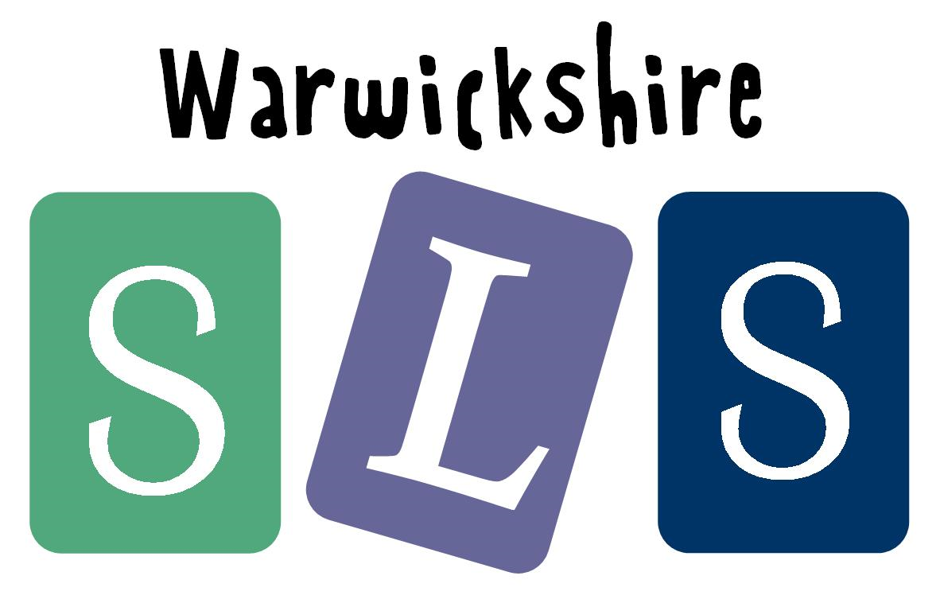
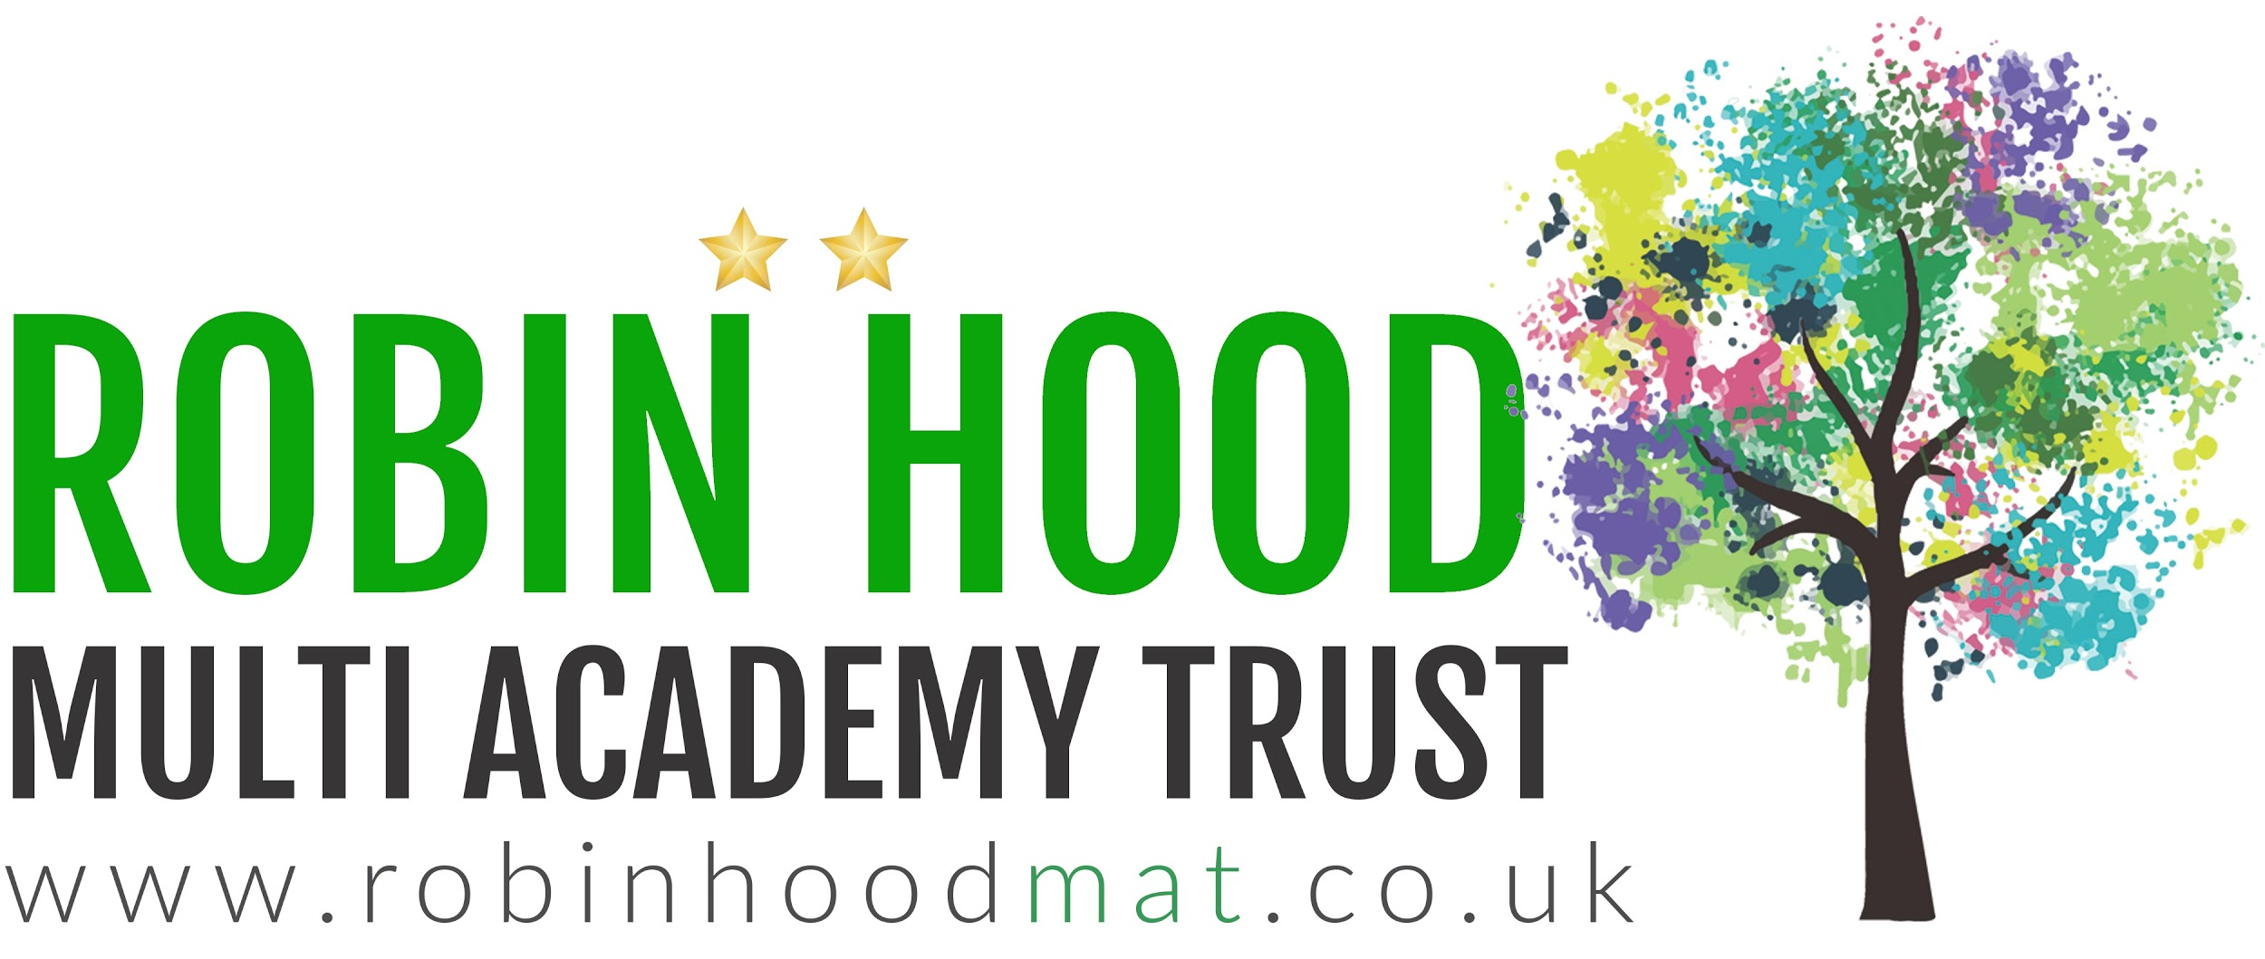
www.robinhoodMAT.co.uk

