Learning Project – Sport
Online
Age Range: KS1
Staying active is really important when you are at home. There are lots of resources, here are just a few to use!
Joe Wicks PE sessions
Go Noodle
Super movers!
Cosmic Yoga
Weekly Reading Tasks | Weekly Phonics Tasks
Monday- Provide your child with a bag and ask them to collect items to go in it that relate to a well-known story. If they can’t find an item, they could draw a picture instead. Ask them to use the objects in the story bag to retell the familiar story. | Monday- The word ‘sport’ contains the sound ‘or’. Ask your child to list as many words as they can containing the ‘or’ sound. Your child might identify words that contain an alternative spelling for ‘or’ such as oor/ore/aw/au.
Tuesday- Talk to your child about a hero from a book they have read recently, for example the Prince from Rapunzel or Mulan. Ask them to draw the hero or heroes from a story and list adjectives to describe their appearance and personality. | Tuesday- Play the Solve, Shoot, Score spelling game on the Premier League Primary Stars. Encourage your child to write down the words spelt and add sound buttons.
Wednesday- Your child can listen to the Cbeebies story ‘Martin the Mouse’ (click here). Ask your child to record the main events from this sporty story. They can draw the events, write sentences or even retell the story orally in their own words. | Wednesday- Ask your child to list words to describe athletes or their sporting hero such as Mo Farah, Lionel Messi or Venus Williams. For example, strong, winner, speedy. Can they use these words to write descriptive sentences about athletes?
Thursday- Ask your child to choose and read a healthy recipe from a recipe book. If you have the ingredients, why not follow the recipe together? | Thursday- Your child could visit Phonics Play and play this Sentence Substitution game. Or practise your weekly spellings.  Year 1 Spellings Year 2 Spellings  dolphin sure  alphabet sugar  photo eye  elephant should  when would  wheel could  what who  where whole  why any  who many
Friday- Watch and listen to ‘The Little Princess: I Want to Win’ based on the Tony Ross book. Talk to your child after this about how the Little Princess felt each time she won a game. Can they think of a time they felt like the Little Princess? | Friday- Ask your child to add the ‘ing’ suffix to these verbs: jump, skip, hike, throw, catch, kick, smile, run & shout e.g. jump + ing = jumping. Which root words need the ‘e’ removing first? Which words need to double the last consonant?
Weekly Writing Tasks | Weekly Maths Tasks- Position and Direction  Choose a task or tasks from each day. These are to be used flexibly
Monday- Has your child got a favourite sportsperson? This could be their P.E. teacher! Ask them to write an information booklet about this person. | Monday- Play a board game together like Snakes and Ladders so that your child can practise their counting and the language of position and direction.  As an extra challenge – why not create a board game one of your own based on a Sports Theme or a topic of your choice?  White Rose Maths online daily maths lessons  Bitesize Maths online daily maths lessons  CODE Maths Hub Daily Fluency Activities - Day 1 Week 4
Tuesday- Ask your child to think of questions they’d love to ask their favourite athlete. They could write a list of questions using a range of questions words such as ‘when’, ‘why’, ‘who’, ‘what’, ‘where’ and ‘how’. Your child could then answer their own questions in the role as their hero. | Tuesday- Create your own maze by drawing or making one. Place an object on the ground and use positional language such as forward, backwards, up, down, left and right, quarter turn, half turn etc to direct them to the object. Then switch roles and get your child to give the directions.  White Rose Maths online daily maths lessons  Bitesize Maths online daily maths lessons  CODE Maths Hub Daily Fluency Activities - Day 2 Week 4
Wednesday-.Visit the Literacy Shed for this wonderful resource on The Catch or your child could write their own sporting story featuring their hero. | Wednesday (theme)- Play ‘Catch’ with your child using a ball or anything else that can be thrown safely. Instead of counting in 1s each time the ball is caught, ask your child to only count every second, fifth or tenth catch.  As an extra challenge start on 20 and count back in 2s, start on 5 and count back in 5s and 100 and count back in 10s.  White Rose Maths online daily maths lessons  Bitesize Maths online daily maths lessons  CODE Maths Hub Daily Fluency Activities - Day 3 Week 4
Thursday- Can your child design a poster all about teamwork? This could be linked to your family and how you all have to work together as a team. | Thursday- Encourage your child to play this NRICH activity to develop their understanding of positional language.  White Rose Maths online daily maths lessons  Bitesize Maths online daily maths lessons  CODE Maths Hub Daily Fluency Activities - Day 4 Week 4
Friday- Ask your child to design a gold medal and present it to somebody deserving within the household. Why have they chosen this person? Ask them to write a few sentences and include the word ‘and’, ‘because’ and ‘if’. | Friday (theme)- Get in the Sports Theme and have a family long jump competition. Ask your child to measure the length of each jump using household objects to start with such as clothes pegs or lego progressing to a standard uit such as measuring tape. Record the lengths using the different units. Who jumped the furthest? Who had the shortest jump? What was the difference between the shortest and longest jump?  White Rose Maths online daily maths lessons  Bitesize Maths online daily maths lessons  CODE Maths Hub Daily Fluency Activities - Day 5 Week 4

Learning Project - to be done throughout the week
The project this week aims to provide opportunities for your child to learn more about sports and games. Learning may focus on the history of sport, sporting-heroes, physical challenges and performance.

- Obstacle Course Fun- Task your child with designing and making their very own obstacle course in the garden. Ask them to draw and label their design first and include all of the equipment they need. They can then use their design to create their obstacle course. Ask the family to complete the obstacle course whilst your child times them. Your child could even make medals from tin-foil or any other suitable material and present them to the winner during a winner’s ceremony.

- Make a Family Mascot- Your child could make their very own family mascot using materials from around the house. First of all, visit the Olympic Mascot Official list here and look at past mascots. What makes a good mascot? What qualities does the mascot represent?

- Remarkable Routines- Can your child create their very own simple routine, just like a gymnast, dancer or synchronised swimmer? Start by watching a video of a routine together, here are some suggestions: men’s gymnastic routine, synchronised swimming routine. After this, your child can choose a piece of music to practise their routine to. When they are confident, why not film your child’s sequence and share it online using #TheLearningProjects.
Watch the performance together- what does your child think went well? What could be even better?

- Terrific Team Kits- Ask your child to design their very own team kit. They should consider the flag of the country that they would represent and how to incorporate these colours into the design. They could draw the design with a pencils/pens/paint or use a computer program to do this.

- Can you Invent a New Olympic Game?- Challenge your child to invent their very own game for the 2021 Olympics. Look at a list of all of the sports that already compete in the summer Olympics here. Can they write a set of instructions for the new game or draw illustrations. Why not test the game out as a family?

- Mindfulness - This week we will bring our attention to different parts of our body.
After your child has done something energetic, like dancing or kicking a ball around your garden, have them take time to lie down with their hands on their chest. Ask them to close their eyes and tune into the feeling of their heart pumping and their chest rising and falling with each breath. Now ask them to bring their attention to their toes, feeling into their little toes and across to their big toes. You might need to gently place your hand on that part of their body to help them feel where they need to focus. Now ask them to bring their attention up to their ankles, then their calves, shins, knees, etc. Keep guiding them to gradually bring their attention in an upwards direction. When they get back to their chest, ask them to again tune into the beating of their heart and the feeling of their breath. Have them remain here, just breathing and staying still, for about 3- 5 minutes.
STEM Learning Opportunities #sciencefromhome
Brilliant Bodies
- What can your body do? Balance on one leg? Touch your nose with your tongue? Look at the Body Challenge Cards and see how many you can do. Ask your family to join in and make your own body challenge cards.
- The complete resource can be downloaded here.
Additional learning resources parents may wish to engage with
- The NHS Change 4 Life website has some great games and activities, specifically ones for staying indoors. Have a look here.
- For lots more clips, activities and ideas to get active visit the sport’s section on the Cbeebies website
- Maths
- Times Table Rockstars and Numbots. Your child can access both of these programmes with their school logins. On Times Table Rockstars, children should aim to play Soundcheck for 20 minutes daily.
- CODE Maths Hub Daily Fluency Activities - Week 4
- https://www.topmarks.co.uk/maths-games/daily10 - arithmetic challenges
- IXL- Click here for Year 1 or here for Year 2 . There are interactive games to play and guides for parents.
- White Rose Maths online maths lessons.
- BBC Bitesize - Lots of videos and learning opportunities for all subjects.

- Classroom Secrets Learning Packs - Reading, writing and maths activities for different ages.
- Twinkl - Click on the link and sign up using your email address and creating a password. Use the offer code UKTWINKLHELPS.
- Y1 Talk for Writing Home-school Booklets and Y2 are an excellent resource to support your child’s speaking and listening, reading and writing skills.
#TheLearningProjects
in collaboration with
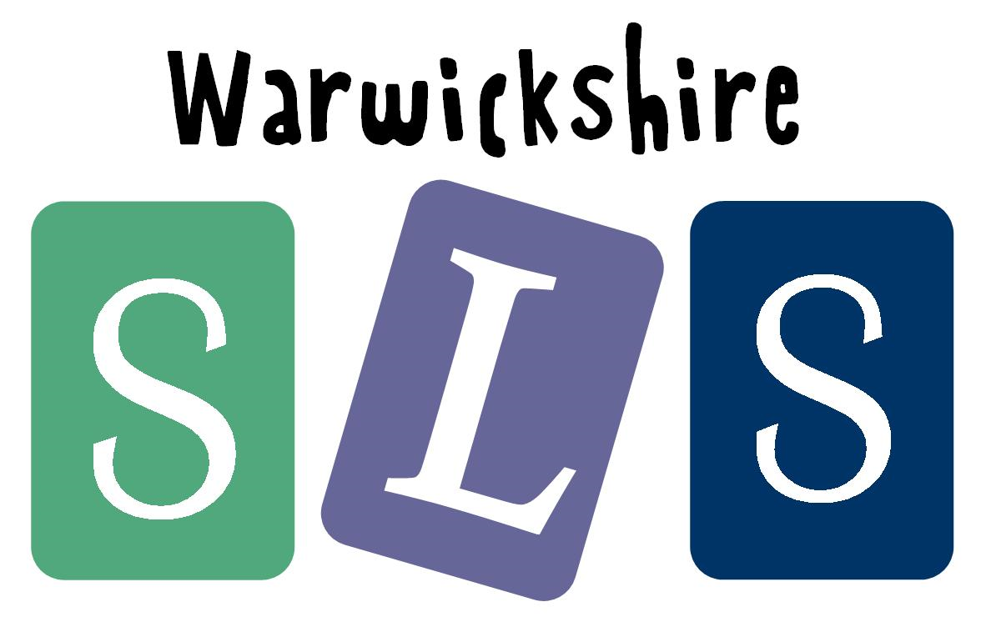
www.robinhoodMAT.co.uk

