Learning Project - Around the World- Online Week 12
Age Range: Y5/6
Staying active is really important when you are at home. There are lots of resources, here are just a few to use!
Joe Wicks PE sessions
Go Noodle
Super movers!
iMoves
Cosmic Kids Yoga
Weekly Reading Tasks | Weekly Spelling Tasks
Year 5 | Year 6
laughable | eligible
enjoyable | illegible
valuable | morning
breakable | mourning
agreeable | decent
miserable | descent
reliable | dessert
available | desert
passable | stationary
impassable | stationery

Monday- Encourage your child to read the world news section of a newspaper. Discuss with them what they have found out. | Monday- Challenge your child to complete an alphabetical list of cities from around the world. Where possible, include capital cities.
Tuesday- https://www.oxfordowl.co.uk/library-page?view=image&query=&type=book&age_group=Age+9-11&level=&level_select=&book_type=&series=#  Choose some Grimm Tales for a fun read! | Tuesday- Ask your child to record the meaning, an example sentence using the word, associations, synonyms (word with the same/similar meaning), antonyms (word that has the opposite meaning) and a dictionary definition of the following words: appreciate, guarantee and occupy.
Wednesday- Click here for a reading activity about The Lost World. Challenge your child to read the text in 3 minutes and complete the questions. | Wednesday- Can your child complete this prefix challenge from Talk for Writing? Ask your child to choose 5 words and apply them into different sentences.
Thursday- Ask your child to read an age-appropriate story from another culture. This could be from their own collection, Google Books or Oxford Owl. | Thursday- Ask your child to mind map words they associate with Birmingham and words they associate with Johannesburg (see here). This will support a later task.
Friday- Ask your child to summarise a book they’ve read this week in 100 words. Alternatively, they could summarise the main events in the form of a cartoon strip. | Friday- Pick 5 Common Exception words from the Year 5/6 spelling list. Task your child with choosing 4 words that have something in common and an odd one out.
Weekly Writing Tasks | Weekly Maths Tasks- Multiplication and Division  Choose a task or tasks from each day. These are to be used flexibly
Monday- Visit the Literacy Shed for this wonderful resource on The Blackhat or your child write a description about their ideal world. | Monday- Get your child to test their times table knowledge by finding the products and factors in this game. Can they work through all of the levels?  White Rose Maths online daily maths lesson  Bitesize Maths online daily maths lesson  CODE Maths Hub Daily Fluency Activities - Day 1 Week 7
Tuesday- Your child can pick a city of choice and create a travel leaflet all about it. Make sure that they include information on: weather, travel time, key tourist spots, accommodation and the local cuisine. | Tuesday- Play multiplication war with your child with a deck of cards. Flip two cards over and multiply. Whoever has the highest product keeps the cards. Ask your child what the inverse division fact would be. Use 3 cards as a challenge.  White Rose Maths online daily maths lesson  Bitesize Maths online daily maths lesson  CODE Maths Hub Daily Fluency Activities - Day 2 Week 7
Wednesday- Listen to Zahra. Discuss what the story is about and how we know Zara is from a different country. Ask your child to rewrite the story of Zahra. | Wednesday- Play Multiplication War (not including Jacks, Queens and Kings) but this time each player picks up 6 cards.  Create your own x calculations where 4 digits are multiplied by 2 digits and solve.  i.e. 4793 x 21 =  Again the person with the highest product (answer) wins. You may also want to use a calculator to check your answers for this activity.  White Rose Maths online daily maths lesson  Bitesize Maths online daily maths lesson  CODE Maths Hub Daily Fluency Activities - Day 3 Week 7
Thursday- Use the story of Zahra to ask your child to create an advert to support WaterAid. What persuasive language could they use? How could they make their advert eye-catching? | Thursday Y5 Other Reinforce your understanding of equivalent fractions, decimals and percentages by playing this game.  Y6 Measures Activity – look at tins and packages from around the home. Try and order the measures from smallest to largest. As an extra challenge you may want to convert the grams into kilograms.  White Rose Maths online daily maths lesson  Bitesize Maths online daily maths lesson  CODE Maths Hub Daily Fluency Activities - Day 4 Week 7
Friday- Ask your child to create a poster which will assist younger children to learn about where the continents, particular countries and oceans of the world are. It must provide key facts and an imaginative layout/design to get children to learn where key places are around the world. | Friday (Theme) Complete the Maths Challenges based on Around the World in 80 days by the cyclist Mark Beaumont. These can be found on Twinkl website.  White Rose Maths online daily maths lesson  Bitesize Maths online daily maths lesson  CODE Maths Hub Daily Fluency Activities - Day 5 Week 7

Learning Project - to be done throughout the week
The project this week aims to provide opportunities for your child to learn more about countries and cities around the world. Learning may focus on different cultures and traditions, famous landmarks, food and clothing.

- Flags of the World- Flags are a national symbol for all countries. Cultures use different symbols and colours on their flags which are meaningful to them and represent their history and people. Ask your child to pick 5 countries and investigate their flags. What symbols and colours have they used? Why are these significant to this country? Can your child create a flag for the UK which they feel represents our culture, history and people? Can you investigate the Cornish Flag? What does the black and white signify?

- Tastes of the World- Children all around the world eat a variety of food and many of the foods we eat today are inspired by other countries. Can your child research and make a dish from another country which they have not tried before? They could find a recipe, source the ingredients via an online shop and follow the recipe to create a dish for the whole family.

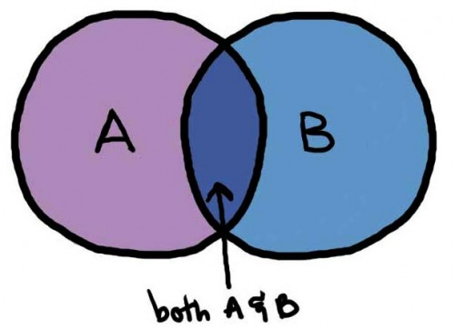
- International Games- As part of the London 2012 Olympics a variety of countries were asked to name a traditional game which represented their culture and traditions. These can be seen here. Ask your child to research these games and take inspiration from them to design their own game. Encourage your child to think about how the game is played, how you win and what equipment is needed. Where possible, they should test their game and make any changes needed. Ask them to present their game through writing and pictures. These could be handwritten or digital.

- From Birmingham to Johannesburg to Cornwall- Direct your child to think about what it would be like to live in another country. Do they think their life would be the same or completely different? Use the following clip to compare living in Birmingham to Johannesburg. Make notes on living in Johannesburg. Ask your child to show the similarities and differences between their life in Cornwall and Nwabisa’s life in South Africa. They may wish to show this in a Venn diagram, table or a poster.

- Exploring the World- Throughout history many people have explored new places. You can find out about some of them here. Ask your child to pick an explorer from the list or one of their choice. They could map out the places that the explorer visited or they could create a piece of art inspired by the places they visited using digital images as support. They may wish to write a diary entry from the explorer’s point of view to share what they have seen and experienced.

- Mindfulness
Find a safe space where you can lie down quietly with your eyes closed for a few minutes (this is a lovely activity to do outside if the weather is good). Get comfortable and take a few deep breaths to relax your body. Imagine you are on a magic carpet that can fly anywhere in the world. Where would you like to go? Think about how it feels as the magic carpet lifts you off the ground and up into the sky. Can you feel the wind on your skin, hear the birds flying past or sense damp clouds moving around you? Imagine how this feeling changes as the magic carpet flies back down closer to the ground near your chosen destination. You are now looking down over the edge of the carpet. What can you see? What can you hear? How does it make you feel?
Continue to take slow, deep breaths as you carry on your magical journey for as long as you like.

STEM Learning Opportunities #sciencefromhome
Engineering Around the World – Telescopes
- The James Webb telescope will be the largest, most powerful and complex space telescope ever built and launched into space in 2021.
- The telescope will be launched into space using a rocket, this means it will have to be strong enough to withstand the vibrations during the launch. Use an egg to represent the telescope and design a rocket that will surround and protect the egg/telescope during the launch.
- For more information and ideas look here.
Additional learning resources parents may wish to engage with
- Times Table Rockstars and Numbots. Your child can access both of these programmes with their school logins. On Times Table Rockstars, children should aim to play Soundcheck for 20 minutes daily.
- IXL online. Click here for Year 5 or here for Year 6. There are interactive games to play and guides for parents.
- CODE Maths Hub Daily Fluency Activities - Week 7
- https://www.topmarks.co.uk/maths-games/daily10 - arithmetic challenges
- BBC Bitesize - Lots of videos and learning opportunities for all subjects.
- Y5 Talk for Writing Home-school Booklets and Y6 are an excellent resource to support your child’s speaking and listening, reading and writing skills.
#TheLearningProjects
in collaboration with
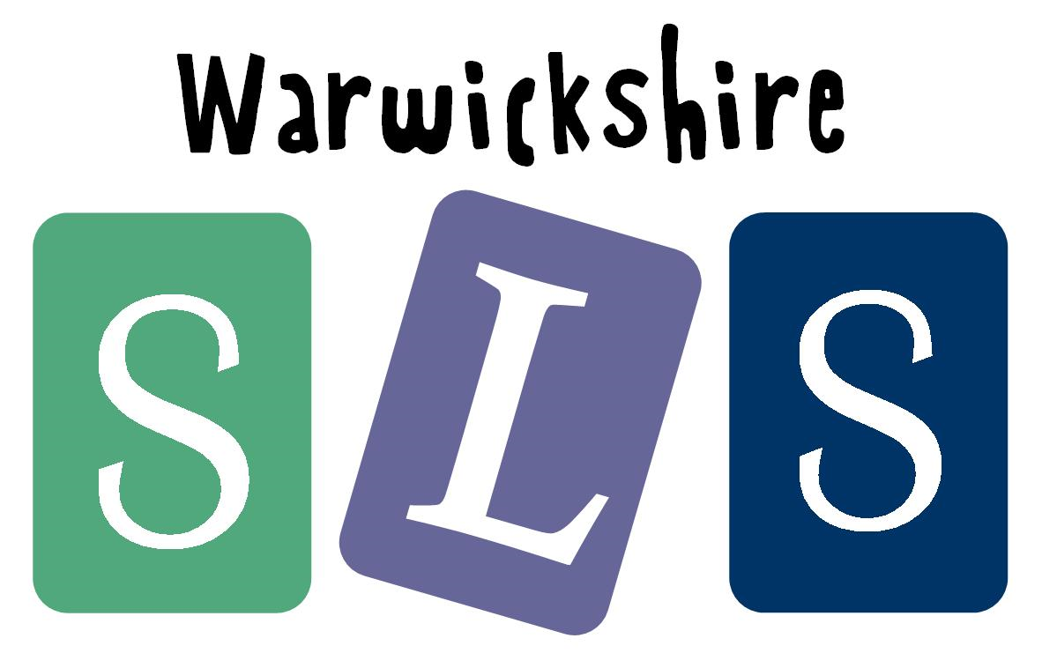
www.robinhoodMAT.co.uk

