Learning Project - Space
Age Range: Y5/6
Staying active is really important when you are at home. There are lots of resources, here are just a few to use!
Joe Wicks PE sessions
Go Noodle
Super movers!
iMoves
Cosmic Kids Yoga
Weekly Reading Tasks | Weekly Spelling Tasks
Year 5 | Year 6
dependable | yew
comfortable | ewe
understandable | side
reasonable | sighed
countable | heard
deliverable | herd
disagreeable | piece
suitable | peace
portable | leek
enjoyable | leak
Remember to practise your spellings on sumdog
Monday- Task your child with reading unusual things in unusual spaces e.g. a recipe book in the bath. How many unusual spaces can they find over the week? Send your favourite one to your teacher on Seesaw! | Monday- Pick 5 Common Exception words from the Year 5/6 spelling list here. Challenge your child to create a word web by finding 5 other related words.
Tuesday- Read the activity here about Space Tourism. Write down as many unknown words as you can find and find out their meaning using a dictionary. | Tuesday- Encourage your child to organise these synonyms from slowest to fastest: quickly, speedily, swiftly, hurriedly & in a flash. Which best describes a rocket launching into space?
Wednesday- Click here to re-read the article about Space Tourism. Challenge your child to read the text fluently and accurately and complete the questions. | Wednesday- Some words contain the letter string -ough- Can your child use this knowledge to complete these sentences against the clock?
Thursday- Ask your child to listen to or read along to the poem Cosmic Disco. What does your child think is the main idea in the poem? Ensure that they give a reason for their response. | Thursday- Task your child with identifying any space related words from the poem Cosmic Disco. Can they draw illustrations to represent these words too?
Friday- Encourage your child to research information on past space expeditions here. Which expedition do they think was the most impressive? Why? | Friday- Get your child to proofread their writing from the previous 2 days. Encourage them to use a dictionary to check the spelling of any words that they found challenging.
Weekly Writing Tasks | Weekly Maths Tasks-Shape, Area and Perimeter  Choose a task or tasks from each day. These are to be used flexibly
Monday - Create a comic strip retelling Armstrong's mission to the moon. Look at as much information as you can find out and put in facts and feelings into the comic strip. You could create you own comic strip or use a template from here! | Monday  Look at the Polygon poster below to support your understanding of irregular / regular polygons.  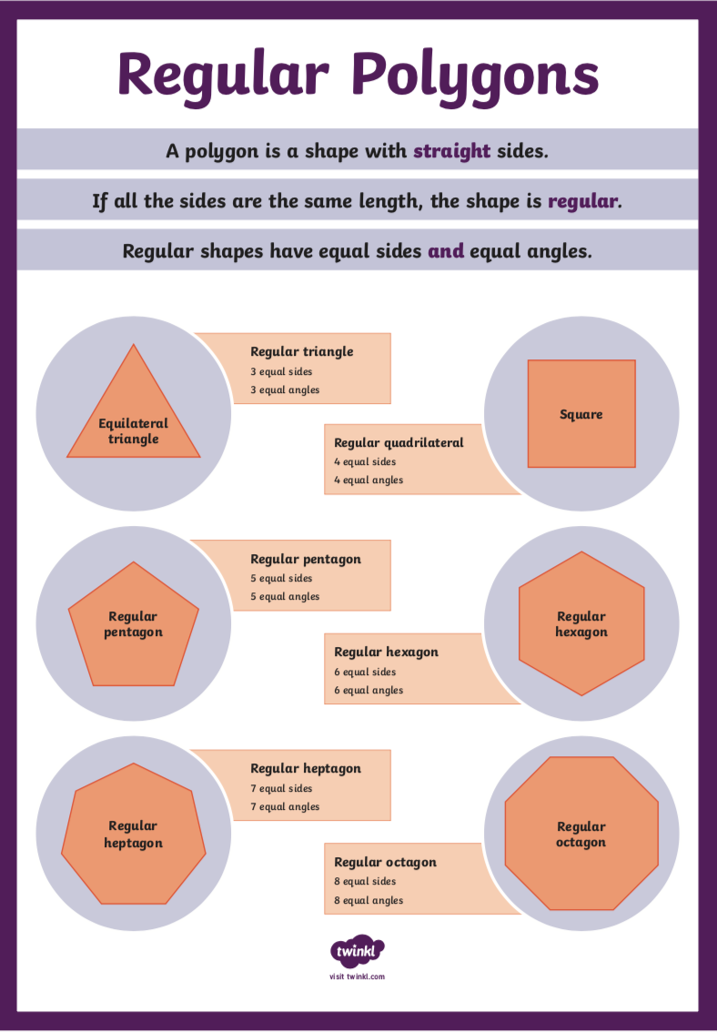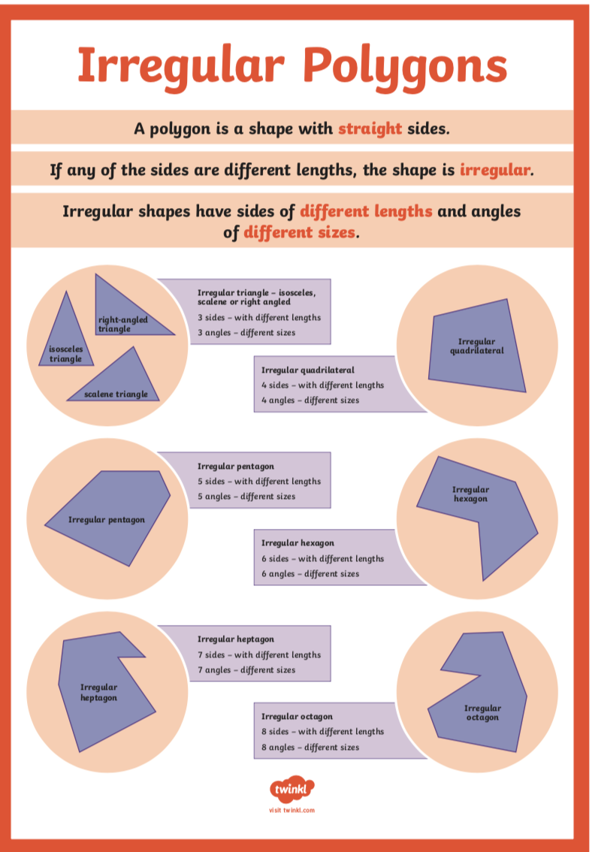  From this either create your own polygon ‘Planet or Planet Scene’ picture or jigsaw linked to our Space topic.  White Rose Maths online daily maths lesson  Bitesize Maths online daily maths lesson  CODE Maths Hub Daily Fluency Activities - Day 1 Week 9
Tuesday- Ask your child to pretend they have woken up to find an alien at the end of their bed. Draw it! What does it look like, sound like, smell like? Try and use as many senses as you can when you are drawing your alien. Then write a detailed description of the alien thinking about language you could use to describe its size, appearance and the sounds it makes. | Tuesday - Go for a 3D shape hunt around your home.  Practise sorting them by the type of shape. You may then want to sort them further by sorting them into categories based on number of faces, vertices and edges.  Practise sorting 3D shapes by playing these games listed below.  3D Shape sorting Venn diagram  3D Shape Sorting Carroll diagram  White Rose Maths online daily maths lesson  Bitesize Maths online daily maths lesson  CODE Maths Hub Daily Fluency Activities - Day 2 Week 9
Wednesday- Get your child to imagine that they are a news reporter, reporting on this alien visit. They can plan a newspaper report. Remind your child of the features of a newspaper. | Wednesday - Practise your understanding of cube nets by playing this game  Practise your understanding of different nets of 3D shapes by playing this game  (level 2)  White Rose Maths online daily maths lesson  Bitesize Maths online daily maths lesson  CODE Maths Hub Daily Fluency Activities - Day 3 Week 9
Thursday- Looking back to the plan from the previous day, ask your child to write up their newspaper report. They could either design the page or they could write it up on a laptop, Chromebook or PC. Remind your child to think about their spelling and punctuation as well as using a variety of sentence types.  Share your child’s report with their teacher using Seesaw. | Thursday - Practise your understanding of area by playing this area and perimeter challenge game  Create your own target numbers (which are even).  Decide if you are going to focus on the perimeter / area or both  Explore creating your own shapes (composite) using 2 or more rectangles.  (However, you may want to start by drawing one rectangle at first to practice this game).  Don’t forget to include your units of measure such as cm.  For rectangles  Remember perimeter = 2( length) + 2(width ) or 2( length + height )  Area = length x width = __ cm or __m ( squared)  If you have a ruler at home, you may want to practise drawing these to scale.  White Rose Maths online daily maths lesson  Bitesize Maths online daily maths lesson  CODE Maths Hub Daily Fluency Activities - Day 4 Week 9
Friday- Ask your child to create a travel brochure for a newly discovered planet. Consider: travel time, location, accommodation and things to do and see.  Either make up a template for the brochure, or you could use one from here! | Friday-  Practise your understanding of area and perimeter by doing this investigation  Practical Activity  Your child could make a map of a newly discovered planet. Provide them with a grid drawn onto paper. Each square on the map represents 5 metres squared (m²). It must include: mountains which have an area of 220m², a water source 140m², three islands that must each be between 120m² and 240m². They can also add some other features and be as creative as they want to be!  White Rose Maths online daily maths lesson  Bitesize Maths online daily maths lesson  CODE Maths Hub Daily Fluency Activities - Day 5 Week 9

Learning Project - to be done throughout the week
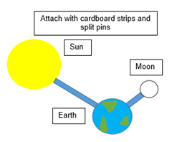
The project this week aims to provide opportunities for your child to learn more about space. Learning may focus on our Solar System, the Sun and the Moon. It could look at life in outer space from the view of an astronaut and travelling through space.

- Moon Moves - Get your child to research the importance of the Moon to life on Earth. Ask your child to research the movement of the Moon relative to the Earth and create a model of the Earth, Moon and Sun. Here is an idea of how your child could do it.

- Through Space and Time- Ask your child to research space exploration history and create a timeline of how people have travelled into space. Get them to think about when the first rocket was launched? When did the first man travel to space? How about the first woman? What other significant events can they add to their timeline?

- What’s the order of the planets?- Create a poem or rhyme to remember the order of the planets. An example of one is:
My - Mercury
Very - Venus
Easy - Earth
Method - Mars
Just - Jupiter
Speeds - Saturn
Up - Uranus
Naming - Neptune
(Planets) – Pluto (Now considered to be a dwarf planet)

- Dancing into Space- Listen to Holst’s 'The Planets' with your child. Ask them to select a planet and decide what they think that planet would be like. Get them to create a dance/ set of movements to go with the music which will portray this. Take a video of their dance to share with the family and encourage your child to self-evaluate whilst watching the video.

- Mission to Space- Get your child to research the different components of a spacecraft and using their understanding of this, design their own spacecraft. Get them to think carefully about what it needs to include in order for astronauts to survive in space. Can they make a small scale model using resources from around the home? There might be inspiration here.

- Mindfulness - To link to the space theme, how about making some space artwork you can use as a relaxation tool. You could paint a starry night picture or create a spaced themed dream catcher or mobile. Find somewhere to di splay your artwork so you can lay down underneath, or sit close by, and gaze at the stars. If you made a dream catcher or a mobile, you could hang it outside so it will move with the breeze. Now keep your body and your mind still. Focus on watching the stars move and the feeling of your breath entering and leaving your body. Just keep breathing. Long, slow breaths. Try to build some mindfulness time into your daily routine. A little bit everyday goes a long way.
STEM Learning Opportunities #sciencefromhome
Mission X – Building a Bionic Hand
- It is difficult and tiring for humans to work in space. Bionic hands that can be remotely operated can help humans work more efficiently in space. Try making a model bionic hand using cardboard, straws, string and elastic bands. You will need to think about how a human hand works to help you with your design. You can find out more here.
- Sign up and access all of the Mission X resources here.
Additional learning resources parents may wish to engage with
- Times Table Rockstars and Numbots. Your child can access both of these programmes with their school logins. On Times Table Rockstars, children should aim to play Soundcheck for 20 minutes daily.
- IXL online. Click here for Year 5 or here for Year 6. There are interactive games to play and guides for parents.
- CODE Maths Hub Daily Fluency Activities
- https://www.topmarks.co.uk/maths-games/daily10 - arithmetic challenges
- BBC Bitesize - Lots of videos and learning opportunities for all subjects.
- Y5 Talk for Writing Home-school Booklets and Y6 are an excellent resource to support your child’s speaking and listening, reading and writing skills.

#TheLearningProjects
in collaboration with
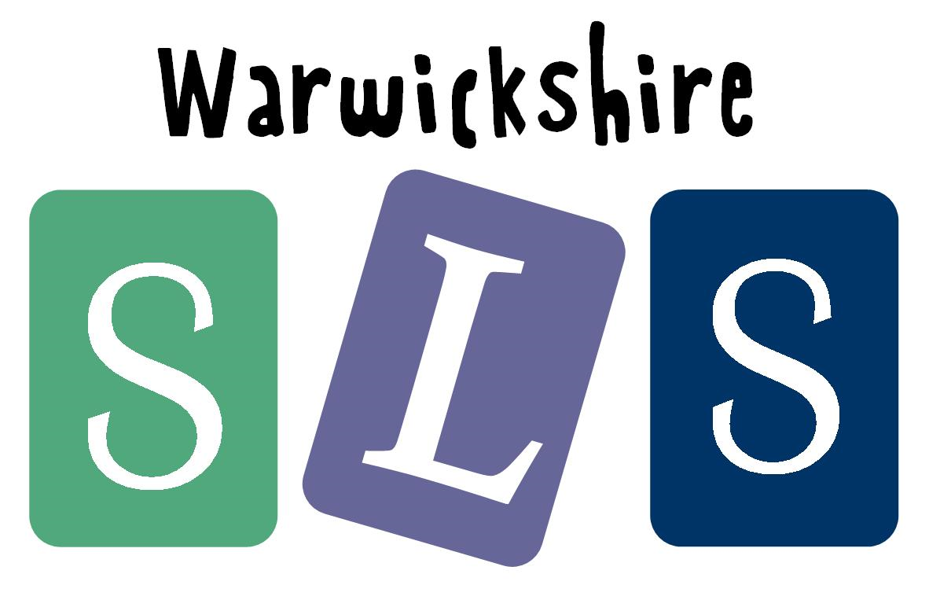
www.robinhoodMAT.co.uk

