Learning Project WEEK 1- My Family
Age Range: Reception
Staying active is really important when you are at home. There are lots of resources, here are just a few to use!
Go Noodle
Super movers!
Cosmic Yoga
Weekly Maths Tasks (Aim to do 1 per day) | Weekly Reading Tasks (Aim to do 1 per day)
MATHS FOCUS: Numbers 11-15 (understanding that they are made up of 1 ten and some ones).  Watch a Numberblocks clip each day at: BBC or CBeebies. Use this guide here to give you ideas on what to do with your children whilst watching an episode. Focus on numbers 11-15.  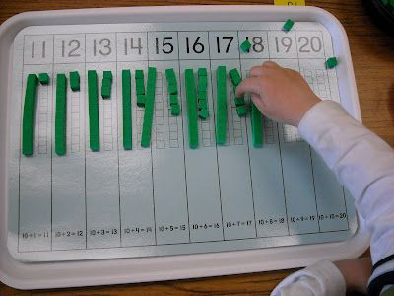  - Show children visualisations of teen numbers using natural resources (11 = 10 + 1 more and the 1 goes in the ones part of the number)  - Work on Numbots - your child will have an individual login to access this.  - Practise counting up to 20 and beyond 20. This can be done through playing hide and seek, singing number songs, chanting, board games etc. Ensure that the children are pronouncing all numbers correctly, especially teen numbers.  - Write out the digits 0 - 9. There are some sheets here that could help you.  - Practise recognising amounts up to five or up to ten by playing these games. This can be done by reading a dice when playing board games, playing with cards, identifying how many food items on the plate etc.  - Sing Number songs to practice counting, reciting numbers in order, one more, one less using number songs: Five Little Ducks, Five Little Men, Ten Green Bottles  - White Rose have got lots of activities for children in the Early Years to complete. Have a go at some of them. If you need to record anything, write or draw it in your home learning book. | - Tune in daily to Ruth Miskin’s phonics lessons on YouTube (times have been put on Tapestry so that you are challenging your child). This is crucial to support your child’s fantastic phonics progress already. After these sessions, practise writing words with the special friend that you have learnt, pinching the sounds on your fingers. Your child will explain to you, as they do this daily.  - Read a variety of books at home. Favourites can be repeated. Hearing the patterns of language in a story will support your child’s language development.  - Children to read to parents daily. Visit Oxford Owl for free eBooks that link to your child’s book band. You can create a free account.  Complete the linked Play activities for each book.  - Listen to a story being read: Story line and CBBC Bedtime stories.  - Listen to different David Walliams books here!  - Listen to a range of free books on audible.  - With your child, look in magazines, newspapers and books for the tricky words they are currently learning. They could use a highlighter, pen or pencil to highlight in magazines and newspapers.  Red words of the week:  I, to, the, into, go, no, so. Talk about the ‘tricky’ (non-decodable) parts of the words. E.g.; no is tricky because the o sounds like ‘ow’ and not the phonic sound ‘o’.
Weekly Phonics Tasks (Aim to do 1 per day) | Weekly Writing Tasks (Aim to do 1 per day)
- Sing Nursery Rhymes and songs together. Add in actions and change the words. Can children think of different rhyming words to add in? Repeat old favourites and learn new rhymes. You can find an A-Z of Nursery Rhymes here.  - Daily phonics - Practise the sounds your child is working on and blend words. This can be oral blending (e.g. spoken out loud c-a-t) or written if appropriate. See ‘reading’ part of document for more information.  - Interactive games.  - Sing the song ‘Daddy Finger’- Can your child change their voice for each person e.g. a deep voice for Daddy finger, a squeaky voice for Baby finger.  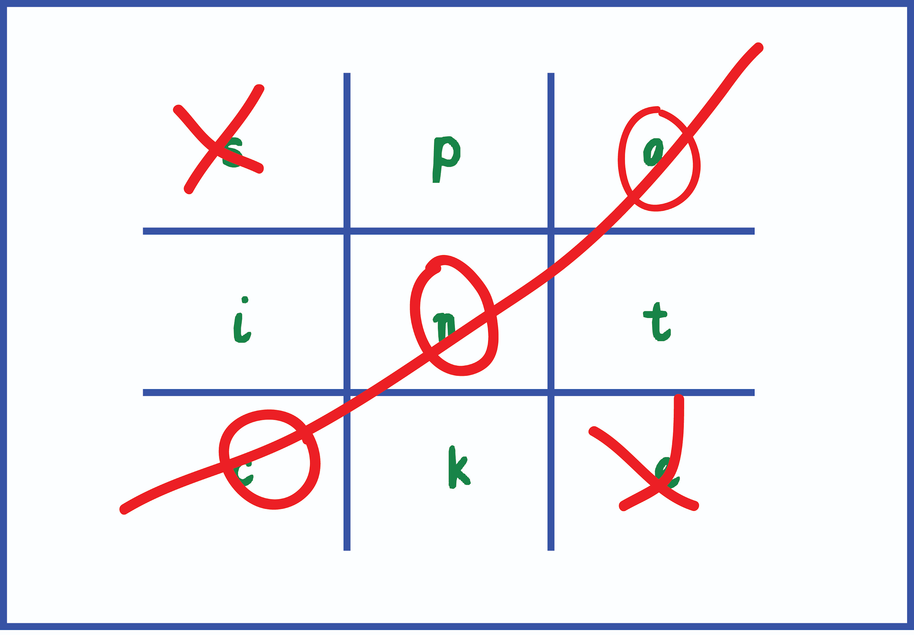  - Play phonics noughts and crosses. Draw out a grid and write a letter, digraph, trigraph or tricky word in each part of the grid. Take it in turns to name what is written in the grid. If you say it correctly you can add your nought or cross in that square. If you get three in a row, you are the winner! | Please do not get the children to copy words or sentences that you have written, as they will not learning anything from this. The children should be encouraged to use their phonics knowledge to ‘sound out’ words.  They can use ‘fred fingers’ to help them.  This clip will help you!  - Ask your child to draw a picture of the people who live in their house. If they share time across two houses, draw who lives in each house. Can they label their family members using their phonics knowledge? Can they write a sentence about their family using their phonics? Challenges: finger spaces, full stop, capital letters, correct letter formation.  - Practise FULL name writing. Can they write their first name? Middle name? Surname? Ensure that they are forming their letters correctly. This is very important.  - Do they know Mummy and Daddy’s real name? Use their phonics knowledge. Can they write this? Using chalks, crayons, paint, felt tips.  - Practise forming the letters of the alphabet. There are handwriting sheets on Twinkl to support you.  - Ask your child to write out the tricky words they are working on at the moment. If they write them on individual pieces of paper twice each, you can turn them into a matching pairs game.  This week’s tricky words are:  I, no, go, the, into, to
Learning Project - to be completed throughout the week
The project this week aims to provide opportunities for your child to gain a better understanding of their own family. Learning may focus on what different makeup of families, what traditions your family has, stories linked to your family etc.

- Look at a selection of family photographs and discuss the changes over time.
  - Show your child a photograph of them as a baby, a 1 year old, a 2 year old…
  - What could they do at that age? What can they do now that they couldn’t do then?
  - Look at a picture of a family member as a baby (this could be parents, siblings). Discuss how everyone was a baby once.
  - Are there any black and white photographs? Why are these photographs black and white? Do they show older family members when they were younger? Talk about how life was different then.

- Draw a family tree- How does your family link together? Can your child draw out their family members and link them together using lines? There are some templates you could use here!

- Do a picture survey of the people in your house. How many family members have blonde/ brown/ black/ red hair? Can you record this with pictures? How many people have blue/ brown/ green eyes? There are some ideas about how to create a pictogram here!

- Have a family picnic. Lay out a blanket in the living room or garden. Can children make sure everyone has a plate, fork, spoon, cup? How many do we need all together? Give your child a selection of food and ask them to share it fairly between everyone? If there is one left over what could we do?

- Sort out the clean clothes. Who do they belong to? Can they deliver them to the right place in the house? Pair up socks. Can they match the patterns/ colours? Can they count in twos to work out how many there are all together? Peg clothes on the airer (this will support children to develop hand strength which will impact on their writing).

- Put on a show or performance- Perform a story or song to your family. Plan out costumes, props. Children could make a show program.

- Lay the table for your family for dinner- How many people are there? How many knives, forks, cups do you need? Write out name cards for everyone in your family to show them where to sit. Write a menu to let them know what is for dinner that night. Roleplay as a waiter/ waitress. What would everyone like in their sandwiches for lunch? What drinks would everyone like to have with their dinner?

- Make a birthday card for the next family birthday- How old are they going to be? Can they write the numerals to show the correct age? Write a message inside for your family member and sign it with your name.

- What jobs do the people in your family do? Talk to your child about your job and what you do. What would they like to be when they grow up? Can they draw a picture of themselves in the job they would like to do?

- Use play dough to make your family members- Use readymade play dough or make your own using this recipe:
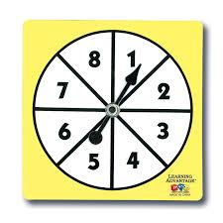
  - 2 cups of plain flour, one cup of salt, a tablespoon of oil, a cup of water (add gradually), a couple of drops of food colouring (optional), a teaspoon of cream of tartar (optional, but will make it last longer)

- Play a family board game- Play a game together. Talk about taking it in turns and playing fairly. Dice games will support your child’s number recognition. You could use a spinner with numerals on to help develop numeral recognition. If you don’t have a spinner you could make one using an old cereal box and a split pin.

- Find out everyone’s favourite song in your family- Listen to each person’s favourite song and make up a dance to match. Do you like the same music? What is your favourite song?

Additional learning resources parents may wish to engage with
Classroom Secrets Learning Packs - These packs are split into different year groups and include activities linked to reading, writing, maths and practical ideas you can do around the home.
Twinkl - to access these resources click on the link and sign up using your own email address and creating your own password. Use the offer code UKTWINKLHELPS.
Headteacherchat - This is a blog that has links to various learning platforms. Lots of these are free to access.

Thank you to all parents. Please pass this information onto parents who may not be able to access this. Please also refer to the front on your green home learning book for fantastic links to educational resources and your child’s Numbot account. We would love to see your hard work uploaded to Tapestry to keep us in the loop, or you can use the home learning book to record any work, which has been sent home!
Thank you,
Miss Guy.

