Learning Project - Music
Age Range: Y5/6
Staying active is really important when you are at home. There are lots of resources, here are just a few to use!
Joe Wicks PE sessions
Go Noodle
Super movers!
iMoves
Cosmic Kids Yoga
Weekly Reading Tasks | Weekly Spelling Tasks
Year 5 | Year 6
reinforceable | aggressive
noticeable | available
peaceable | bargain
pronounceable | criticize
replaceable | foreign
serviceable | individual
traceable | occupy
sliceable | leisure
danceable | rhyme
embraceable | immediately

Monday- During your child’s daily reading, play some classical music, rock music, jazz music and pop music. Ask your child to draw an emoji to represent how each music genre made them feel whilst they were reading. | Monday- Pick 5 Common Exception words from the Year 5/6 spelling list. Play a song and stop it at different points. When it stops, one spelling should be selected from a bag and your child must spell it before the music starts again.
Tuesday- Ask your child to find the lyrics to their favourite song and to create some new verses. Can they perform the new verses to the family? | Tuesday- The word rhythm has a silent letter - what other words can your child spell which also have silent letters?
Wednesday- Click here for a reading activity about Music. Challenge your child to read the text quickly and fluently and then complete the questions. | Wednesday- Practise spellings on Spelling Frame or practise spelling words with silent letters on this game.
Thursday- Your child can listen or read along to the poem Cat Rap here. Can they write their own version using a different noisy animal? | Thursday- Using the letters C A R N I V A L, task your child with listing associated adjectives or verbs that correspond with each letter.
Friday- Visit Audible and let your child choose a book to listen to. Ask them to write a review when they have finished listening to it and share their thoughts about it with a friend or relative (remotely). | Friday- Can your child create a musical glossary for the following vocabulary: dynamics, structure, timbre, texture & tempo.
Weekly Writing Tasks | Weekly Maths Tasks- Shape and Angles  Choose a task or tasks from each day. These are to be used flexibly
Monday- Visit the Literacy Shed for this wonderful resource on Once in a Lifetime. Read page 3 of the pack before you watch the clip and discuss the questions as you go through – there are no right over!  Once you’ve watched and talked about the clip, complete the activity on page 5 – job description! | Monday- Get your child to practise measuring and reading angles with a protractor with this online game.  This game is also good to play and you can choose to measure using a protractor or not.  White Rose Maths online daily maths lesson  Bitesize Maths online daily maths lesson  CODE Maths Hub Daily Fluency Activities - Day 1 Week 8
Tuesday- Listen to A Night on Bare Mountain by Modest Mussorgsky and the inspiration behind it. Ask your child to create a story with the title ‘A Night on Bare Mountain’ that reflects the emotions created by the music. | Tuesday-  Work with your child to find the missing angle in the triangles.  White Rose Maths online daily maths lesson  Bitesize Maths online daily maths lesson  CODE Maths Hub Daily Fluency Activities - Day 2 Week 8
Wednesday- Ask your child to create an information booklet about two contrasting pieces of music they have listened to. Include information about the instruments they have heard within each piece and a brief history on the musicians. | Wednesday- Ask your child to draw a map from their bedroom to the kitchen. Calculate the total degrees of turn involved on the journey.  Play this game to calculate finding angles around a point  White Rose Maths online daily maths lesson  Bitesize Maths online daily maths lesson  CODE Maths Hub Daily Fluency Activities - Day 3 Week 8
Thursday- Find the lyrics of a favourite song. Ask your child to change the lyrics of their favourite song into a short story. Alternatively, they could write and perform their own song. | Thursday-. Practise finding the missing angles on a straight line by playing this game.  Tip – click on the red part of the missing angle to give you your answer.  White Rose Maths online daily maths lesson  Bitesize Maths online daily maths lesson  CODE Maths Hub Daily Fluency Activities - Day 4 Week 8
Friday- Listen to 'Toccata and Fugue in D Minor'. Ask your child to think about what the setting might be and describe the atmosphere. Ask them to create two characters and think about what could be happening. Get them to write a short piece of dialogue between the characters that would go with this music. | Friday (theme)- Ask your child to create a rhythm by clapping/clicking, e.g. clap, clap, clap, click, clap, clap, clap, click etc. Ask your child to predict what action they would do on the 15th beat. Can they work it out without having to do the rhythm? What about the 20th, 50th, 99th beat? Do they notice any patterns?  You may want to create a rhythm grid clip like the one below to help you and continue the pattern.  Clap 1 Clap 2 Clap 3 Click 4  White Rose Maths online daily maths lesson  Bitesize Maths online daily maths lesson  CODE Maths Hub Daily Fluency Activities - Day 5 Week 8

Learning Project - to be done throughout the week
The project this week aims to provide opportunities for your child to learn more about music. Learning may focus on famous musicians, listening to and performing music and exploring a range of music genres and instruments.

- Sound Effects- Many audio books use sound effects to enhance the retelling of books. Ask your child to think about a narrative that they are currently reading or have read recently. What sound effects would enhance the retelling of the story? Ask your child to source a range of props to help add sound effects and record the retelling of the story with their sound effects. Remember to tweet a video of their retelling using #TheLearningProjects. Or share your work with your teacher on Seesaw.

- Carnival Time- The Rio carnival is a spectacle of samba, costumes and dance and takes place every year. Here are some of the pictures from this year’s parade. Challenge your child to research the samba inspired costumes and headdresses worn during the parades. Ask them to design, label and make their own mask or headdress taking inspiration from the research completed.

- Expression- Kandinsky felt that he could express emotions and music through colours and shapes within his painting. Ask your child to create a piece of artwork inspired by their favourite piece of music. Encourage them to listen to the music several times and feel free to draw or paint the emotion they feel at the time.

- I’m with the Band!- Ask your child to create their own musical instrument. This could be a cereal box guitar, drums or shakers. They may even want to make a range of instruments to create a family band. Ask your child to decorate their instruments to make them appealing. After this, your child can research which famous musicians perform with their chosen instrument and watch videos of their performance to inspire their own!

- Music Video Directors- Using the song your child created for their writing task this week, direct them to think about the sort of music video that they could create to go with it. They could storyboard their ideas and think about whether they need any props or even come up with a dance routine before recording it.

- Mindfulness - Find a quiet space where you can sit or lay down comfortably without interruptions. This is your special mindfulness time which helps to keep your brain and body healthy. You are safe to close your eyes and relax. Focus on relaxing your body as you listen to the music. Start by relaxing your toes, then your legs, next your stomach and chest, followed by your arms and hands. Finish by making sure your face is completely relaxed. Now just focus on feeling your breath enter and leave your body as you listen to the music. Stay here, just listening and relaxing for as long as you like. Click this link for a music suggestion.
STEM Learning Opportunities #sciencefromhome
Making Instruments
- A kazoo is a simple wind instrument that allows the player to create sound by humming.
- You will need a cardboard tube, square of grease proof paper and an elastic band. Cover the end of the tube in paper and secure it in place using the elastic band.
- Hum a tune into the open end of the kazoo. What happens to the kazoo? What happens to the sound of your voice?
- Learn more about sound by researching how ears work and different ears are adapted to different environments. Find out why elephants have such big ears.
- For more ideas take a look at the full resources here.
Additional learning resources parents may wish to engage with
- Times Table Rockstars and Numbots. Your child can access both of these programmes with their school logins. On Times Table Rockstars, children should aim to play Soundcheck for 20 minutes daily.
- IXL online. Click here for Year 5 or here for Year 6. There are interactive games to play and guides for parents.
- CODE Maths Hub Daily Fluency Activities
- https://www.topmarks.co.uk/maths-games/daily10 - arithmetic challenges
- BBC Bitesize - Lots of videos and learning opportunities for all subjects.
- Y5 Talk for Writing Home-school Booklets and Y6 are an excellent resource to support your child’s speaking and listening, reading and writing skills.
#TheLearningProjects
in collaboration with
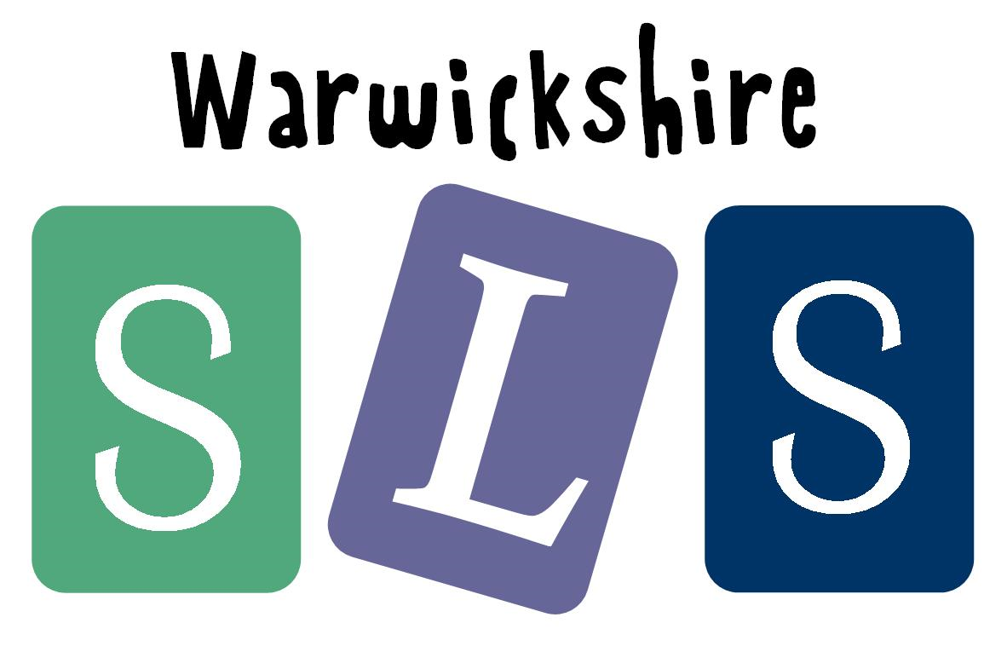
www.robinhoodMAT.co.uk

