Learning Project WEEK 6- Food offline
Age Range: EYFS (Kynance)
Weekly Maths Tasks (Aim to do 1 per day) | Weekly Reading Tasks (Aim to do 1 per day)
MATHS FOCUS: Positional language  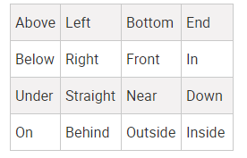  ADULTS: Positional language (prepositions) refers to the place where something or someone is, often in relation to other things, such as over, under, beside or beneath.  ‘Put your beanbag (Positional Language Song)’ from Twinkl.  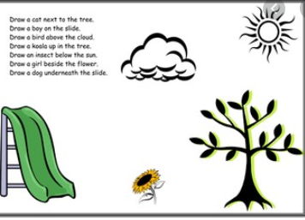  Encourage the children to create a picture using your instructions. EG put the sun above the trees etc. this will help you assess which areas of positional language your chil may need support with.  Go on a pine cone/nature hunt for your daily exercise. Collect some items from nature and bring them home. Can you children tell you where the pinecones are? EG under the tree, next to the bench.  Home hunt: Can you give the children clues to find some ‘toys’ that have run away and played hide and seek? Using our positional language.  Supporting last week’s learning:  Get the children to make a pattern using 2D/3D shapes. Give them instructions EG the cube goes behind the triangle, the square goes on top of the circle. | GUIDED READING  This is used to help the children identify features of a picture or text through talk. The skill of comprehension is being used here and allows the children to develop reasoning, prediction and engagement with text.  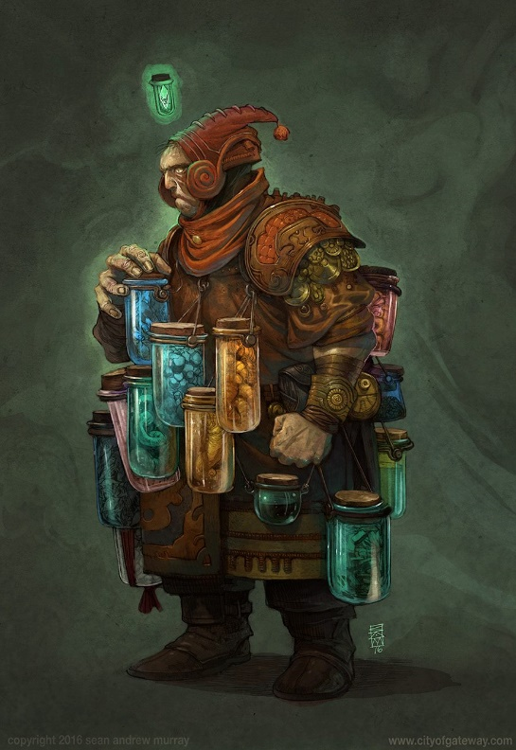  Show your child this pictures. Talk through these questions. There are no right or wrong answers and share your thoughts with the children too:  Show the image without the title first.  - Who do you think this is?  - Why is he carrying all of those jars? What’s inside them? Why are they attached to his clothing? Couldn’t he just carry them in a bag?  - Why is he wearing this clothing?  - Is he going to open the blue jar? Why?  - Why is his other fist clenched?  - What does his body language tell you about his thoughts and feelings?  - Choose 3 words to describe this character.  Red words of the week:  said, have  Read a variety of books at home. Favourites can be repeated. Hearing the patterns of language in a story will support your child’s language development.  - Reception age children: Children to read to parents daily. Visit Oxford Owl for free eBooks that link to your child’s book band. You can create a free account.  Complete the linked Play activities for each book.
Weekly Phonics Tasks (Aim to do 1 per day) | Weekly Writing Tasks (Aim to do 1 per day)
.  Tune in daily to Ruth Miskin’s phonics lessons on YouTube (times have been put on Tapestry so that you are challenging your child). This is crucial to support your child’s fantastic phonics progress already. After these sessions, practise writing words with the special friend that you have learnt, pinching the sounds on your fingers. Your child will explain to you, as they do this daily. https://www.youtube.com/channel/UCo7fbLgY2oA_cFCIg9GdxtQ  https://www.phonicsplay.co.uk/Phase3Menu.htm#  Play these games to support your child’s phonics knowledge.  Hide some flash cards/written sounds around the house. Can the children find them?  https://brizeprimary.org//documents/phonics_sounds_set_1__2_and_3-2.pdf this is the order in which the phonics sounds are taught. | - Can you create a set of instructions on how brush your teeth? You can add pictures. Encourage the children to sound out using their phonics. Their writing might look like this:  ‘Poot toofpayst on the brush an git it wet’. This is a great application of their phonics knowledge.  - Practise forming the letter ‘b’. Please ensure that your child is not drawing a circle and then adding a line. It is of upmost importance that your child is forming their letters correctly. Down the boot, over the shoe. Use the powerpoint to help (you must be playing it as a slideshow to see the movements for each letter) https://www.twinkl.co.uk/resource/t-l-8548-upper-and-lowercase-letter-formation-powerpoint  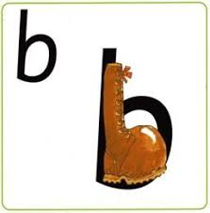  Practise writing your FULL NAME.  - Ask your child to write out the tricky words they are working on at the moment on pieces of paper and do a tricky word hunt in the house!  they, you
Learning Project - to be done throughout the week
The project this week aims to provide opportunities for your child to learn more food. Learning may focus on where different foods originate from, what makes a healthy meal, opportunities to cook etc.

Can you make a cake/biscuits/banana bread? Use an online recipe (or one from your head!) and write the steps down for your children, with simple words, pictures and amounts. See if they can lead this task!

Healthy/ Unhealthy- Provide your child with a selection of items from your kitchen cupboards. Can they sort them into things that are healthy and unhealthy? Discuss why the food is good for you or bad for you. Look at the Eat Well Guide below to help figure out which foods they should eat a lot of or not very much of.
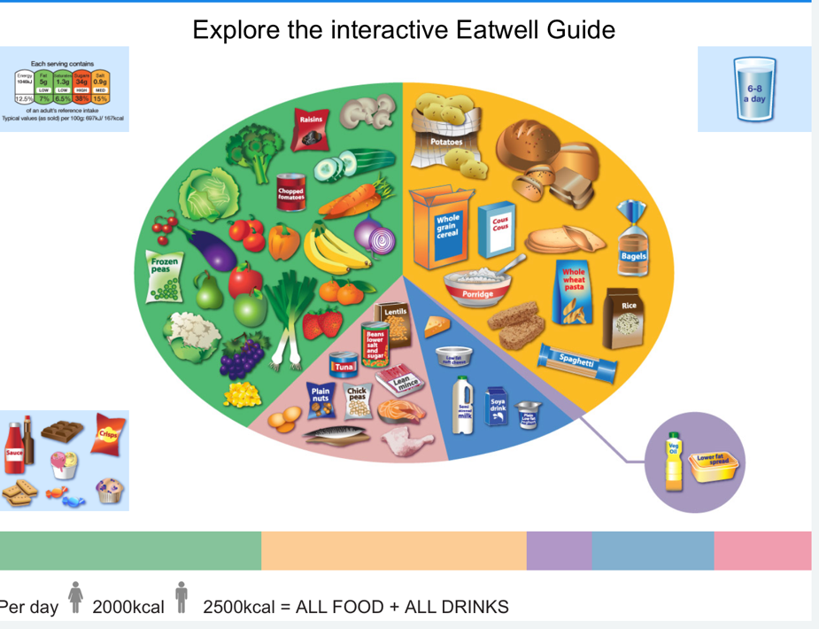

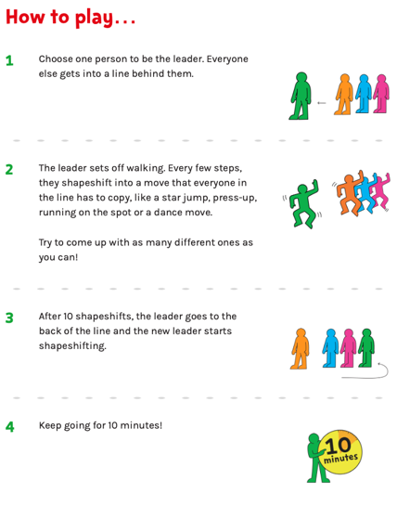
Discuss how exercise is an important part of staying healthy. Complete a 10-minute shake up.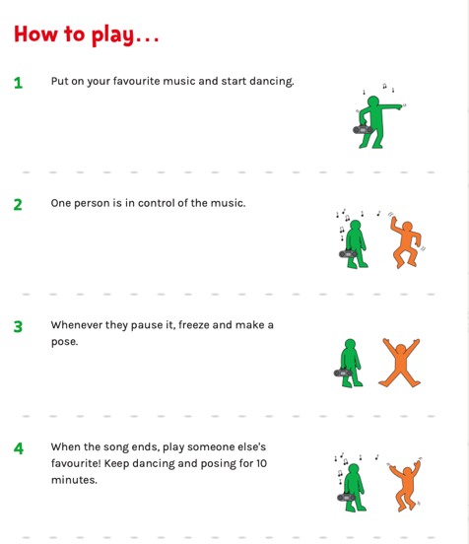

5 a day- Support your child to create a food diary to record how many pieces of fruit and vegetables they eat in a day. They could write these using their phonics knowledge and draw a picture of each item.

Create a collage- Ask your child to draw out a number of fruits or vegetables, large enough to fill a piece of A4 paper. Provide them with a selection of colourful packaging. Can they cut out and collage on to their picture?

Play shops- Using toy food or old packaging, set up a food shop for your child to act out being the shopkeeper and customer. You could introduce coins to support their developing knowledge of money. Give them a notepad to use as a shopping list to encourage writing and recording of numbers.

Potato/ Vegetable Printing- Using a selection of vegetables available in your kitchen, support your child to print and explore the shapes and patterns created:
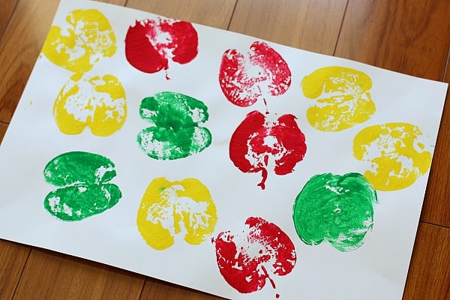
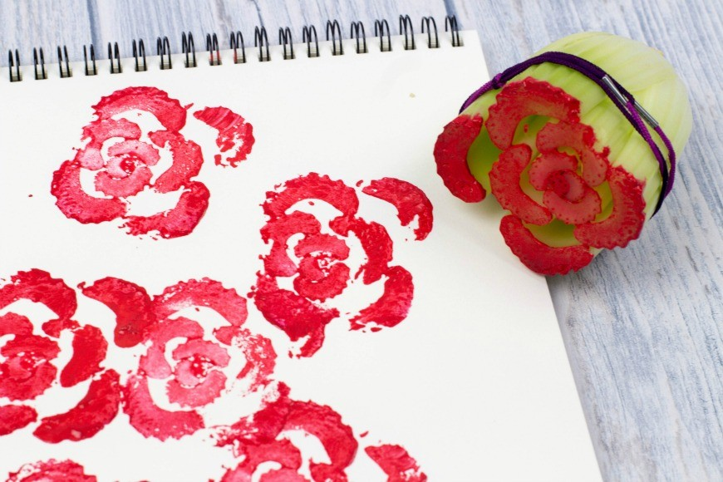
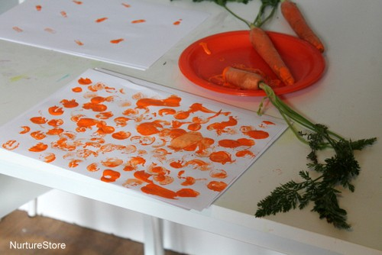

Make cornflour gloop- Mix cornflour with a small amount of water in a mixing bowl. It will make a slimy. Add colours! This has proved to be a favourite in Kynance this year!
Additional learning resources parents may wish to engage with
Classroom Secrets Learning Packs - These packs are split into different year groups and include activities linked to reading, writing, maths and practical ideas you can do around the home.
Twinkl - to access these resources click on the link and sign up using your own email address and creating your own password. Use the offer code UKTWINKLHELPS.
Headteacherchat - This is a blog that has links to various learning platforms. Lots of these are free to access.
White Rose Maths -click for spring term guidance
#TheLearningProjects

Please check Tapestry for uploads or useful links and please, if possible, share some fabulous home learning!
Miss Guy

