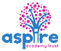
Learning Project - Famous & Significant People
Wk 11
Age Range: Y3/4
Staying active is really important when you are at home. There are lots of resources, here are just a few to use!
Joe Wicks PE sessions
Go Noodle
Super movers!
iMoves
Cosmic Kids Yoga
Weekly Reading Tasks | Weekly Spelling Tasks
Year 3 - Revision | Year 4
television | guard
invasion | guide
confusion | persuasion
division | adventurous
vision | presentation
conclusion | direction
explosion | tradition
illusion | description
decision | admission
collision | repossession
Remember to practise your spellings on sumdog
Monday- Task your child with reading something unusual in an unusual place e.g. a cookbook in the bath. How many unusual places can your child read in this week? | Monday- Your child can choose a person that is significant to them and mindmap all of the words that they associate with this individual e.g. inspirational, heroic, intelligent, courageous.
Tuesday- Visit Ducksters and encourage your child to choose a person to read about. Ask them to create a fact file on their chosen person using facts learnt. | Tuesday- Practise spelling these words: information, adoration, sensation, preparation, admiration. Your child can list other words ending in ‘tion’. Spelling Frame year group lists
Wednesday- Ask your child to read a magazine or newspaper article about a famous person. Ask them to write a diary entry from the viewpoint of that person. | Wednesday- Your child can practise their year group spelling on Spelling Frame. Can they write mnemonics for 5 words e.g Rhythm Helps Your Two Hips Move.
Thursday- Read through this book about famous artists together. Encourage your child to choose one of the artists and create their own inspired painting. | Thursday- Puzzle fun. Choose 5 Common Exception words and create a word search containing these spelling words. Who can find the words?
Friday- With your child, take a look at this information all about Neil Armstrong, the first man to walk on the moon. Complete the quiz and test your knowledge! | Friday- A-Z fun. Ask your child to list a famous or significant person that begins with each letter of the alphabet.
Weekly Writing Tasks | Weekly Maths Tasks- Addition and Subtraction  Choose a task or tasks from each day. These are to be used flexibly
Monday- Visit the Literacy Shed for this wonderful resource on The Clocktower or take part in a writing masterclass using your authorfy login from last week. | Monday- Addition Card Challenge  Y3 Using playing cards ( but not including Jacks, Queens and Kings) pick up 3 cards  i.e. 385. Then pick up another 3 cards i.e.213 Add them together 385  + 213  518  As an extra challenge re – arrange your cards to explore the largest total which you can make/ the smallest total or a total which is nearest to 500 etc.  Y4 Play the same game but with 4 cards for each amount.  White Rose Maths online daily maths lesson  Bitesize Maths online daily maths lesson  CODE Maths Hub Daily Fluency Activities - Day 1 Week 6
Tuesday- Tell your child to imagine that they are famous. What would they be famous for? Can they write a diary entry recounting the day’s events in role?  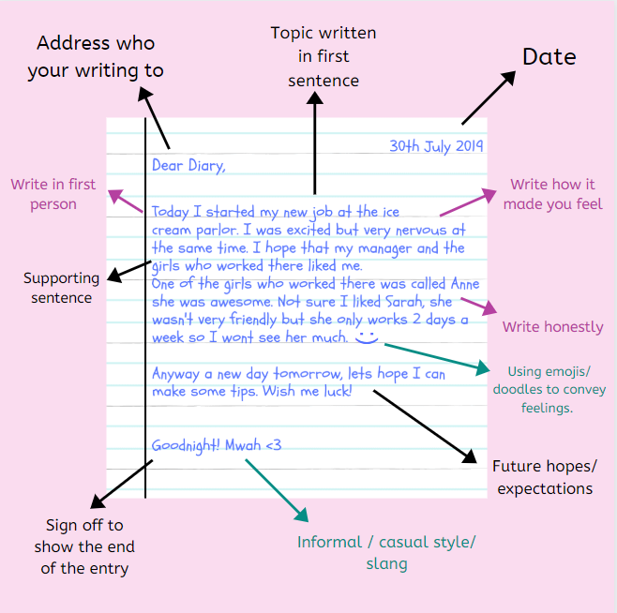 | Tuesday- Subtraction Card Challenge  Y3 Using your playing cards ( but not including Jacks, Queens and Kings) pick up 3 cards i.e. 465. Then pick up another 3 cards i.e. 798. Organise them so that the largest amount is at the top and then subtract the smallest amount.  798  - 465  Y4 to follow the same process but with 4 cards for each amount i.e  2798  - 1465  - Challenge your child to use the Subtraction Grids to see how many calculations they can solve correctly in 2 minutes.  .  White Rose Maths online daily maths lesson  Bitesize Maths online daily maths lesson  CODE Maths Hub Daily Fluency Activities - Day 2 Week 6
Wednesday- Ask your child to find out when the NHS began. Who was the founder? Encourage them to compare the NHS then and now. Can they represent information on a timeline or in an information booklet? | Wednesday-  Using your playing cards create your own addition and subtraction pyramid like the one below.  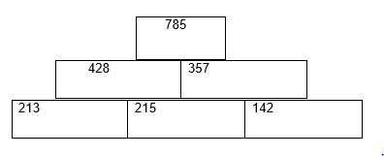  Tip Create 2 sets of numbers i.e. 785 and 213. Insert them in the places of your choice on your pyramid and then solve. Try putting your numbers in different places for an extra challenge  Ask your child to explore making their own pairs of 3 digit numbers (Y3) and 4 digit numbers (Y4)  White Rose Maths online daily maths lesson  Bitesize Maths online daily maths lesson  CODE Maths Hub Daily Fluency Activities - Day 3 Week 6
Thursday- All famous people should earn £1,000,000 per year. Does your child agree/disagree? Ask them to have and write a discussion on this statement. | Thursday-  Ask your child to create and solve their own bar models showing both addition and subtraction like the examples below.  Answer 529 Bar model used for addition  316 213  Answer 214 – Bar model used for subtraction  529  316  For an extra challenge, your child may want to create their own word problem for each one i.e. The penguins at Paignton Zoo eat 316 fish in one week. In Newquay Zoo they eat 213 fish in a week. What is the total amount of fish they eat in a week?  Play this calculation game to practise your calculation skills.  White Rose Maths online daily maths lesson  Bitesize Maths online daily maths lesson  CODE Maths Hub Daily Fluency Activities - Day 4 Week 6
Friday- Ask your child to use the words FAMOUS PEOPLE to write an acrostic poem about significant people in history.  An acrostic poem is a very fun poem for kids. Each acrostic poem has a topic idea running down the left side of the poem. Each letter in the topic word has a new thought that runs off the side from left to right and is relevant to the topic word. The topic word is typically the title as well.  For example...  If you were writing an acrostic poem with the topic word "school" the title would be school and each line of the poem would start with one of the letters in the word school.  School  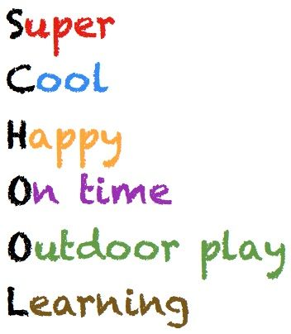 | Friday Theme Famous Mathematicians  Create a famous mathematicians poster using this website. and showing key facts and pictures. Alternatively, if you are registered on Twinkl you may want to use some of these posters to help you  Play this calculation game to practise your calculation skills.  White Rose Maths online daily maths lesson  Bitesize Maths online daily maths lesson  CODE Maths Hub Daily Fluency Activities - Day 5 Week 6

Learning Project - to be done throughout the week
The project this week aims to provide opportunities for your child to learn more about famous or significant people. Learning may focus on past or present inventors, explorers or scientists and how they influence society today.

- Famous Fact Find - Find out about one or more Famous British People here. Ask your child to decide how they would like to present the information they have discovered. This could be a slide show, a poster or an information report about them. Can your child create a true or false quiz about their chosen person and test it out on the family during a games night?

- Healthcare Heroes - As the NHS plays such a significant role in our lives, ask your child to represent our amazing NHS staff with their own piece of artwork. This could be a painting, collage or even a collectable stamp of a famous medic e.g Florence Nightingale, Mary Seacole or Aneurin Bevan. Remember to tweet a photo of their artwork #TheLearningProjects. Or share it on Seesaw for your teacher to see.

- Sport Superstar - Watch an interview with Rod Ellingworth, a famous, British cyclist. Then go for your own bike ride as part of your daily exercise. Don’t forget to wear your helmet. No bike? Then take a walk and look out for any cyclists you see. Recommendation at least 2 hours of exercise a week.

- Family Matters - As a family, discuss the famous people that may have had an impact on their lives and the choices they have made about the jobs they have chosen. Talk about who has inspired them and why. Your child can create a family tree that illustrates inspirations and choices.
- Religious Role Models - Ask your child to find out about significant religious people, like Jesus, Moses , Guru Nanak or someone else who is important to your family. What do they notice about these people? What is similar about them? What is different? Help! Record the similarities and differences in a table format or make a Religious Role Model mini-book.
Mindfulness
Find a quiet space where you can sit comfortably without interruptions. This is your special mindfulness time which helps to keep your brain and body healthy. You are safe to close your eyes and relax.
Think of a famous person you admire. What do you admire or like about this person? Are they strong? Are they kind?
Now turn this into positive phrase such as ‘I am strong’, ‘I am kind’, or ‘I am helpful’.
Say these words inside your head every time you take a breath in, whilst picturing yourself feeling or acting in this way. Really try to imagine how good it feels to have this positive quality. Every time you breathe out, you can relax your body a little bit more.
Keep breathing and saying the words silently for a few minutes, all the time imagining how good it feels to have those positive qualities in your life.
STEM Learning Opportunities #sciencefromhome
Sophia Barnacle
- Sophia was a British inventor who, in 1907, invented the Helter-skelter. Try using junk box material to make your own helter-skelter or marble run.
- To find out more about building your own marble run click here.
Additional learning resources parents may wish to engage with
- BBC Bitesize - Lots of videos and learning opportunities for all subjects.
- Classroom Secrets Learning Packs - Reading, writing and maths activities for different ages.
- Twinkl - Click on the link and sign up using your email address and creating a password.
- White Rose Maths online maths lessons.
- Times Table Rockstars and Numbots. Your child can access both of these programmes with their school logins.
- IXL online. Click here for Year 3 or here for Year 4. There are interactive games to play and guides for parents.
- Y3 Talk for Writing Home-school Booklets and Y4 are an excellent resource to support your child’s speaking and listening, reading and writing skills.
#TheLearningProjects
in collaboration with
