Learning Project - Transport
Age Range: Y3/4
Staying active is really important when you are at home. There are lots of resources, here are just a few to use!
Joe Wicks PE sessions
Go Noodle
Super movers!
iMoves
Cosmic Kids Yoga
Weekly Reading Tasks | Weekly Spelling Tasks
Year 3 | Year 4
confession | expression
depression | profession
percussion | discussion
mission | permission
passion | mansion
possession | comprehension
profession | chemist
permission | character
procession | choir
discussion | ache

Monday- Your child can listen to a free audiobook during their daily walk here. Talk to your child about how it made them feel listening to a book in nature. | Monday- Your child can create an A-Z list of transport related words. How quickly can they complete this?
Tuesday- Read ‘Downhill Racers’ using Oxford Owl. Encourage your child to answer the questions at the back of the book in full sentences. | Tuesday- Dotty Words. Choose 5 Common Exception words and write them in a series of dots. Apply them into sentences about travelling.
Wednesday- Encourage your child to find a car advert in a magazine/newspaper and find the meaning of any new vocabulary, especially technical words! | Wednesday- Learn about word families here. Your child can show their learning by designing a word family reminder poster.
Thursday- Ask your child to read the poem Look at the Train! They can write their own poem about a mode of transport using onomatopoeia (when a word describes a sound and mimics the sound of the object/action) to evoke sounds and rhythm. | Thursday- Practise spelling these words: invention, injection, action, hesitation, completion. Can your child think of other suffixes to add to the root words to alter the meanings e.g. invent+ing= inventing, invent+ed= invented.
Friday- Challenge your child to complete an author study of one of their favourite authors. Can they create a list of their famous books and tick the ones they have read? Can they learn enough about the author to write a biography of their life? | Friday- Ask your child to mind map all of the verbs (action words) they associate with transport and travelling e.g. steers, paddles, control. Which suitable verbs can they include in their writing tasks?
Monday- Wednesday  Look through a newspaper or magazine and list the different types of transport found. Record these in a table.  Read and complete the comprehension activity about the Wright Brothers | Monday- Wednesday  Ask your child to spell the Common Exception words in a fun way using this online game, ‘Spooky Spelling’  Use the common exception word list to undertake a ‘spelling bee’- how many can you get right in a minute- overall.
Weekly Writing Tasks | Weekly Maths Tasks- Measures  Choose a task or tasks from each day. These are to be used flexibly
Monday- Visit the Literacy Shed for this wonderful resource on Ruckus. Or ask your child to design a ticket for their chosen mode of transport. This should include space for the destination, date, cost of ticket, expiry date and class. | Monday- Help your child to practise reading scales by measuring the mass and capacity of ingredients in a home baking recipe! Encourage them to use maths to calculate measurement totals or convert between units of measure.  White Rose Maths online daily maths lesson  Bitesize Maths online daily maths lesson  CODE Maths Hub Daily Fluency Activities - Day 1 Week 10
Tuesday- Ask your child to write an advert advertising a job to work as a pilot, train driver or bus driver. Include persuasive language to encourage applicants. | Tuesday- With an adult, select 10 objects write down their mass from the pack.  Then order the objects by lightest to heaviest.  Remember 1000 g = kg.  You may want to predict where they would go first before looking at the measures!.  To make this easier you may want to convert the weights into grams ( if you have some kilograms in your selection)  As an extra challenge practise your rounding skills by drawing a large scale number line from 0 up to 1000g ( 1kg) counting in multiples of 100g.like this one from Twinkl  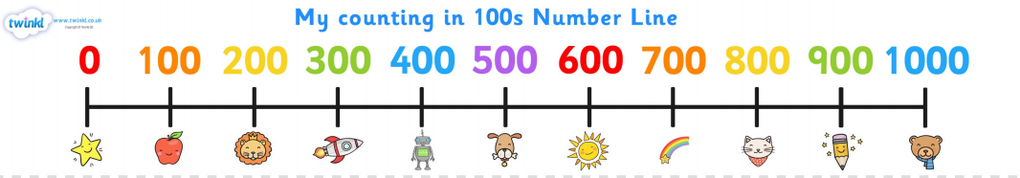  Pick up an object and place on the number line the nearest 100g which it would round to i.e. a cake weighing 454g would round to 500g. Some crisps weighing 35g would round to 0.  White Rose Maths online daily maths lesson  Bitesize Maths online daily maths lesson  CODE Maths Hub Daily Fluency Activities - Day 2 Week 10
Wednesday- Your child can plan and write a journey story. Where is the main character going and why? What happens on his/her journey? How does the main character overcome this? If you have access to a PC, your child can type up the final version of their story after they have proofread it. | Wednesday  Go on a measures hunt around your home select 10 objects decide if their measurement would be recorded in millimetres, centimetres or metres.  Sort them into sets under the 3 headings.  Then on a piece of paper estimate how long you think each object will be.  Then check with a ruler to see if you were correct.  If you would like to do some extra work on measures, investigative activities can be found on this website.  White Rose Maths online daily maths lesson  Bitesize Maths online daily maths lesson  CODE Maths Hub Daily Fluency Activities - Day 3 Week 10
Thursday- Watch this video about The Orient Express. Your child can imagine that they have travelled on this beautiful train and write a recount about their journey. | Thursday  Practise reading thermometers by playing this game.  As an extra challenge look at the weather report for your local area and draw your own thermometers to represent the temperatures.  You may want to create your own thermometers where the scales go in steps of 1s, 2s, 5s or 10s  White Rose Maths online daily maths lesson  Bitesize Maths online daily maths lesson  CODE Maths Hub Daily Fluency Activities - Day 4 Week 10
Friday- Families should only be allowed to use their car 3 times per week. Can your child write a for/against argument about this, with adult support? They should consider the impact it would have on the family/environment. | Friday  Create your own table like the one below and then a bar chart linked to the colours of the different cars in your local area.  Car Colour Number of cars  Red  Blue  White  Black  Silver  Below are examples of bar charts which you may wish to create but using your own data.  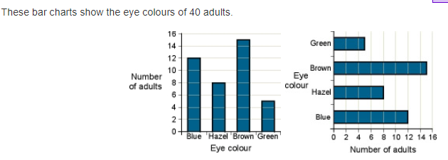  Taken from https://www.ncetm.org.uk  White Rose Maths online daily maths lesson  Bitesize Maths online daily maths lesson  CODE Maths Hub Daily Fluency Activities - Day 2 Week 10
Monday – Wednesday  Ask your child to write a letter or postcard to their new teacher in September. Tell the teacher all about themselves including their likes/dislikes, friends and favourites. Perhaps you could share it with your teacher on Seesaw?  Using the poem styles learned during your home learning write a poem, about Summer. What is the weather like? What things can you do? What foods do you eat? What you see, hear and smell?  And/ or write a diary during the summer. | Monday – Wednesday  Practise your problem solving and calculation skills by playing these number card activities by Babcock.  Click on the link above which will take you through to the resources  CODE Maths Hub Daily Fluency Activities Week 11

Learning Project - to be done throughout the week
The project this week aims to provide opportunities for your child to learn more about transport. Learning may focus on modes of transport, transport in the past, the science behind transport, road safety and how to be safe around water.

- Transport Inventors - Ask your child to find out about famous transport inventors such as Henry Ford and The Wright Brothers. Create fact files about these inventors. Can your child draw sketches of different modes of transport then and now? Can they place different modes of transport on a timeline using their invention date?

- Colourful Collage - Ask your child to create their own transport collage. Encourage them to draw, colour or paint a variety of vehicles or make a large collage of one vehicle. Ask them to use bold colours to really make their vehicles stand out! The collage could be made using cut up squares from magazines and leaflets. Share the collages at #TheLearningProjects.

- Obstacle Course - Ask your child to find any toy transport (cars, trains, etc) they may have at home, then they can design an obstacle course for their vehicle to travel around. This could be on a track or floor involving ramps inside or in the garden. Another idea - get each family member to make a paper aeroplane and throw each one in turn and see whose travels the furthest. Ask your child to measure the lengths of the distance travelled and record these on a bar chart. Recommendation at least 2 hours of exercise a week.

- Let’s Talk Transport -Talk as a family about transport in your life. Talk about how you get to school and work. Do you get your food delivered? Does anyone in the family operate a mode of transport? Is it their job? Discuss the first family car owned. Ask your child to mind map all of the ways your family relies on transport and then to imagine a life without it.

- Transport Around the World - Ask your child to look at how people travel around in India. Research online for - Buses, cycle-rickshaws, autorickshaws, e-rickshaws, tempos (big, brutal-looking autorickshaws), taxis, boats, tongas (horse-drawn carts), metros and urban trains provide transport around India's cities. Encourage them to compare this to Venice and how the people there travel around (gondola and sandolo tours all around the city). Can your child design a new vehicle suitable for each of these places thinking carefully about suitable and local materials?
STEM Learning Opportunities #sciencefromhome
Brilliant Boats
- Using just 1 sheet of paper and some paperclips design a raft that will hold as many coins or marbles as possible. You can download the activity card here to help you.

Additional STEM activities for Monday to Wednesday and the summer- https://primarylibrary.crestawards.org/all-superstar-challenges/61747644/62
Mindfulness
Sometimes when we think about new situations or when we know things are going to change, it can make us feel worried. Feeling anxious or worried is normal; it’s a step your body takes to make sure you are safe.
There are techniques we can use to help us feel calm, even when things are changing or when times are difficult. Today we will learn one of these techniques. It’s all about using your superpowers! Stand in a quiet space with your legs slightly apart, your back straight and your head tall, with your arms bent and your hands on your hips. Make sure your position is tall and strong. Just like Superman or Wonder Woman might stand!
Keep still in this position and start to take long, slow breaths. You can even think about which power you would like to have to help you through the difficult time by saying things like ‘I am brave’ or ‘I am strong’.
Notice how you feel after spending a few moments in this big, strong position.
Try it anytime you are feeling worried or nervous… it will really help you to feel brave!
For addition materials on coping with the social and emotional aspects of returning to school visit https://www.traumainformedschools.co.uk/resources
Additional learning resources parents may wish to engage with
- https://classroom.thenational.academy/activity-clubs this has many subjects and lessons to dip into.
- BBC Bitesize - Lots of videos and learning opportunities for all subjects
- White Rose Maths online maths lessons. .
- Classroom Secrets Learning Packs - Reading, writing and maths activities for different ages.
- Twinkl
- White Rose Maths online maths lessons.
- Topmarks mental maths activities
- Times Table Rockstars and Numbots. Your child can access both of these programmes with their school logins. On Times Table Rockstars, children should aim to play Soundcheck for 20 minutes daily.
- IXL online. Click here for Year 3 or here for Year 4. There are interactive games to play and guides for parents.
- Y3 Talk for Writing Home-school Booklets and Y4 are an excellent resource to support your child’s speaking and listening, reading and writing skills.
#TheLearningProjects
in collaboration with
www.robinhoodMAT.co.uk

