Learning Project - Transport
Age Range: Y5/6
Staying active is really important when you are at home. There are lots of resources, here are just a few to use!
Joe Wicks PE sessions
Go Noodle
Super movers!
iMoves
Cosmic Kids Yoga
Weekly Reading Tasks | Weekly Spelling Tasks
Year 5 | Year 6
invincible | shrugged
forcible | skimmed
eligible | sobbed
tangible | slammed
legible | throbbed
negligible | stunned
submergible | grinned
illegible | planned
intangible | trimmed
unintelligible | drummed

Monday- Encourage your child to listen to an audiobook on their daily walk here. Perhaps they could choose a journey tale? | Monday- Pick 5 Common Exception words from the Year 5/6 spelling list here.  Challenge your child to write three clues for each of their words.
Tuesday- Ask your child to look at a car manual and look up any new technical terms. | Tuesday- Can your child create a transport glossary of these terms: underground, cargo, gangway, pedestrian, terminal & voyage?
Wednesday- Click here for a reading activity about The Titanic. Challenge your child to read the text in 3 minutes and complete the questions. | Wednesday- Using the vocabulary from yesterday, ask your child to apply these words into sentences to show their understanding of the meanings.
Thursday- Ask your child to look at leaflets, newspaper articles or other literature about transport. What does the information tell you about how we use transport? | Thursday- Can your child work out the Year 5/6 words from these bouncing anagrams?
Friday- Your child can learn all about Robert Fulton here. Encourage them to take the quiz about this famous inventor, located at the bottom of the page. | Friday- Task your child with creating a space themed word boardgame. When it’s complete, play together as a family.
Weekly Writing Tasks | Weekly Maths Tasks- Volume  Choose a task or tasks from each day. These are to be used flexibly
Monday- Travelling around Cornwall can be really long and tiresome because the roads are winding and there is a lot of traffic in the summer. You need to design a new form of transport that will take you to wherever you would like to go at the flick of a switch. Please design your vehicle and label it to show what different features your vehicle will have. | Monday- Go for a volume hunt around the home.  Using the concept that volume is the amount of space which something occupies get pairs of objects and identify which ones have the greatest volume  Compare the objects by using the following sentence stems as in the ideas  from the NCTEM Professional Development Materials below  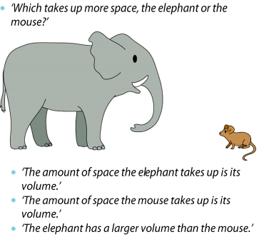  NCETM Professional Development Materials  White Rose Maths online daily maths lesson  Bitesize Maths online daily maths lesson  CODE Maths Hub Daily Fluency Activities - Day 1 Week 10
Tuesday- Thinking about the mode of transport your child designed yesterday, ask them to think about how it works (how you would control it etc…), what it looks like and safety procedures whilst on board. | Tuesday- Create your own poster showing what volume is.  You may want to use from this website to help you.  You may also want to include these facts too.  You may also want to do these activities to support your understanding of this area.  White Rose Maths online daily maths lesson  Bitesize Maths online daily maths lesson  CODE Maths Hub Daily Fluency Activities - Day 2 Week 10
Wednesday- Research information about Sir Francis Drake and ‘life on board’ of oats at that time. Think about what conditions would have been like on board ships in the Tudor times. Write a fictional diary entry from Sir Francis about his day on board the ship. | Wednesday  Using sugar cubes, marshmallows or cubes( if you have them), encourage your child to make a shape with a volume of 24 centimetres cubed. How many different shapes can they make? Remember the formula is length x width x height  Can they draw each shape they make with a ruler.  As an extra challenge select your own target number and explore how many different cubes or cuboids you can create using your target number.  Ask your child to find the volume and surface area of these rectangular prisms in this online game.  White Rose Maths online daily maths lesson  Bitesize Maths online daily maths lesson  CODE Maths Hub Daily Fluency Activities - Day 3 Week 10
Thursday- Think about and research some of the amazing journeys that have taken place in the past (eg: 80 days around the world, circumnavigating the world on your own, travelling to the south or north pole) Which journey would you like to undertake now and why? Think about how you would travel and your motivation for undertaking the journey. | Thursday Converting Measures length  Using the attached sheet practise converting the distances from km to metres.  Remember there are 1000m = 1 km (so you need to multiply the distances by a 1000 when converting from km to m).  Then research the distances from your home to places in Cornwall.  Record the distance in km and practise converting the distances to metres by multiplying by 1000 so 5.3 kilometres = 5300 metres.  Activity  Create your own digit cards 0 – 9 pick up 3 , 4 or 5 cards.  Write down the distance in metres such as 4653 metres.  Then practise converting it to km so 4653 metres = 4.653 km  Remember to divide by 1000 when converting from metres to kilometres.  White Rose Maths online daily maths lesson  Bitesize Maths online daily maths lesson  CODE Maths Hub Daily Fluency Activities - Day 4 Week 10
Friday- Your child could research the famous explorer Christopher Columbus, how he travelled and his voyages. Ask your child to create a journey story to retell this. This could be written in the first person as Columbus himself. | Friday  Get a collection of objects from around the home where the mass is written grams or kilograms.  Or weigh a selection of objects instead.  From this divide a piece of paper into 12 squares – in each square draw a picture of the object and its mass underneath.  Then cut out the squares and practise ordering the objects lightest to heaviest.  You may also want to show the mass in both grams and kilograms using the formula 1000 grams = 1 kilogram.  Then pick up 2 cards and compare the mass of the different items using the comparison signs > greater than and < less than  Extra challenge ensure that all of your measures are converted into grams.  Then practise converting them into milligrams - 1000mg = 1 gram  Therefore you need to multiply by 1000 to do this i.e. 2.5 grams = 2500 mg  White Rose Maths online daily maths lesson  Bitesize Maths online daily maths lesson  CODE Maths Hub Daily Fluency Activities - Day 5 Week 10
Monday – Wednesday  Ask your child to write a letter or postcard to their new teacher in September. Tell the teacher all about themselves including their likes/dislikes, friends and favourites. Perhaps you could share it with your teacher on Seesaw?  Using the poem styles learned during your home learning write a poem, about Summer. What is the weather like? What things can you do? What foods do you eat? What you see, hear and smell?  And/ or write a diary during the summer. | Monday – Wednesday  Practise your problem solving and calculation skills by playing these number card activities by Babcock.  Click on the link which will take you through to the resources  CODE Maths Hub Daily Fluency Activities Week 11.

Learning Project - to be done throughout the week
The project this week aims to provide opportunities for your child to learn more about transport. Learning may focus on modes of transport, transport in the past, the science behind transport, road safety and how to be safe around water.
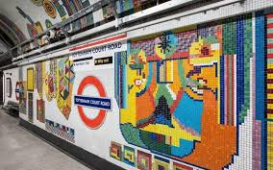
- Is it a Bird? Is it a Plane? Is it a paper aeroplane- Look at this link and choose a few different paper aeroplanes to make. Which ones flies the best? Why do you think that is? Could you modify the design at all to make it even better? Then think about how you are going to test them, how you can make it a fair test, and what results you want to find. Make a chart to show your results! (This is really about enjoying making and testing the planes!)

- Coming down without a bump! – Using everyday household objects, you need to make a parachute that works effectively. Your challenge is to make it work well enough to hold an egg and stop int from breaking when you drop it from a height (and upstairs window!) Make sure you test your parachute before you put the egg in it! (NB – it’s worth hard-boiling the egg first to stop it from being too messy!)

- Beep beep! - Make a balloon powered car using the instruction here. Can you make the car more efficient? Can you decorate it so that it looks like a car you would like to be seen in!?
- Faster Than a Speeding Bullet...Train- The Shanghai Maglev, also known as Shanghai Transrapid, is currently the fastest train in the world, running between Shanghai and Beijing in China. Challenge your child to be just as speedy and complete the following 5 activities as fast as possible: Star jumps, tuck jumps, press-ups, squats and lunges. Ask them to record how many repetitions of each activity they can perform in 1 minute. Can they beat their personal best? Challenge them to record their heart rate (beats per minute) after each activity. Recommendation at least 2 hours of exercise a week.

- Make and Do - Make it Go!- Support your child to try this hover balloon activity. You will need the following equipment: CD, bottle top with push/pull closure, like those on some sports drinks or water bottles, blu-tack or glue and a balloon. Alternatively, they could have a go at creating a baking powder powered boat. You will need the following equipment: empty water bottle, baking powder, kitchen roll or tissue, scissors, straw, vinegar, sellotape. If you don’t have access to this equipment, your child can watch and read about the experiments and can discuss with you their favourite, providing reasons for their opinions.

- Mindfulness - Sometimes when we think about new situations, or when we know things are going to change, it can make us feel worried. Feeling anxious or worried is normal; it’s a step your body takes to make sure you are safe. There are techniques we can use to help us feel calm, even when things are changing or when times are difficult. Today we will learn one of these techniques. It’s all about increasing your superpowers! Stand in a quiet space with your legs slightly apart, your back straight and your head tall, with your arms bent and your hands on your hips. Make sure your position is tall and strong. Just like Superman or Wonder Woman might stand! Keep still in this position and start to take long, slow breaths. If you like, you can also try focusing on the positive feeling, or the superpower, you want to have to help you through the difficult time. For example, you could say to yourself ‘I am brave’ or ‘I am confident’. Notice how you feel after spending a few moments in this big, strong position. Try it anytime you are feeling worried or nervous… it will really help you to feel powerful!
STEM Learning Opportunities #sciencefromhome
Brilliant Boats
- Watch this video about boat designs.
- Try creating your own boat designs and testing them. You might like to use something smaller and more waterproof than a bag of sugar for testing though!
Additional learning resources parents may wish to engage with
- Times Table Rockstars and Numbots. Your child can access both of these programmes with their school logins. On Times Table Rockstars, children should aim to play Soundcheck for 20 minutes daily.
- IXL online. Click here for Year 5 or here for Year 6. There are interactive games to play and guides for parents.
- CODE Maths Hub Daily Fluency Activities
- https://www.topmarks.co.uk/maths-games/daily10 - arithmetic challenges
- BBC Bitesize - Lots of videos and learning opportunities for all subjects.
- Y5 Talk for Writing Home-school Booklets and Y6 are an excellent resource to support your child’s speaking and listening, reading and writing skills.
#TheLearningProjects
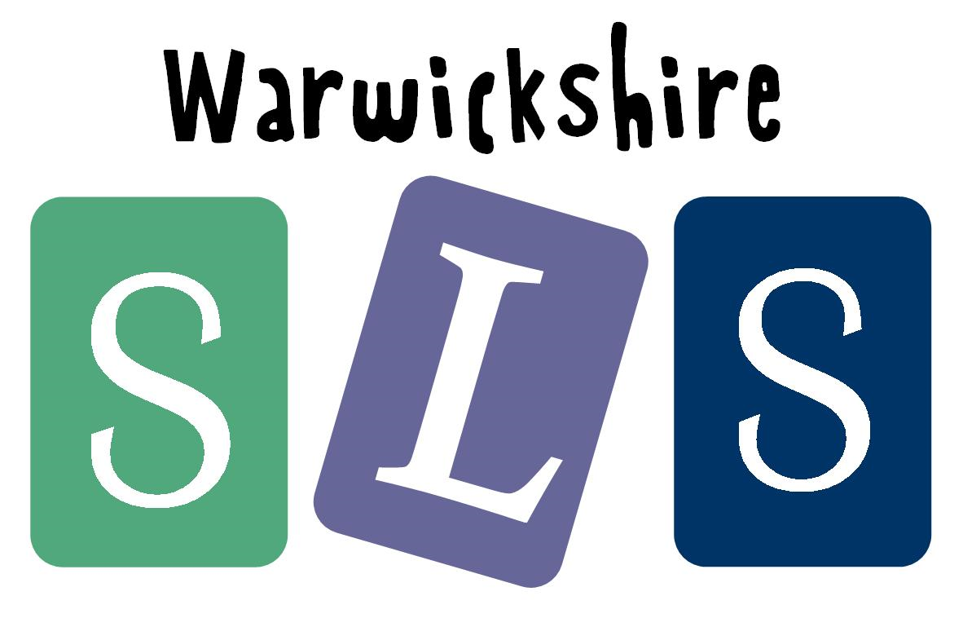
in collaboration with
www.robinhoodMAT.co.uk

