Learning Project WEEK 7- Celebrations
Age Range: EYFS (Kynance)
Weekly Maths Tasks (Aim to do 1 per day) | Weekly Reading Tasks (Aim to do 1 per day)
MATHS FOCUS: Directional language  ADULTS: Directional language is language that refers to the place where something travels.  e.g. forwards, backwards, left, right, straight on, clockwise, anti-clockwise.  Create an obstacle course in your house or outside in the garden. Give the children instructions on how to complete. Use directional language such as ‘move forwards 3 steps. Go backwards one step’. Can the children do this blindfolded?  There are lots of fun activities online to teach left and right. The children should be able to put on their shoes correctly. Perhaps colour an area of the left shoe in a colour or mark with ‘L’.  Show them this video https://www.youtube.com/watch?v=4VZLVcYsaQk (Left and Right song).  Use the words ‘left’ and ‘right’ in everyday language e.g. ‘I’m going to put my left shoe on first!’.  Make pizzas and get the children to put certain ingredients on either side e.g. ‘put cheese on the left side and tomato on the right side’.  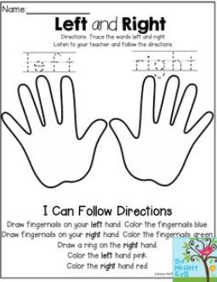  Other activities:  Play this game to practise counting, ordering and matching numbers to 10.  Listen to a number song from the CBeebies website. After listening to them, watch again and sing along if you can. Talk about the maths you can see in the video clip.  White Rose Weekly Maths White Rose Maths -click for Summer Term guidance. | GUIDED READING  This is used to help the children identify features of a picture or text through talk. The skill of comprehension is being used here and allows the children to develop reasoning, prediction and engagement with text.  Show your child this picture. Talk through these questions. There are no right or wrong answers and share your thoughts with the children too:  Show the image without the title first.  Who do you think this is?  Has the character in the picture always been so big?  What has caused him to grow to this size?  Where do you think he might be going?  How will ‘normal sized’ people feel when they see him?  What would you do if you saw someone of this size?  What’s on the other side of the wall he is stepping over?  Are all his family this big?  Perfect picture!  Can you draw a picture of what you think the enormous person will do next?  Red (tricky) words of the week:  all, have, come.  Read a variety of books at home. Favourites can be repeated. Hearing the patterns of language in a story will support your child’s language development.  Reception age children: Children to read to parents daily. Visit Oxford Owl for free eBooks that link to your child’s book band. You can create a free account.  Complete the linked Play activities for each book.
Weekly Phonics Tasks (Aim to do 1 per day) | Weekly Writing Tasks (Aim to do 1 per day)
Tune in daily to Ruth Miskin’s phonics lessons on YouTube (times have been put on Tapestry so that you are challenging your child). This is crucial to support your child’s fantastic phonics progress already. After these sessions, practise writing words with the special friend that you have learnt, pinching the sounds on your fingers. Your child will explain to you, as they do this daily. https://www.youtube.com/channel/UCo7fbLgY2oA_cFCIg9GdxtQ  https://www.phonicsplay.co.uk/Phase3Menu.htm#  Play these games to support your child’s phonics knowledge.  Hide some flash cards/written sounds around the house. Can the children find them?  https://brizeprimary.org//documents/phonics_sounds_set_1__2_and_3-2.pdf this is the order in which the phonics sounds are taught.  Learn the song ‘On Bonfire Night’ and encourage your child to make marks to represent the sounds in the song e.g. whiz, whiz could be a swirling pattern.  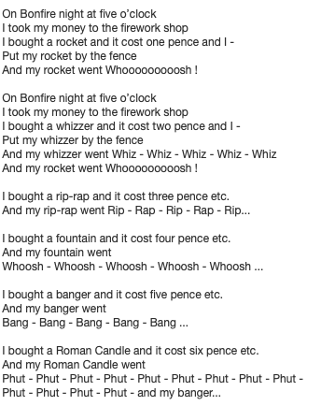 | - Share some family photographs. Have your child write a sentence about what they can see in the photograph. Ensure that they do this independently. You can help with some spelling on tricky words, but the children will need to apply their phonics themselves.  - Ask your child to write some celebration cards to friends/family. Send them off!  - Ask your child to draw a picture of a celebration they have taken part in. Encourage them to use their phonics knowledge to write simples sentences about their memory of that day. Remind your child where to start on the page, starting with a capital letter, finger spaces and a full stop. Make a high frequency word mat for your child to use.  - Practise forming the letter ‘h’. Please ensure your child is not writing an ‘n’ and then adding the top.  - 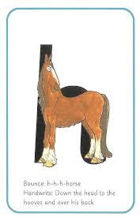 https://www.twinkl.co.uk/resource/t-l-8548-upper-and-lowercase-letter-formation-powerpoint  - Create a card for a celebration of your choice. Can your child use their phonics knowledge to write a message for the person they would like to give it to?  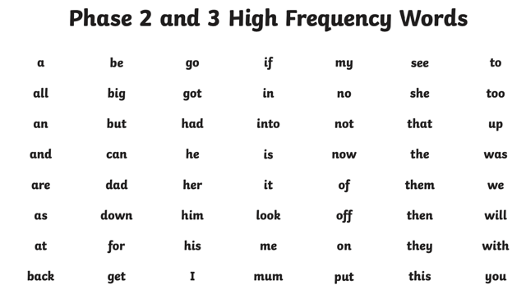  Practise writing your FULL NAME.  - Ask your child to write out the tricky words they are working on at the moment on pieces of paper and do a tricky word hunt in the house!  all, have, come
Learning Project - to be done throughout the week
This project this week aims to provide opportunities for your child to learn more about celebrations. Learning may focus and different types of celebrations that take place and who may celebrate them. It could look at how people celebrate different events differently in other parts of the world.

Family Photographs- Look over a selection of photographs of family celebrations and discuss with your child: what the celebration was about, who attended, what you did to celebrate, when it took place, whether it is an event that happens each year. Can your child remember the event taking place? What do they remember of it?
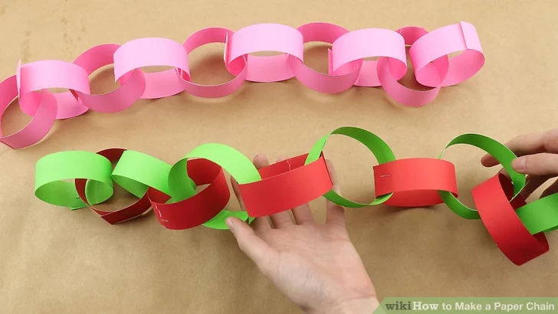
Plan a family celebration- Decide on a family celebration for the week. This could be a family indoor picnic, meal, dance etc. Ask your child to write invitations to family members to the party.
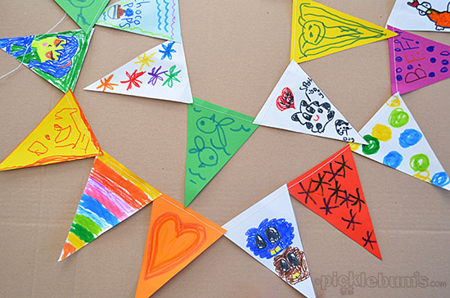
Create homemade decorations using coloured paper (If you do not have coloured paper at home, you could use old newspaper or wrapping paper) You could make paper chains or bunting.
Plan a menu for the party and make the food together.

Discover religious celebrations-
Discuss Easter celebrations with your child. Did you celebrate Easter? Which of the events did they take part in?
Think of different celebrations across the year. Are there any similarities and differences between the celebrations? Write a list of the similarities and the differences.

Mindfulness – Balance the toy!
Helping your child to have some focused mindfulness time is a great way to help them cope with any difficult feelings or emotions so over the next few weeks we will be offering some techniques to try.

Help your child to find a soft toy (it will need to be something that will balance on their body, so make sure it’s not too big or heavy!). Explain to your child that they should lie down on their back with their legs stretched out straight and their arms straight down by their sides. Tell them you are going to balance the toy on their tummy, and they need to stay still so that it doesn’t fall off. Explain this is a quiet time when you are both going to focus on your breathing because it’s a great way to keep your brain and body healthy. Ask your child to take big slow breaths. Can they feel their toy moving up and down? Encourage them to keep quiet and still, with just their belly moving up and down as they continue to focus on taking long, slow breaths. Keep going until you sense your child is getting restless. You could try doing this a few times throughout the week. You can use different toys to maintain your child’s interest. You could add some gentle music to relax to.

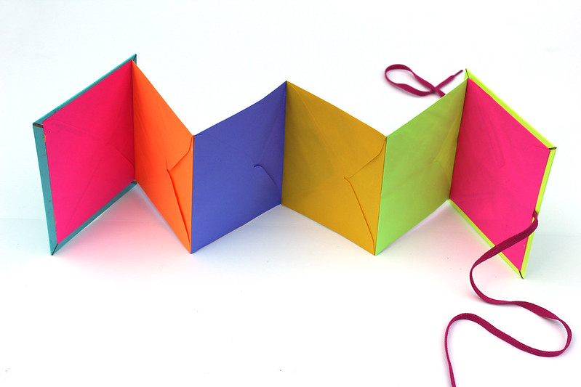
Birthdays- Talk to your child about when they were born. Look at photographs of the day they were born, if you have them available. Do they know the date of their birthday? Support your child to create an all about me folding book (as pictured) with their birth date, current age and anything else they think is important for people to know about them.
Additional learning resources parents may wish to engage with
Classroom Secrets Learning Packs - These packs are split into different year groups and include activities linked to reading, writing, maths and practical ideas you can do around the home.
Twinkl - to access these resources click on the link and sign up using your own email address and creating your own password. Use the offer code UKTWINKLHELPS.
Headteacherchat - This is a blog that has links to various learning platforms. Lots of these are free to access.
White Rose Maths -click for spring term guidance
#TheLearningProjects

Please check Tapestry for uploads or useful links and please, if possible, share some fabulous home learning!
Miss Guy

