Week 10: Learning Project - The Rainforest Online
Age Range: EYFS
Weekly Reading Activities | Weekly Phonics Tasks
Monday- Watch Go Jetters: Amazon Rainforest. Can your child tell you where the tree frog was found? What sound did it make? Which rainforest insect steals the picnic? What happens when the tree frogs aren’t there to eat the ants? | Monday- Ask your child to find different things around the house/garden. Can they segment each word into sounds i.e. c-u-p (cup), b-e-d (bed) t-ea (tea), ch-air (chair)? If they are able, they could write these too.
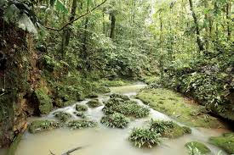  Tuesday- This is a picture of the amazon rainforest:  Who do you think lives there? What animals might be there? Why can you only see some colours? What would you like to do if you were there?  Can you think about why there are so many trees? | Tuesday- Think of words to describe the rainforest animals - each word should start with the same letter i.e. mad, munching monkey or large, loving lion.  Additional challenge: Can you make rhyming word strings? Such as
Wednesday- Ask your child to use pictures from a familiar story book to make up their own story or to retell their favourite story. | Wednesday- Daily Phonics –  Can your child sing the alphabet? Can they match they alphabet letter names (for example ‘a’ pronounced as ‘ay’ and ‘a’ pronounced as ‘ah’?
Thursday- Enjoy listening to online stories together including: Slowly Said the Sloth | Thursday- Play ‘I Spy in the Rainforest’. ‘I spy, with my little eye, something beginning with t’. CHALLENGE: Change it to ‘I spy, with my little eye, my word includes the digraph ee’ - ‘Tree’.
Friday- Enjoy listening to online stories together including: The Tiger Who Came To Tea.  Keep up with your online phonics tasks  Red words this week: one, once | Friday- Play the Word Machine - Ask your child to read each word carefully. Match the correct word to the picture. If you get it right, you will hear a clap. Click ‘Next’ and have a go at another word.
Weekly Writing Tasks | Weekly Maths Tasks- Number Recognition and Counting
Monday- Say or write a list of all the animals you would find in the rainforest. CHALLENGE: Can your child think of an animal for each letter of the alphabet e.g. a=alligator, b=bird. | Focus this week: subtraction.  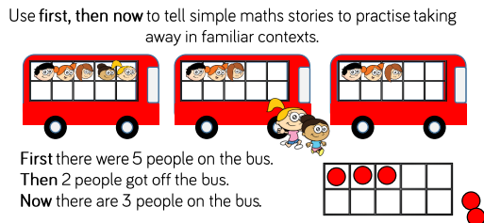  Monday:
Tuesday-  Click here to watch Go Jetters Amazon Rainforest, South America  Talk about the rainforest with your child and ask: What can you see? What can you hear? Ask your child to draw a picture of the rainforest and write a sentence about what they can see or hear. | Tuesday-  Use subtraction in everyday language. For example using the words. Take away, minus, less than, subtract, less, fewer. Get your child to identify if you have taken an amount away or added. What is the difference? Get them to explain.
Wednesday- Use this animated letter formation tool to help your child practise letter formation. You can select those they find most challenging. Practise writing your first name and your surname. Practise writing the following letters, can you write them onto a line? r,a,i,n,f,o,r,e,s,t,. Take care with the letter ‘f’ make sure the ‘tail’ comes below the line. | Wednesday- Go over subtraction number sentences. Can the children made up a story based on the number sentence? Model this first to grasp their understanding.  EG 5-4=1.  There were 5 birds in the tree. Some wind came and 4 birds flew off. There was only 1 bird left in the tree. Get the children to use physical resources to help them.
Thursday- Using the story The Tiger Who Came To Tea, draw a picture of the tiger and label the picture using words to describe him e.g. stripy fur, sharp teeth. | Thursday  Answer subtraction sentences based on your child’s understanding.  6-3=?  12-5=?  22-3=?  Reception children only need to know numbers to 20. If you believe your child can INDEPENDENTLY access numbers above that, then feel free to use these numbers  Please give your children physical resources to visualise the subtraction.
Friday- Ask your child to create a rainforest animal mask then talk about the sounds that different animals make. CHALLENGE: Can they write a sentence to describe the animal e.g. I like the monkey. He is cheeky. He jumps in the trees. | Friday-  Show children some pictures with some other pictures crossed out. For example:  Can they create a number sentence for them? (5-1=4)

Learning Project - to be done throughout the week
The project this week aims to provide opportunities for your child to learn more about the world’s rainforests. Learning may focus on the plants, animals and insects that inhabit the rainforest, food that originates there and weather patterns. It could look at plants and animals that can be found in the garden too.
Which Animals Live in the Rainforest?
- Watch this video about animals in the rainforest. Can your child tell you about some of the animals that live in the rainforest? Can they remember any facts? Can they describe the animals?.
- Ask your child to make their own explorers outfit (e.g. binoculars, sunhat, backpack) and head out to the garden or on your daily walk. What creatures can your child find? Are they similar to any you might see in the rainforest? Take photographs.

Draw or paint a picture of a Rainforest Animal
- Ask your child to draw or paint a picture of a rainforest animal.

Play the Animal Jungle Quiz
- Listen to the clues. Can you match the clue to the correct animal?
- Click here to create your own jungle. Drag the animals onto the picture. Where do you think the animals should go? Why? i.e. on the ground, in the trees…
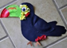
Make a Collage of a Rainforest Animal
- Use collage to create your own rainforest animal using recycled materials from around the house.

Make an Animal Home
- Create an animal home e.g. a bug hotel using things from the garden. Use a plastic tub or cardboard box. Ask your child what the animal will need in the home in order to survive.
STEM Learning Opportunities #sciencefromhome
Rainforest Materials
- A rainforest has lots of tall trees and grows in warm countries that have a lot of rain. People use the wood from the trees to make paper and furniture. They also take lots of ingredients like sugar and oil to make food. Here you can find a list of food and ingredients that grow in rainforests.
What plants can we find in the garden? Can you name the different parts of a plant? Stem, leaves, branches, roots, flower? Try using some of the material found in your garden to make something useful. For example, a nature paint brush.
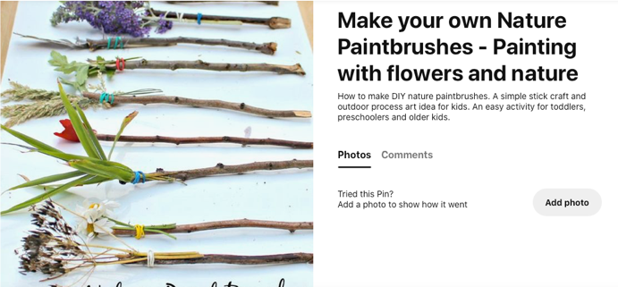
Mindfulness - Helping your child to have some focused mindfulness time is a great way to help them cope with any difficult feelings or emotions that they might be experiencing at the moment. Mindfulness activities also contribute to brain health and general wellbeing. Start with short amounts of time and build up as your child develops the ability to be still, calm and quiet.
You can use this rainforest music or sit outside in the garden with the sound of nature around you as your focus. Have your child sit or lie down in a comfortable position with their eyes closed. They might like to use a snuggly blanket, a cuddle toy or a cushion so that they feel cosy, safe and relaxed. Ask them to close their eyes and say still. All they need to do is listen to the music / sounds of nature. If any thoughts pop into their head, you can tell them that the thoughts are just like clouds and float away. Every time a thought comes along, just let it float away like a cloud and continue listening to the sounds. You can do this for 2 or 3 minutes every day, or for as long as your child feels able to focus.
Additional learning resources parents may wish to engage with
White Rose Weekly Maths White Rose Maths -click for Summer Term guidance
Numbots. Your child can access this programme with their school login.
IXL Click on Maths, Reception. There are interactive games to play and guides for parents.
Talk for Writing Home-school Booklets are an excellent resource to support your child’s speaking and listening, reading and writing skills.
#TheLearningProjects
in collaboration with
www.robinhoodMAT.co.uk

