Learning Project WEEK 4- Animals
Age Range: EYFS
Staying active is really important when you are at home. There are lots of resources, here are just a few to use!
Go Noodle
Super movers!
Cosmic Yoga
Weekly Maths Tasks (Aim to do 1 per day) | Weekly Reading Tasks (Aim to do 1 per day)
White Rose maths session  MATHS FOCUS: Identifying 2D shapes.  - Talk with the children about the difference between 3D and 2D shapes (the children know that 3D are solid and 2D are flat).  - This is a brilliant song to play daily. Encourage your children to sing alongside it.  - Stick pictures of 2D shapes up. Talk through the names of these shapes. Can the children tell you facts that they know? Encourage the children to talk about straight and curved sides, differences and similarities.  - Talk through the PROPERTIES of 2D shapes. How many sides do they have? How many corners (vertices)? Are the sides that same length? Use a ruler to find out!  - Guess my shape game! Describe a shape whilst the children look at pictures of 2D shapes and ask the children to guess which one you’re talking about based on your clues.  - It is very important for the children to understand that 2D shapes can be found in the world around them. Can they spot any and take photographs using your phone or tablet?  - A fantastic Numberblocks episode on 2D shapes that will help you and your child!  - Recap teen numbers from last week. Hide them around your house and retalk over all of the learning that you did previously.  - Working on Numbots - your child will have an individual login to access this.  - Practise counting backwards from 20. This can be done through playing hide and seek, singing number songs, chanting, board games etc. | GUIDED READING  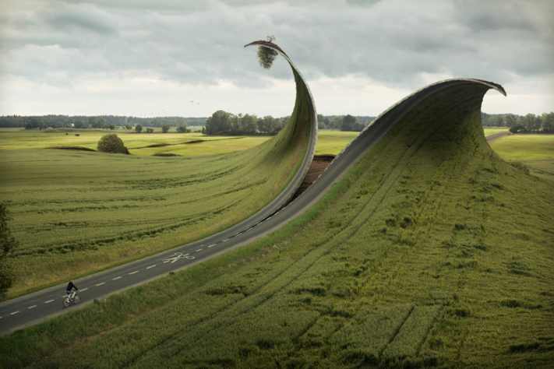  This is used to help the children identify features of a picture or text through talk. The skill of comprehension is being used here and allows the children to develop reasoning, prediction and engagement with text.  Show your child this pictures. Talk through these questions. There are no right or wrong answers and share your thoughts with the children too:  - Who is controlling the scissors?  - Why do you think the World is being re-shaped?  - If you could change the World what would you change?  - What would you keep the same?  - What is going to happen next?  - What happened to make it like this?  - Where is everyone?  Red words of the week:  by, my, all  Read a variety of books at home. Favourites can be repeated. Hearing the patterns of language in a story will support your child’s language development.  - Reception age children: Children to read to parents daily. Visit Oxford Owl for free eBooks that link to your child’s book band. You can create a free account.  Complete the linked Play activities for each book.  - Listen to a story being read: Story line and CBBC Bedtime stories.  - Listen to different David Walliams books here!  - Listen to a range of free books on audible.  - With your child, look in magazines, newspapers and books for the tricky words they are currently learning. They could use a highlighter to highlight in magazines and newspapers.
Weekly Phonics Tasks (Aim to do 1 per day) | Weekly Writing Tasks (Aim to do 1 per day)
- Sing Nursery Rhymes and songs together. Add in actions and change the words. Can children think of different rhyming words to add in? Repeat old favourites and learn new rhymes. You can find an A-Z of Nursery Rhymes here.  Tune in daily to Ruth Miskin’s phonics lessons on YouTube (times have been put on Tapestry so that you are challenging your child). This is crucial to support your child’s fantastic phonics progress already. After these sessions, practise writing words with the special friend that you have learnt, pinching the sounds on your fingers. Your child will explain to you, as they do this daily. https://www.youtube.com/channel/UCo7fbLgY2oA_cFCIg9GdxtQ  - Play this animal sound match game.  - Sing the song, ‘Old McDonald Had a Farm’. Instead of saying the name of the animal, make the sound. Can your child figure out which animal it is? Reception age children could write the digraphs/ trigraphs they can hear in the song e.g. ee, igh, ee, igh, ow | - Draw an animal of your choice. Label the parts of the animal. Can you write a sentence about your animal?  - Can you write a letter to Miss Guy’s cat Chester? We have just moved house and he isn’t allowed outside yet so is feeling bored!  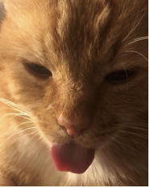  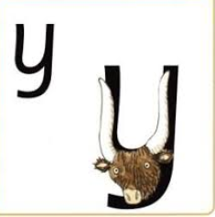  - Practise forming the letter ‘y’. This is similar to ‘g’ last week. Down a horn, up a horn, under his head,  - Ask your child to write out the tricky words they are working on at the moment on pieces of paper and do a tricky word hunt in the house!  my, by, all
Learning Project - to be done throughout the week
The project this week aims to provide opportunities for your child to learn more about key animals they are interested in. Learning may focus on exploring the physical aspects of an animal, their habitat, categorising animals etc.

- Read the story, ‘Dear Zoo’ or watch the online video -
  - Visit the book’s website and play the interactive games
  - Add your own animal into the story and label it e.g. So they sent me a...hedgehog, but he was too prickly....so I sent him back.
  - Choose a soft toy animal or small animal figure and create a junk modelled container for it.

- Teach the children about differences between herbivores and carnivores. What does it mean? Make some ‘poo’ and the children have to identify whether the poo came from a carnivorous or herbivorous animal. A super recipe can be found here: https://naturalsciences.org/docs/special-exhibits/AnimalScat.pdf

- Identify the birds in your garden-
  - Use the RSPB bird identifier website
  - Draw a picture of the birds you can see.

- Play animal charades-
  - Take it in turns to act as different animals. Add in noises as a clue…

- Learn the song, ‘The Animals Went in Two by Two’
  - Ask your child to draw out two of each animal and practise writing the numeral 2. Can they count in twos to 10? What about 20?

- Looking after your pet-
  - If you have a pet at home encourage your child to take part in their daily care. They could help feed, groom and clean up after your pet. If you do not have a pet, get the children to create a new ‘pet’. They could design its body and name it.

- Big and small animals-
  - Draw as many big animals as you can on one piece of paper and as many small animals as you can on another sheet of paper. Some children may be able to write a list as an alternative.

- Find all of the animal books in your house-
  - Ask your child to look through the books in your house and to find any with animals on the front cover. Ask them to sort the books into groups of their choice e.g. animals that can fly, swim, big, small, live on a farm/ at the zoo.

- Create an animal den-
  - Provide your child with blankets and sheets to make an animal den. Act out being an animal in the den.

Additional learning resources parents may wish to engage with
Classroom Secrets Learning Packs - These packs are split into different year groups and include activities linked to reading, writing, maths and practical ideas you can do around the home.
Twinkl - to access these resources click on the link and sign up using your own email address and creating your own password. Use the offer code UKTWINKLHELPS.
Headteacherchat - This is a blog that has links to various learning platforms. Lots of these are free to access.
#TheLearningProjects

Please check Tapestry for uploads or useful links and please, if possible, share some fabulous home learning!
Miss Guy

