Year 1/2
Core Texts   | Autumn 1 (7 weeks) |  |  |  |  |  |  |  |  |  | Autumn 2 (7 weeks)
 | Snail and the Whale  Bee  and additional wider curriculum reading texts |  |  |  |  |  |  |  |  |  | Queen Victoria’s Bathing Machine  and additional wider curriculum reading texts
Writing   | Transcription unit  (1 week)  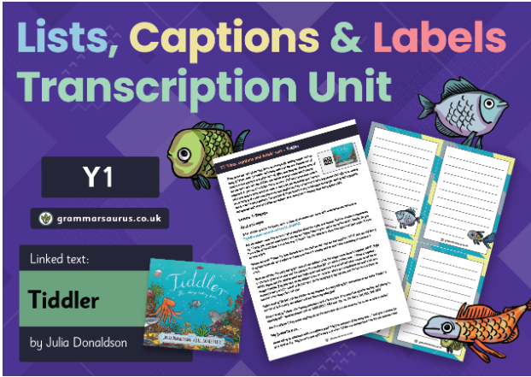  Tiddler |   The Place Value of Punctuation and Grammar (5 weeks)  Common nouns  Poper nouns  Being verbs  Being verbs + to have  Regular action verbs  Irregular action verbs  What is a subject?  Building single clause sentences (Stage 1 and 2) |  |  |  |  |  | Sentence pattern  building unit (1 week)  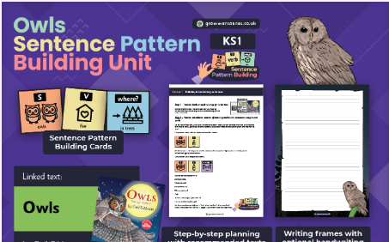  Owls |  |  | 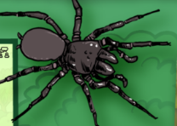  Marvellous minibeasts  Non-chronological report (4 weeks)  Heading  Brief introduction Subheadings  Technical vocabulary  Pictures and captions  Third person - formal Statements giving factual information  Expanded noun phrases Adverbs/adverbials of manner Adverbs/adverbials of place  Commands  Subheadings  Commas in a list  Question mark  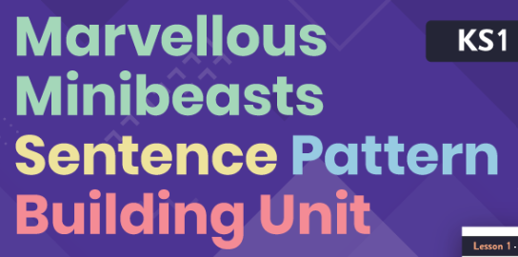 |  |  | 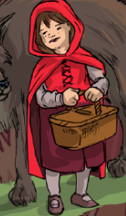  Little Red  Recount -letter (3 weeks)  Address  Date  Salutation  Brief introduction  Chronological order  First person  Past tense  Facts and opinions  Rhetorical questions  Sign off  Subordinating conjunctions  Co-ordinating conjunctions to join clauses  Expanded noun phrases Adverbs/adverbials of time Adverbs/adverbials of place  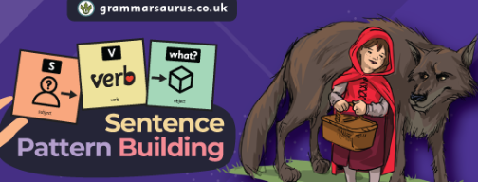
Spelling  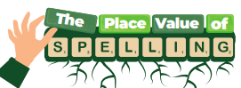 | Assessments | Vowels and Consonants |  | Compound words | Intro to morphology |  |  |  | 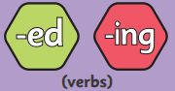 |  |  |  |  |  | Buffer weeks
Comprehension crushers   | Animal groups |  | The enormous carrot |  |  | The world |  |  |  | Monarchs of England and Great Britain |  |  | Village, town or city? |  |  | A magical Christmas
Handwriting   | Pupils continue to refine their letter formation, spacing and size.  

Spring Term
Core Texts | Spring 1 (6 weeks) |  |  |  |  |  | Spring 2 (4 weeks, 4 days)
 | The Mousehole Cat  and additional wider curriculum texts |  |  |  |  |  | Ella and the Ocean  and additional wider curriculum texts
Writing | 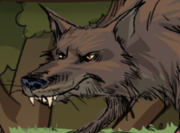  Have you seen this wolf?  Character description (3 weeks)  Heading  Introduction  Subheadings  Third person  Present tense  Paragraphs pan the character  Rhetorical questions  Reward  Co-ordinating conjunctions  Expanded noun phrases  Adverbs/adverbials of place  Subordinating conjunction ‘if’  Commas in a list   |  |  | 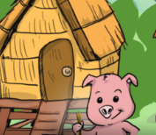  The Three Little Pigs  Narrative (3 weeks)  Repetitive speech  Statements  Commands  Exclamation sentences  Expanded noun phrases  Past tense  Pronouns  Adverbials of time, place and manner  Co-ordinating conjunctions  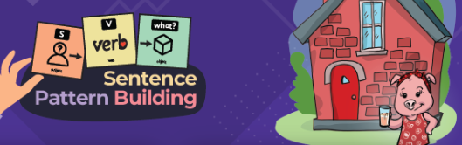 |  |  | 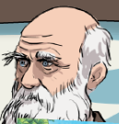  Charles Darwin’s journey  Recount (3 weeks)  Date  Salutation  Chronological order  Past tense  First person – informal  Facts and opinions  Rhetorical questions  Sign off  Co-ordinating conjunctions  Subordinating conjunctions  Adverbs/adverbials of time Adverbs/adverbials of place  Expanded noun phrases  Exclamation marks  Commas for lists  Apostrophes for omission  Apostrophes for possession (GDS  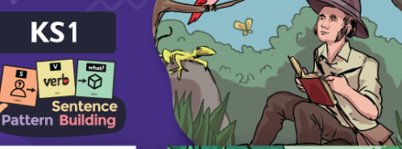 |  |  |  | 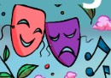  At the park poetry  Acrostics and sound poems (1 week, 4 days)
Spelling | 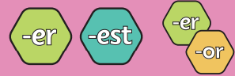 |  |  |  |  |  | 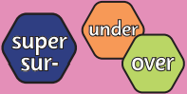 |  | Buffer weeks
Comprehension Crushers | The Legend of Nian |  | Materials/pottery |  |  | I’ve seen a moose bake banana bread |  | Tim Peake/The incredible Darwin |  | The caterpillar and the tadpole
Handwriting | Pupils continue to refine their letter formation, spacing and size.  

Summer Term
Core Texts | Summer 1 (7 weeks) |  |  |  |  |  | Summer 2 (7 weeks)
 | The Tiny Seed  The Secret Garden  and additional wider curriculum texts |  |  |  |  |  | Tiddler  Pebble  and additional wider curriculum texts
Writing | 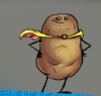  Join our Super Vegetable Crew!  Persuasive advert (3 weeks)  Deals and bargains  Direct address (can include flattery) Alliteration and assonance  Facts and statistics  Opinion (can be expert opinion) Repetition  Rhetorical questions Emotive/exaggerated language Triples/the rule of three  Expanded noun phrases  Co-ordinating conjunctions Subordinating conjunctions Commands Question marks Exclamation marks  Apostrophes for possession (GDS  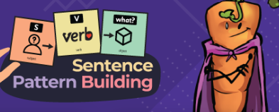 |  | 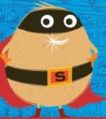  Mighty Marrow  Narrative (4 weeks)  Past tense  Rhetorical questions  Statements and exclamation sentences  Exciting action verbs  Expanded noun phrases  Adverbials of time  Adverbials of place  Adverbials of manner  Question marks  Exclamation marks   |  |  |  | 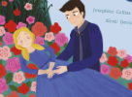  Sleeping Beauty’s castle  Setting description (3 weeks)  Introduction  Paragraphs pan the setting  Third person  Rhetorical questions  Conclusion including a cliffhanger Expanded noun phrases  Adverbials of manner including similes Adverbials of place  Commas in a list  Apostrophes for possession Apostrophes for omission  Capital letters for proper nouns Question marks |  |  |   How do butterflies change?  Explanation (4 weeks)  Title  Introductory paragraph Paragraphs detailing a process  Facts  Present tense  Formal language and technical vocabulary  Co-ordinating conjunctions Subordinating conjunctions Expanded noun phrases Statements  Questions Commas in a list Apostrophes for possession (GDS)
Spelling | 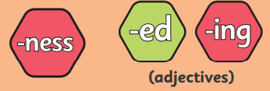 |  |  |  |  | Matrix application |  | Buffer weeks
Comprehension Crushers | Weather | Why does it rain? |  |  | How to grow a vegetable/How to catch the Big Bad Wolf |  | Florence Nightingale |  | Visit London |  | Changes in mobile phones/Changes in toys
Handwriting | Pupils continue to refine their letter formation, spacing and size. By the end of Year 2, more able pupils may begin learning and applying horizontal and vertical joins, laying the groundwork for joined handwriting.

Year 3 Autumn Term
Core Texts | Autumn 1 (7 weeks) |  |  |  |  |  |  |  |  |  | Autumn 2 (7 weeks)
 | Evie and the Animals |  |  |  |  |  |  |  |  |  | Greek Myths & Legends
Writing | 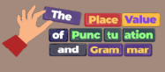  The Place Value of Punctuation and Grammar  (5 weeks)  Common and proper nouns  What is a collective noun?  What are partitive nouns?  Being verbs- ‘to have’  Regular action verbs and verb phrases  Irregular action verbs and verb phrases  What is a subject?  Building single clause sentences (Stage 1, 2 and 3)  Co-ordinating conjunctions to join clauses |  |  |  |  |  | 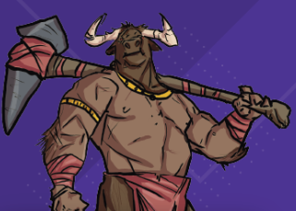  How to slay the Minotaur  Sentence pattern building unit (2 weeks) |  |  |  | 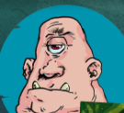  Mythological monsters  Non-chronological report (3 weeks)  Heading  Brief introduction  Subheadings  Technical vocabulary  Pictures and captions  Third person - formal Statements giving factual information  Co-ordinating conjunctions Subordinating conjunctions  Expanded noun phrases  Present perfect tense  Commas for list  Apostrophes for possession  Commas after fronted adverbials |  |  |  |  |   Charlie and the Chocolate Factory  Recount (4 weeks)  Date  Salutation  Brief introduction  Chronological order  First person  Past tense  Facts and opinions  Rhetorical questions  Sign off  Active voice  Subordinating conjunctions  Co-ordinating conjunctions to join clauses Expanded noun phrases  Adverbs/adverbials of time  Adverbs/adverbials of manner Adverbs/adverbials of place
Spelling | Assessments | Vowels and Consonants |  | Compound words |  | Intro to morp-hol-ogy | 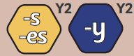 |  | 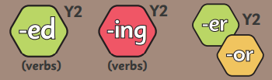 |  |  |  |  |  |  |  |  | Buffer weeks
Year 3 Spelling  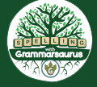 |  |  |  |  |  |  |  |  |  |  |  |  |  |  |  |  |  |  | 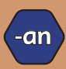 |  | Buffer weeks
Comprehension Crushers | Human skeleton |  | Mexican Folk Tales |  | Edmund Hilary’s Amazing Achievements |  |  | Performance Poetry |  | Midas and the golden touch |  |  | Christmas in Halloween |  |  |  | Arabian Peninsula |  |  | Performance poetry
Handwriting | Pupils continue to refine their letter formation, spacing and size.

Year 3 Spring Term
Core Texts | Spring 1 (6 weeks) |  |  |  |  |  |  |  |  | Spring 2 (4 weeks, 4 days)
 | Charlie and the Chocolate Factory |  |  |  |  |  |  |  |  | The Iron Man
Writing |   Wonka World  Setting description (3 weeks)  Introduction  Paragraphs pan the setting  Figurative language  Short sentences for effect  Rhetorical questions  Conclusion including a cliffhanger Expanded noun phrases including sights, sounds and smells  Adverbials of manner including similes Participial phrases (-ing and -ed openers) Adverbials of place  Apostrophes for possession  Commas in a list Commas for fronted adverbials  Ellipses |  |  | 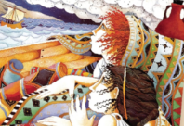  Escape from Pompeii  Narrative-characterising speech (3 weeks)  Introduction  Direct speech  Short sentences for effect  Colloquial language (non-Standard English)  Discourse markers  Expanded noun phrases  Adverbs/adverbials of manner  Participial phrases & clauses  Adverbs/adverbials of place  Apostrophes for omission |  |  |  |  |  | 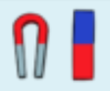  Do all magnets pull a paper clip from the same distance?  Science experiment (3 weeks)  Title – question  Prediction/hypothesis  Equipment list  Method in sequenced, chronological steps Results/observations  Conclusion Diagrams  Present tense  First person  Commands  Detailed information  Technical vocabulary  Co-ordinating conjunctions  Subordinating conjunctions  Expanded noun phrases  Adverbs/adverbials of manner  Adverbs/adverbials of time  Commas in a list  Apostrophes for possession |  |  |  |  |  | Animal poetry  Kennings and rhyming poetry
Spelling | 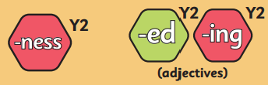 |  |  | 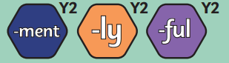 |  |  |  |  |  | 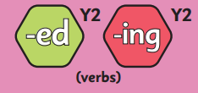 |  |  |  | 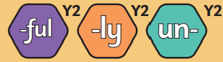
Year 3 Spelling |  |  |  |  |  |  |  | 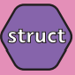 |  |  | 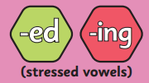 |  | Matrix application | Buffer weeks
Comprehension | Jane’s jungle journey |  | A food map of the UK |  |  | The centipede song |  |  | Africa |  |  | Arctic Ocean |  |  | Performance poetry
Handwriting | Yr 3: Introducing joins. Letter formation is further embedded, and pupils begin learning to join letters. This stage focuses on building fluency and consistency in the early stages of joined writing.

Year 3 Summer Term
Core Texts | Summer 1 (7 weeks) |  |  |  |  |  |  |  |  |  | Summer 2 (7 weeks)
 | Stig of the Dump |  |  |  |  |  |  |  |  |  | The Firework maker’s daughter
Writing | 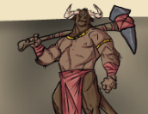  How to slay the Minotaur  Instructions (3 weeks)  Title statement  List of equipment or materials Sequenced, chronological steps Diagrams or illustrations  Present tense  Imperative verbs (commands)  Detailed information  Co-ordinating conjunctions Subordinating conjunctions  Expanded noun phrases  Commands, using the imperative Statements using the pronoun ‘you’ Adverbs/adverbials of manner Adverbs/adverbials of time  Commas in a list  Apostrophes for possession Apostrophes for omission |  |  |  | 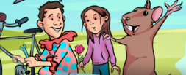  Land of the Whale Songs  Narrative (4 weeks)  Past tense  Co-ordinating conjunctions  Expanded noun phrases  Adverbials of time/place/manner  Apostrophes for possession |  |  |  |  |  | 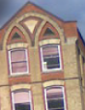  Visit your locality  Persuasive advert (3 weeks)  Deals and bargains  Direct address (can include flattery)  Alliteration and assonance  Facts and statistics  Opinion (can be expert opinion)  Repetition  Rhetorical questions  Emotive/exaggerated language  Triples/the rule of three  Adverbs  Personal pronouns  Expanded noun phrases  Co-ordinating conjunctions  Subordinating conjunctions  Commands  Commas in a list  Apostrophes for possession (GDS) |  |  |  |  |  | 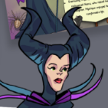  The evil fairy  Biography (4 weeks)  Heading  Brief introduction  Subheadings  Chronological order  Technical vocabulary  Pictures and captions  Third person – formal Statements giving factual information  Co-ordinating conjunctions Subordinating conjunctions Expanded noun phrases  Perfect tense Adverbs/adverbials of time Commas in a list  Apostrophes for possession
Spelling | 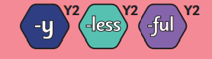 |  |  |  |  | 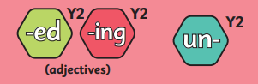 |  |  |  |  |  |  | 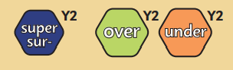 |  |  |  |  | 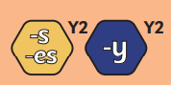
Year 3 Spelling | 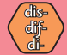 |  |  |  |  |  | 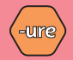 |  | 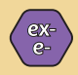 |  |  |  |  | Matrix applic-ation |  | Buffer Weeks
Comprehension | Hunter gatherers |  |  | Counties and regions of England |  |  |  | Rumpelstiltskin |  |  | Rocks |  |  |  | Hansel and Gretel |  |  |  | The royal escape
Handwriting | Yr 3: Introducing joins. Letter formation is further embedded, and pupils begin learning to join letters. This stage focuses on building fluency and consistency in the early stages of joined writing.

Year 4 Autumn Term
 | Autumn 1 (7 weeks) |  |  |  |  |  |  |  |  |  | Autumn 2 (7 weeks)
Core Texts | Alice in Wonderland |  |  |  |  |  |  |  |  |  | The Thieves of Ostia
Writing | 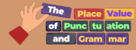  The Place Value of Punctuation and Grammar (5 weeks)  Common and proper nouns  What is a collective noun?  What are partitive nouns?  Being verbs- ‘to have’  Regular action verbs and verb phrases  Irregular action verbs and verb phrases  What is a subject?  Building single clause sentences (Stage 1, 2 and 3)  Co-ordinating conjunctions to join clauses |  |  |  |  | 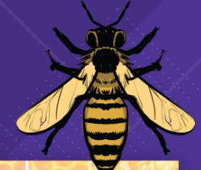  All about bees  Sentence pattern building unit (2 weeks) |  |  |  |  | 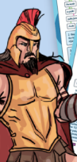  Roman gods  Non-chronological report (3 weeks)  Heading  Brief introduction  Subheadings  Technical vocabulary  Pictures and captions  Third person - formal  Statements giving factual information  Co-ordinating conjunctions  Subordinating conjunctions  Adverbs/adverbials of time  Adverbs/adverbials of reason  Adverbs/adverbials of manner Adverbs/adverbials of place  Expanded noun phrases  Commas in a list  Apostrophes for possession  Commas after fronted adverbials |  |  |  |  |  |   Camilla Milliner and the King’s hat  Recount – diary (4 weeks)  Address  Date  Salutation  Brief introduction  Chronological order  First person  Past tense  Facts and opinions  Rhetorical questions  Sign off  Active voice  Subordinating conjunctions  Co-ordinating conjunctions to join clauses Expanded noun phrases  Adverbs/adverbials of time Adverbs/adverbials of place
Spelling | Assessments | Vowels and Consonants |  | Compound words | Intro to morphol-ogy | 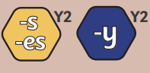 |  |  | 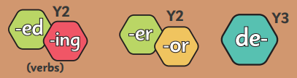 |  |  |  |  | 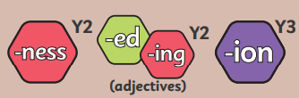 |  |  |  |  |  | 
Year 4 Spelling |  |  |  |  |  |  |  | 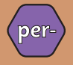 |  |  |  |  |  |  |  |  |  | 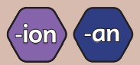 |  |  | Buffer weeks
Comprehension | Stoke on Trent |  | Plymouth |  |  |  | Black Britons |  |  | Roman Empire |  |  |  |  | The Bronze age |  |  |  | Cindy-Lou visits the Grinch
Handwriting | Yr 4: Securing joins. Pupils consolidate their understanding of joins, working towards confident and automatic use of joined handwriting across subjects.

 | Spring Term
Core Texts | Spring 1 (6 weeks) |  |  |  |  |  | Spring 2 (4 weeks, 4 days)
 | The Explorer |  |  |  |  |  | 20,000 Leagues under the Sea
Writing | 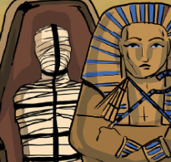  How to mummify your best friend  Instructions (3 weeks)  Title  statement  List of equipment or materials  Sequenced, chronological steps  Diagrams or illustrations  Present tense  Imperative verbs (commands)  Detailed information  Co-ordinating conjunctions  Subordinating conjunctions  Expanded noun phrases  Commands, using the imperative  Statements using the pronoun ‘you’  Adverbs of manner  Adverbs of time  Commas for lists  Apostrophes for possession  Apostrophes for omission |  |  | 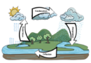  How does the water cycle work?  Explanation (3 weeks)  Title  Introductory paragraph  Paragraphs detailing a process  Facts  Present tense  Formal language  Technical vocabulary  Co-ordinating conjunctions  Subordinating conjunctions  Expanded noun phrases  Adverbs/adverbials of time  Adverbs/adverbials of manner  Commas for fronted adverbials  Apostrophes for possession |  |  | 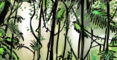  Jungles/rainforests  Setting description (3 weeks)  Introduction  Paragraphs pan the setting  Figurative language  Short sentences for effect  Rhetorical questions  Conclusion including a cliffhanger  Expanded noun phrases including sights,  sounds and smells  Adverbials of manner including similes  Participial phrases (-ing and -ed openers)  Adverbials of place  Apostrophes for possession  Commas in a list  Commas for fronted adverbials  Ellipses (Y4) |  |  |  |  |  |   Villain poetry  Limericks, clerihews, list poems (1 week, 4 days)
Spelling | 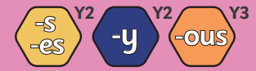 |  |  | 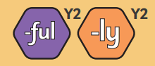 |  |  | 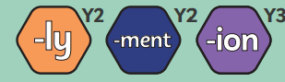 |  |  |  | 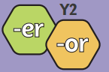
Year 4 Spelling | 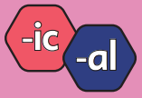 | 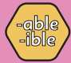 |  |  |  |  |  | Matrix application |  | Buffer Weeks
Comprehension | The rainforest doesn’t talk |  | Save our forest |  |  | Orangutans |  |  | Scandinavia |  |  | Biomes of the world
Handwriting | Yr 4: Securing joins. Pupils consolidate their understanding of joins, working towards confident and automatic use of joined handwriting across subjects.

Core Texts | Summer Term
 | Summer 1 (7 weeks) |  |  |  |  |  |  |  |  |  | Summer 2 (7 weeks)
 | Beowulf |  |  |  |  |  |  |  |  |  | The Saga of Erik the Viking
Writing | 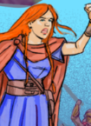  Boudicca Vs the Romans  Narrative- characterising speech (4 weeks)  Introduction  Direct speech  Each character shows emotions  Short sentences for effect  Colloquial language (non-Standard English)  Discourse markers  Expanded noun phrases  Adverbs/adverbials of manner  Participial phrases & clauses  Adverbs/adverbials of place  Apostrophes for omission  Commas for fronted adverbials  Inverted commas  Ellipses to show a pause or incomplete  thought |  |  |  |  | Visit your locality  Persuasive advert (3 weeks)  Deals and bargains  Direct address (can include flattery) Alliteration and assonance  Facts and statistics  Opinion (can be expert opinion)  Repetition  Rhetorical questions  Emotive/exaggerated language  Triples/the rule of three  Adverbs  Personal pronouns  Expanded noun phrases  Co-ordinating conjunctions  Subordinating conjunctions  Commands  Commas in a list  Apostrophes for possession (GDS) |  |  |  |  | 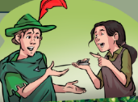  Robin Hood 8 ½  Narrative (4 weeks)  Past tense (simple, perfect, progressive)  Adverbials of time/manner/place  Expanded noun phrases  Speech |  |  |  |  | 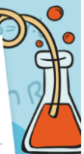  Does the sound get quieter as the distance increases?  Science experiment (3 weeks)  Title – question Prediction/hypothesis Equipment list  Method in sequenced, chronological steps Results/observations Conclusion  Diagrams  Present tense  First person  Commands  Detailed information Technical vocabulary  Co-ordinating conjunctions Subordinating conjunctions Expanded noun phrases Adverbs/adverbials of manner Adverbs/adverbials of time Commas in a list  Apostrophes for possession Commas for fronted adverbials
Spelling | 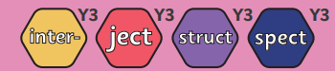 |  |  |  | 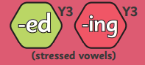 |  |  |  |  |  |  |  |  |  |  | 
Year 4 Spelling | 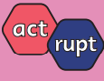 |  |  | 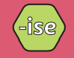 | 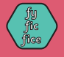 |  |  |  | 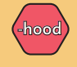 |  |  |  | 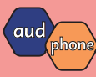 | Matrix application |  |  | Buffer Weeks
Comprehension | Dental hygiene |  | Europe |  |  |  | Storyteller of the skies |  |  | How does the ear work? |  | Discover Dudley Castle |  |  | Visit Ancient Egypt |  |  | Performance poetry
Handwriting | Yr 4: Securing joins. Pupils consolidate their understanding of joins, working towards confident and automatic use of joined handwriting across subjects.

Year 5 Autumn Term
Core Texts | Autumn 1 (7 weeks) |  |  |  |  |  |  |  |  | Autumn 2 (7 weeks)
 | Treason |  |  |  |  |  |  |  |  | The Girl of Ink and Stars
Writing | 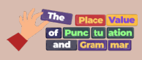  The Place Value of Punctuation and Grammar (5 weeks)  Common and proper nouns  What are collective and partitive nouns?  What are abstract nouns?  Being verbs ‘to have’  Regular action verbs and verb phrases  Irregular action verbs and verb phrases  Phrasal verbs  What is a subject?  Building single clause sentences (Stage 1, 2 and 3)  Co-ordinating conjunctions to join clauses  Compound subjects and dummy subjects  Gerunds |  |  |  |  |  |  | 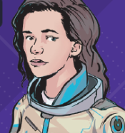  Luminara  Sentence Pattern Building unit (2 weeks) |  | 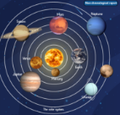  Planets of the solar system  Non-chronological report (4 weeks)  Heading  Brief introduction  Subheadings  Technical vocabulary  Pictures and captions  Third person - formal  Statements giving factual information  Co-ordinating conjunctions  Subordinating conjunctions  Adverbs/adverbials of time  Adverbs/adverbials of reason  Adverbs/adverbials of manner  Adverbs/adverbials of place  Expanded noun phrases  Commas in a list  Apostrophes for possession |  |  |  | 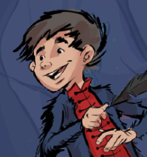  Xor: the wannabe wizard  Recount- letter (3 weeks)  Address  Date  Salutation  Brief introduction  Chronological order  First person  Past tense  Facts and opinions  Rhetorical questions  Sign off  Active voice  Subordinating conjunctions  Co-ordinating conjunctions to join clauses  Expanded noun phrases Adverbs/adverbials of time Adverbs/adverbials of manner Adverbs/adverbials of place
Spelling | Assessments | Vowels and Consonants |  | Compound words | Intro to morph-ology | 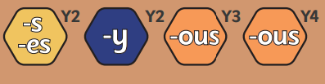 |  |  |  | 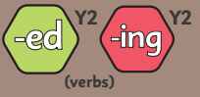 |  |  | 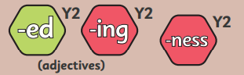
Year 5 Spelling |  |  |  |  |  | 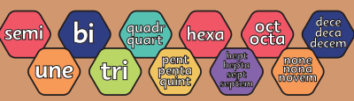 |  |  |  | 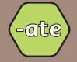 |  | 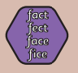 |  |  |  | Buffer weeks
Comprehension | Jabberwocky/The Walrus and the Carpenter |  | Flamma: The Gladiator/The Legend of Boudicca |  |  |  | Teeth/The Digestive System |  | Space Tourism/Astronauts |  | Pandora’s Box/King Midas and the Golden Touch |  |  |  | River Trent/River Thames
Handwriting | Upper Key Stage 2 – developing fluency and presentation. Children practise joined handwriting with a focus on speed, fluency, and presentation. They apply these skills consistently across all written work.

Core Text | Spring 1 (6 weeks) |  |  |  |  |  |  |  | Spring 2 (4 weeks, 4 days)
 | Secrets of a Sun King |  |  |  |  |  |  |  | Always Clementine
Writing |   Charles Darwin  Recount – diary (3 weeks)  Date  Salutation  Chronological order  Past tense  First person  Facts and opinions  Rhetorical questions  Sign off  Subordinating conjunctions  Conjunctive adverbs  Relative clauses  Adverbs/adverbials of time Adverbs/adverbials of place  Expanded noun phrases |  |  |  | 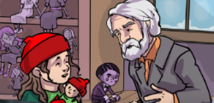  Alma vs the Dollmaker  Characterising Speech (3 weeks)  Introduction  Direct speech  Each character shows emotions  Each character performs actions  Short sentences for effect  Colloquial language (non-Standard English) Discourse markers  Expanded noun phrases  Adverbs/adverbials of manner  Participial phrases/clauses  Relative clauses  Adverbs/adverbials of place  Inverted commas  Parentheses  Ellipses to show stammer, pause or incomplete thought  Hyphens to show stutter |  |  |  | 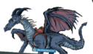  How to Train your Dragon  Instructions (3 weeks)  Title  Statement  List of equipment or materials Sequenced, chronological steps Diagrams or illustrations  Present tense  Imperative verbs (commands) Detailed information  Co-ordinating conjunctions Subordinating conjunctions Expanded noun phrases Commands, using the imperative Adverbs/adverbials of manner Adverbs/adverbials of time Commas in a list  Parentheses  Apostrophes for possession Commas |  |  | 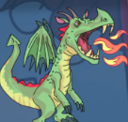  Dragon Poetry  Poetry (1 week 4 days)
Spelling | 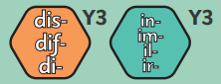 |  |  |  |  |  |  |  | 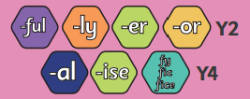 |  |  | 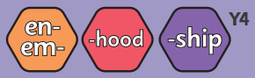
Year 5 Spelling | 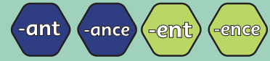 |  |  |  |  |  |  |  | 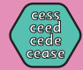 |  |  | Buffer weeks
Comprehension | The Good Ferryman and the Water Nymphs/An Old Dog’s Trick | How are Volcanoes formed? /How are Rivers formed? |  | The Car Trip/Chocolate Cake |  |  | The Legend of Ragnor Lothbrok/  The Blood in the Snow | Romeo and Juliet. Act 1 Scene 4/Romeo and Juliet. Act 1 Scene 5 |  | Physical Features of North America/ The Biomes of North America |  |  | No Problem/The British
Handwriting | Upper Key Stage 2 – developing fluency and presentation. Children practise joined handwriting with a focus on speed, fluency and presentation. They apply these skills consistently across all written work.

Year 5 Summer Term
Core Texts | Summer 1 (7 weeks) |  |  |  |  |  |  |  |  | Summer 2 (7 weeks)
 | The White Horse of Zennor |  |  |  |  |  |  |  |  | Tom’s Midnight Garden
Writing | 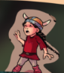  Artura and the Silver Lasso  Narrative (4 weeks)  Past tense  Expanded noun phrases  Relative clauses  Participial phrases  Punctuating and characterising speech |  |  |  | 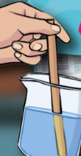  Does the Size of Sugar affect how Quickly it Dissolves in Water?  Science Experiment (3 weeks)  Title – question  Prediction/hypothesis  Equipment list  Method in sequenced, chronological steps  Results/observations  Conclusion  Diagrams  Present tense  First person  Commands  Detailed information  Technical vocabulary  Subordinating conjunctions  Modal verbs  Expanded noun phrases Adverbs/adverbials of manner Adverbs/adverbials of time  Conjunctive adverbs  Relative clauses  Commas, brackets and dashes for parentheses |  |  |  |  | 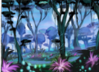  Pandora  Setting description (4 weeks)  Introduction  Paragraphs pan the setting  Figurative language  Short sentences for effect  Rhetorical questions  Conclusion including a cliffhanger Expanded noun phrases including sights, sounds and smells  Adverbials of manner including similes Participial phrases (-ing and -ed openers)  Relative clauses  Adverbials of place  Apostrophes for possession |  |  |  |  |   Visit California  Persuasive advert (3 weeks)  Deals and bargains  Direct address (can include flattery) Alliteration and assonance  Facts and statistics  Opinion (can be expert opinion) Repetition  Rhetorical questions Emotive/exaggerated language Triples/the rule of three  Modal verbs  Adverbs for possibility/degree Personal pronouns  Expanded noun phrases Subordinating conjunctions Conjunctive adverbs  Commands  Commas in a list  Hyphens
Spelling | 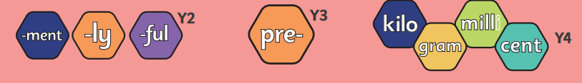 |  |  |  |  |  |  | 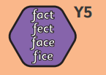 |  |  |  |  |  |  |  | 
Year 5 Spelling | 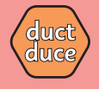 | 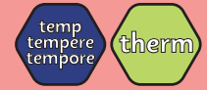 |  | 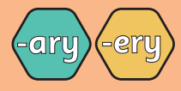 |  |  | 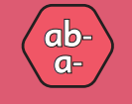 |  | 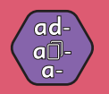 |  |  | 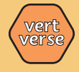 |  | 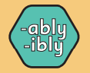 |  |  |  | Buffer weeks
Comprehension | Nature’s Poem/A Waterdrop’s Adventure |  | Baby Yaga/The Tale of Little Thumb |  |  | The Ungrateful Snake/ The Story of Lord Krishna |  |  |  | Tell-Tale Heart/Frankenstein |  |  | Physical Features of the UK/Physical Features of California |  |  |  | Plant Reproduction/Life Cycles
Handwriting | Upper Key Stage 2 – developing fluency and presentation. Children practise joined handwriting with a focus on speed, fluency, and presentation. They apply these skills consistently across all written work.

Year 6 Autumn Term
Core Texts | Autumn 1 (7 weeks) |  |  |  |  |  |  |  |  |  | Autumn 2 (7 weeks)
 | The Vanishing Trick |  |  |  |  |  |  |  |  |  | Goodnight Mr Tom
Writing | 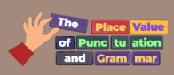  The Place Value of Punctuation and Grammar (5 weeks)  Common and proper nouns  What are collective and partitive nouns?  What are abstract nouns?  Being verbs ‘to have’  Regular action verbs and verb phrases  Irregular action verbs and verb phrases  Phrasal verbs  What is a subject?  Building single clause sentences (Stage 1, 2 and 3)  Co-ordinating conjunctions to join clauses  Compound subjects and dummy subjects  Gerunds |  |  |  |  |  |  | 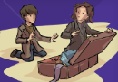  Danger at the Lighthouse  Sentence pattern building unit (2 weeks) |  |  |   Mechanimals  Non-Chronological Report  (4 weeks)  Heading  Brief introduction  Subheadings  Technical vocabulary  Pictures and captions  Third person - formal Statements giving factual information  Co-ordinating conjunctions Subordinating conjunctions Adverbs/adverbials of time Adverbs/adverbials of reason Adverbs/adverbials of manner Adverbs/adverbials of place Expanded noun phrases  Apostrophes for possession |  |  |   Raysha and Aashman  Characterising Speech (3 weeks)  Introduction  Each character shows emotions  Each character performs actions  The audience reacts to each character Short sentences for effect  Colloquial language (non-Standard English)  Discourse markers  Expanded noun phrases Adverbs/adverbials of manner Participial phrases/clauses  Relative clauses  Adverbs/adverbials of place  Inverted commas  Colons/semi-colons  Parentheses  Ellipses to show stammer, pause or incomplete thought  Dashes to show change of thought or interruption  Hyphens to show stutter
Spelling | Assessments | Vowels and Consonants |  | Compound words | Intro to morphology | 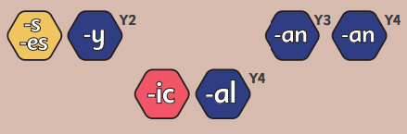 |  |  | 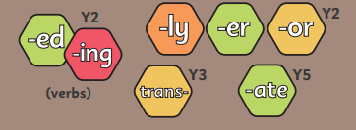 |  |  | 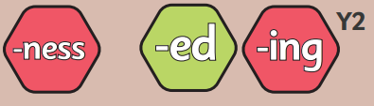
Year 6 Spelling |  |  |  |  |  |  |  |  | 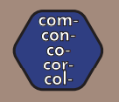 |  |  | 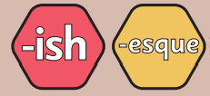 |  |  |  | Buffer weeks
Comprehension | Cyber bullying/Medusa |  | Katherine Ferrers/Julius Caesar |  |  |  | Winston Churchill/Tutankhamen |  |  | Hamlet/Macbeth |  |  | Reginald Joseph Mitchell/World War II |  | A Christmas Carol: Marley’s Ghost/Bob Crachit’s House
Handwriting | Upper Key Stage 2 – embedding legibility and style. Pupils refine their handwriting style, ensuring legibility, fluency, and appropriate presentation. Joined handwriting becomes a natural and efficient tool for written communication.

Year 6 Spring Term
Core Texts | Spring 1 (6 weeks) |  |  |  |  |  |  |  |  | Spring 2 (4 weeks, 4 days)
 | Wolf Wilder |  |  |  |  |  |  |  |  | Wolf Wilder
Writing | 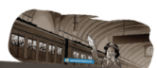  Evacuee’s Letter  Recount – letter (3 weeks)  Address  Date  Salutation  Brief introduction  Chronological order  First person  Past tense  Facts and opinions  Rhetorical questions  Sign off  Active voice  Subjunctive mood/form Subordinating conjunctions Conjunctive adverbs  Relative clauses  Expanded noun phrases Adverbs/adverbials of time Adverbs/adverbials of place Parentheses  Semi-colons/colons  Apostrophes for plural possession |  |  |  |   Danger at the Lighthouse  Narrative (3 weeks)  Past tense  Adverbials and fronted adverbials to vary sentence structure  Speech  Informal language and contractions  Relative clauses  Semi colons  Show don’t tell (conveying characters’ emotions)  Creating drama |  |  |  |  |   How Does the Circulatory System  Work?  Explanation (3 weeks)  Title  Introductory paragraph Paragraphs detailing a process  Facts  Present tense  Formal language  Technical vocabulary  Passive voice  Subordinating conjunctions Expanded noun phrases Relative clauses  Conjunctive adverbs for cause and effect  Adverbs / adverbials of time Evaluative adverbs  Semi-colons / colons Parentheses |  |  |   Personal poetry  Poetry (1 week, 4 days)
Spelling | 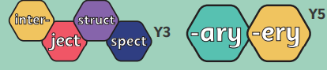 |  |  |  |  | 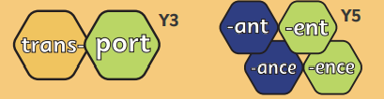 |  |  |  | 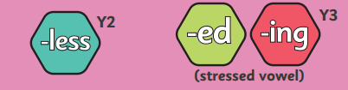 |  |  |  | 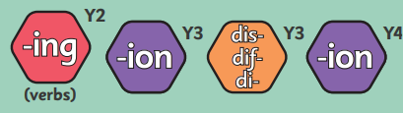
Year 6 Spelling |  | 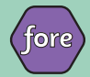 |  | 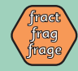 |  |  |  | 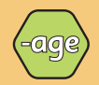 |  |  | Matrix application |  |  | Buffer weeks
Comprehension | Gothic Fiction Characters/The Maya |  | What is Light and How do we See? / How Does Electricity Travel in a Circuit? |  |  |  | Migration to the UK/Windrush Passenger |  | The Listeners/The Scarecrow |  |  | Exports of the UK/Biomes of the World
Handwriting | Upper Key Stage 2 – embedding legibility and style. Pupils refine their handwriting style, ensuring legibility, fluency, and appropriate presentation. Joined handwriting becomes a natural and efficient tool for written communication.

Year 6 Summer Term
Core Texts | Summer 1 (7 weeks) |  |  |  |  |  |  | Summer 2 (7 weeks)
 | Pig Heart Boy |  |  |  |  |  |  | Wonder
Writing |   How to Slay a Legendary Beast  Instructions (3 weeks)  Title statement  List of equipment or materials  Sequenced, chronological steps  Diagrams or illustrations  Present tense  Imperative verbs (commands)  Detailed information  Co-ordinating conjunctions  Subordinating conjunctions  Expanded noun phrases  Commands, using the imperative Adverbs/adverbials of manner Adverbs/adverbials of time  Commas in a list  Parentheses  Apostrophes for possession  Commas |  |  | SATS |  |  |  | 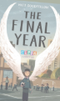  The Last Year  Recount –diary (4 weeks)  Date  Salutation  Chronological order  Past tense  First person  Facts and opinions Rhetorical questions  Sign off  Active voice  Subjunctive mood Subordinating conjunctions Conjunctive adverbs  Relative clauses Adverbs/adverbials of time Adverbs/adverbials of place Expanded noun phrases Semi-colons |  |   Famous Outlaws  Non-Chronological Report (3 weeks)  Heading  Brief introduction Subheadings  Technical vocabulary Pictures and captions  Third person - formal Statements giving factual information  Co-ordinating conjunctions Subordinating conjunctions Adverbs/adverbials of time Adverbs/adverbials of reason Adverbs/adverbials of manner  Adverbs/adverbials of place Expanded noun phrases Apostrophes for possession
Spelling | 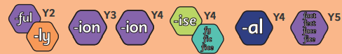 |  |  |  |  | TBC
Year 6 Spelling |  | Matrix application |  |  |  | TBC
Comprehension | Desert Creatures/Desert Biomes |  | The Circulatory System and the Heart/The Digestive System |  | SATS |  | SATS |  | A Day in the Life of a Cardiologist/A Day in the Life of a Pharoah |  | Narwhals/Polar Bears
Handwriting | Upper Key Stage 2 – embedding legibility and style. Pupils refine their handwriting style, ensuring legibility, fluency, and appropriate presentation. Joined handwriting becomes a natural and efficient tool for written communication.

