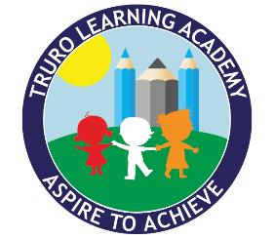


Characteristics of Effective Teaching and Learning

The Characteristics of Effective Teaching and Learning describe how children learn best: through playing and exploring, active learning, and creating and thinking critically as they investigate, persist, and solve problems with increasing independence.
- Playing and Exploring – how children engage with experiences, show curiosity and are willing ‘to have a go’. We give children space to explore while stepping in at the right moments to extend their thinking.
- Active Learning – how children stay motivated, sustain effort, and keep trying when things are tricky. We plan environments and experiences that encourage children to take initiative and persevere with new challenges.
- Creating and Thinking Critically – how children make connections, solve problems, and reflect on what they have learned. We give children time to plan, make choices, and explain their reasoning.

At the end of every day, our children sit together to share their successes and together, we build a class of confident learners.

