Multiplication and Division
Year 2
Multiplication as Repeated Addition
Vocabulary:
Group Equal Unequal Repeated Addition Multiplication Expression Equation Part Altogether Represents Amount Size

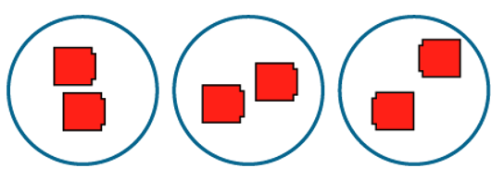
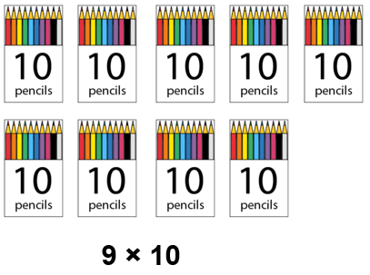


Understand the difference between equal and unequal groups.
The ___ have been grouped.

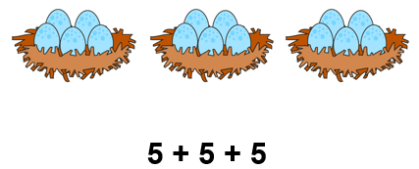
We can represent equal groups as repeated addition.
There are 3 groups of 5.

We can skip count in multiples of __ to work out the total amount.
10, 20, 30, 40 … there are 90 pencils altogether.

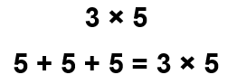

The ___ represents the number of groups.
The __ represents the number of ___ in each group.
___ represents the total number of ___.

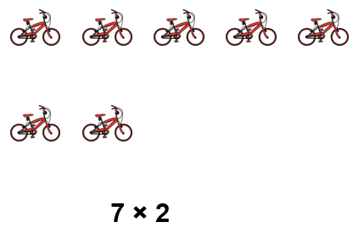

We can represent repeated addition using a multiplication expression.
The 3 represents the number of groups.
The 5 represents the number of eggs in each group.
15 represents the total number of eggs.

Notice how the representations allow the children to see each of the numbers (i.e. 10 pencils and 9 packets).

Vocabulary:
Ones Tens Digit Represents Place Value Gattegno Chart Column Model Part Whole Addend Sum Minuend Subtrahend Difference Plus Minus Equals Combine Partition

Addition and Subtraction
Year 1
Compose and Partition Numbers to 10
Vocabulary:
Multiplication Division Factor ‘divided by’ Represents Skip Counting
Multiplication facts Groups Amount Size

Multiplication and Division
Year 2
Grouping problems: missing factors and division

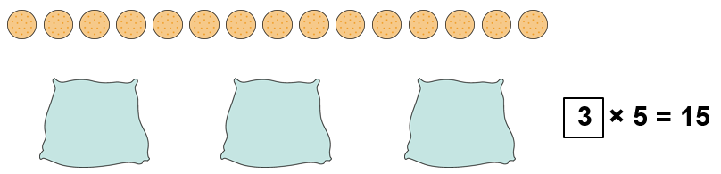

The 15 represents the number of biscuits.
The 5 represents the number of biscuits in each bag (group).
The 3 represents the number of bag (groups).

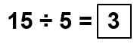
We can solve division problems by finding missing factors.

We can use ÷ to mean ‘divided by’
We can use our knowledge of times tables to help solve division problems.

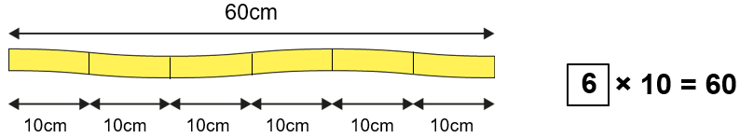

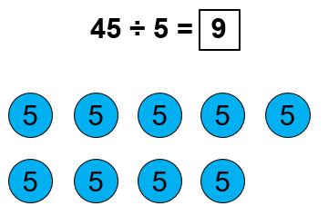

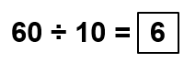

The 60cm represents the length of the ribbon.
The 10 represents the size of each piece.
The 6 represents the number of pieces we can make.

Multiplication and Division
Year 3
Multiplication and Division Structures
Vocabulary:
Multiplication Division Commutative Grouping (Quotitive) Sharing (Partitive)
‘Divided into’ ‘Divided between’ ‘Divided by’ Equation Factor Product

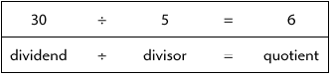

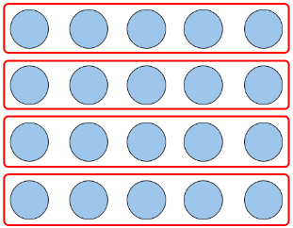
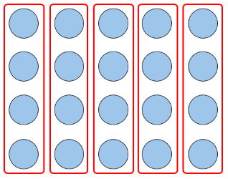
Division equations can be used to represent ‘grouping’ problems.
We can use multiplication facts to find the number of groups.
(Quotitive division)
15 divided into groups of 5 is equal to 3.
5 + 5 + 5 = 15
15 – 5- 5 – 5 = 0
15 ÷ 5 = 3

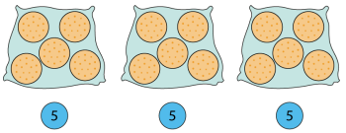

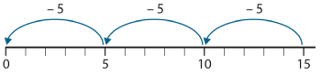
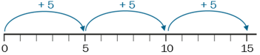
Removing groups of

Making groups of

Identify that multiplication is commutative.
4 x 5 = 5 x 4
Factor times factor is equal to product.
The order of the factors does not affect the product.

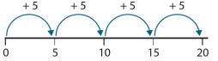
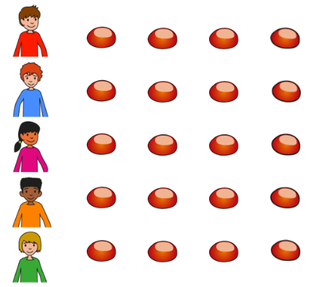
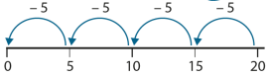
Division equations can be used to represent ‘sharing’ problems.
We can use multiplication facts to find the size of groups.
(Partitive division)
Four fives are four each.
20 divided between 5 is equal to 4 each.
20 ÷ 5 = 4

20 divided by 5 is 4 each.

Giving a share

Receiving a share

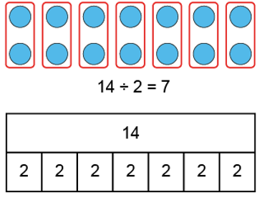
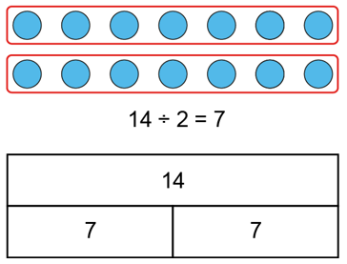
The same equation can be represented in both grouping and sharing contexts.
7 times 2 is 14, so 14 ÷ 2 = 7

Vocabulary:
Multiply Divide Unitise Ten/Hundred times Bigger Smaller One-tenth the size One-hundredth the size Gattegno chart Factor Product Multiple Groups of Inverse

Multiplication and Division
Year 4
Multiplying and Dividing by 10 and 100

Generalisations

All multiples of 10 have a ones digit of zero.

All multiples of 100 have both a tens and ones digit of zero.

To find the inverse of ___times as many, you divide by ____.

If one factor if made ___ times bigger/smaller then the product will be ten times bigger/smaller

Develop language in order to multiply and divide by 10 or 100.
80 is ten times bigger than 8.
8 is ten times smaller than 80.
80 is ten times the size of 8
8 is one-tenth the size of 80.

800 is one hundred times bigger than 8.
8 is one hundred times smaller than 800.
800 is on hundred times the size of 8
8 is one-hundredth the size of 80.

8 x 1 = 8
8 x 1 ten – 8 tens
8 x 1 hundred = 8 hundreds

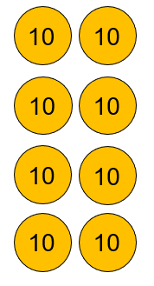
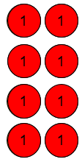
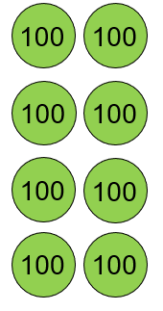
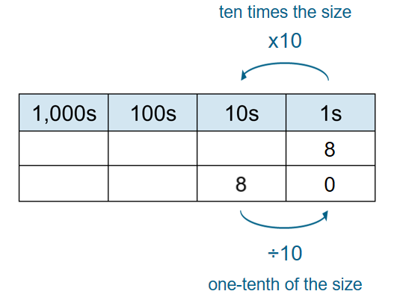
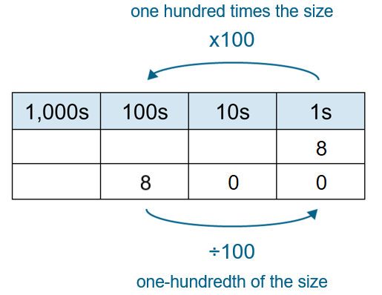

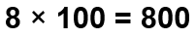
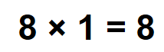
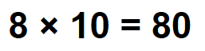
8 groups of ___ is ___.

Vocabulary:
Multiply Divide Commutative Groups of Times Equal to Factors Product Quotient Dividend Divisor Represents Array

Multiplication and Division
Year 4
Manipulating the Multiplicative Relationship

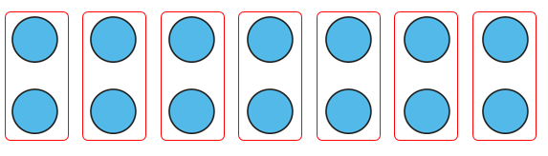
Understand that multiplication is commutative and the factors can be
2 groups of 7 is equal to 14.
2, 7 times is equal to 14.
2 groups of 7 is equal to 7, two times.

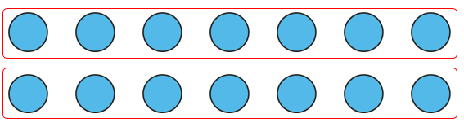
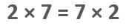

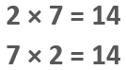
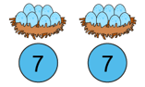
The 2 represents ___.
The 7 represents ___.
The 14 represents ___.

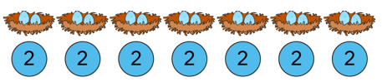
Match equations to representations and contexts.

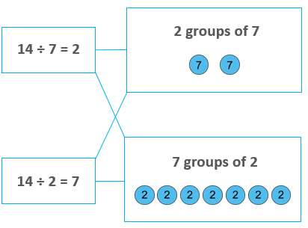

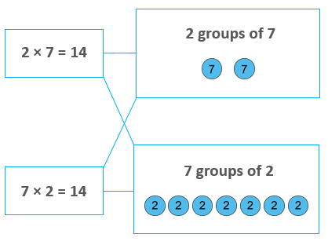

Vocabulary:
Multiplication Distributive Law Adjacent Multiples Factors Partitioning Equations Expressions Arrays Part-whole model Difference

Multiplication and Division
Year 4
The Distributive Property of Multiplication

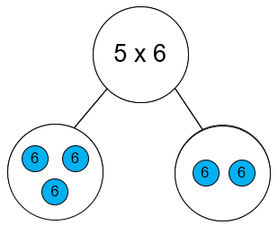
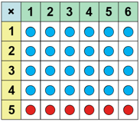
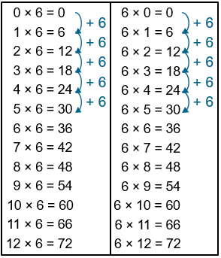

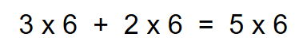

5 is equal to 3 plus 2, so 5 sixes is equal to 3 sixes plus 2 sixes.

Five sixes is one more six than four sixes.

Adjacent multiples of ___ have a difference of ___.

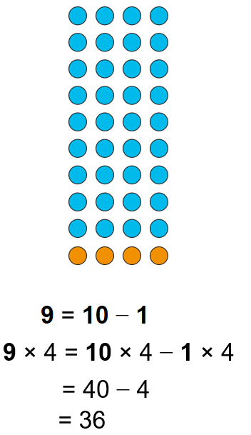
We can partition the factors in different ways to make calculations easier.

We can partition one of the factors to make calculations easier.

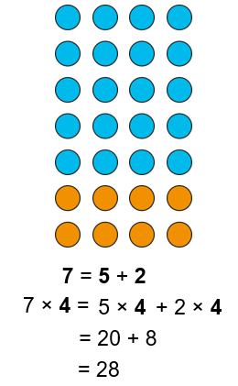
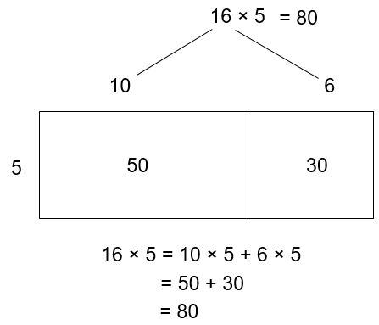
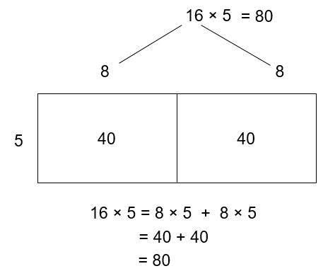
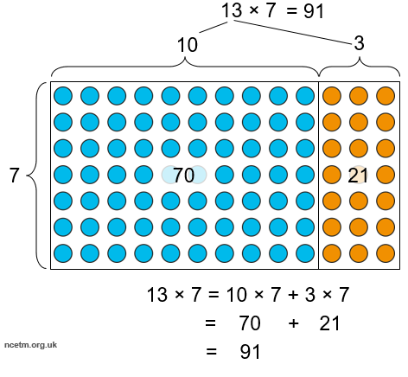

Vocabulary:
Multiply Divide Unitise Ten/Hundred times Bigger Smaller One-tenth the size One-hundredth the size Gattegno chart Factor Product Multiple Groups of Inverse Ones Tens Hundreds Tenths Hundredths

Multiplication and Division
Year 5
Multiplying and Dividing by 10 and 100 (1)

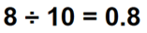
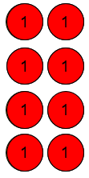
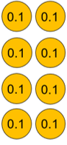
We can multiply and divide a number by 10.

8, made one-tenth the size is 0.8.
8 divided by 10 is 0.8.
First we had 8 ones, now we have 8 tenths.

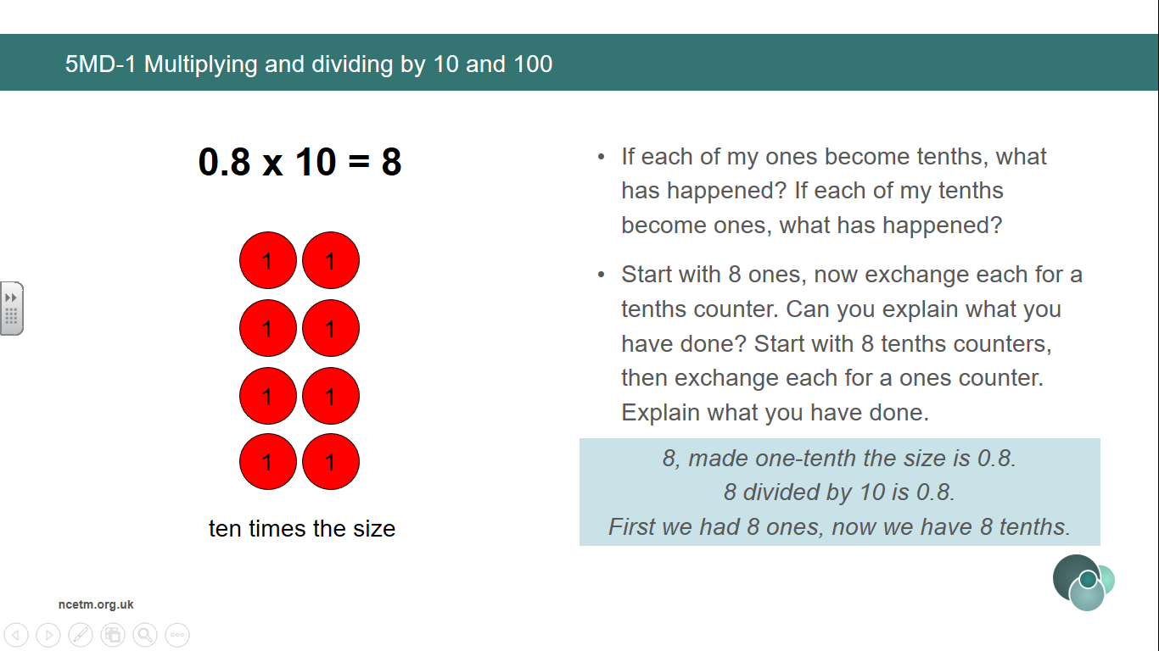

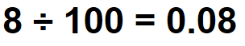
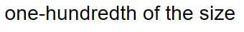
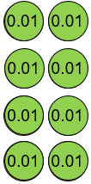
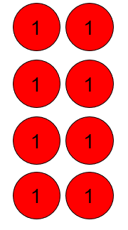
We can multiply and divide a number by 100. Multiplying by 100 is the same as multiplying/dividing by 10 twice.

8, made 100 times smaller is 0.08.
8 divided by 100 is 0.08.
First we had 8 ones, now we have 8 hundredths

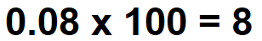
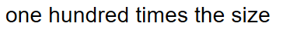
3
Multiplication and Division
Year 5
Multiplying and Dividing by 10 and 100 (2)
Vocabulary:
Multiply Divide Unitise Ten/Hundred times Bigger Smaller One-tenth the size One-hundredth the size Gattegno chart Factor Product Multiple Groups of Inverse Ones Tens Hundreds Tenths Hundredths

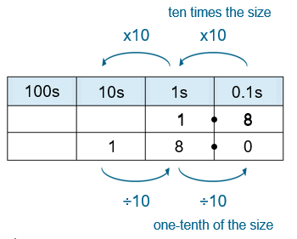

1.8 is one-tenth the size of 18
18 divided by 10 is 1.8.
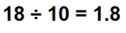

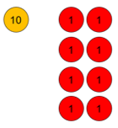
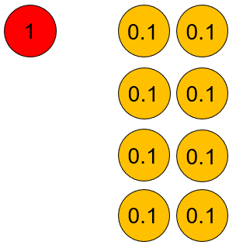
__ divided by 10/100 is equal to__.
__ is one-tenth/hundredth the size of __.
__ multiplied by 10/100 is equal to__.
__ is 10/100 times the size of __.

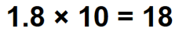
We can multiply and divide numbers with digits greater than 0 by 10 or 100.
Generalisation
To multiply by 10, move each digit one place to the left.
To multiply by 100, move each digit two places to the left.
To divide by 10, move each digit one place to the right.
To divide by 100, move each digit two places to the right.

Vocabulary:
Multiply Divide Unitise Ten/Hundred times Bigger Smaller One-tenth the size One-hundredth the size Gattegno chart Factor Product Multiple Groups of Inverse Ones Tens Hundreds Tenths Hundredths

Multiplication and Division
Year 5
Multiplying and Dividing by 10 and 100 (3).

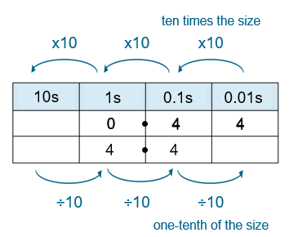

0.27 is one-tenth the size of 2.7
2.7 divided by 10 is 0.27.

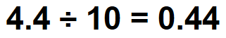
__ divided by 10/100 is equal to__.
__ is one-tenth/hundredth the size of __.
__ multiplied by 10/100 is equal to__.
__ is 10/100 times the size of __.

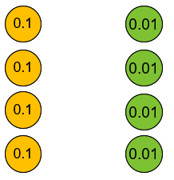
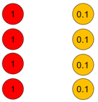

We can multiply and divide numbers with digits greater than 0 by 10 or 100.
Generalisation
To multiply by 10, move each digit one place to the left.
To multiply by 100, move each digit two places to the left.
To divide by 10, move each digit one place to the right.
To divide by 100, move each digit two places to the right.

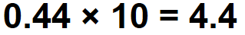

Multiplication and Division
Year 5
Find Factors and Multiples
Vocabulary:
Factor Multiple Composite Square Prime Common Factor Prime Factor
Factor Bug Array Positive Integer Working Systematically
Factor x Factor = Product Dividend ÷ Divisor = Quotient

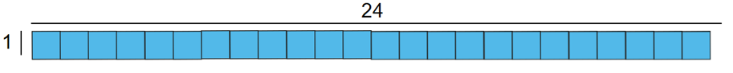
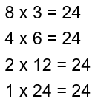
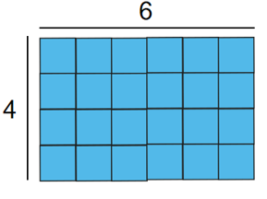
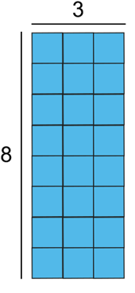
There are ___ tiles. There are ___ rows and ___ columns. So ___ and ___ are factors of ___.
Generalise: Numbers that have more than two factors are composite numbers.

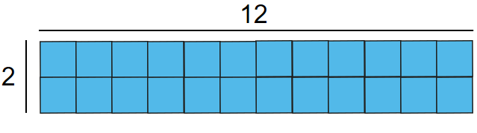
Manipulate the array and write the equations to support each representation.
Factor x Factor = Product
Use factor bugs to record pairs of factors.

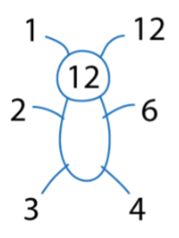

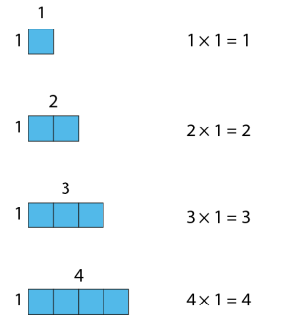
Generalise:
When one is a factor, the product is equal to the other factor.
All positive integers have a factor of 1.
Every positive integer is a factor of itself.
The smallest factor of a positive integer is always 1. The largest factor of a positive integer is always itself.

Multiplication and Division
Year 5
Find Factors and Multiples
Vocabulary:
Factor Multiple Composite Square Prime Common Factor Prime Factor
Factor Bug Array Positive Integer Working Systematically
Factor x Factor = Product Dividend ÷ Divisor = Quotient


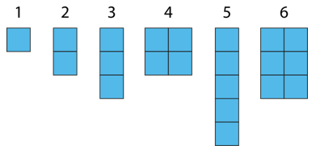
Make connections with factors and times tables. Make connections with factors of factors
___ is a factor of ___ because it is in the ___ times table.
Nine is a factor of all of these numbers.
Three is a factor of nine which means it is also a factor of all of these numbers.

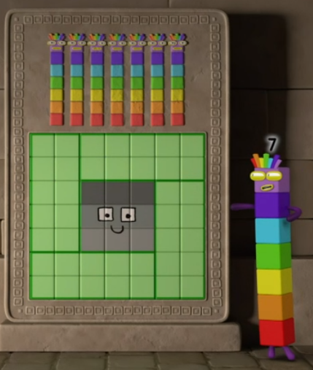

Is 9 a factor of 54?
54 ÷ 9 = 6
9 and 6 are factors of 54.
Factor x Factor = Product

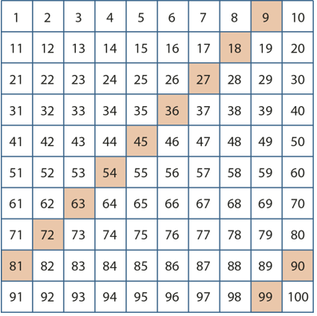
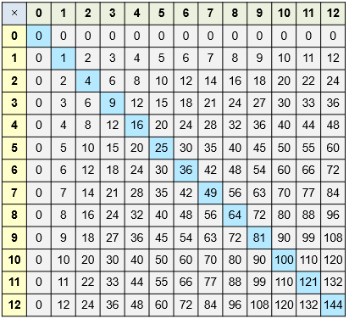
Extend this to square numbers, and prime numbers recognising the number of factors.

Use factor bugs to find
common factors and prime factors.

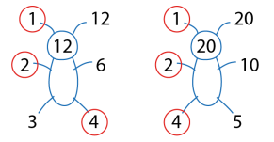
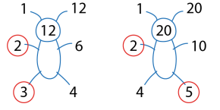

Vocabulary:
Factor Multiple Composite Square Prime Common Factor Prime Factor
Factor Bug Array Positive Integer Working Systematically
Factor x Factor = Product Dividend ÷ Divisor = Quotient

Multiplication and Division
Year 5
Find Factors and Multiples
Subtract from any two-digit number by subtracting tens then ones without crossing a tens boundary.

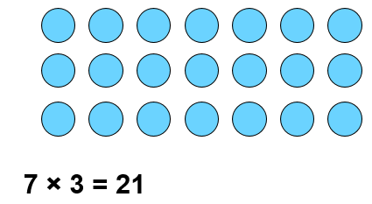

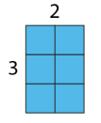
Introduce Multiples

___ is a factor of ___ because ___ x ____ = ____.
___ is a multiple of ___ because ___ x ___ = ____
___ is a factor of ___ because ___ ÷ ____ = ____.
___ is a multiple of ___ because ___ ÷ ___ = ____

Make statements about factors and multiples whilst increasing the amount of each counter in the array.
___ represents the number of counters in each row.
___ represents the total value of the counters in each column.
____ represents the total value of the counters.
3, 7, 10, 21 and 70 are factors of 210.
210 is a multiple of 3, 7, 10, 21 and 70.

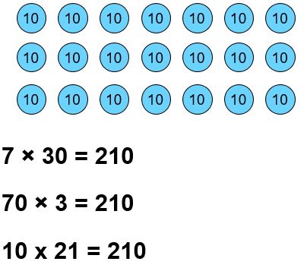
Identify Common Multiples using a 100 square.

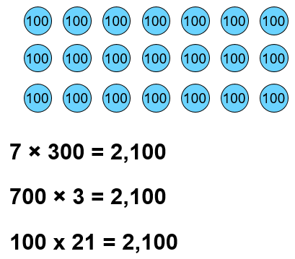
Factors of 100 can be applied to contexts


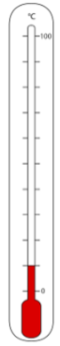
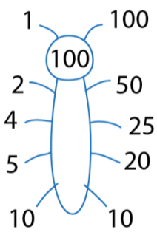
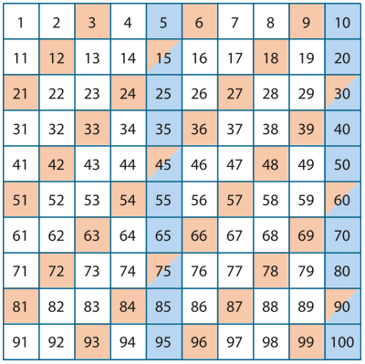

Multiplication and Division
Year 5
Multiply using a Formal Written Method (1)
Vocabulary:
Ones Tens Hundreds Thousands Represents Partition Recombine Multiply Unitising Partial Product Aligned Calculation Expanded layout Compact layout Equation Regroup Algorithm

Factor x Factor = Product

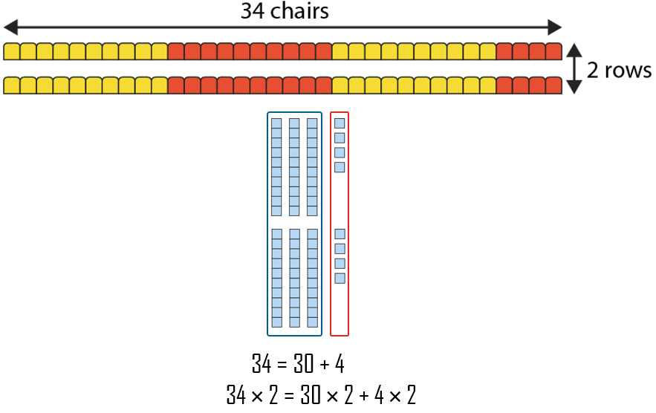
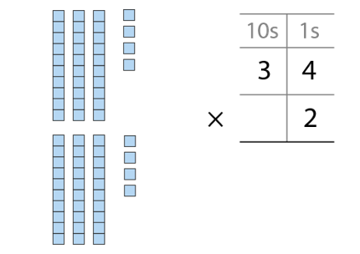
Move between representations of dienes and expanded written multiplication.

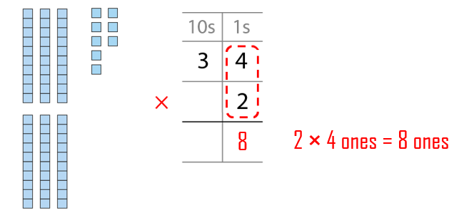
Use dienes to represent context as repeated addition and move to multiplication.

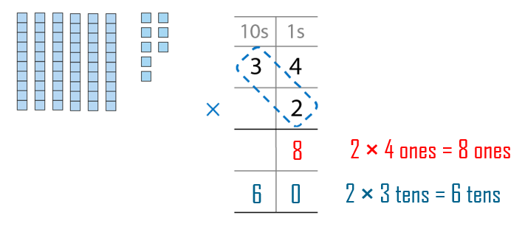

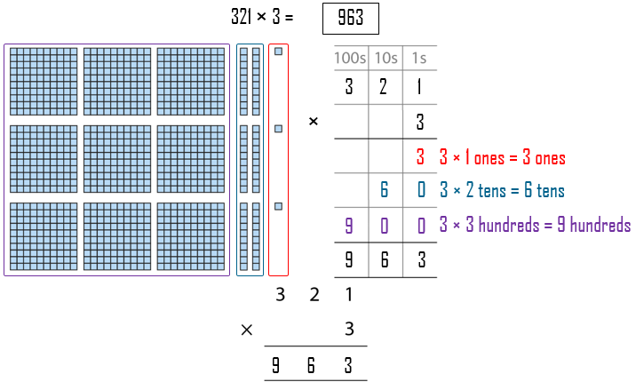
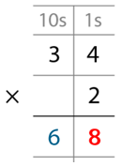

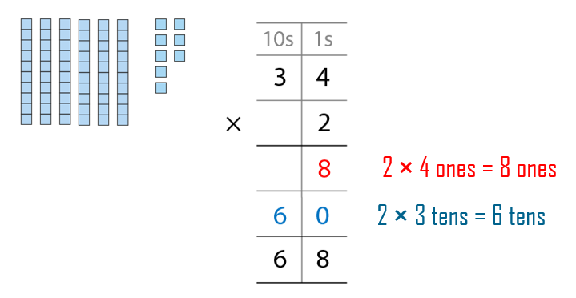

Represent 3 digit by 1 digit multiplication without exchanges using dienes, moving from expanded layout to compact layout.

Move between representations of expanded layout and compact layout.

Vocabulary:
Ones Tens Hundreds Thousands Represents Partition Recombine Multiply Unitising Partial Product Aligned Calculation Expanded layout Compact layout Equation Regroup Algorithm

Factor x Factor = Product

Multiplication and Division
Year 5
Multiply using a Formal Written Method (2)

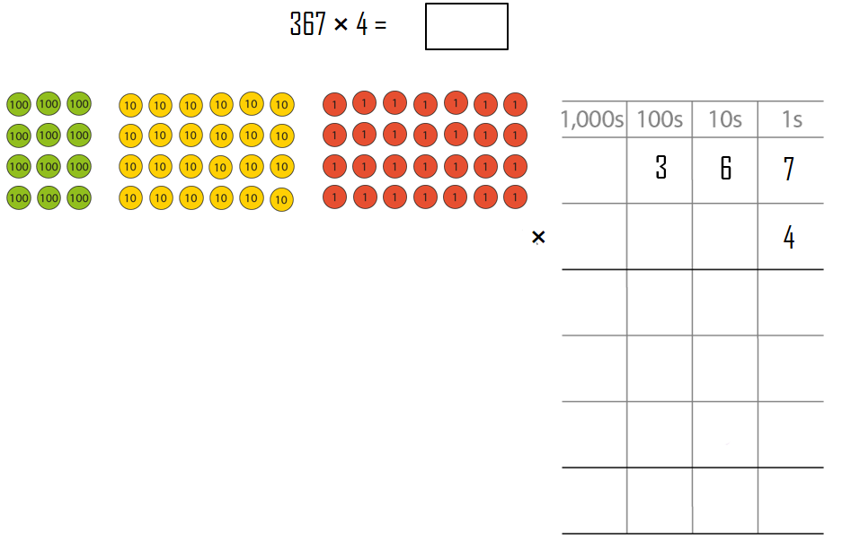
Represent 3 digit by 1 digit multiplication with exchanges using place value counters, moving from expanded layout to compact layout.

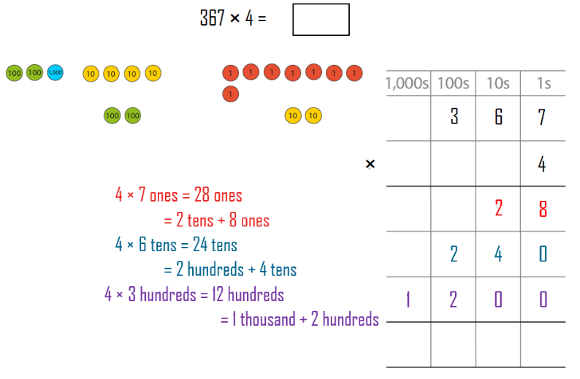

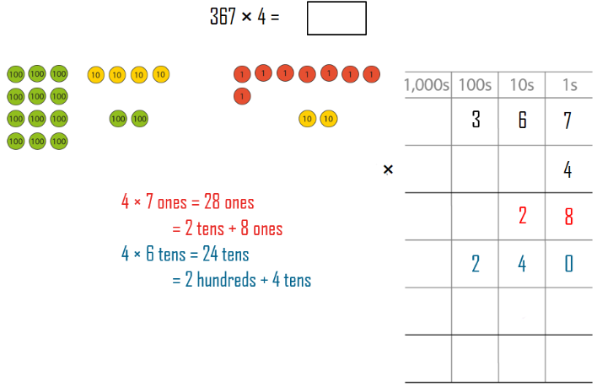

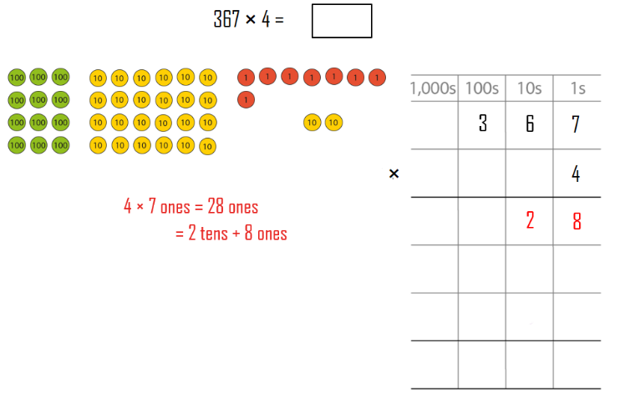

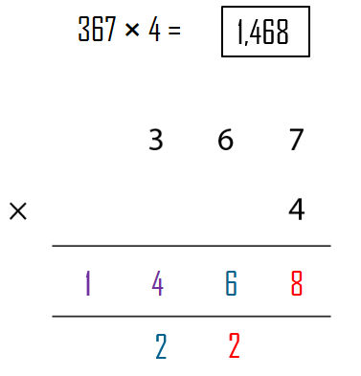

Move from expanded layout to compact layout.

If there are 10 or more ones, we must regroup ones into tens and ones.
If there are 10 or more tens, we must regroup into hundreds and tens.
If there are 10 or more hundreds, we must regroup into thousands and hundreds.

Vocabulary:
Partitive (sharing) Quotitive (grouping) Ones Tens Hundreds Thousands Represents Divide Unitising Dividend Divisor Quotient Partial Quotient Aligned Calculation Equation Exchange Algorithm ‘Sharees’ Divisible Remainder Short Division

Multiplication and Division
Year 5
Divide using a Formal Written Method (1)

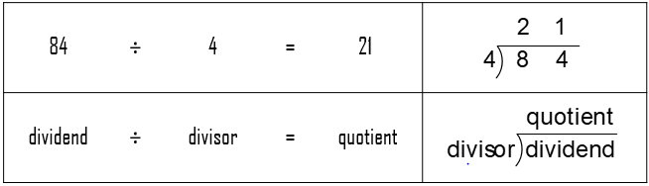

Use sticks to represent partitive (sharing) context where the dividend is divisible (to give a whole number). Skip count in multiples of the divisor.
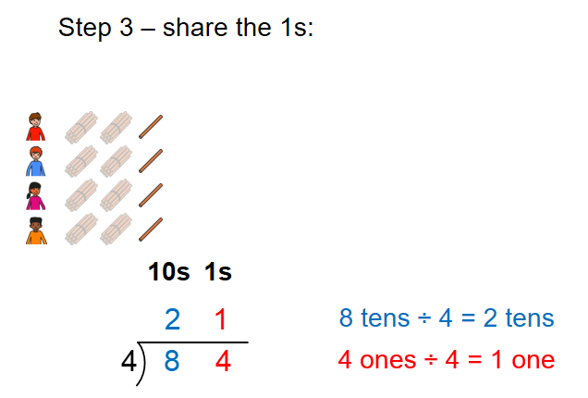
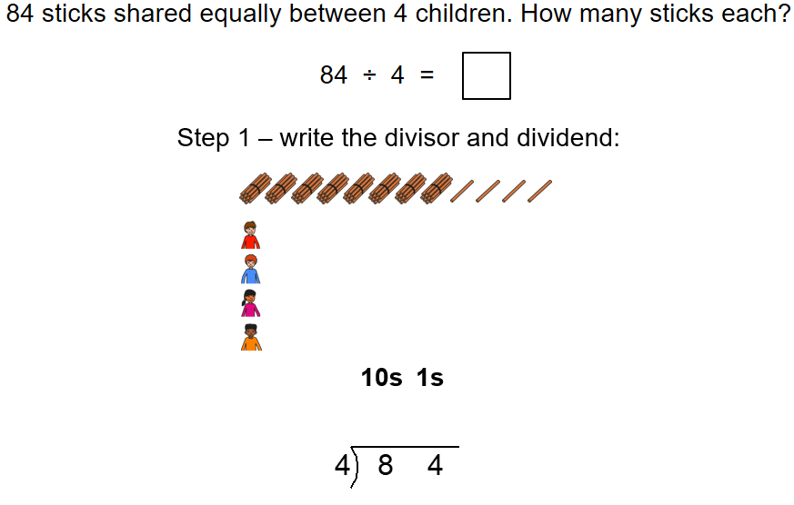
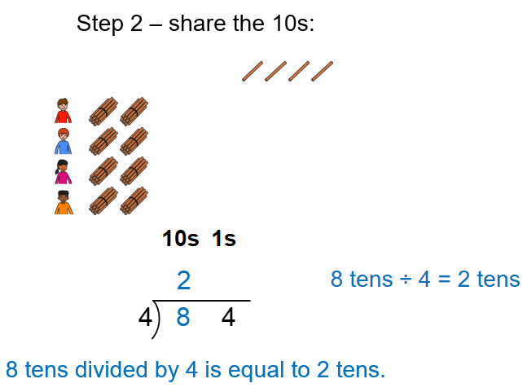

Add the partial quotients to find the quotient.
2 tens + 1 one = 21

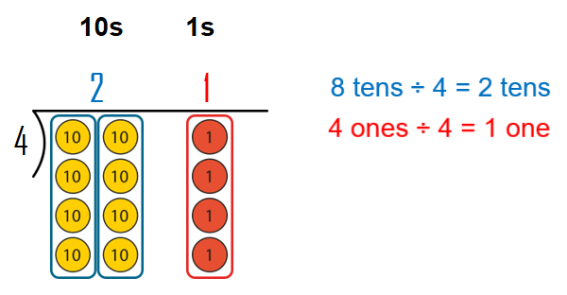
Remove a group of 4 each time before sharing.
One four is one each. That’s four.
Two fours is two each. That’s eight.
Eight divided between 4 is equal to two each.
Each child gets two sticks.

Vocabulary:
Partitive (sharing) Quotitive (grouping) Ones Tens Hundreds Thousands Represents Divide Unitising Dividend Divisor Quotient Partial Quotient Aligned Calculation Equation Exchange Algorithm ‘Sharees’ Divisible Remainder Short Division

Multiplication and Division
Year 5
Divide using a Formal Written Method (2)

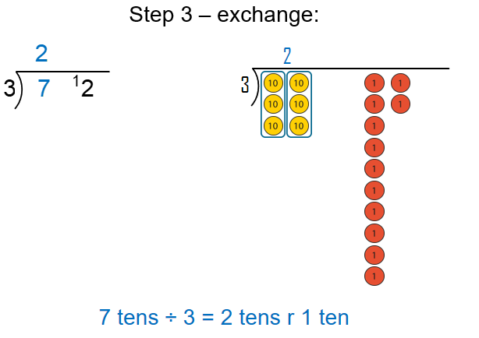
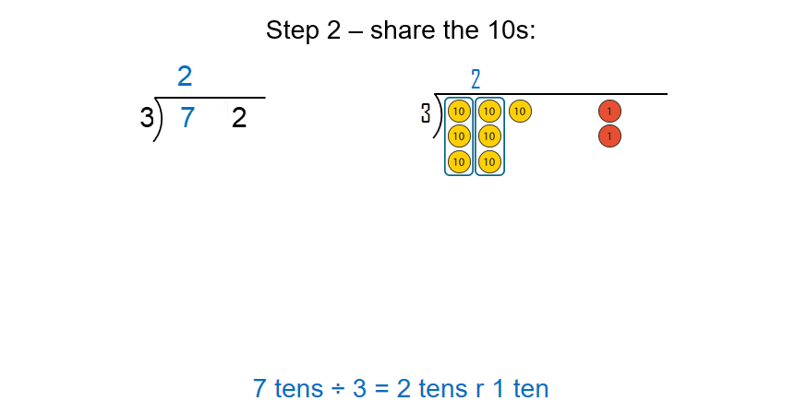
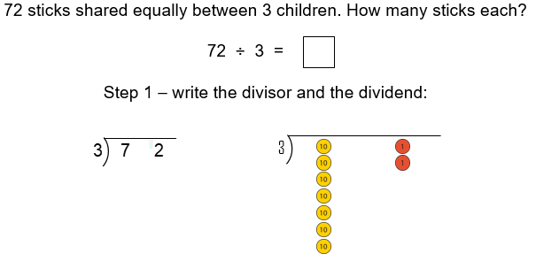

Use sticks and place value counters to represent partitive (sharing) context where the dividend is divisible (to give a whole number) though requires an exchange from the tens. Skip count in multiples of the divisor.
If dividing the tens gives a remainder of one or more ten, we must exchange the remaining tens for ones.

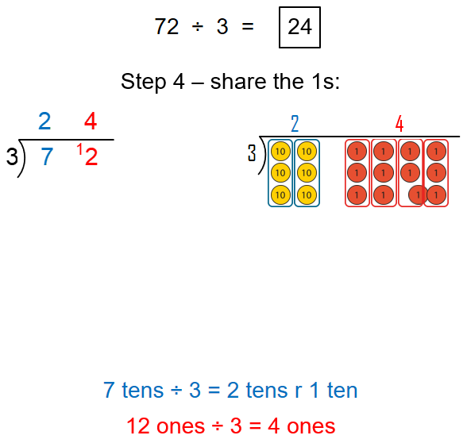
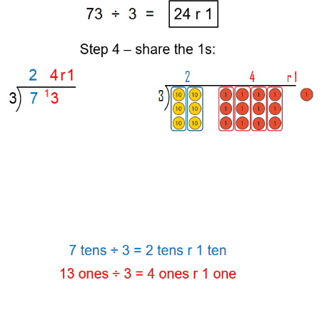

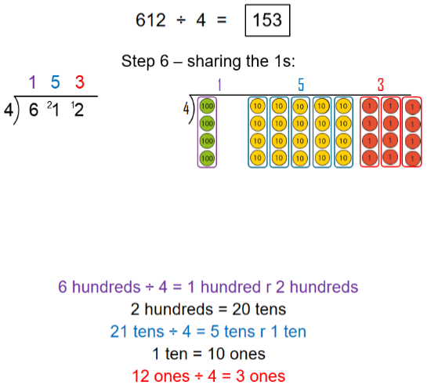
Apply the same representations though this time include a remainder.
Then extend to division of 3 digits by one digit and where there can be no hundreds cannot be shared.
If dividing the hundreds gives a remainder of one or more hundred, we must exchange the remaining hundreds for tens.

Vocabulary:
Additive Multiplicative Relationship Represents Compose Combine Total More than Less than Plus + Minus - Equal to = Addition Subtraction Divide ÷ Multiply x One-_____ of Equation Expression Bar Model Whole Part Difference Multiplier Unknown Sequence
Addend + Addend = Sum Factor x Factor = Product (Multiplicand x Multiplier = Product)
Minuend – Subtrahend = Difference Dividend ÷ Divisor = Quotient
Minuend – Subtrahend = Difference

Addition, Subtraction, Multiplication and Division
Year 6
Quantify additive and multiplicative relationships

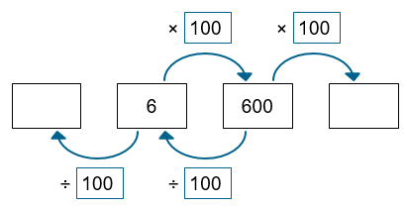
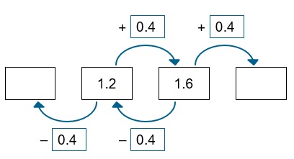
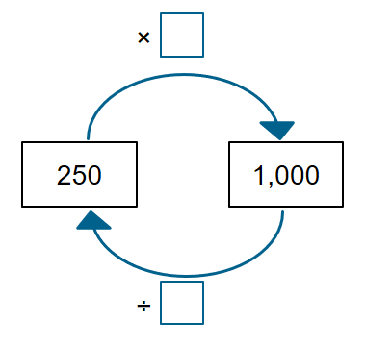
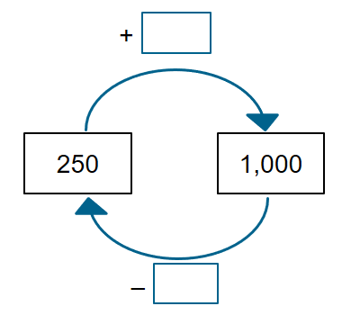
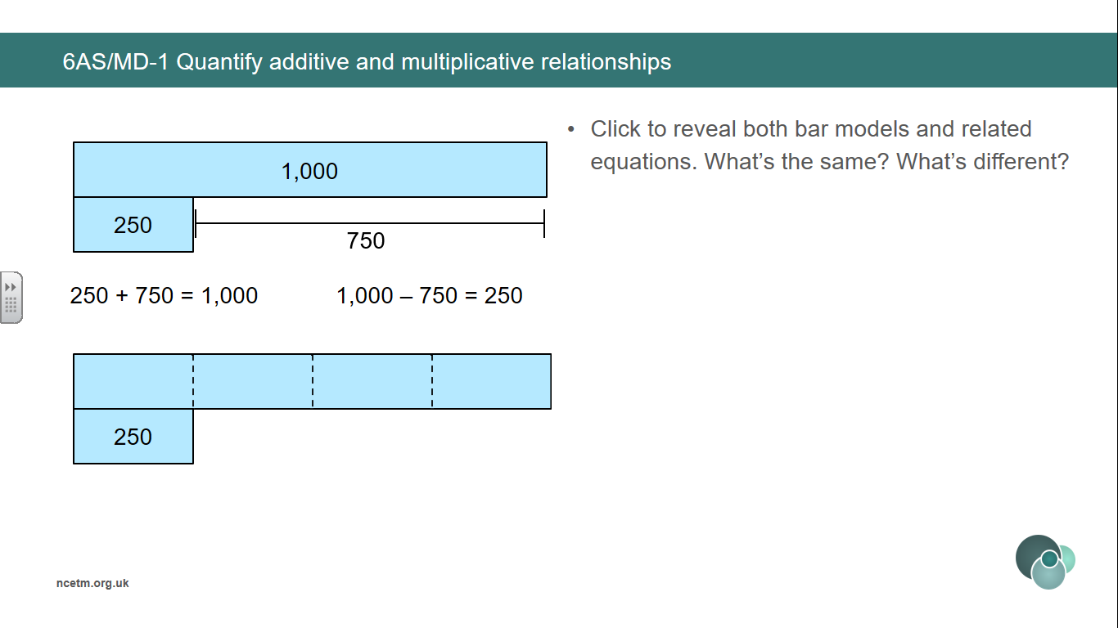
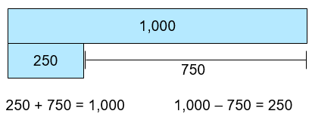
Finding the difference can help calculate the unknown terms in a sequence.
Finding the known multiplier can help calculate the unknown terms in a sequence.

1000 is ___ times the size of 250.
250 is one-_____ of 1000.
To find one-quarter of a number, we divide by 4.

1000 is ___ more than 250.
250 is ____ less than 1000.

The relationship between two numbers can be expressed both additively and multiplicatively.

Vocabulary:
Additive Multiplicative Relationship Represents Compose Combine Total More than Less than Plus + Minus - Equal to = Addition Subtraction Divide ÷ Multiply x One-_____ of Equation Expression Bar Model Whole Part Difference Multiplier Unknown Sequence
Addend + Addend = Sum Factor x Factor = Product (Multiplicand x Multiplier = Product)
Minuend – Subtrahend = Difference Dividend ÷ Divisor = Quotient
Minuend – Subtrahend = Difference

Addition, Subtraction, Multiplication and Division
Year 6
Quantify additive and multiplicative relationships

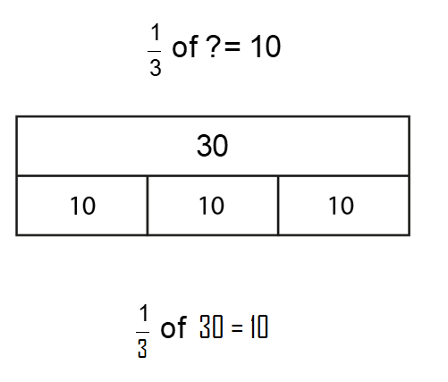
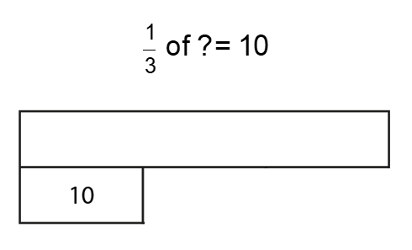
Calculate the unknown whole by recognising how many parts the whole has been divided into.

Vocabulary:
Additive Multiplicative Relationship Represents Equation Unknown Re-arrange Inverse Place Value Properties Commutative Associative Distributive Compensation
Addend + Addend = Sum Factor x Factor = Product (Multiplicand x Multiplier = Product)
Minuend – Subtrahend = Difference Dividend ÷ Divisor = Quotient

Addition and Subtraction
Year 6
Derive Related Calculations

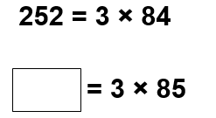
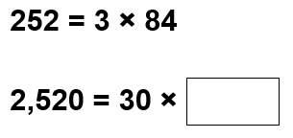
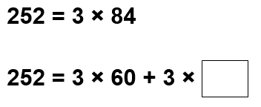
Manipulate an equation to solve another. Pupils could:
- rearrange the terms;
- rewrite using inverse operations;
- apply place value;
- use the properties of division that correspond to the commutative, associative or distributive property of multiplication;
- use the compensation property.

Additive examples
Multiplicative examples

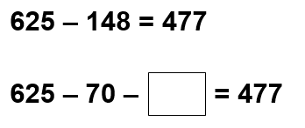
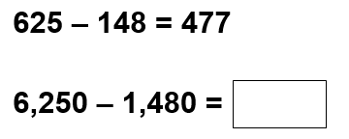
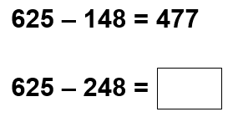
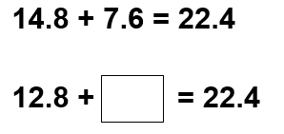
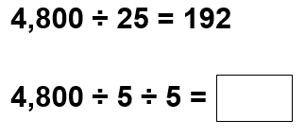
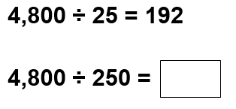
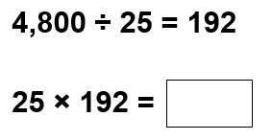
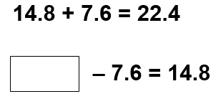
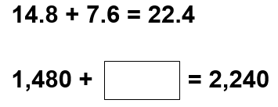

Vocabulary:
Additive Multiplicative Relationship Represents Equation Unknown Scale-factor Ratio Ratio Table ___ times the size one-___ the size of Vertical Horizontal
Factor x Factor = Product (Multiplicand x Multiplier = Product)
Dividend ÷ Divisor = Quotient

Addition and Subtraction
Year 6
Solve Problems involving Ratio Relationship

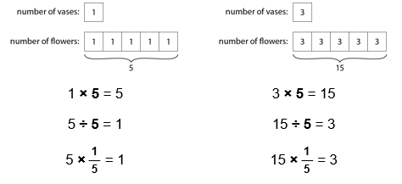
Ratio table to compare sets of information.
For every ___, there are ___.
For every 1 litre of petrol, you can drive 7 miles.
For every 7 miles you will drive, you need 1 litre of petrol.
Extend sequences using knowledge of patterns based on ratio table.

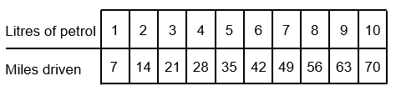

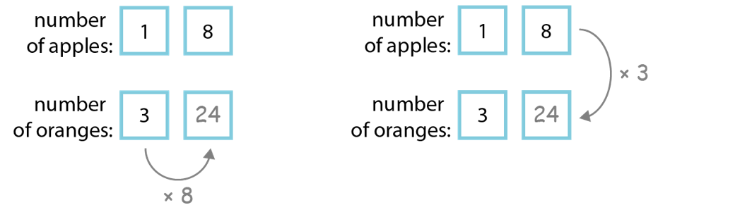
Explore vertical and horizontal relationship between numbers.
For every ___, there are ___.

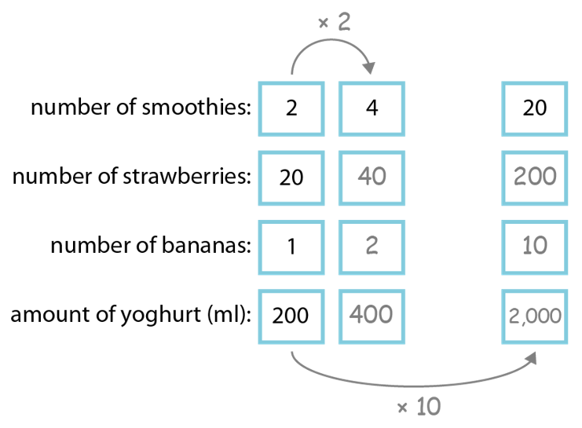
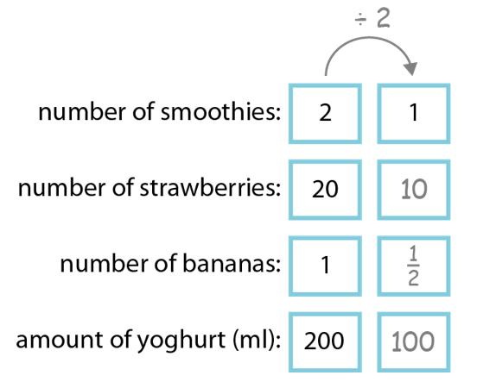
Identify the scale-factor in order to find unknown values.
___ is ___ times the size of ___.
Therefore I must multiply/divide by ___.
___ is one-__ the size of ___.

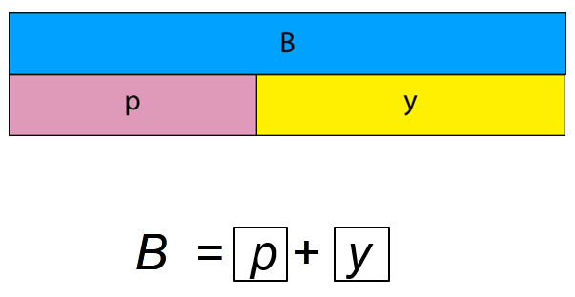
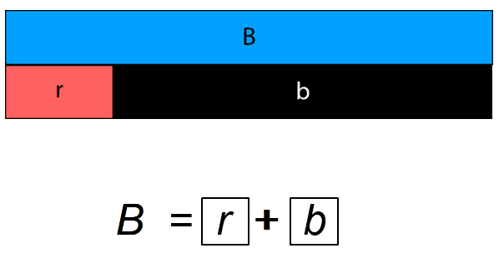
Addition and Subtraction
Year 6
Solve Problems with Two Unknowns
Vocabulary:
Additive Multiplicative Relationship Represents Equation Two Unknowns Scale-factor Ratio ___ times the size one-___ the size of Total Bar Model Structure

Solve multiplicative problems with two unknowns when the total is known.

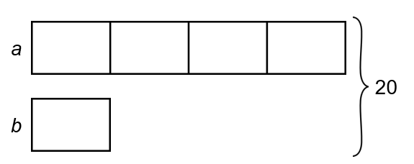
Use Cuisenaire to find 2 bars of total length that are equal to another.
There is more than one solution to the problem.
There can be infinite solutions to a problem.

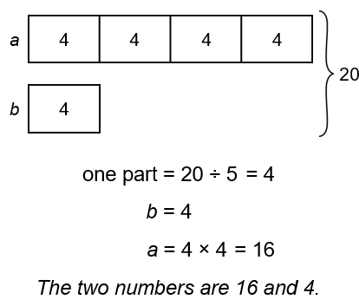
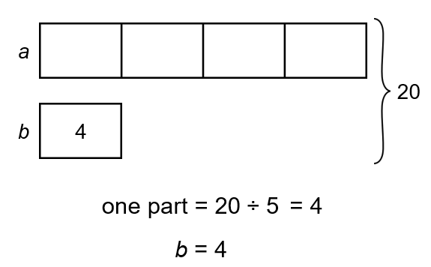
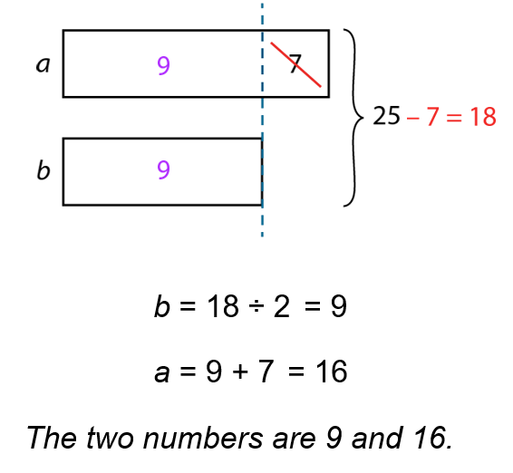
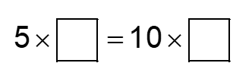
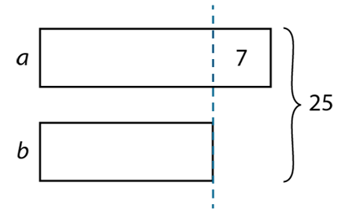
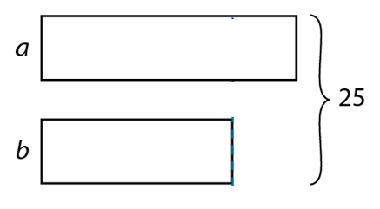
v
Solve additive problems with two unknowns when the total is known.

