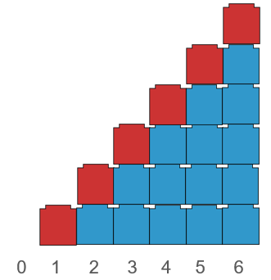
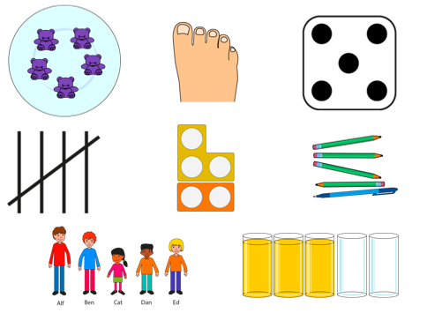
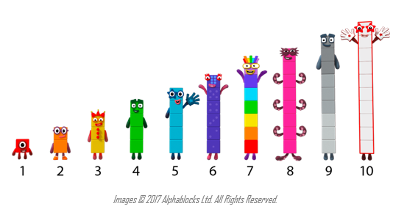
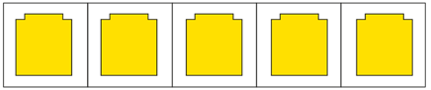
Addition and Subtraction
Year 1
Compose and Partition Numbers to 10 (1)
Understand that numbers to 10 can be represented in many different ways.
Numbers to 5 can be identified without counting (subitising).

Each number is composed of the previous number and one more.

Vocabulary:
Part Whole One Two Three Four Five Six Seven Eight Nine Ten Represents Compose Combine Partition Numberblocks Part-Part-Whole (Cherry) model Tens Frame Fingers Five and-a-bit Systematic Subitise One more One less

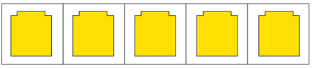
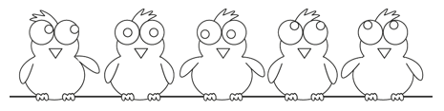



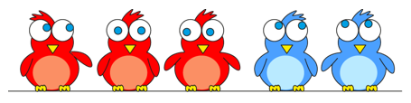

Each number can be partitioned into two smaller numbers
There are 5 ____. 3 are ____. 2 are ____.
5 is the whole. 3 is a part. 2 is a part.

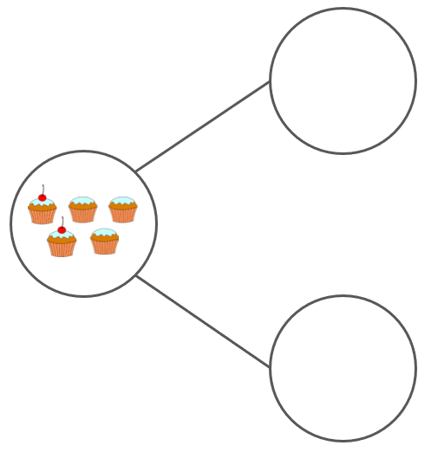
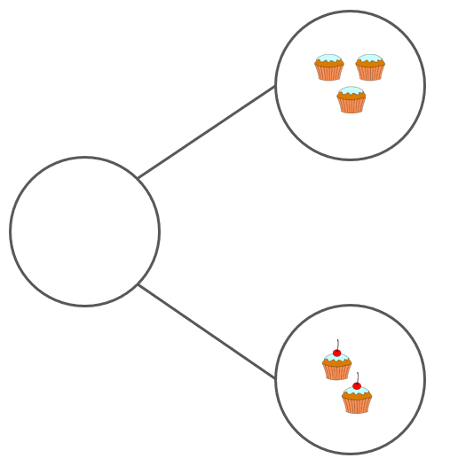
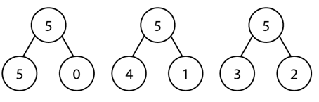
A number can be partitioned in different ways.
There are 5 ____. 3 are ____. 2 are ____.
5 is the whole. 3 is a part. 2 is a part.

Vocabulary:
Ones Tens Digit Represents Place Value Gattegno Chart Column Model Part Whole Addend Sum Minuend Subtrahend Difference Plus Minus Equals Combine Partition

Addition and Subtraction
Year 1
Compose and Partition Numbers to 10
Vocabulary:
Part Whole One Two Three Four Five Six Seven Eight Nine Ten Represents Compose Combine Partition Numberblocks Part-Part-Whole (Cherry) model Tens Frame Fingers Five and-a-bit Systematic Subitise One more One less

Addition and Subtraction
Year 1
Compose and Partition Numbers to 10 (2)

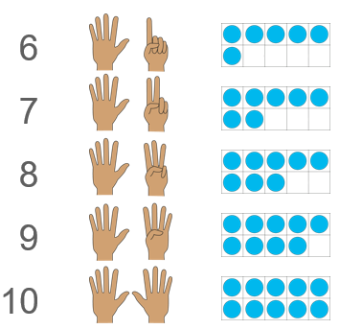
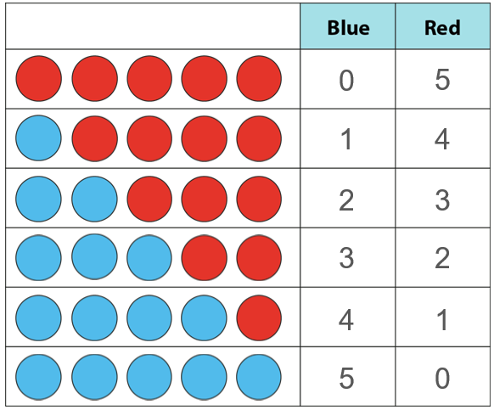
A number can be partitioned in different ways systematically.

Numbers from 6 – 10 are composed of the ‘5 and a bit’ structure.

Vocabulary:
Part Whole One Two Three Four Five Six Seven Eight Nine Ten Represents Compose Combine Partition Total Part-Part-Whole (Cherry) model Tens Frame Fingers Five and-a-bit Systematic Plus + Minus - Equal to = Addition Subtraction Quantity Increase Decrease First, Then, Now Expression Equation
Addend + Addend = Sum Minuend – Subtrahend = Difference

Addition and Subtraction
Year 1
Read, Write and Interpret Additive Equations (1)

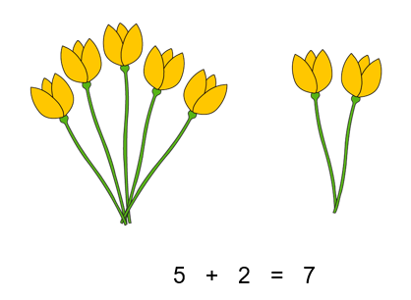
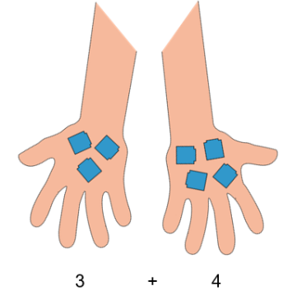
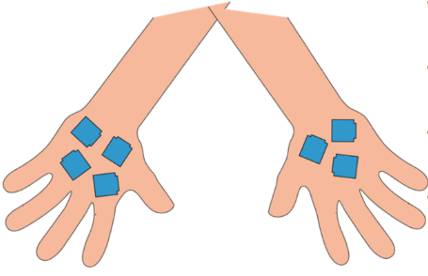

We can write the addends in either order.
(Commutative Law)

Identify what each number represents in an expression.
The 4 represents the 4 yellow flowers.
The 3 represents the 3 red flowers.

4
3
+

Identify what each number represents in an expression.
We can write 5 plus 2 is equal to 7.
The 5 represents ____.
The 2 represents___.
The 7 represents the total number of ___.

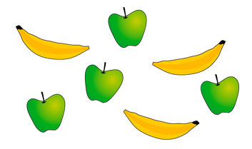

4 + 3 = 7
Vocabulary:
Part Whole One Two Three Four Five Six Seven Eight Nine Ten Represents Compose Combine Partition Total Part-Part-Whole (Cherry) model Tens Frame Fingers Five and-a-bit Systematic Plus + Minus - Equal to = Addition Subtraction Quantity Increase Decrease First, Then, Now Expression Equation
Addend + Addend = Sum Minuend – Subtrahend = Difference
Addend + Addend = Sum Minuend – Subtrahend = Difference

Addition and Subtraction
Year 1
Read, Write and Interpret Additive Equations

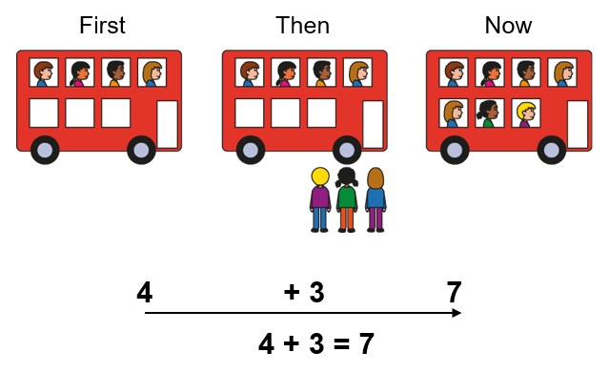
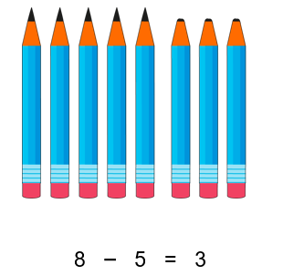
Subtraction can tell us about partitioning.

There are 8 ____ altogether.
5 ___ are ____.
3 ___ are ____.
We can write this as 8 minus 5 is equal to 3.

Understand the First, Then, Now structure of addition and subtraction.
Addition can tell us about a quantity increasing.
Subtraction can tell us about a quantity decreasing.
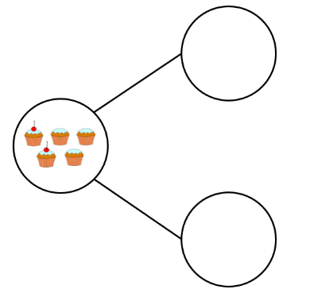
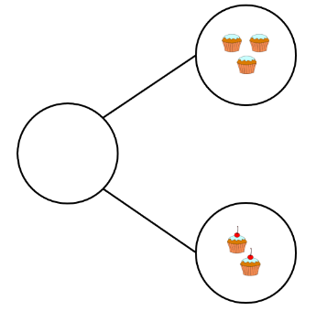
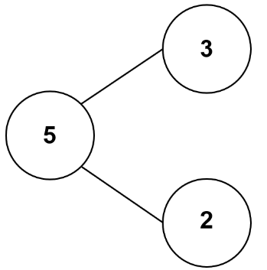
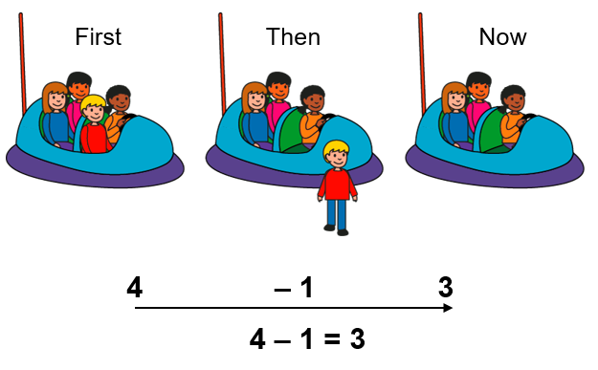
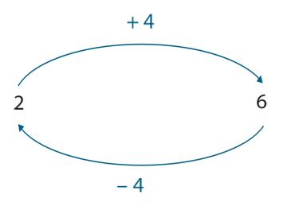
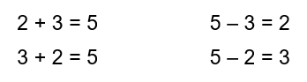
Addition and Subtraction undo eachother.

Make connections between addition and subtraction using the part-part-whole model.
Addition can tell us about combining objects.
Subtraction can tell us about partitioning objects.

Vocabulary:
Part Whole One Two Three Four Five Six Seven Eight Nine Ten Represents Compose Combine Partition Total Part-Part-Whole (Cherry) model Tens Frame Fingers Five and-a-bit Systematic Plus + Minus - Equal to = Addition Subtraction Quantity Increase Decrease First, Then, Now Expression Equation
Addend + Addend = Sum Minuend – Subtrahend = Difference
Addend + Addend = Sum Minuend – Subtrahend = Difference

Addition and Subtraction
Year 2
Add and Subtract across 10 (1)

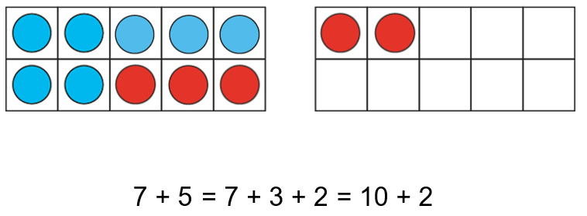
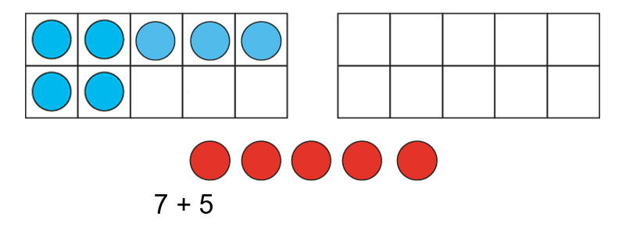

Use knowledge of known facts to bridge 10 using a ‘make 10’ strategy.
First, I partition the __ into ___ and ___.
Then, I add ___ and ___ to make 10.
Then, I add the remaining ___ to make ___.

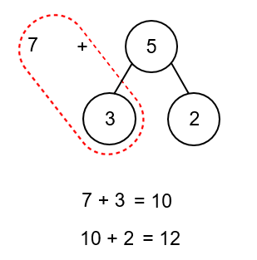

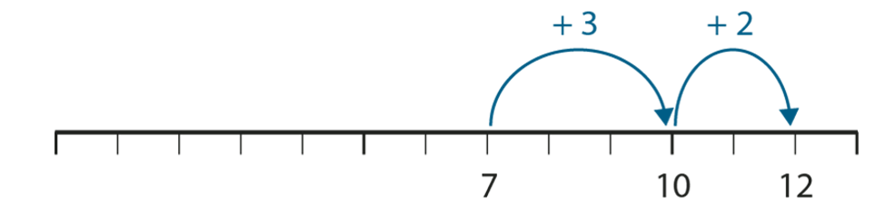

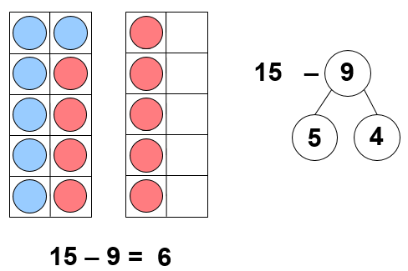
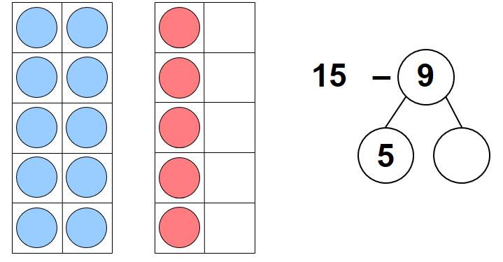
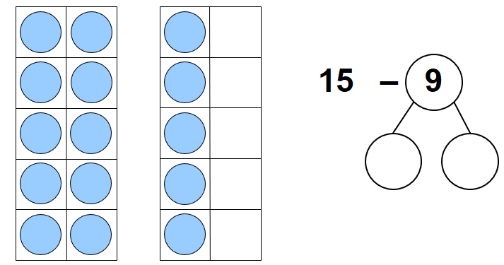
Vocabulary:
Part Whole One Two Three Four Five Six Seven Eight Nine Ten Represents Compose Combine Partition Total Part-Part-Whole (Cherry) model Tens Frame Fingers Five and-a-bit Systematic Plus + Minus - Equal to = Addition Subtraction Quantity Increase Decrease First, Then, Now Expression Equation
Addend + Addend = Sum Minuend – Subtrahend = Difference
Addend + Addend = Sum Minuend – Subtrahend = Difference

Addition and Subtraction
Year 2
Add and Subtract across 10 (2)

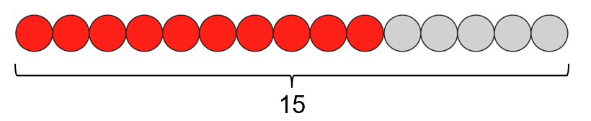
Use knowledge of known facts to subtract through 10. We can partition the subtrahend to help us subtract.
First, I partition the __ into ___ and ___.
Then, I subtract ___ and ___ to get to 10.
Then, I subtract the remaining ___ to make ___.

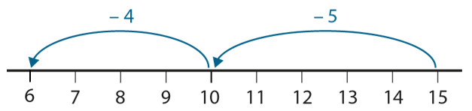
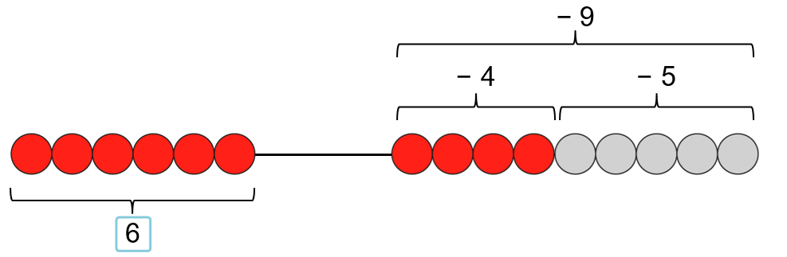
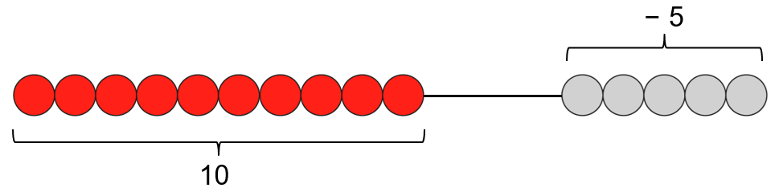

Vocabulary:
Part Whole One Two Three Four Five Six Seven Eight Nine Ten Represents Compose Combine Partition Total Part-Part-Whole (Cherry) model Tens Frame Fingers Five and-a-bit Systematic Plus + Minus - Equal to = Addition Subtraction Quantity Increase Decrease First, Then, Now Expression Equation
Addend + Addend = Sum Minuend – Subtrahend = Difference
Addend + Addend = Sum Minuend – Subtrahend = Difference

Addition and Subtraction
Year 2
Add and Subtract across 10 (3)

Use knowledge of known facts to subtract from 10. We can partition the subtrahend to help us subtract.
First, I partition the __ into ___ and ___.
Then, I subtract ___ from 10 to make ___.
Then, I add the remaining ___ to make ___.

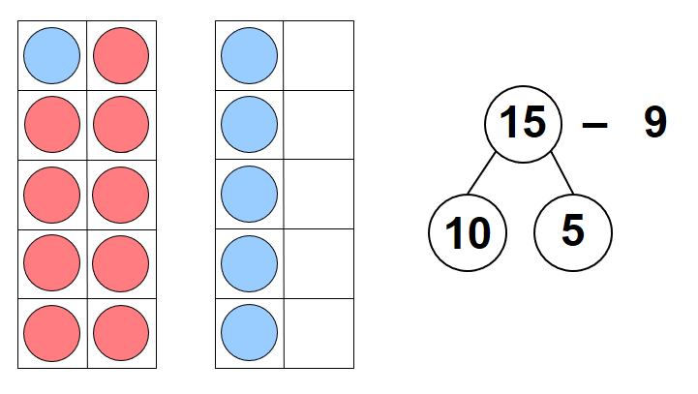
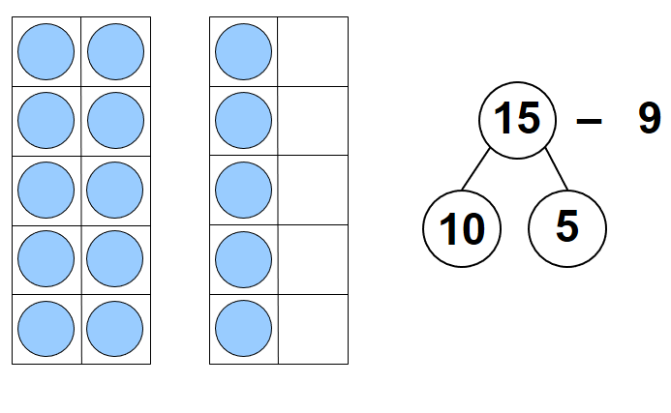
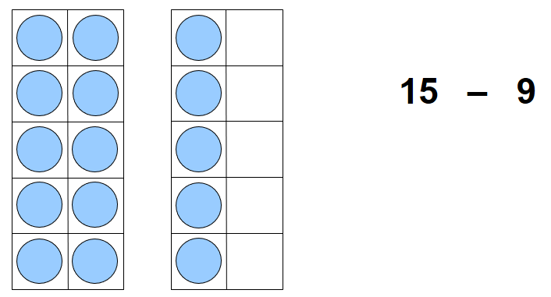

10 – 9 = 1
1 + 5 = 6
15 – 9 = 6

3
Addition and Subtraction
Year 2
Solve Comparative Addition and Difference Problems
Vocabulary:
Part Whole One Two Three Four Five Six Seven Eight Nine Ten Represents Compose Combine Partition Total Part-Part-Whole (Cherry) model Tens Frame Fingers Five and-a-bit Systematic Plus + Minus - Equal to = Addition Subtraction Quantity Increase Decrease First, Then, Now Expression Equation Difference Bar model
Addend + Addend = Sum Minuend – Subtrahend = Difference
Addend + Addend = Sum Minuend – Subtrahend = Difference

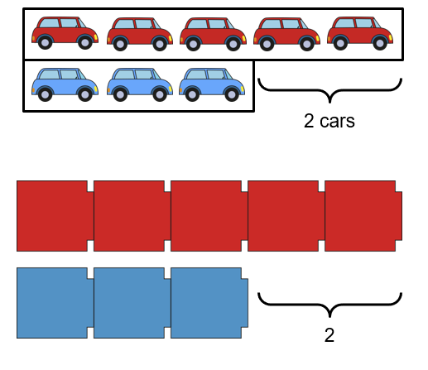
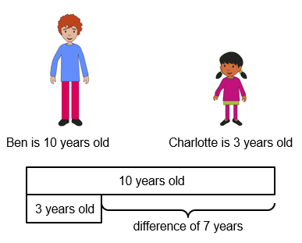
Represent a range of comparison contexts.
Ben is 7 years older than Charlotte.
Charlotte is 7 years younger than Ben.

Line up sets of objects in a bar model structure to support comparison.
There are 2 fewer blue cars than red cars.
There are 2 more red cars that blue cars.

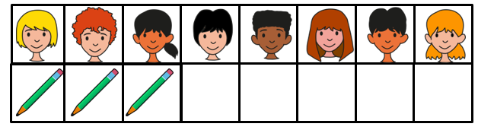
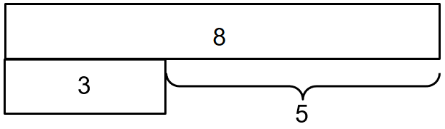
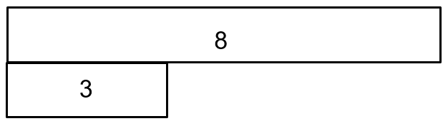

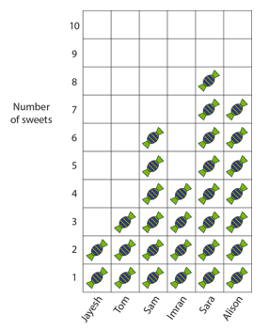
We can use subtraction to help solve difference problems / missing addend problems about ‘how many more?’ and ‘how many fewer?’
3 + __ = 8
8 – 3 = 5
Create contexts for recognising the difference/comparative addition structure with all representations below.
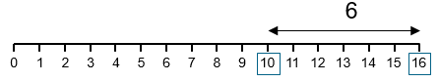
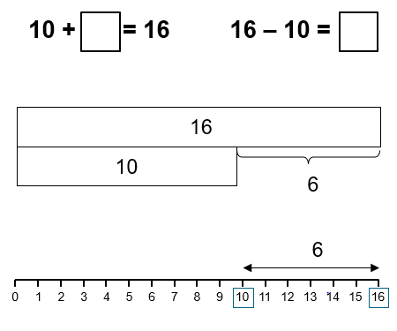

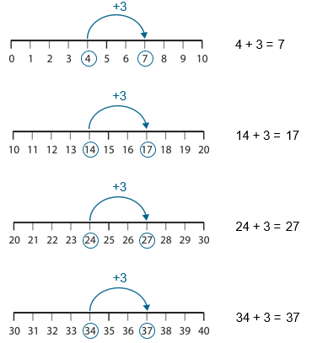
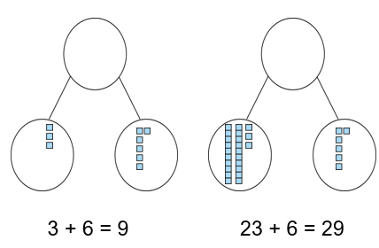
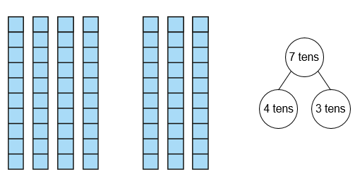
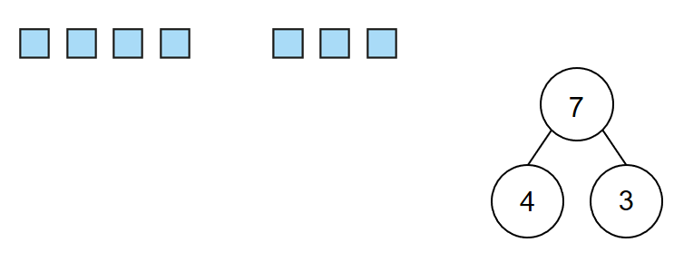
Generalise that adding/subtracting within 10 can be applied to adding a 2 digit number with a 1 digit number – not crossing the tens boundary.
I know that 4 plus 3 is equal to 7.
So, 1 ten and 4 ones plus 3 ones is equal to 1 tens and 7 ones.
14 + 3 = 17.
70 – 40 = 30

Use known facts within 10 to add/subtract ones to/from a 2 digit number.
I know that 3 plus 6 is equal to 9.
So, 2 tens and 3 ones plus 6 ones is equal to 2 tens and 9 ones.
23 + 6 = 29.
70 – 40 = 30

Use known facts within 10 to add/subtract multiples of 10.
I know that 4 plus 3 is equal to 7.
So, 4 tens plus 3 tens is equal to 7 tens.
40 + 30 = 70.
70 – 40 = 30

Vocabulary:
Part Whole Ones Tens Represents Compose Combine Partition Total Part-Part-Whole (Cherry) model Tens Frame Deines Plus + Minus - Equal to = Addition Subtraction Expression Equation Exchange Count on Count back Number line Tens Boundary
Addend + Addend = Sum Minuend – Subtrahend = Difference
Addend + Addend = Sum Minuend – Subtrahend = Difference

Addition and Subtraction
Year 2
Add and Subtract within 100 (1).

Vocabulary:
Part Whole Ones Tens Represents Compose Combine Partition Total Part-Part-Whole (Cherry) model Tens Frame Deines Plus + Minus - Equal to = Addition Subtraction Expression Equation Exchange Count on Count back Number line Tens Boundary
Addend + Addend = Sum Minuend – Subtrahend = Difference
Addend + Addend = Sum Minuend – Subtrahend = Difference

Addition and Subtraction
Year 2
Add and Subtract within 100 (2).
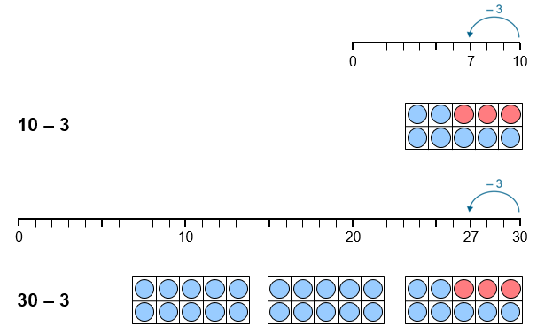
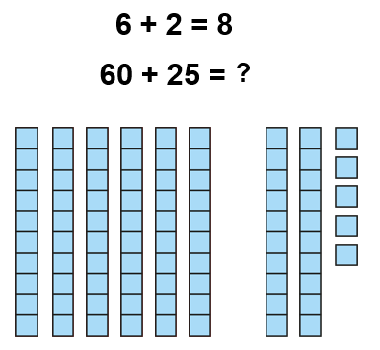
Use knowledge of subtracting from 10 to subtract a single-digit number from a multiple of 10.
I know that 10 minus 3 is equal to 7.
So, 3 tens minus 3 ones is equal to 2 tens and 7 ones.
30 - 3 = 27.

Use known facts within 10 to add/subtract multiples of 10 to a 2 digit number.
I know that 6 plus 2 is equal to 8.
So, 6 tens plus 2 tens is equal to 8 tens. Then add the additional 5 ones.
60 + 25 = 85.
70 – 40 = 30

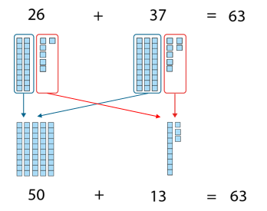
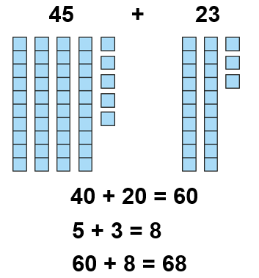
Partition both addends to add efficiently without crossing the tens boundary.

Partition both addends to add efficiently when the ones require an exchange.

Vocabulary:
Part Whole Ones Tens Represents Compose Combine Partition Total Part-Part-Whole (Cherry) model Tens Frame Deines Plus + Minus - Equal to = Addition Subtraction Expression Equation Exchange Count on Count back Number line Tens Boundary
Addend + Addend = Sum Minuend – Subtrahend = Difference

Addition and Subtraction
Year 2
Add and Subtract within 100 (3).

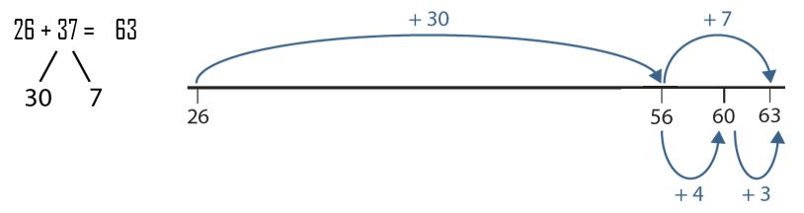

Partition one addend and count on in ones and tens.

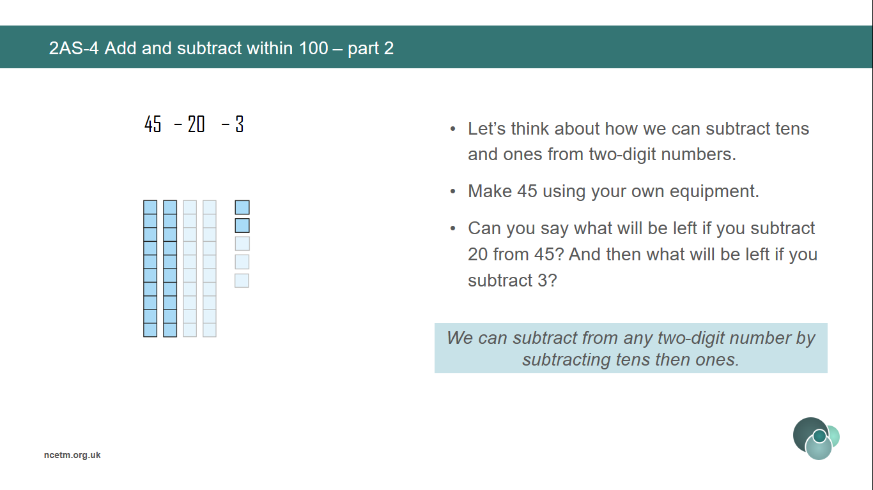
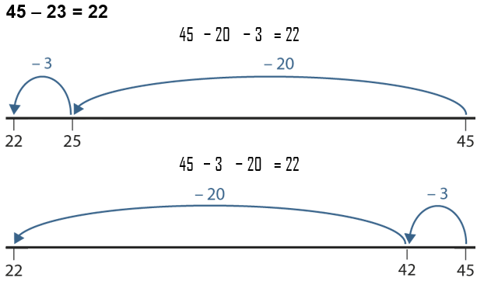

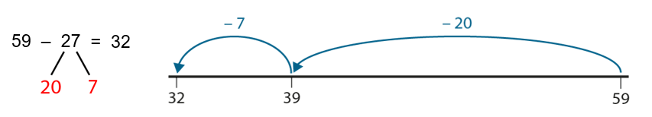
Subtract from any two-digit number by portioning the subtrahend into tens and ones and counting back.
Subtract from any two-digit number by subtracting tens then ones without crossing a tens boundary.

Vocabulary:
Part Whole Ones Tens Represents Compose Combine Partition Total Part-Part-Whole (Cherry) model Deines 100 square Plus + Minus - Equal to = Addition Subtraction Expression Equation Exchange Complements
Addend + Addend = Sum

Addition and Subtraction
Year 3
Calculate complements to 100.

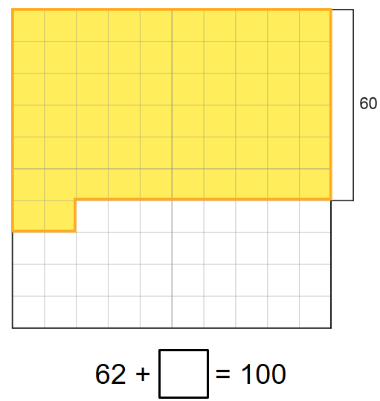
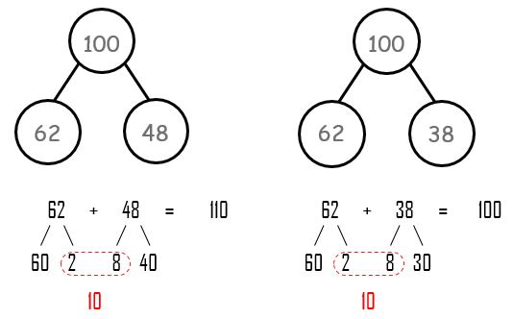
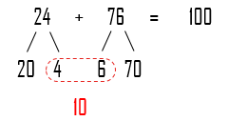
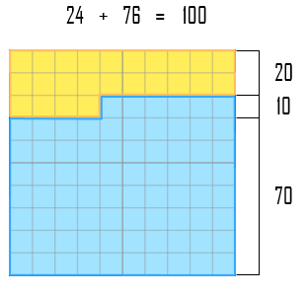
Solve missing number problems that sum to 100.

Compare equations which do and do not sum to 100.

Use knowledge of subtracting from 10 to subtract a single-digit number from a multiple of 10.
First we make 10 ones. The ones digits add up to make 1 ten, so we need 9 more tens to make a total of 100.

Vocabulary:
Ones Tens Represents Compose Combine Total Deines Plus + Minus - Equal to = Addition Subtraction Equation Regroup Algorithm
Addend + Addend = Sum
Minuend – Subtrahend = Difference

Addition and Subtraction
Year 3
Columnar Addition and Subtraction

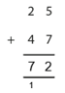
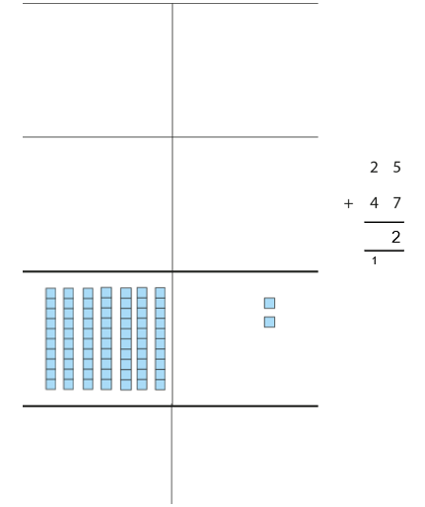
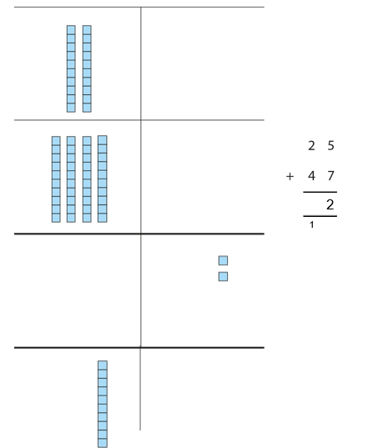
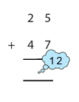
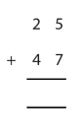
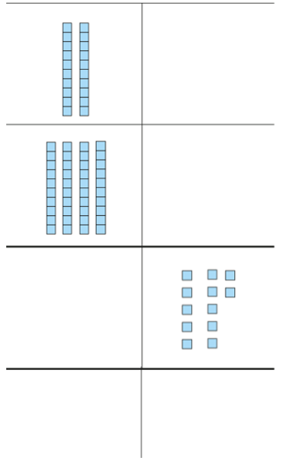
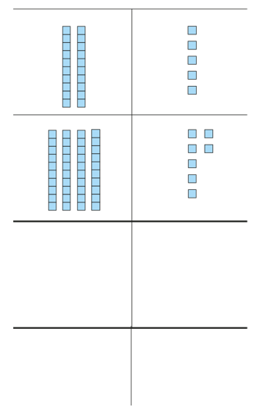
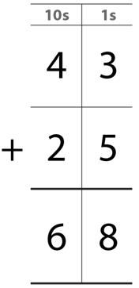
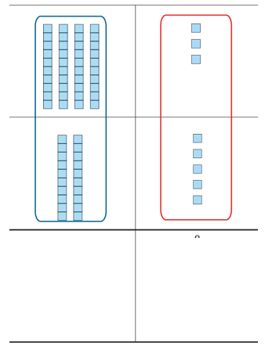
Use deines to represent columnar addition without exchange pictorially before moving to abstract algorithm.
We add the ones. 3 ones plus 5 ones are equal to 8 ones.
We add the tens. 4 tens plus 2 tens is equal to 6 tens.

Use deines to represent columnar addition with exchange pictorially before moving to abstract algorithm.
5 ones plus 7 ones is equal to 12 ones. I can regroup 12 ones. 12 ones is equal to 1 ten and 2 ones.
2 tens plus 4 tens is equal to 6 tens. We also need to add 1 ten from the regrouping. There are 7 tens altogether.
If a column group is equal to 10 or more we must regroup. 10 ones is equal to 1 ten. 10 tens is equal to 1 hundred.

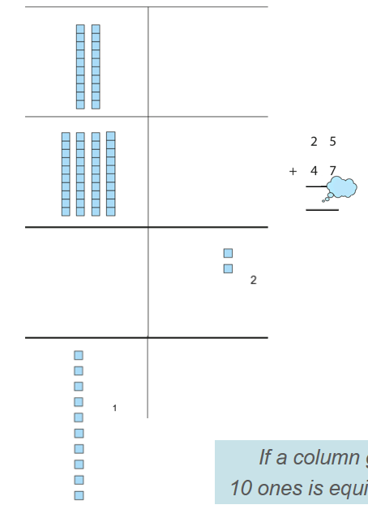

Vocabulary:
Ones Tens Represents Compose Combine Total Deines Plus + Minus - Equal to = Addition Subtraction Equation Expression Regroup Algorithm
Addend + Addend = Sum
Minuend – Subtrahend = Difference

Addition and Subtraction
Year 3
Columnar Addition and Subtraction

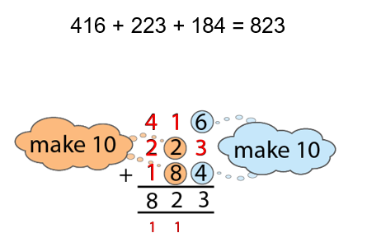
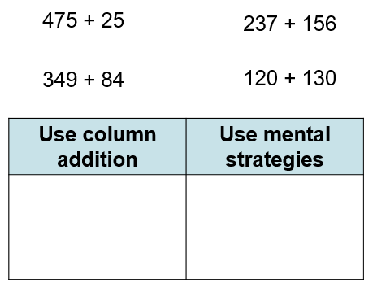
Compare expressions which can be calculated using mental or written strategies.

Add 3 addends using columnar addition, using a make 10 strategy to support.

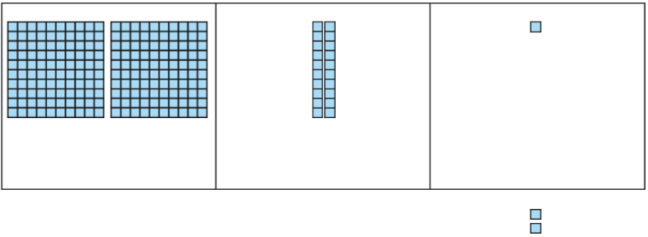
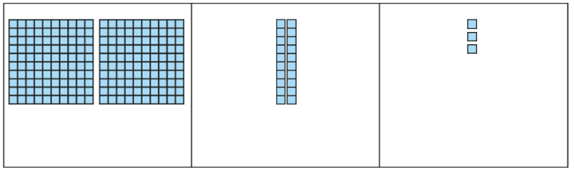
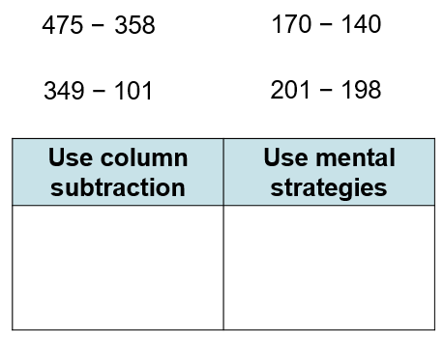
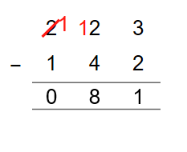
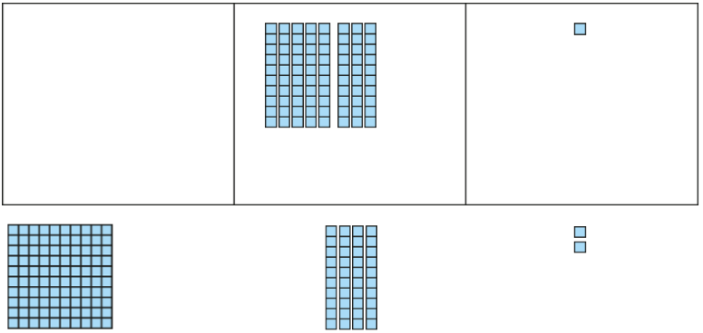
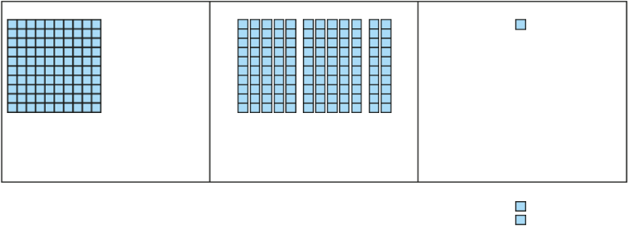
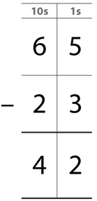
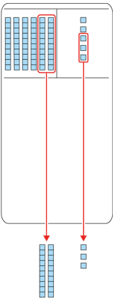
Compare expressions which can be calculated using mental or written strategies.

Use deines to represent columnar subtraction without exchange pictorially before moving to abstract algorithm.
We subtract the ones. 5 ones minus 3 ones is equal to 2 ones.
We subtract the tens. 6 tens minus 2 tens is equal to 4 tens.

Vocabulary:
Ones Tens Represents Compose Combine Total Deines Plus + Minus - Equal to = Addition Subtraction Equation Expression Regroup Algorithm
Addend + Addend = Sum
Minuend – Subtrahend = Difference

Addition and Subtraction
Year 3
Columnar Addition and Subtraction

Vocabulary:
Represents Compose Combine Total Deines Plus + Minus - Equal to = Addition Subtraction Equation Expression Bar Model Part-Part-Whole Model (Cherry) Whole Part
Addend + Addend = Sum
Minuend – Subtrahend = Difference

Addition and Subtraction
Year 3
Manipulate the Additive Relationship

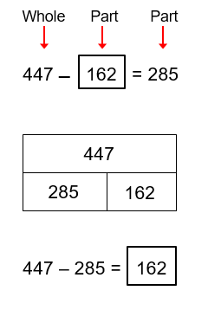
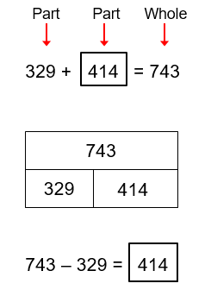
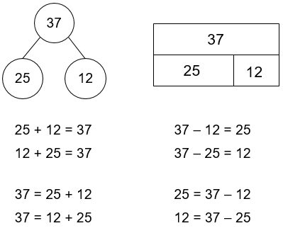

Recognise the different equations that can be recorded based on the part-whole structure.
Addend + addend = sum
Minuend – subtrahend = difference

Use the part-whole structure to support finding a missing part.
There is a missing part. To find the missing part, we subtract the other part from the whole.

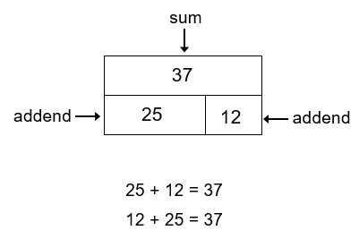
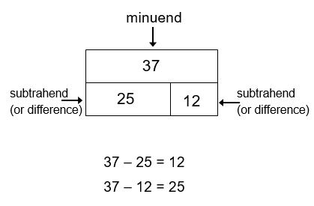
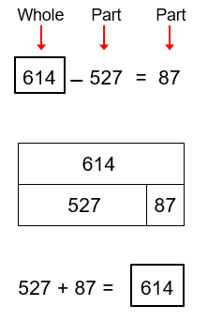
Use the part-whole structure to support finding a missing whole.
There is a missing whole. To find the missing whole, we add the two parts.

Vocabulary:
Additive Multiplicative Relationship Represents Compose Combine Total More than Less than Plus + Minus - Equal to = Addition Subtraction Divide ÷ Multiply x One-_____ of Equation Expression Bar Model Whole Part Difference Multiplier Unknown Sequence
Addend + Addend = Sum
Minuend – Subtrahend = Difference

Addition and Subtraction
Year 6
Quantify additive and multiplicative relationships

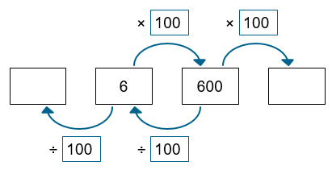
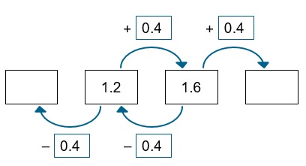
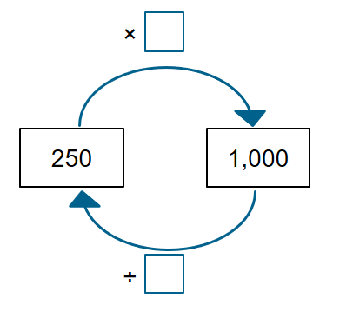
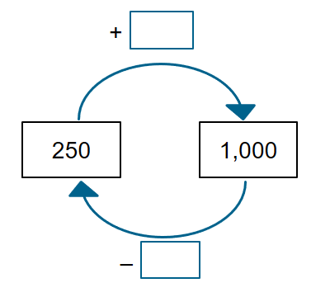
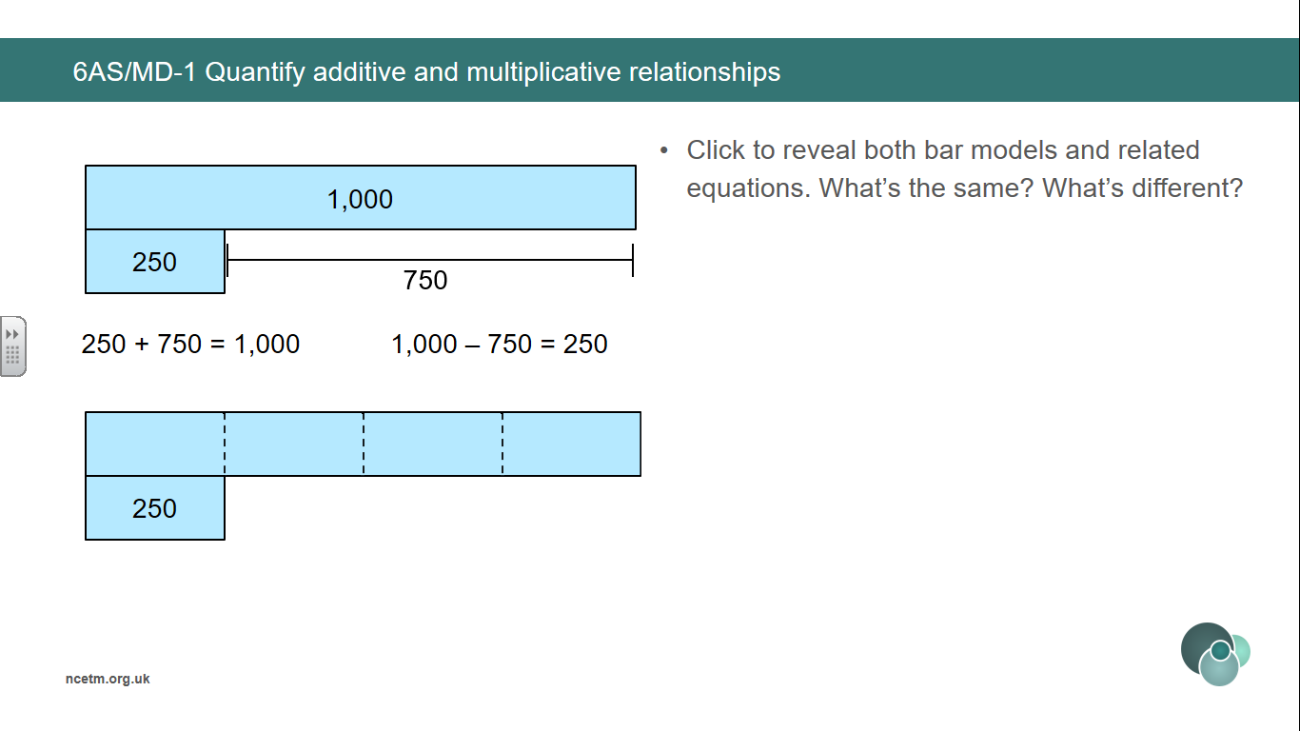
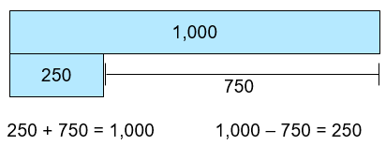
Finding the difference can help calculate the unknown terms in a sequence.
Finding the known multiplier can help calculate the unknown terms in a sequence.

1000 is ___ times the size of 250.
250 is one-_____ of 1000.
To find one-quarter of a number, we divide by 4.

1000 is ___ more than 250.
250 is ____ less than 1000.

The relationship between two numbers can be expressed both additively and multiplicatively.

Vocabulary:
Additive Multiplicative Relationship Represents Compose Combine Total More than Less than Plus + Minus - Equal to = Addition Subtraction Divide ÷ Multiply x One-_____ of Equation Expression Bar Model Whole Part Difference Multiplier Unknown Sequence
Addend + Addend = Sum
Minuend – Subtrahend = Difference

Addition and Subtraction
Year 6
Quantify additive and multiplicative relationships

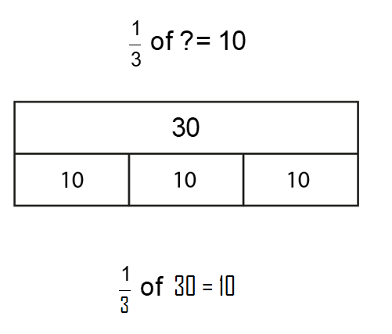
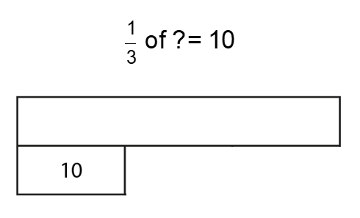
Calculate the unknown whole by recognising how many parts the whole has been divided into.

Vocabulary:
Additive Multiplicative Relationship Represents Equation Unknown Re-arrange Inverse Place Value Properties Commutative Associative Distributive Compensation
Addend + Addend = Sum Factor x Factor = Product (Multiplicand x Multiplier = Product)
Minuend – Subtrahend = Difference Dividend ÷ Divisor = Quotient

Addition and Subtraction
Year 6
Derive Related Calculations

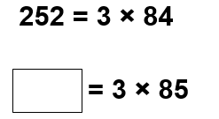
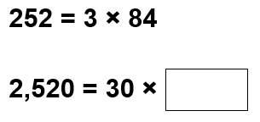
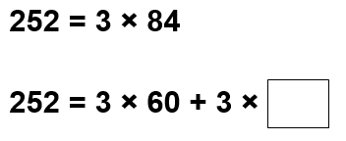
Manipulate an equation to solve another. Pupils could:
- rearrange the terms;
- rewrite using inverse operations;
- apply place value;
- use the properties of division that correspond to the commutative, associative or distributive property of multiplication;
- use the compensation property.

Additive examples
Multiplicative examples

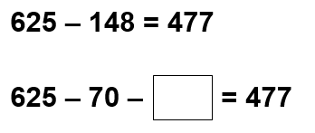
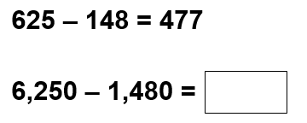
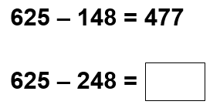
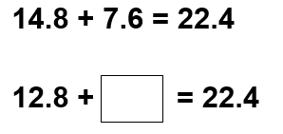
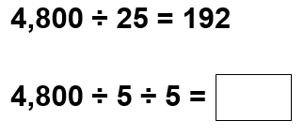
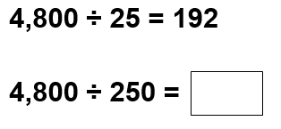
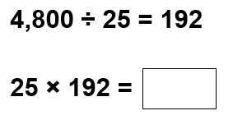
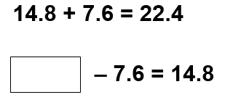
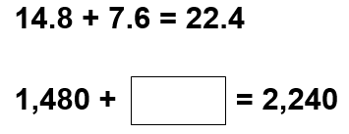

Vocabulary:
Additive Multiplicative Relationship Represents Equation Unknown Scale-factor Ratio Ratio Table ___ times the size one-___ the size of Vertical Horizontal
Factor x Factor = Product (Multiplicand x Multiplier = Product)
Dividend ÷ Divisor = Quotient

Addition and Subtraction
Year 6
Solve Problems involving Ratio Relationship

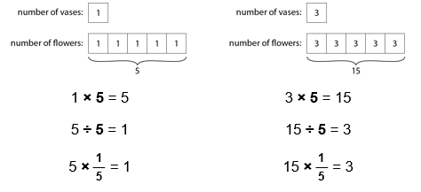
Ratio table to compare sets of information.
For every ___, there are ___.
For every 1 litre of petrol, you can drive 7 miles.
For every 7 miles you will drive, you need 1 litre of petrol.
Extend sequences using knowledge of patterns based on ratio table.

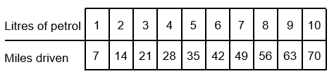

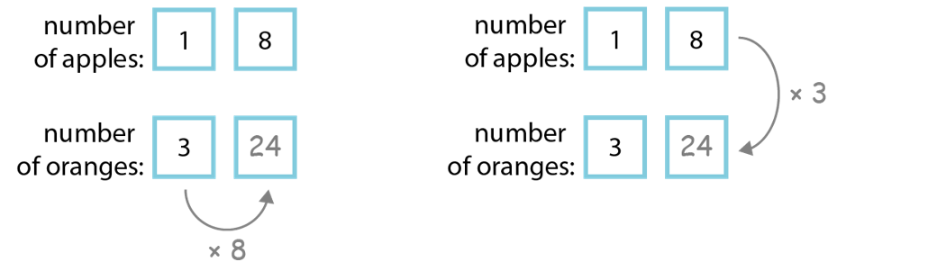
Explore vertical and horizontal relationship between numbers.
For every ___, there are ___.

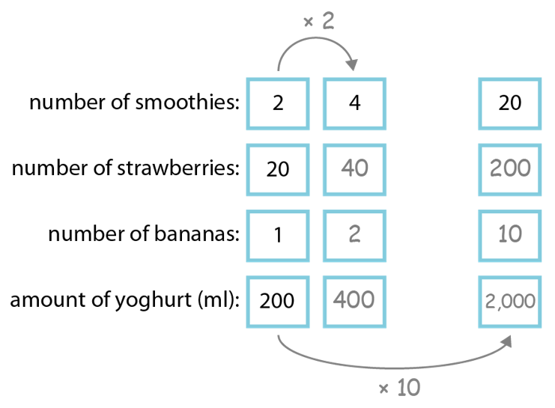
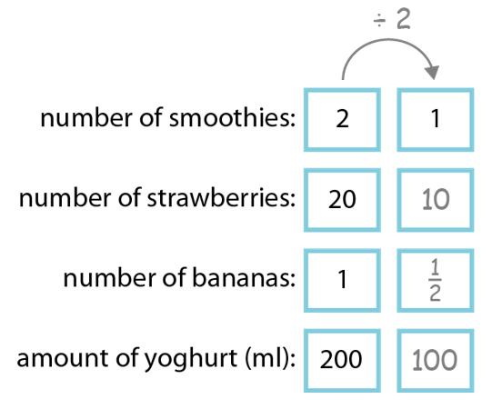
Identify the scale-factor in order to find unknown values.
___ is ___ times the size of ___.
Therefore I must multiply/divide by ___.
___ is one-__ the size of ___.

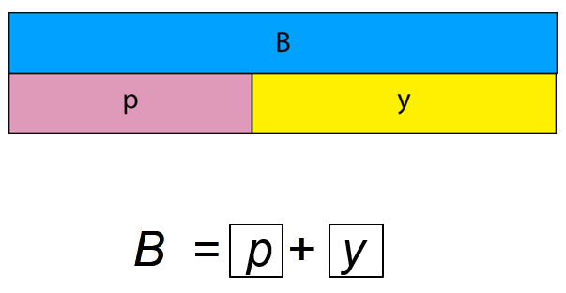
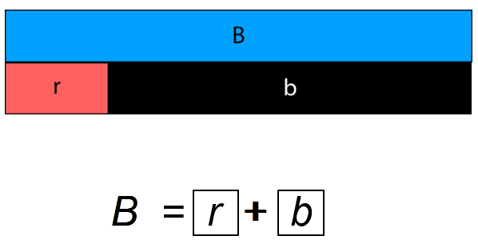
Addition and Subtraction
Year 6
Solve Problems with Two Unknowns
Vocabulary:
Additive Multiplicative Relationship Represents Equation Two Unknowns Scale-factor Ratio ___ times the size one-___ the size of Total Bar Model Structure

Solve multiplicative problems with two unknowns when the total is known.

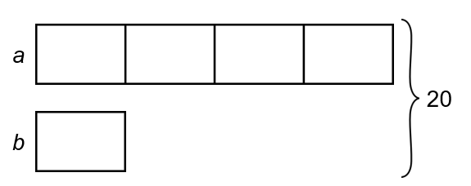
Use Cuisenaire to find 2 bars of total length that are equal to another.
There is more than one solution to the problem.
There can be infinite solutions to a problem.

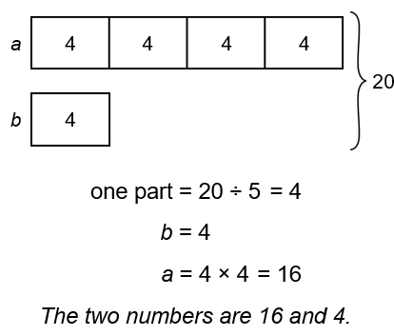
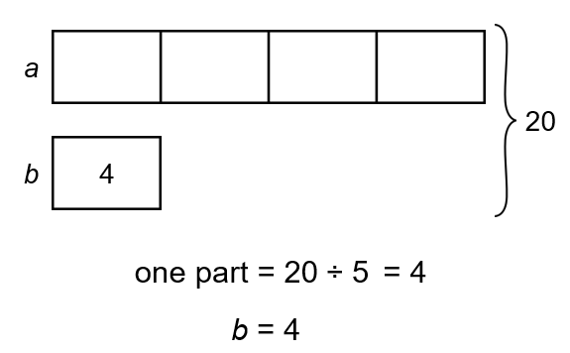
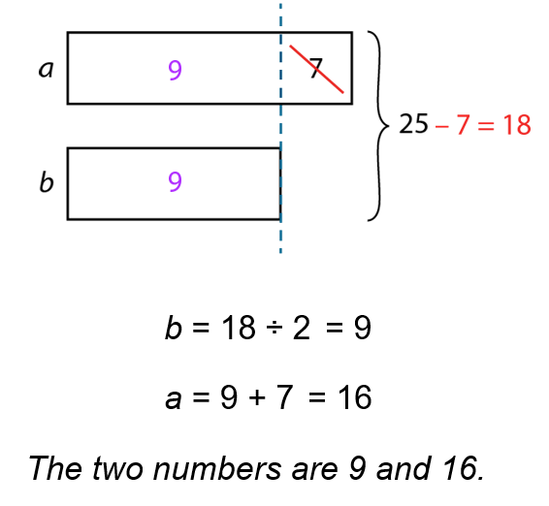
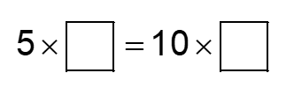
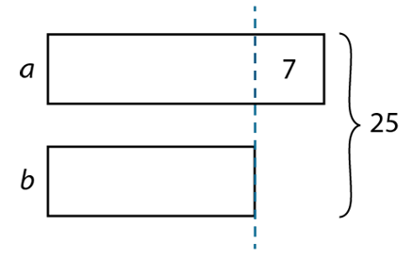
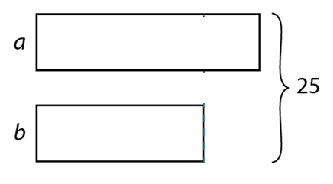
v
Solve additive problems with two unknowns when the total is known.

