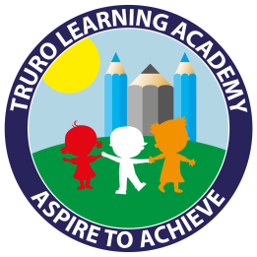
Truro Learning Academy
How to support your child with Pink books
Children reading Pink books are learning to:
Phonic Skills
- Blend sounds to read CVC words.
- Recognise the first letter sound of a word.
Mechanical reading skills
- Read a few very common High Frequency words.
- Recognise a word that is repeated in a book.
- Use picture cues to help reading
Showing understanding (comprehension)
- Read simple sentences and understand their meaning.
- Recall the main points of a text.
- Add more understanding by looking at the pictures.
How texts work
- Distinguish between a word, letter and a space.
- Know that text is read from left to right.
- Know that books a read from front to back.
- Know which way a book should be held.
Your child will be able to do some of these things more easily than others. If there is something that they find difficult, practising it during reading time at home will help them develop their reading skills.
Phonic Skills
If your child takes a long time to think of what each sound says, it will slow down their reading. Phonic sounds can be practised separately. Please ask us which sounds your child is working on.

Mechanical Reading
There is a lot of repetition in pink books and this is to help children begin to recognise words that are repeated. If there are names in the book you could remind your child that it will probably come up lots of times so they could try to remember what it looks like.
Simple High Frequency words such as ‘the’, ‘and’, he’, ‘she’, ‘it’, ‘is’, ‘I’, ‘am’ ‘went’, ‘up’, ‘on’ can be practised in the book, but also made into flashcards, or put on post-its to practise recognition on sight.
Children reading at this level should point to each word as they read to help them focus.

Showing Understanding
Encourage your child to remember what they have read by asking them simple questions e.g. What is the boy’s name? What was the book about?
You can also talk about the pictures in the book and there is often more information shown in these than in the writing.
Some pink books have no words. These books allow children to practise telling stories using story language and also develop the skill of using the pictures as cues to the story.

How texts work
Allow your child to open the book and get to the first page by themselves. They could also look at the front cover to see if they can work out what it will be about. You may read the title to them, especially if there is a challenging word or name in it.

