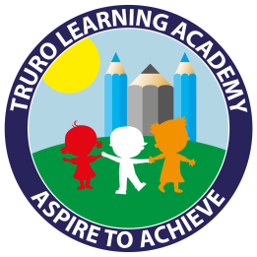
Truro Learning Academy
How to support your child with Orange and Turquoise books
Children reading Orange and Turquoise books are learning to: Mechanical reading skills
- Read automatically, and without thinking, the 100 High Frequency Words
- Identify when reading does not make sense and attempt to self correct.
- Show some awareness of punctuation (e.g. pausing at full stops).
Showing understanding (comprehension)
- Sustain independent reading to complete and gain meaning from texts.
- Begin to use awareness of character and dialogue to read with expression
- Comment on events, characters or ideas in stories, making links to own experience supported by questioning.
Knowing how texts work
- Locate pages/sections of interest (e.g. favourite characters, events or pictures).
- Recognise ways text is organised (e.g. labels, captions and on screen).
- Understand that simple diagrams and charts present information.
Your child will be able to do some of these things more easily than others. If there is something that they find difficult, practising it during reading time at home will help them develop their reading skills.
Mechanical Reading
Children reading Orange and Turquoise books are generally able to show a good level of fluency. They think about what they are reading as they go along and pause if it does not make sense. You could encourage them to think about why it didn’t make sense. Did they miss a word or section? Have they mis-read something? Which part was it?
You could also encourage your child to look at the punctuation and pause very slightly at a full stop. Some children have a tendency to stop at the end of each line instead.
Showing Understanding
Does your child always have to look back through the text to answer a question? If they do they are not ‘taking in’ what they have read. Why not tell them that they are going to ask you some questions at the end of the page instead of vice versa? Alternatively you could ask them a question before they read which they will need to find the answer to as they read.
Some stories have links to the child’s own experience, or characters are like people they know. When talking about the story you could encourage them to make links e.g. “This character reminds me of someone we know, can you guess who I’m thinking of?”
How texts work
After we read a book or text we sometimes want to go back and find a particular piece of information, or event. You can help your child to develop this skill by asking them to find the section where things happen. They can begin by thinking whether it was at the beginning, middle or end of the story so that they don’t search through the whole book.
In non-fiction books you could talk about why there are headings or titles (or in fact in other places e.g. on websites or in the newspaper.)

